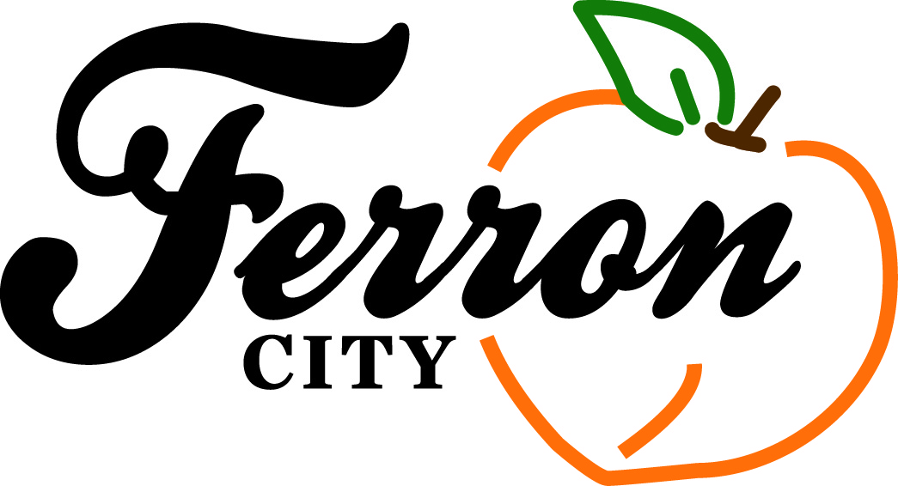 Ferron City

Mayor Adele Justice
Council Members:
Troy Winter
Dell Mead
Wendy Price
Chris Winn
Shala Hunsaker

G
August 22, 2017

August 5, 2020

Castle Valley Special Service District
P.O. Box 877
Castle Dale, UT 84513

Re: Project Requests for 2020-21

Dear Mr. Sharp,

The following is the proposed list of projects for Ferron City for the funding year 2021 in order of priority. Please contact us if you have any questions.

- Drainage on Main St from State to 100 E
- Curb and Gutter with possible drainage on Canyon Rd from 300 W to 400 W (north side)
- Curb and Gutter on 400 N from State to 200 E
- Curb and Gutter on 100 E from 300 N to 400 N (west side) CANNOT BE DONE PER ENGINEER BECAUSE OF GARAGE BUILT ON PROPERTY LINE AND WON’T ALLOW TO DO TO ADA SPECIFICATIONS
- Curb and Gutter on 200 E from 200 N to 300 N (east side)
- Curb and Gutter with possible drainage needed on 400 N from 200 E to 225 E (north side)
- Curb and Gutter on 400 W from Canyon Rd to Main St
- Curb and Gutter on 200 E from 300 N to 600 N (east side)
- Curb and Gutter on 500 N from 100 E to 200 E (both sides)
- Curb and Gutter on 100 E from 400 N to 600 N (both sides)

Respectfully,

Brittany Yeates
Ferron City Recorder

