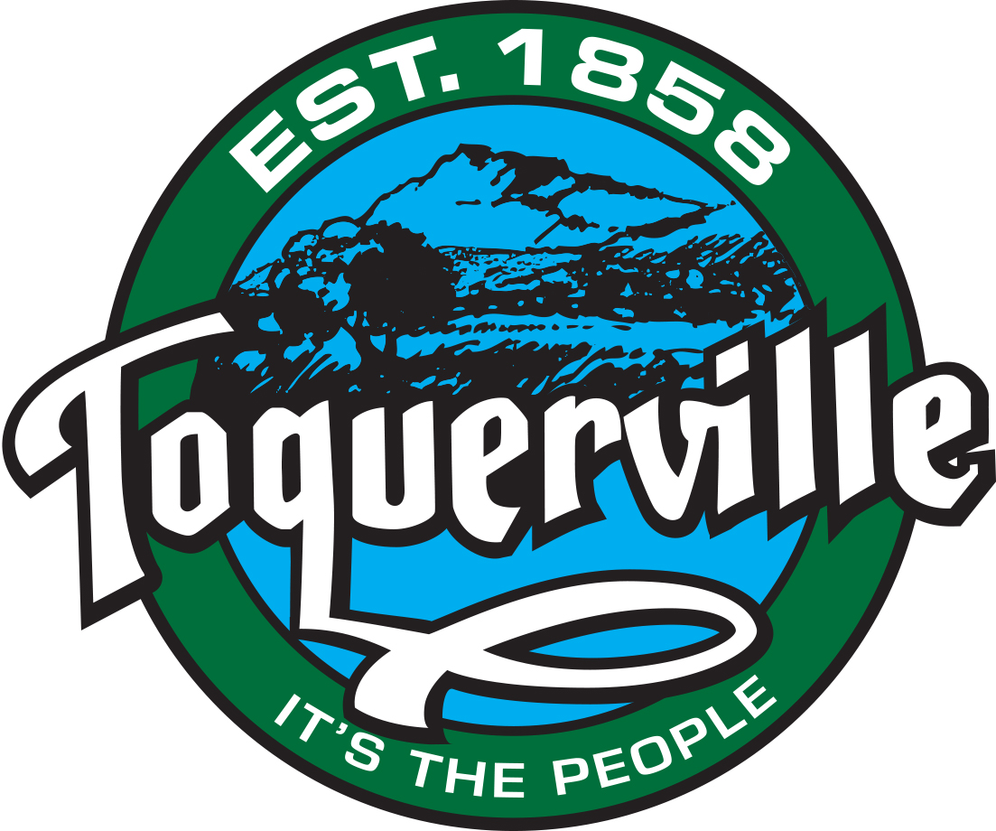
BUDGET MESSAGE
Final Budget FY2021

The Truth In Taxation Public Hearing is to be held on August 12th, 2020 as published and set forth as required by State Code.

The Tentative Budget as presented at the May 14th City Council Meeting has not changed. Requested increase in Property Taxes to $250,000 has raised the Tax Levy to .001650 from .000898 as designated by the advertising.

Appropriation of Funds 10-39-900: The Final Budget has been adjusted to correct the proposed levy with the actual Tax Levy, The Final Budget has been balanced at $1,265,625.00.

