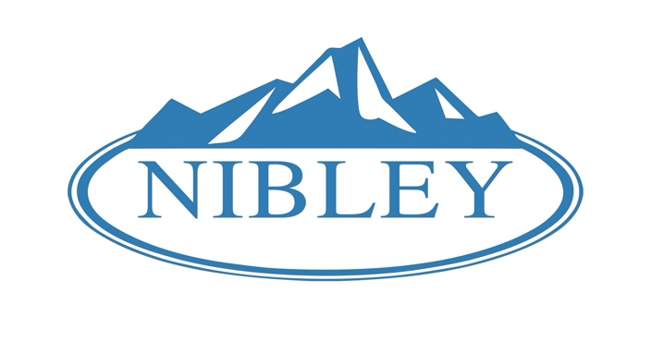
Mayor Council Members
Shaun Dustin Kathryn Beus
Tom Bernhardt
Norman Larsen
Nathan Laursen
Kay Sweeten

August 4, 2020

Nibley City Council Public Hearing Notice

The Nibley City Planning Council will hold a public hearing to receive comment on the following ordinance:

Ordinance 20-15: Amending the Logan Wastewater Treatment Impact Fee

When: August 13, 2020 at 6:30 p.m.
Where: Nibley City Hall, 455 W 3200 S Nibley Utah
For more information, please see www.nibleycity.com or visit Nibley City Hall. A full report will be posted on the City's website by August 7, 2020 as part of the City Council's agenda and packet report. Any updates to the plan will be posted on the City's website. You may submit comments in writing before the meeting either by mail to Nibley City Hall or email to cheryl@nibleycity.com.

Thank you,

Cheryl Bodily
Nibley City Deputy Recorder
(435) 752-0431

