Hyde Park City Annexation Policy Plan
City Annexation Policy Plan



A

August 2020
Hyde Park City

Introduction

Utah law requires that all municipalities within the State adopt an Annexation Policy Plan (UCA10-2-4). In that Annexation Policy Plan, cities are required to develop an expansion area map and to plan for the future growth of the community for the next 20 years.

The Annexation Policy Plan is intended to guide decision-making regarding future annexations. It also helps the City plan for future expansion in conjunction with neighboring political entities. Open communication between the City and other political entities, particularly the County, is a priority in the process of developing the Annexation Policy Plan. As such, all neighboring communities, local districts, and the county are invited to participate in the drafting of this plan.

Through its Annexation Policy Declaration Urban Service Boundary Plan, Hyde Park City has established a common boundary to the south with North Logan City; to the north with Smithfield City; and a small common boundary with Logan City by the airport. On the east is US Forest Service land. To the west is unincorporated Cache County land, west of the airport and this land to 2400 West is included in Hyde Park's annexation policy declaration. The City may, as requested by property owners, annex lands within its Annexation Policy Declaration area provided there is the ability to provide adequate public services and it is deemed beneficial to the City to incorporate that land. (Hyde Park City Gen Plan, pg. 1)

Consideration

In accordance with Utah Municipal Code 10-2-401.5, Hyde Park City considers the annexation of the unincorporated area using the following criteria:

- The area is within the boundaries of an approved expansion area map (i.e. the Annexation Declaration Boundary as shown on the Future Land Use Map).
- The area proposed for annexation shall be evaluated using the following standards for review:
  - Consistency with the general plan and the overall character of Hyde Park City;
  - The need for municipal services in developed and undeveloped unincorporated areas:
    - Plans for extension/expansion of municipal services;
    - Plans to finance extension/expansion of municipal services.
  - An estimate of the tax consequences to residents both currently within the municipal boundaries and in the area proposed for annexation.
  - The interests of all affected entities

- The map of the expansion area was, and shall be when modified or proposed to be modified, developed using the following criteria:

  - Attempt to avoid gaps between or overlaps with the expansion areas of other municipalities;
  - Consider population growth projections for Hyde Park City and adjoining areas for the next 20 years;
  - Consider current and projected costs of infrastructure, urban services, and public facilities necessary:
    - to facilitate the full development of the area within Hyde Park City; and
    - to expand the infrastructure, services, and facilities into the area being considered for inclusion in the expansion area;
  - Consider, in conjunction with Hyde Park City's general plan, the need over the next 20 years for additional land suitable for residential, commercial, and industrial development; and,
  - Consider the reasons for including agricultural lands, forests, recreational areas, and wildlife management areas in Hyde Park City.

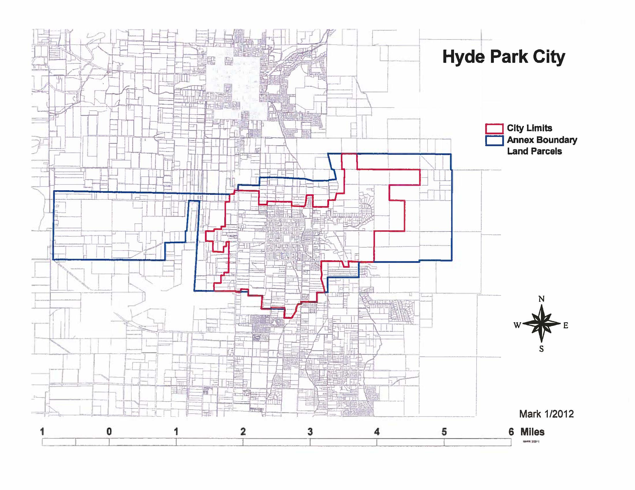

Annexation Petition Process

The following outlines the current steps for annexation as required by Utah Law as of July 2020. These steps are subject to change depending on state law. Hyde Park City’s intention is to follow state law with each annexation it considers.
Applicant
Submits Petition for Annexation
City Council
Considers Annexation Petition for Further Consideration
City Reviews
Application and Determines if it Complies with State Law; Denies or Certifies
City Council
Considers Application; Denies or Approves
Planning
Commission Recommends Zoning
Protest Period:
Affected Entities Can Voice Opposition
Step 1
Step 2
Step 3

The area proposed for annexation must meet the following requirements (UCA 10-2-402):
Step 6
Step 5
Step 4
- The area proposed to be annexed must be a contiguous, unincorporated area that is contiguous to the municipality, see UCA 10-2-402(1)(a); and
  - Does not leave or create an unincorporated island or peninsula (except as provided by UCA 10-2-418(1)(b); or unless the county and the municipality have otherwise agreed, see UCA 10-2-402(1)(b)(iii), and;
  - Is located within the annexing municipality’s proposed expansion area, see UCA 10- 2-402(1)(b)(iv); and
- The area to be annexed must include whole parcels only, unless the owner of a parcel of which only a part is desired to be annexed joins in the petition. See UCA 10-2-402(3).
- An area cannot be annexed for the sole purpose of acquiring municipal revenue or to impede the capacity of another municipality to annex the same area unless the municipality has the ability and intent to benefit the annexed area by providing municipal services. See UCA 10- 2-402 (4).

Petition Requirements (UCA 10-2-403)
- Be filed with the city recorder. See UCA 10-2-403(3)(a).
- Contain the signatures of:
  - Owners of a majority of the private land area located within the proposed annexation area (property must be equal to at least one-third (1/3) of the value of all private property located within the proposed annexation area, see UCA 10-2-403(3)(b)(ii)(A)
& (iii);
  - Owners of 100% of rural real property within the area proposed for annexation, see UCA 10-2-403(3)(b)(ii)(B) and UCA 17B-2a-1107; and
  - Owners of 100% of the private land area within the proposed annexation area if the area is within an agricultural protection area, see UCA 10-2-403(3)(b)(ii)(C) and UCA 17-41-101 et seq., or a migratory bird production area, see UCA 10-2- 403(3)(b)(ii)(C) and UCA 23-28-101 et seq.; or
  - The owner of all the publicly owned property if all property in the proposed annexation area is owned by a public entity other than the federal government. See UCA 10-2-403(3)(b).
- Be accompanied by an accurate and recordable map, prepared by a licensed surveyor, of the proposed annexation area. See UCA 10-2-403(3)(c)(i).
- Designate five (5) signers as sponsors, one of whom is designated as the contact sponsor and include mailing addresses of all sponsors. See UCA 10-2-403(3)(f).
- If the proposed annexation area includes property from another county, the petition must also include a resolution from that county’s county commission approving the proposed annexation. (as detailed above).
- The proposed annexation area cannot include an area that was included in a previously filed petition that has not been denied, rejected, or granted by the City. See UCA 10-2-403(4).
- In addition to delivery of the petition to the city recorder, on the date of filing, the petition sponsors must deliver or mail a copy of the petition to the clerk of the county in which the area proposed for annexation is located. See UCA 10-2-403(7).

City Council Review UCA 10-2-405
The City Council may deny or accept the petition for further consideration. See UCA 10-2- 405(1)(a)(i). (Note: the petition is considered to have been accepted for further consideration if the city council does not act on the petition at the next regularly scheduled meeting of the city council that is at least fourteen (14) days after the date the petition was filed. See UCA 10-2- 405(1)(a)(ii).)
DENIED – Mail written notice of denial within five (5) days after the denial to:
  - The petition’s contact sponsor;
  - The clerk of the county in which the area proposed for annexation is located. See UCA 10-2-405(1)(b).

ACCEPTED FOR FURTHER CONSIDERATION – Within thirty (30) days of acceptance for further consideration, the city recorder shall:
- Obtain from the county assessor, clerk, surveyor, and recorder of the county in which the proposed annexation area is located the records the city recorder needs to determine whether the petition meets the petition requirements (as explained above),
See UCA 10-2-405(2)(a); and
- With the assistance of the city attorney, determine whether the petition meets the petition requirements. See UCA 10-2-405(2)(b).

If the petition meets the petition requirements, the city recorder must:
- Certify the petition; and
- Mail or deliver written notice of certification to:
  - The city council body;
  - The contact sponsor; and
  - The county legislative body. See UCA 10-2-405(2)(c)(i).

If the petition fails to meet the petition requirements, the city recorder must:
- Reject the petition; and
- Mail or deliver notice of rejection and the reasons the petition was rejected to:
  - The city council body;
  - The contact sponsor; and
  - The county legislative body. See UCA 10-2-405(2)(c)(i).

Publishing & Providing Notice of Certified Petition UCA 10-2-406
After receiving notice of certification of the petition from the city recorder, the City Council shall:
- Public notice once at least once a week for three (3) successive weeks, beginning no later than ten (10) days after receiving notice of the certification in the newspaper of general circulation within:
  - The proposed annexation area; and
  - The unincorporated area within one-half (1/2) mile of the proposed annexation area; and
  - In accordance with UCA 45-1-101, legal notice publication requirements for three (3) weeks, beginning no later than ten (10) days after receiving notice of the certification. See UCA 10-2-406(1)(a).
- Within twenty (20) days of receiving notice of the certification of the petition, mail notice to each affected entity. See UCA 10-2-406(1)(b). “Affected entity” means:
  - County of the first or second class in whose unincorporated area the area proposed for annexation is located;
  - A county of the third, fourth, fifth, or sixth class in whose unincorporated area proposed for annexation is located, if the area included residents or commercial or industrial development;
  - A local district under Title 17B, Limited Purpose Local Government Entities – Local Districts, or special service district under Title 17D, Chapter 1, Special Service District Act, whose boundary includes any part of an area proposed for annexation;
  - A school district whose boundary includes any part of an area proposed for annexation, if the boundary is proposed to be adjusted as a result of the annexation; and
  - A municipality whose boundaries are within 1/2 mile of an area proposed for annexation UCA 10-2-401(1)(a).

The published and mailed notices shall:
- State that a petition has been filed proposing annexation;
- Provide the date the city council received notification of the certified petition;
- Describe the area proposed to be annexed;
- State that the complete petition is available for inspection and copying at the city recorder’s office;
- State that the city council may grant the petition unless, within thirty (30) days after the city council received notice of the certified petition, a written protest is filed with the commission and a copy of the written protest is delivered to the city recorder of the proposed annexing municipality;
- Provide the address of the commission, or if one has not yet been created, the address of the county clerk, where a protest to the petition may be filed;
- Provide the action date that is thirty (30) days after the notice is published by which written protests must be filed;
- (if applicable) state that the proposed annexation area will be annexed to a local district providing emergency services if (a) the city lies entirely within a local district’s boundaries that provides emergency services and an election was not required to form the district, and
(b) the area to be annexed does not already lie within the boundaries of a local district; and
- (if applicable) state that the area will be automatically withdrawn from a local district providing emergency services if (a) the petition proposed annexation of an area that lies within a local district that provides emergency services in the creation of which an election was not required to form the district, and (b) the city is not within the boundaries of the local district.

Planning Commission Review and Zoning Recommendation
The Hyde Park City Planning Commission’s responsibility is to recommend zoning of the subject parcels if annexed. An annexation petition shall be treated the same as a petition for zone change; a public hearing shall be scheduled and notice provided as specified in the Hyde Park Municipal Code. The Planning Commission shall hold a public hearing and recommend zoning prior to the final review of the annexation petition.

Final Review by City Council UCA 10-2-407 and 408
DENIAL OF ANNEXATION – If the city council denies the annexation, it must provide written notice within five (5) days after denial to:
  - The petition’s contact sponsor;
  - The commission; and
  - Each entity that filed a protest. See UCA 10-2-407(3)(a)(ii).

APPROVAL OF ANNEXATION – No timely Protest
If no protest was timely filed, the city council may approve the petition after holding a public hearing for which written notice was provided for at least seven (7) days before the hearing in:
- A newspaper of general circulation within the municipality and the area proposed for annexation; or if there is no newspaper in those areas, posted in conspicuous places most likely to give notice; and
- Posted on the Utah Public Notice Website (http://www.utah.gove/pmn/index.html). See UCA 10-2-407(3)(b).

APPROVAL OF ANNEXATION – After receipt of the commission’s decision
If the city council waits to take further action until after receipt of the commission’s decision on a protest, upon receipt of the decision the city council may either:
- Deny the petition; or
- Approve the annexation consistent with the commission’s decision. See UCA 10-2- 408(1).

Zoning of the Subject Parcels by the City Council
In the case of zoning, an annexation petition shall be treated the same as a petition for zone change. The City Council shall approve zoning of the subject parcels considering the recommendation of the Planning Commission. The City Council and Planning Commission intends to follow the General Plan and Future Land Use Map as the primary guide in zoning decision.

