SOUTH WEBER CITY
CITY COUNCIL MEETING

DATE OF MEETING: 9 June 2020 TIME COMMENCED: 6:00 p.m.

LOCATION: South Weber City Office at 1600 East South Weber Drive, South Weber, UT

PRESENT: MAYOR: Jo Sjoblom

COUNCIL MEMBERS: Hayley Alberts
Blair Halverson
Angie Petty
Quin Soderquist
Wayne Winsor

CITY RECORDER: Lisa Smith

CITY ENGINEER: Brandon Jones

CITY MANAGER: David Larson

Transcriber: Minutes transcribed by Michelle Clark

ATTENDEES: Edward Mueller, Nathan Harmston, James Durrant, Paul Sturm, Corinne Johnson, Joe Prantil, and Amy Mitchell.

Mayor Sjoblom called the meeting to order and welcomed those in attendance. She announced public is seated 6 ft. apart and there are clear dividers in between the City Council.

COVID UPDATE: Davis County has reported a 56.6% increase in cases with 83 cases total.
2.6% positive results of tests administered (goal is below 3%). South Weber City currently has 2 active cases.

- PLEDGE OF ALLEGIANCE: Councilman Halverson

- PRAYER: Councilman Soderquist

- PUBLIC COMMENT: Please respectfully follow these guidelines:
  - Individuals may speak once for 3 minutes or less
  - Do not make remark from the audience
  - State your name and address
  - Direct comments to the entire council
  - Note city council will not respond during the public comment period

James Durrant, 7478 S. 1980 E., explained he is the manager for the Cedar Cove Subdivision
Homes Owner’s Association (HOA). He identified on a map the Cedar Cove Park which the HOA has been maintaining over the years. Recently he discovered South Weber City owns a portion of this park. He explained four of the sprinkler zones are controlled by the HOA’s sprinkler box. He contacted Mark Larsen, public works director, to further discuss broken sprinkler heads. Mark Larsen told him the sprinklers need to be maintained by the HOA. Mr. Durrant suggested the city could share the existing sprinkler box or attach their own timer to the box. He requested the city maintain their sprinklers located in the Cedar Cove Park boundaries. David Larson, city manager, had previously spoken to Mark about the situation. He understood the city is to maintain sprinklers on the city property. It was decided David will work with Mr. Durrant to find a solution.

Joe Prantil, 800 East Cottonwood Rod, opposed the RV Park on Cottonwood Drive. He understood the city is moving forward, but he feared the city is afraid of litigation. He encouraged the city to develop some strong expectations and sanctions for not complying.

Nate Harmston, 838 E. 6600 S., expressed the proposed RV Park will have a major impact on his life. He met with some of the city council members individually. He felt it was a bad idea for South Weber City. He echoed the need for severe ramifications for the developer.

Michael Poff, 154 E. Harper Way, addressed the RV Park development agreement. He verified the owner can adjust the number of short term and long term stays at any time. He wondered how that will affect the TUF funds. He believed residency was an issue and questioned how that would be addressed. He said the secondary access was confusing to him. It didn’t look like the turnaround was wide enough. He was concerned about the fence. He reviewed the city ordinance for water use. He recommended another public hearing be held whenever an agenda item has been tabled.

Paul Sturm, 2527 Deer Run Drive, articulated South Weber City has tried to keep citizens informed and participating in city government considering the difficulty with the social distancing requirements surrounding the COVID Pandemic; however, he had issues with the planning commission meeting held on 3 June 2020 concerning Morty’s Car Wash. Mr. Sturm submitted his written comments following city instructions regarding on-line meeting public comments. During the meeting he learned that the planning commission members had not received his written comments prior to the meeting and couldn’t comment regarding the specifics he had addressed. Following the meeting, he was asked by the planning commission to send his comments directly to them because the city was not getting the information to them. He remarked there appears to be a disconnect in providing public comments to the city council and planning commission. He stated there were several agenda items that weren’t shown as titles in the packet. He identified pages in the packet and corrections he felt should be made. He also identified questions he had concerning agenda items 9, 10, 11 of the planning commission meeting held on 23 May 2019 regarding the proposed RV Park at 852 E. Cottonwood Lane. (see citizen input #3 Sturm)

Corinne Johnson, 8020 S. 2500 E., was grateful to address everyone in person. She asked to continue the ability of the citizens to meet in person in public meetings.

Julie Losee, 2541 E. 8200 S., (read by Amy Mitchell) discussed her frustration with not being able to meet for city business in person. (see citizen input #5 Losee)

Amy Mitchell, 1923 Deer Run Drive, thanked the City Council for allowing public comment in person. She felt that public comments had been lost over time in meetings. She addressed her concerns with Morty’s Car Wash. She thought the car wash needed to be scaled back. She felt the packet was confusing. She wanted to know how the city will address the parking at Maverik with the car wash. She stated the entrance to the car wash should stand alone. She suggested reviewing the transitional use zone prior to approving anything on the Stephens property. She remarked the chain link fence between car wash and school was an oversight.

Mayor Sjoblom encouraged those with questions to contact the city council to receive answers.

ACTION ITEMS:

- APPROVAL OF CONSENT AGENDA:
  - Minutes of 12 May 2020 • Minutes of 19 May 2020
  - Minutes of 26 May 2020

Councilman Halverson moved to approve the consent agenda as written. Councilman Winsor seconded the motion. Mayor Sjoblom called for the vote. Council members Alberts, Halverson, Petty, Soderquist, and Winsor voted aye. The motion carried.

Councilman Winsor moved to open the public hearing to amend the FY 2019-2020 Budget. Councilwoman Petty seconded the motion. Mayor Sjoblom called for the vote. Council members Alberts, Halverson, Petty, Soderquist, and Winsor voted aye. The motion carried.

************************* PUBLIC HEARING *************************

- Public Hearing: Open and Amend the FY 2019-2020 Budget
Mayor Sjoblom reported the current city budget for 2019-2020 was adopted on August 20, 2019. During the fiscal year unanticipated changes and expenses have occurred. This year’s budget needs to be opened and amended to reflect those changes. To amend an adopted budget, a public hearing is required to afford citizens an opportunity to address the proposed changes.

Mark McRae, Finance Director, explained the necessary changes to the 2019-2020 budget. They were as follows:

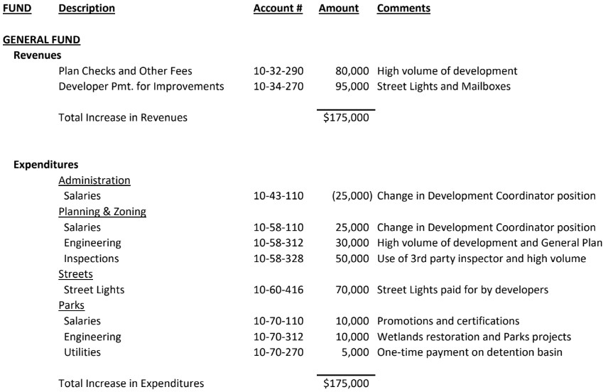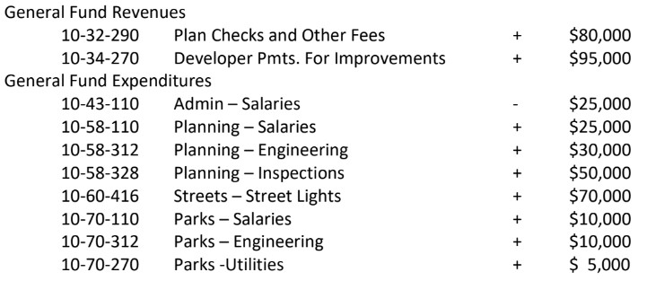

He discussed the amendment to the resolution in the packet to include the garbage can cost of $16,000. There have been a lot of individuals moving into new homes which require cans. There will be a restriction on second cans until the supply arrives. In order to place the order, the money must be appropriated into this budget.

Mayor Sjoblom asked if there was any public comment. There was none.

Councilman Winsor moved to close the public hearing to open and amend the FY 20192020 Budget. Councilwoman Alberts seconded the motion. Mayor Sjoblom called for the vote. Council members Alberts, Halverson, Petty, Soderquist, and Winsor voted aye. The motion carried.

************************* PUBLIC HEARING CLOSED ************************* Councilman Winsor moved to open the public hearing for Fiscal Year 2020-2021 Tentative Budget. Councilman Halverson seconded the motion. Mayor Sjoblom called for the vote. Council members Alberts, Halverson, Petty, Soderquist, and Winsor voted aye. The motion carried.

************************* PUBLIC HEARING *************************

6. Public Hearing: Fiscal Year 2020-2021 Tentative Budget: Mayor Sjoblom explained the city staff and the city council have worked together over the past several months to put together a balanced budget for all funds which is both fiscally responsible and meets the needs of the city for the fiscal year ending June 30, 2021. All cities in Utah are required to adopt a tentative budget outlining expected revenues and expenditures for the next fiscal year. The city council adopted its tentative budget for 2020-2021 on May 12, 2020. A public hearing was set for June 9, 2020 for public comment on the tentative budget.

Mark McRae, Finance Director, reported the following changes being proposed to the tentative budget:

General Fund - Revenues – Property Tax An increase of $34,000 due to new growth figures from Davis County.
General Fund - Revenues – Contribution from Fund Balance An increase of $51,000. General Fund – Administration – Professional & Tech. - Attorney An increase of $75,000 for a property rights attorney.
General Fund-Fire-Salaries An increase of $10,000 due to an employee salary adjustment recommended by the finance committee and recalculation of 2020 budget amendment for captains and holidays.
Capital Projects – Revenues – Contribution from Fund Balance An increase of $930,000. Capital Projects – Revenues – Developer Pmts. for Improv. An increase of $110,000 for developer share of streetlight installation.
Capital Projects – Admin. – Improv. Other than Bldgs. An increase of $30,000 for audio/video upgrade of city council chambers.
Capital Projects – Streets - Land An increase of $800,000 to purchase property for a new public works’ shop. This was being re-budgeted from fiscal year 2020.
Capital Projects – Streets – Improv. Other than Bldgs. An increase of $210,000 for streetlight installation.
Sewer Fund – Salaries An increase of $6,000 due to an employee salary adjustment recommended by the finance committee.
Storm Drain Fund – Salaries An increase of $6,000 due to an employee salary adjustment recommended by the finance committee.
Water Fund – Projects An increase of $565,000 in the Job Corp portion of the east bench transmission lines as per signed agreement. An increase of $50,000 in the city portion of the east bench transmission line for property easements.

Councilman Soderquist asked about the $800,000 budgeted in capital projects for a new public works’ shop. Mark explained it will be left until after July 1, 2020 and moved to next year’s budget.

Mayor Sjoblom asked if there was any public comment.

Corinne Johnson, 8020 S. 2500 E., addressed the South Weber fire department budget. She was concerned about the high amount of money being spent in this department. She opined the city is overspending in this area. She discussed 35% of South Weber City tax revenue being spent in this department. She presented figures she had collected which compared various cities to South Weber City and the amount of money budgeted, tax revenue received, and money spent on their fire departments. She asked the public safety committee to look into the number of calls outside this city. (see citizen input #4 Johnson)

Michael Poff, 154 E. Harper Way, pointed out his cable bill taxes go to Riverdale City. He requested South Weber City review this issue this year. He asked how much of the general fund goes to streets and roads. He suggested prioritizing. He also suggested reviewing the TUF again. He cautioned being careful with salary surveys.

Councilwoman Petty moved to close the public hearing for Fiscal Year 2020-2021 Tentative Budget. Councilwoman Alberts seconded the motion. Mayor Sjoblom called for the vote. Council members Alberts, Halverson, Petty, Soderquist, and Winsor voted aye. The motion carried.

************************* PUBLIC HEARING CLOSED *************************

- Resolution 2020-23: Budget Amendments for the Fiscal Year Ending June 30, 2020:

Councilman Winsor moved to approve Resolution 2020-23: Budget Amendments for the
Fiscal Year Ending June 30, 2020. Councilman Soderquist seconded the motion. Mayor Sjoblom called for the vote. Council members Alberts, Halverson, Petty, Soderquist, and Winsor voted aye. The motion carried.

- Resolution 2020-03: Development Agreement for Riverside RV Resort:
Mayor Sjoblom explained the city council originally reviewed the Riverside RV Park plans and conditional use permit (CUP) on December 10, 2019. After discussion, the council continued the item to January 28, 2020 and established a working committee to research, review, and recommend amendments to the CUP to the full council.

The working committee presented their work for council’s consideration on January 28, 2020.
They brought forward an amended CUP along with a proposed development agreement. Considering public comment, developer comment, and council discussion, the council continued the items and requested the working committee continue to work on some items that they did not feel were ready for consideration. Some outstanding items the council was hopeful to address in the meantime included but were not limited to city/county boundary, ingress/egress, fire protection & water system setup.

The committee has since met multiple times to discuss these and other issues relating to the development proposal. The final plans now include two points of ingress/egress, compliance with applicable fire codes, privately-owned water lines, and fencing along I-84 that will include a cable barrier and opaque masonry fence. The development agreement addresses the boundary
line situation with approval on the undisputed acreage and contingent approval on the disputed acres based on a satisfactory resolution.

Councilman Halverson referenced a public comment inquiring how the fence and cable barrier requirement along the property line that borders Interstate 84 right-of-way line is justified in regard to setbacks. He remarked the setback is an exception on Interstate 84, which the developer had approved from UDOT and the fire department. He explained UDOT didn’t put any restrictions, but the city added the fence and cable barrier requirement. The setbacks are being met on every other boundary except Interstate 84 property line. Brandon explained the city code requires 15% landscaping and the developer is providing 40%. The developer’s landscape plan includes a lot of park-like landscaping. Councilwoman Petty had discussed the cable barrier fence with the fire department and was assured it is very strong and will protect visitors in the RV Park. Councilman Soderquist questioned exhibit C concerning the boundary area. Brandon pointed out the label was on page 141 of the packet. Councilwoman Petty explained the second egress is simply to get people out quickly, not necessarily RVs. The turnaround accommodates the fire truck. David Larson revealed in the case of a major evacuation, the main entrance and secondary access would be used. In case something was blocking the main entrance, then the secondary access would be used.

Councilman Winsor referenced a public comment concerning the transportation utility fee (TUF). He indicated even if the developer had every site as a short-term stay, there would still be a TUF collected. Councilman Winsor questioned item #15 in the development agreement concerning the length of stay which states, 15.1 Patrons. Developer shall not permit patrons to stay at the RV Park for more than one hundred twenty (120) consecutive days (the “Maximum Stay Period”). Any patron who stays for the Maximum Stay Period is required to adhere to a seven (7) day leave period before returning to stay at the RV Park (the “Leave Period”). Councilman Winsor asked what happens after 10 years. He recommended including the length of stay in the conditional use permit (CUP) as well. Councilman Halverson expressed none of the construction elements should have any expiration. Brandon Jones, city engineer, agreed. McKay Winkel, developer, understood the agreement was indefinite. He agreed with 120 days being on the CUP. He assumed the TUF would be forever.

Wade Budge, McKay Winkel’s attorney, agreed with what McKay stated. Mr. Budge proposed changing the expiration date to be coterminous with the CUP. He explained if the CUP terminated, then the development agreement is terminated. He recommended making sure the development agreement went along with the CUP.

David clarified the development agreement is dependent on the CUP, but not the other way around. Mr. Budge stated they are linked together. He suggested amending the Development Agreement Paragraph 26.3 to read: “The term of this Agreement shall run and be concurrent with the term of the conditional use permit (CUP) #2020-01.”

Councilwoman Alberts asked about the boundary resolution concerning the 3.32 acres (“Disputed Property”). She pointed out the development agreement states unless and until the boundary issue is resolved between Uintah City and South Weber, the owner shall delay construction and improvements of any RV sites, cabin units, park models, or tiny homes upon the disputed property. Mr. Winkel stated they would probably have to move the green space into the 3.32-acre area. David explained the city code still applies.

Councilwoman Alberts asked Mr. Winkel to expand on development agreement item #7 Stream Alteration Permit. Mr. Winkel stated that was required for engineering and he applied for and received it.

Councilwoman Alberts queried how information will be given to the city on the TUF length of stay. Mr. Winkel commented their software will keep track of that information. David explained the utility fee is calculated based upon the actual length of stay. Councilwoman Petty specified if the owner fails to report the short-term stays (STS) and long-term stays (LTS), it does default to LTS. Councilman Halverson explained the city encourages as many STS as possible and still receives the transient tax. Mr. Winkel commented they make more money on the STS.

Discussion took place regarding page 4 of the development agreement item 13.1 paragraph 2 concerning long term occupancy and short-term occupancy.

13.1 ERU Calculation Paragraph 2 - The fee for this Development will be calculated based on the number of sites used for long-term stays (“LTS”) versus short-term stays (“STS”). For purposes of this Agreement only, an LTS shall be considered a site where a guest has stayed thirty (30) consecutive days or more, and an STS is a site where a guest has stayed twenty-nine (29) consecutive days or less, including any vacant spaces. The determination of LTS versus STS shall be determined based on actual occupancy of the Development on the fifth (5th) day of each month.

Councilwoman Alberts requested an explanation on 13.2 Long-term Stays and ERU Adjustment.

13.2 Long-Term Stays and ERU Adjustment. The Owner, in its sole and absolute discretion, may adjust the number of LTS up or down at any time. It shall be the Owner’s responsibility to report the number of STS and LTS to the City for the preceding measured month by sending a snapshot report showing how many sites were occupied on the 5th day of the month by LTS vs STS. In the event that Owner fails to report the STS and LTS, the default maximum number of ERUs to be used for the TUF is sixty-nine (69) ERUs.

Mr. Winkel explained the TUF will change and it will be available through the reports. For example, if an occupant comes in and stays 15 days through the reporting period, the RV Park would pay the short-term TUF, and if the occupant stayed another 20 days, the next month the RV Park would report the occupant as long-term. David remarked as soon as someone moves from being at the RV Park from 29 days to a long-term stay, the report will capture that information. He commented this is more of a report conversation and the software needed to gather this type of information for those reports. Councilman Soderquist understood what was meant but wanted to make sure what was written captures what was meant. Discussion took place regarding the monthly report and what date the report should be submitted. David expressed the report should identify over the last 30 days how many times an occupant went over 30 days.

Councilwoman Alberts questioned 13.2 Long-Term Stays and ERU Adjustment. The Owner, in its sole and absolute discretion, may adjust the number of LTS up or down at any time. McKay explained the TUF will change based on the reports. David acknowledged this came about because at one time there was no discretion. Councilman Winsor suggested amending the sentence to read as follows: 13.2 Long-Term Stays and ERU Adjustment. The Owner, in its sole and absolute discretion, may adjust the number of LTS up or down at any time. Wade Budget, attorney for Mr. Winkel, agreed with the amendment.

Councilwoman Alberts addressed item #17 in the development agreement concerning landscaping and was concerned about the buffer along Interstate 84. She suggested adding that landscape needs continual upkeep to be maintained. Wade stated they will comply with the city ordinance in that regard. Councilwoman Petty voiced the developer will be subject to code enforcement. Councilman Soderquist suggested letting everyone know the boundary had been discussed at length with Uintah City.

Councilwoman Alberts asked if there was an easement for the access road. Mr. Winkel commented there will be a breakaway style gate with a sign for emergency access. David proclaimed that is noted in the plans. Councilwoman Alberts questioned item #26.4 Agreement to Run with the Land concerning if the property were sold would the agreement go with the property. David reported any new owner would be required to abide by the same development agreement.

Brandon Jones, City Engineer’s, review of 4 June 2020 is as follows:
This memo addresses the proposed development of the Riverside RV Park. There are three elements needing approval for this development to proceed: 1) Conditional Use Permit (CUP) for use of the ground as a Recreational Vehicle Park (larger than 1 acre), 2) Development Agreement (DA), and 3) Final Construction Plans.

CONDITIONAL USE PERMIT
- No comments.

DEVELOPMENT AGREEMENT The purpose of the Development Agreement is address in
more detail elements that need additional clarity, direction or approval. The following are items dealing with some of the engineering and design elements. These are mentioned mainly for informational purposes.
- Boundary Resolution. The overall property is 11.85 acres. There is a portion of the development adjacent to the river (about 3.32 acres) where the city’s jurisdictional authority is in question. The DA would require that this area receive a determination that it lies within South Weber City before the ground could be developed and used as an RV Park (e.g. no construction of any park sites). Exhibit C shows where the County line is located in relationship to the proposed improvements.
- Flood Plain. A Flood Plain Permit will be required for development in the flood plain. The 3 permanent structures will require an Elevation Certificate showing that they are at or above the Base Flood Elevation (BFE).
- Culinary water for Outdoor Use. There are no pressure irrigation service providers near this development. Therefore, the use of culinary water for outdoor use would be authorized. The development would pay for all water used based on their metered usage.
- Trail. A 15’ wide easement will be dedicated by the developer to the Trails Foundation of Northern Utah (TFNU), and a 10’ trail built by TFNU prior to occupancy.
- Water, Sewer and Storm Drain Responsibility. All interior water main lines, fire hydrants and services will be private past the water meter servicing the development. All sewer mains and laterals will be private and connect to the Central Weber Sewer main.
All elements of the storm drain system are private and connect to the UDOT storm drain line that discharges into the river.
- Cottonwood Drive Waterline Project. The developer agrees to contribute $35,000 towards South Weber City’s portion of the project. The City agrees to complete the project by November 30, 2020.
- Fire Flow. The required fire flow is 1,500 gpm and must be provided prior to any structures being built.
- Transportation Utility Fee. The TUF will be charged based on a monthly report provided by the RV Park showing evidence of how many long-term stays vs. short-term stays occurred. The fee may be adjusted monthly accordingly. If no report is provided, the maximum fee will be charged.
- Setback Exception. In exchange for the City allowing sites within the 75’ setback, the developer will install a cable barrier fence and an opaque masonry fence along I-84. The cable barrier fence is intended to protect the occupants of the park against errant vehicles/trucks potentially running off the freeway. The masonry fence is intended to be an attractive element of the development as well as protect against park occupants (especially children) climbing the fence and getting into the freeway property.

FINAL PLANS
- Two means of ingress/egress are being provided.
- All other elements shown on the plans (dated May 19, 2020) meet the City Standards.

RECOMMENDATION
We recommend approval of the CUP, Development Agreement and Final Plans, as currently proposed.

Barry Burton, City Planner’s, review of 5 June 2020 is as follows:

PL 1. APPLICANT: FM Winkel Family LLC

PL 2. REQUEST: Conditional Use approval for an RV Park next to the Weber River east of the bridge into Uintah.

PL 3. GENERAL INFORMATION: The Park will consist of 102 RV sites and 4 tent sites. Twenty-three of the RV sites will be Alternate Units (also called Park Units or tiny homes) that will be owned by the RV Park and rented. Seventy-nine will be back-in or pull-through spaces. This is well within the 174 spaces allowed by the ordinance on an 11.85-acre parcel. There will be three permanent buildings: an office building, a laundry building and a restroom/shower building. Amenities include a swimming pool and a pickle ball court. They are also allowing the installation of a public trail along the river to be constructed by others.

PL 4. ORDINANCE COMPLIANCE: The provisions of Section 10-7, Conditional Uses, apply to this proposal. Sections 10-7-3 and 10-7-5 are general provisions applying to all conditional uses in non-residential zones. There are both subjective and objective provisions in these code sections. The objective requirements have been met. In my opinion, the subjective requirements have also been fulfilled.

Section 10-7F contains requirements specific to RV parks. There are several conditions listed in Section 10.7F.1 of the Zoning Ordinance that I believe have all been met. I also believe the requirements of Section 10.7F.2 have been fulfilled with one exception. Section 10.7F.2 states that:

Setbacks:
- No trailer or service building or structure shall be placed or permitted within one hundred feet (100') of the road or street upon which the lot or area fronts, or within seventy-five feet (75') of any other boundary line.
- The Planning Commission or City Council can approve setbacks of less dimensions than required if in its review of the site plan of the proposed RV park it finds evidence of special landscape buffering that in its determination effectively: a) visually screens the park from adjoining land uses; b) mitigates adverse impact on and from the park; and c) provides for an attractive park-like setting. In no cases shall the setback distance be less than three feet (3').

All of the RV sites adjacent to I-84 are less than 75’ from the boundary of the property, but all are at least 100’ from the shoulder of the freeway. For safety purposes, the developer is proposing a cable fence barrier along this property line. I believe the distance from these RV and tent sites to the nearest freeway lane as well as the proposed barrier fence, introduced landscaping and natural landscaping justify the granting of this reduction in setback.

PL 5. FLOODPLAIN: Much of this property, including the sites of the three permanent buildings, lies within the floodplain. According to FEMA Flood Insurance Rate Maps (FIRMs), the proposed finish floor elevations of these structures is at or above the Base Flood Elevation (BFE) as required. Developers will need to apply for a Floodplain Development Permit and, upon completion of the floors, provide an Elevation Certificate for each structure verifying it is at or above the BFE. The floodplain development permit requires that they show no rise in BFE as a result of the development. It would be issued by me as the Floodplain Administrator for the City. Elevation Certificates are provided by a licensed surveyor.

PL 6. OTHER: The developers are willing to grant an easement along the river for the purpose of a public trail. The trail, however, will be built by the Trails Foundation of Northern Utah (formerly Weber Pathways) later. Therefore, the Foundation will need an easement for public use along the trail alignment. We propose that those easements be surveyed after construction in order to have a more accurate description of the locations and that the easements be provided prior to occupancy. This is specified in a provision of the proposed development agreement.

Sewer, water and storm drain lines within the site will be privately owned and maintained. This is outlined in a provision of the proposed development agreement.

The one unresolved issue I see at this point is regarding the legal jurisdiction over the 3.32 acres of the site that may or may not be in Uintah City/Weber County. The developer is being tasked with resolving this issue by the development agreement. Mr. Winkel is requesting the entire site plan be approved subject to the resolution of this issue. If he is subsequently successful in proving this property is in South Weber, no further action by the City would be required. If the Council agrees with this approach, I recommend they be allowed to proceed with installation of all utilities and roadways for the entire development, but not be allowed to construct any RV pads on the 3.32 acres. In this way, the City only approved the land use for the portion of the site unquestionably within its jurisdiction. They would only be installing private pipelines and private roads on the disputed property which any landowner can do without jurisdictional approval.

PL 7. STAFF RECOMMENDATION: I recommend the City Council approve this proposed conditional use with the following conditions:

- No RV sites be constructed on the disputed 3.32 acres until proof has been provided that the property is in South Weber.
- A Floodplain Development Permit be obtained for the 3 permanent structures.
- At the appropriate time, Elevation Certificates for the 3 structures will be provided.
- Approval of the accompanying development agreement.

Councilwoman Petty moved to approve Resolution 2020-03: Development Agreement for Riverside RV Resort with the following amendments:

  - Amend 13.2 Long-Term Stays and ERU Adjustment. The Owner, in its sole and absolute discretion, may adjust the number of LTS up or down at any time. And indicate it will be a monthly report for STS versus LTS.
  - Amend Paragraph 26.3 to read: “The term of this Agreement shall run and be concurrent with the term of the conditional use permit (CUP) #2020-01.”

Councilman Soderquist seconded the motion. Mayor Sjoblom called for the vote. Council members Halverson, Petty, Soderquist, and Winsor voted aye. Councilwoman Alberts voted nay. The motion carried 4 to 1.

- Final Site and Improvement Plans: Riverside RV Resort:
Councilwoman Alberts asked if parking stalls are within code. It was stated they are within code. The cable fence will be installed on the boundary line and inside that will be the masonry fence.

Councilman Soderquist moved to approve the Final Site and Improvement Plans: Riverside RV Resort. Councilman Winsor seconded the motion. Mayor Sjoblom called for the vote. Council members Alberts, Halverson, Petty, Soderquist, and Winsor voted aye. The motion carried.

- Conditional Use Permit 2020-01: Riverside RV Resort:
Conditional Use Permit #2020-01
Applicant: Riverside RV Park
Proposed Use: RV Park
Address: 855 E Cottonwood Drive, South Weber UT 84405
Zone: Commercial Recreation
Along with compliance to all applicable state and city codes, the conditional use permit has been approved with the following conditions:
  - 24-hour on-site management shall be provided.
  - Quiet hours shall be from 10:00 p.m. to 7:00 a.m.
  - RV Park rules must be posted on-site and given to all patrons.
  - Management must enforce park rules. Any changes to the park rules shall be provided to the City within 1 week.
  - Patrons shall stay for no more than one hundred twenty (120) consecutive day and must abide by a seven (7) day leave period before returning to stay at the RV Park.

David explained if the CUP is out of compliance with code, it will go through the proper process. Councilman Winsor wondered how the public would be assured of compliance to the conditions. David explained the city has a code enforcement officer. Mr. Winkel stated it will be a very wellrun RV Park.

Councilman Winsor moved to approve Conditional Use Permit 2020-01: Riverside RV Resort. Councilman Soderquist seconded the motion. Mayor Sjoblom asked if there was any comment. Councilwoman Alberts commented this was a tough spot to be in. She was not on the council for these changes and choices but is now. She commented there are not likely any who have studied this development more than she had. She walked the property. She observed some of the concerns that she and many others have firsthand. She personally met and spoke with those who live closest to it. She listened to every past meeting concerning the changes and votes that took place leading to this point. She spent probably 15 hours doing a deep study of city code and finding things that still needed to be addressed. In fact, many of the changes made were due to those findings.

She appreciated some of the concession made by McKay, but still felt like it is less of an RV park and more of a mobile home park on wheels. She believed McKay has every intention of making this a beautiful park, but she worried if it ever got sold the new owner wouldn’t have the same enthusiasm for a nice place and all the allowances.

*She lamented many additions in the city make big promises but under deliver. Once everything is said and done, it is the citizens who must pay the price for any nuisance that the city did not address at the time catering instead to a developer or owner. She indicated the city has a habit of mandating the code be followed completely when it is in favor of the developer, and yet making concessions when it is in favor of the city. She expressed the owner changing long-term and short-term stays at will is not okay. There needs to be notice before changes are made, and she wanted a limited number of changes a year. There was nothing in the agreement about up keeping existing landscaping. The code requires a landscape buffer but says nothing about ensuring that landscape is continually maintained. This agreement ends in 10 years – then what? Why would we only want to make sure this RV Park does its due diligence for 10 years when it is expected to be within the city inevitably? Additionally, while the agreement expires, the RV Park wants to be grandfathered into the code. One of those needs to change. She also opposed the agreement moving with ownership. This agreement is with McKay based in good faith that are representative of McKay’s diligence in this project. The city is not guaranteed the same philosophy with a new owner. Additionally, once again there are no teeth in this CUP. She refused to put the citizens through another CUP that cannot be enforced. For example, the RV Park rules say it will be given to each patron and the rules will be enforced, but what happens if they are not? What recourse does the city have?

Councilwoman Alberts stated, “We have had too many additions in the city that make big promises but under deliver. Once everything is said and done, it is our citizens who must pay price for the nuisance that the city did not address at the time catering instead to a developer or owner. We seem to have a habit of mandating the code to be followed completely when it is in favor of the developer, and yet make recessions when it is in favor of the city. I do not feel the owner changing long term and short term stays at will is okay. I think these TUF dispersants is going to be a difficult. I am also not okay with the agreement moving with new ownership. This agreement is with McKay based in good faith and are representative of McKay’s diligence to this project and his promise to focus on short term stays, we are not guaranteed the same philosophy with a new owner. Additionally, once again we have a CUP I feel has no teeth. I refuse to put our citizens through another CUP we cannot actually do anything with. It’s hard to know when we are being served platitudes. The CUP is a lose/lose situation for the city – revoking and having an abandoned RV park does not solve our problems. There are simply too many concerns for me.”

Mayor Sjoblom called for the vote. Council Members Halverson, Petty, Soderquist, and Winsor voted aye. Councilwoman Alberts voted nay. The motion carried 4 to 1.

11. Resolution 2020-24: 2020 Streetlight Installation Project:
Mayor Sjoblom explained on May 28, 2020 at 2:00 pm., bids were opened for the 2020 Street light installation project. Five bids were received. The results of the bidding are shown on the enclosed bid tabulation. A few minor errors were found; however, these errors did not change the ranking of the bids.

The project entails installation of new city-purchased streetlights in subdivisions where developers have previously paid for them. There will be 18 residential and 21 intersection style streetlights installed. City engineer Brandon Jones recommended that the council award the project to BIG BEAR ELECTRIC with their bid of $183,980.00. This recommendation is based upon the contractor’s experience in doing similar work, as well as a favorable recommendation from our streetlight supplier Carson Fillin (SSCO). Carson has been involved in several other projects with Big Bear Electric and highly recommends them.

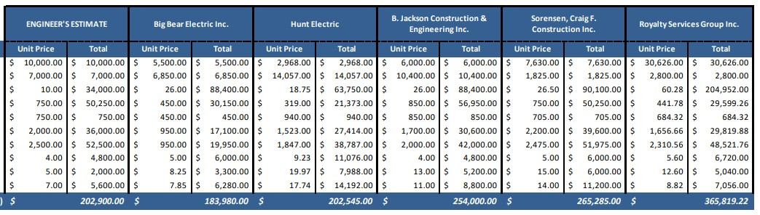

Councilman Halverson moved to approve Resolution 2020-24: 2020 Streetlight Installation
Project to accept the bid and award the project contract to Big Bear Electric for
$183,980.00. Councilman Winsor seconded the motion. Mayor Sjoblom called for the vote.
Council members Alberts, Halverson, Petty, Soderquist, and Winsor voted aye. The motion carried.

Councilwoman Alberts thanked the municipal committee and city staff for all their work on this project.

- Fraud Risk Assessment:
Mayor Sjoblom reported the state auditor has issued a new requirement that each local government entity will need to complete an annual fraud risk assessment the end of each fiscal year starting with the current fiscal year. The governing board of each entity may assign a board member, staff member, volunteer, or paid professional to complete the assessment on their behalf. The chief administrative officer and chief financial officer must certify the assessment. The completed and certified assessment must be presented to the governing board prior to the end of the fiscal year. The purpose of this agenda item was for the Council to assign an individual to complete this assessment.

Councilwoman Petty moved to appoint Mark McRae, finance director, to complete the Fraud Risk Assessment by the end of the fiscal year. Councilman Winsor seconded the motion. Mayor Sjoblom called for the vote. Council members Alberts, Halverson, Petty, Soderquist, and Winsor voted aye. The motion carried.

- Resolution 2020-25: Legal Services Contract:
Mayor Sjoblom expressed South Weber City needs legal advice from a firm with land use expertise. The city staff reached out to firms with known experience in these matters and received offers from three different firms: Snow Christensen & Martineau, Parsons Behle & Latimer, and Jones Waldo. After a review of each firm’s experience and qualifications, discussions with the individual attorneys who would be working with the city, and an evaluation of the hourly rates of each firm; the city staff recommended engaging the services of Snow Christensen & Martineau. Although all three firms have knowledge and experience that would benefit South Weber City, Snow Christensen & Martineau will provide a three-person team of experienced attorneys at the lowest hourly rate of the three firms.

Councilwoman Alberts asked what the rates were. David reported Parsons Behle & Latimer is $280/hr. and Jones and Waldo is $350/hr.

Councilman Halverson moved to approve Resolution 2020-25 for Snow, Christensen, &
Martineau: Legal Services Contract. Councilwoman Alberts seconded the motion. Mayor Sjoblom called for the vote. Council Members Alberts, Halverson, Petty, Soderquist, and Winsor voted aye. The motion carried.

DISCUSSION ITEMS:

14. Northern City Boundary
Mayor Sjoblom reported Uintah City recently approached South Weber City about discussing the two cities’ common boundary. Mayor Sjoblom, City Manager David Larson, and City Planner Barry Burton met with representatives from Uintah City on May 5 and determined that a joint working group with four representatives from each city would get together and develop a joint resolution between both cities that would clarify the boundary and could go before both city councils for consideration.

South Weber City’s representatives on the working group are Mayor Sjoblom, Barry Burton,
Councilmember Blair Halverson, and Planning Commission Chair Rob Osborne. They met with Uintah City representatives as a working group on May 21 to begin discussions. Mayor Sjoblom reported on those discussions during the May 26 City Council Meeting.

It has been determined that the boundary should cross I-84 at the east end of the northernmost Geneva Gravel Pit, follow along the north side of I-84 (next to the freeway) west until it reaches the east end of the McKay Winkel property, and follow the current river alignment until approximately Adams Ave where it follows a section line
westward to the rear lot line of the last house on the north side of the west end of Harper Way. At that point, it would follow the south right-of-way line of I-84 to the Riverdale City boundary.

This discussion item was a chance for the entire city council to provide input to the members of the working group as they continue to represent the city in discussions with Uintah City to prepare a joint resolution to come before the council at a future date. Councilman Halverson asked about the Layne Kap property next to Riverdale City. David understood there are issues with that parcel, but the city needs to approach Riverdale. Councilwoman Petty identified the proposed new city/county boundary on the map. David discussed city boundaries are generally based on city services and so this has been the driving force behind this discussion.
Councilwoman Petty asked if Uintah City could provide services to the RV Park. Councilman Halverson did ask that question to the Uintah mayor. David pointed out that is a question the mayor from Uintah would need to answer. He stated as we move forward the working committee will continue to meet together. A metes and bounds description will be put together. Ultimately, a joint resolution declaring the boundary will come before each council for approval. Councilwoman Alberts asked about the possibility of shared funds with Uintah concerning maintenance of Cottonwood Drive. She suggested it as a compromise for South Weber City taking over the service of the RV Park. Councilman Soderquist recommended looking at the location of the Weber River. He asked if South Weber City and Uintah City agree but the counties don’t agree. David expressed the city boundary doesn’t need to follow the county boundary.

REPORTS:

- New Business: Councilman Winsor recommended the city put together a task force to discuss possible location for a new city office building. Councilman Halverson agreed. It was decided the admin/finance committee would take on this task.

Mayor Sjoblom expressed the need for the Red Hawk HOA to maintain the corner piece of property along 8200 South.

Councilwoman Alberts suggested public/safety committee look into Corinne Johnson’s concerns with the fire department.

Councilman Soderquist asked if Maverik had been consulted about the entrance for Morty’s Car Wash. Brandon stated Maverik signed an easement. It was decided David will work with Mark Larsen and the Cedar Cove HOA concerning the sprinkling system concerns at Cedar Cove Park. Councilman Soderquist commented Mark told him he wants to make sure the system is up to city code.

- Council & Staff:
Mayor’s Items:
  - Facts from the Wasatch Front Regional Council Committee Meeting: In the past 3 months:
    - Fuel tax: - 13%
    - E-commerce: +40%
    - Telecommuting: +40%
    - Transit use: -70%
    - Bicycle and Open Space use: +100%
    - Freeway volumes: -40%
    - Travel time by auto: -15%
    - Air Emissions: -38%
  - Rapid growth predicted for the Wasatch front will likely not decrease due to COVID but could possibly be accelerated due to economy of Utah.
Councilman Halverson: reported on the planning commission meeting on 3 June 2020. The conditional use permit and final plat were approved for Morty’s Car Wash. There was public comment concerning this item.

Councilwoman Alberts: explained the public relations committee met to discuss an upgrade for the audio sound system for city hall. They are looking at options for possible two-way communication. On 7 July 2020 there will be a town hall meeting. She appreciated the service from the municipal utilities committee. She reported the country fair days committee decided to go forward with modified celebration.

Councilman Soderquist: revealed the admin committee met twice to discuss salaries. He met with the gravel pit committee. They have done many things to mitigate dust. They have delayed the start time to accommodate high winds.

Councilwoman Petty: reported the parks and recreation committee met with the train club. They will do a train ride in June with restrictions. The wetland restoration project must be completed by 1 July 2020. David explained any known entities that have participated in putting fill there are being contacted.

Councilman Winsor: explained the town hall meeting on 7 July 2020 will be a panel discussion concerning fiber. They have asked a few members of the community to sit on the panel to discuss options for the city. This will be an informative discussion. The utilities committee is continuing to discuss option for the streetlight improvement project. They will report on the

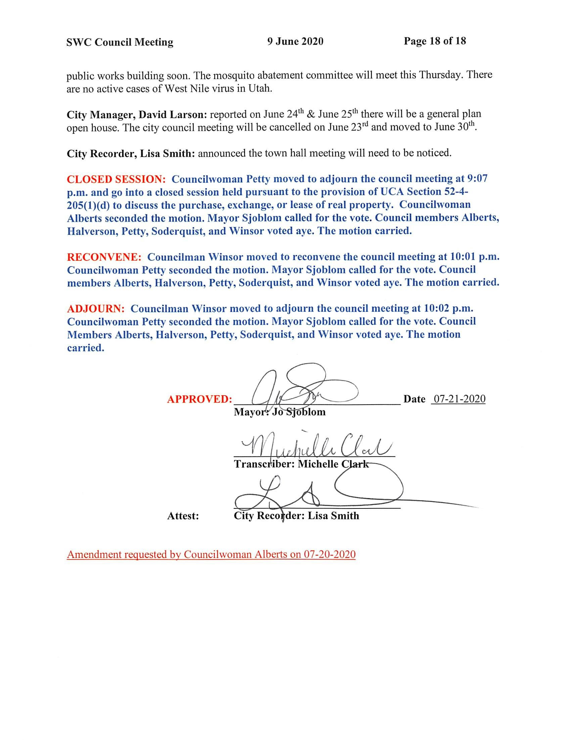

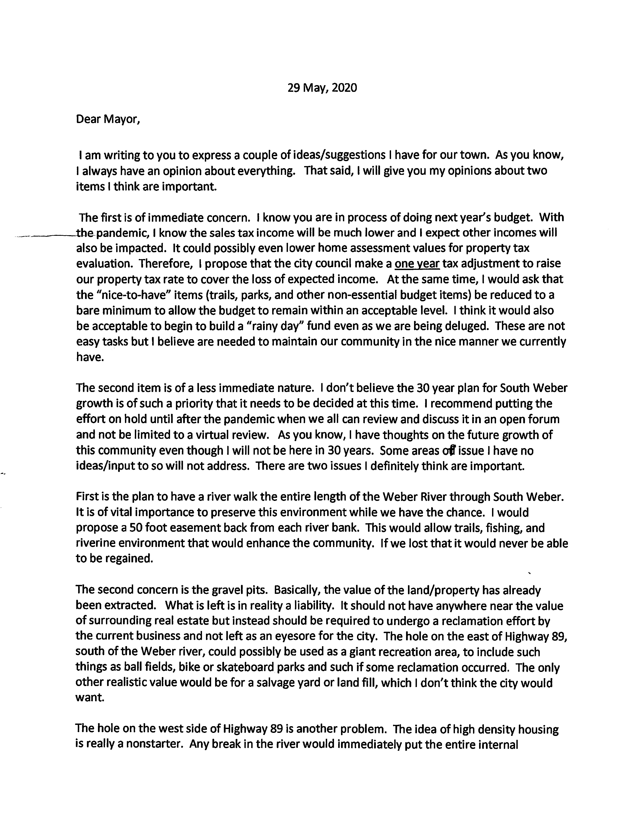
CC 2020-06-09 CI #1 McCracken

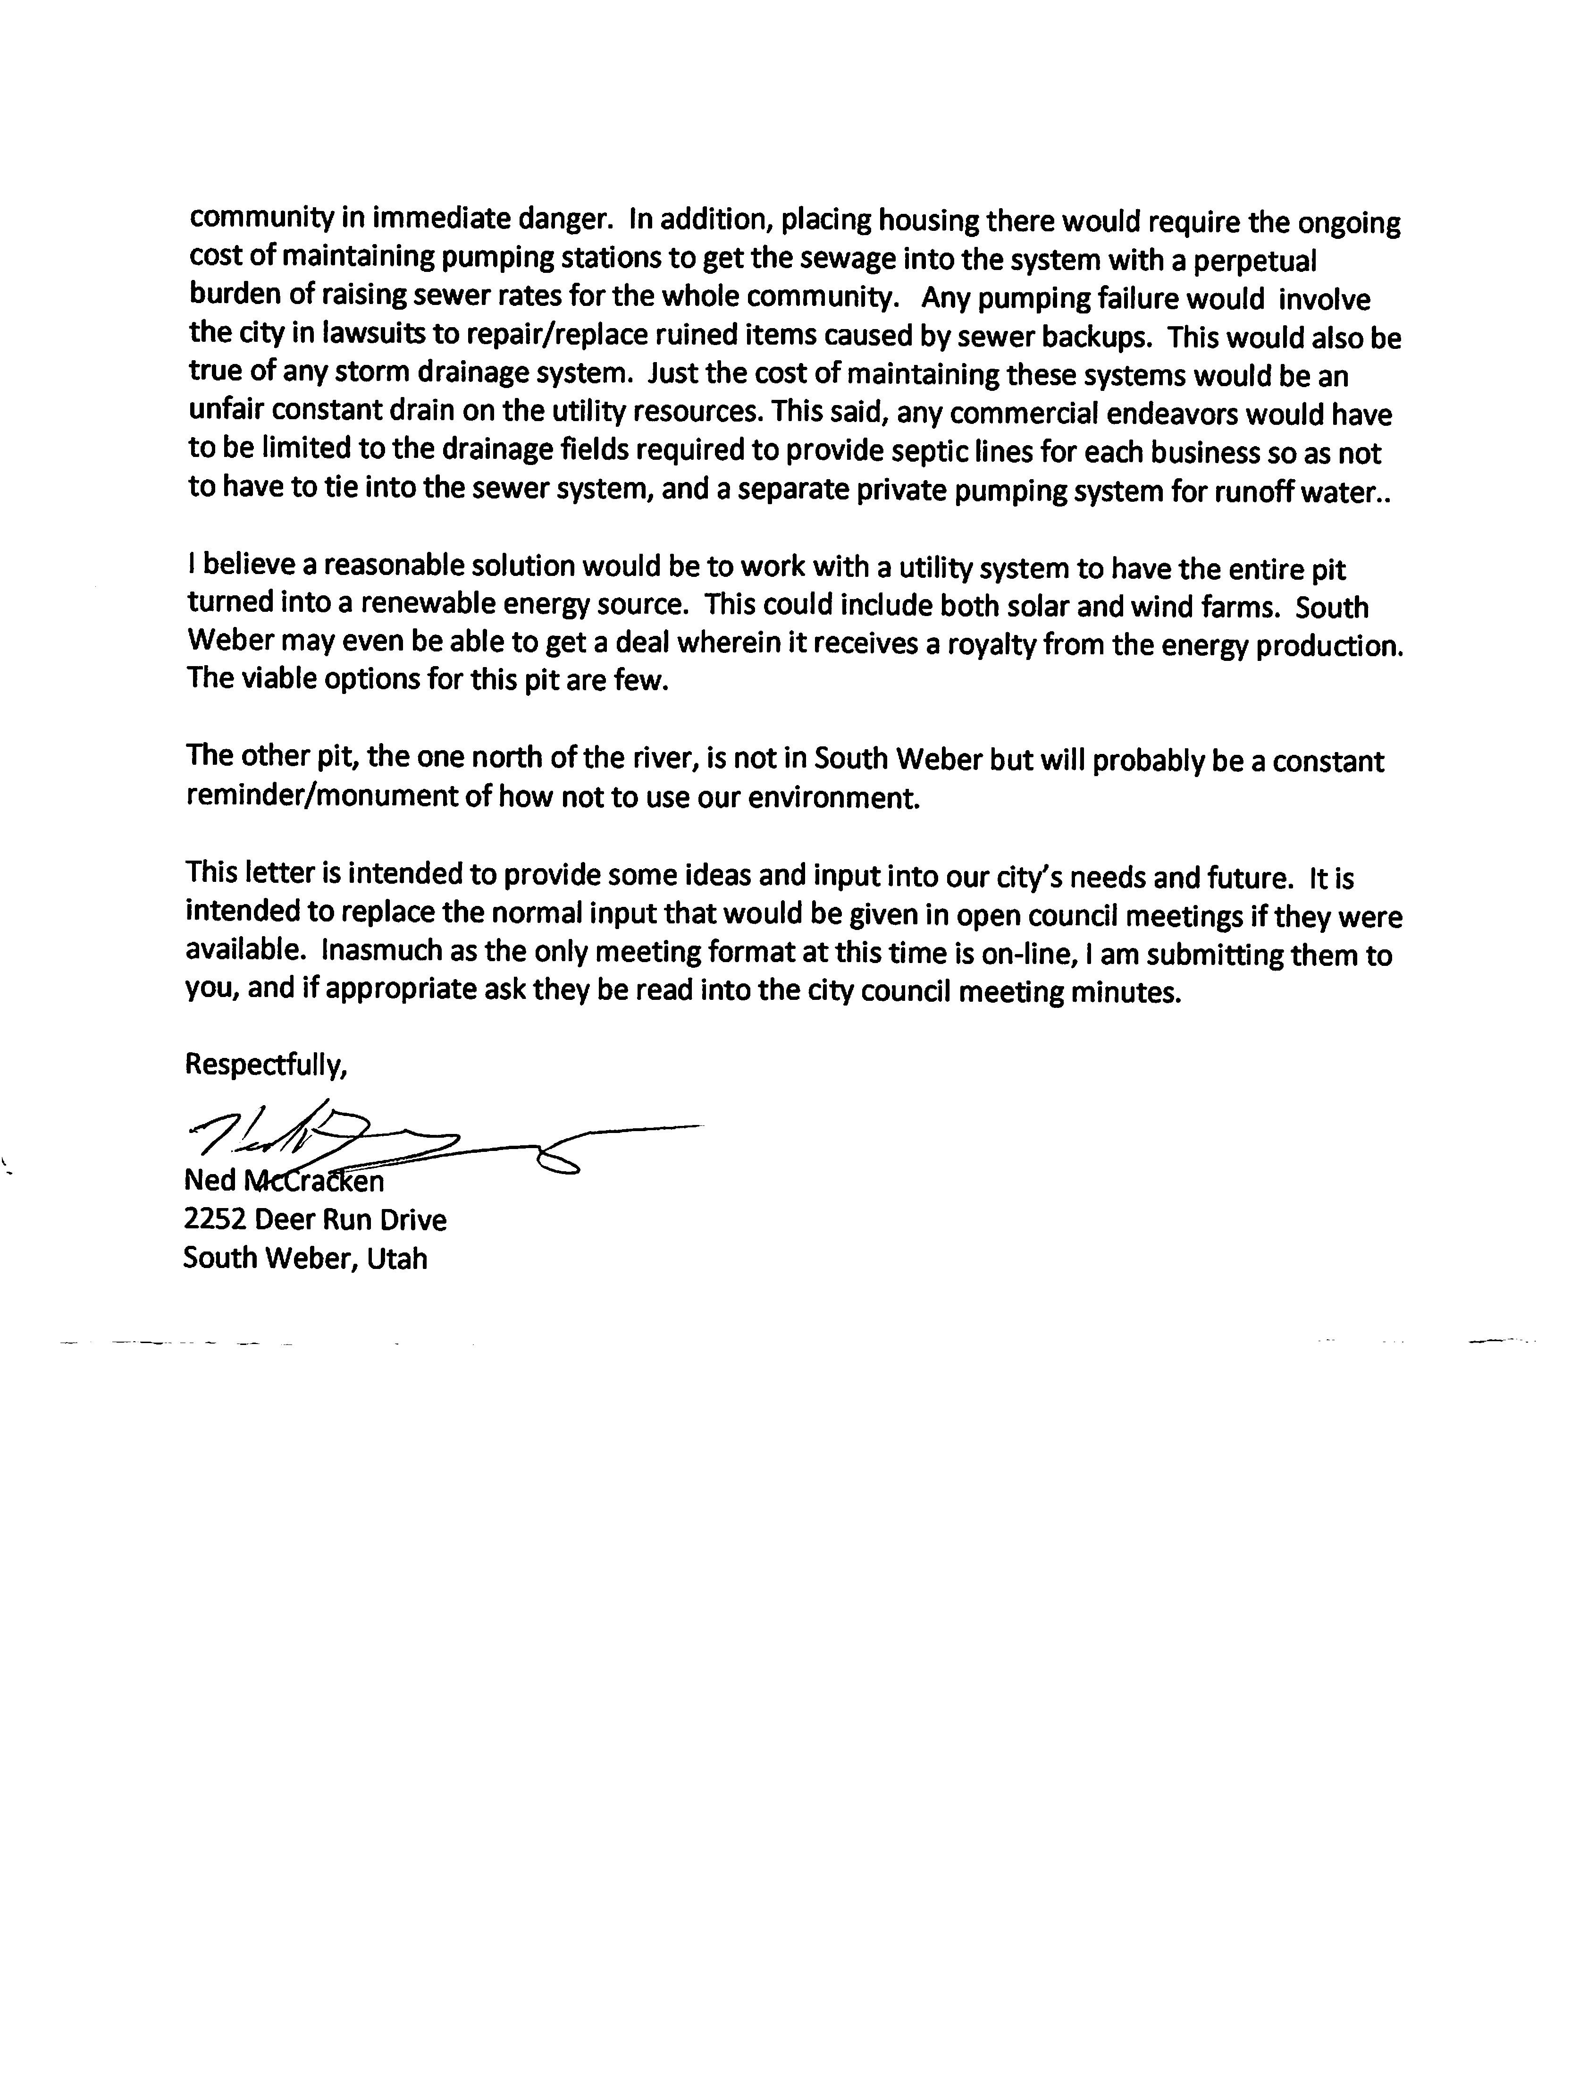

CC 2020-06-09 CI #2 Gagnon
From: | TYRON GAGNON
To: | Public Comment
Subject: | Landfill growth.
Date: | Monday, June 8, 2020 7:36:07 PM

Landfill managers are now adding another layer above the the man made earth berm located above Cedar Bench drive. The windstorms that occurred this past week blew large amounts of trash into south Weber along with a pretty consistent smell of garbage. Video can be provided upon request.
Questions:
Can the City formally request the landfill be cleared by South Weber City before expanding upward along the earth berm?
What can the city do to prevent landfill debris or smell from entering the city?
Can the city provide a status of the complaints logged in the General Plan being built I.e number of complaints the city has received, trends by month.
Can the city inquire and provide to its residents Landfill planning documents for awareness?
Please let me know if you have any comments or questions.
Tyron “Ty” Gagnon
(801) 389-6747

