

NOTICE OF PUBLIC HEARING

PUBLIC NOTICE is hereby given that Milford City Council will be holding public hearings as part of a regular Council Meeting at the Council Chambers, Milford City Office, 26 South 100 West, Milford City, Utah 84751 at 4:00 p.m. on Tuesday, June 16, 2020.
The purpose of the hearings are:
Hearing 1: To hear public comment relating to Waiving Payment for the Interfund Services for Municipal Use.

Hearing 2: To hear public comment relating to FY 2020-2021 Operating Budget.

Hearing 3: To hear public comment relating to Petition to Vacate an Alley abutting Parcel 05-0013-0008 located at 325 West 400 South.

Hearing 4: To hear public input and allow the property owner to be heard and to discuss the matter of obtaining the property and easements necessary to complete the culinary water project. The property and easement required is located adjacent to the current Milford City Property where the culinary water tank is located.

Dated this 1st day of June, 2020.

CERTIFICATE OF DELIVERY & POSTING
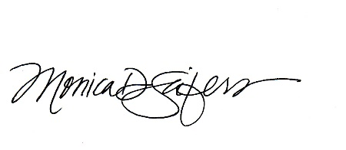
The undersigned, duly appointed and acting City Recorder does hereby certify that the above Notice of Public Hearing was posted in three public places within the Milford City Limits on this 1st day of
June, 2020. These public places being 1) Milford City Office; 2) U.S. Post Office; and 3) Milford Public Library. The foregoing Notice and Agenda was also delivered to each member of the governing body and posted at utah.gov.pmn, on the city Facebook page linked to www.milfordcityutah.com.

_______________________________
MONICA D. SEIFERS
MILFORD CITY RECORDER

In compliance with the Americans with Disabilities Act, the City of Milford will make efforts to provide reasonable accommodations to disabled members of the public in accessing City programs. Request for assistance can be made by contacting the City Recorder at 435.387.2711 at least 24 hours in advance of the meeting to be held.

