Kanosh Town is committed to taking steps to protect the health, safety, and well-being of our community. With the recent spread of COVID-19, some changes are necessary for conducting Kanosh Town public meetings. To follow the "Stay Safe, Stay Home" directive given by Governor Gary Herbert on March 26, 2020, we will suspend all Kanosh Town face-to-face public meetings until this directive is lifted and conditions within our State are deemed safe for social interaction.
Kanosh Town Corporation held the regular council meeting on Wednesday, April 8, 2020, electronically through the town office at 7:00 p.m.
Members present:
Mayor Frank Paxton, Councilmember's: Brandon Stephenson, Hayden George, Rodney Whatcott, Neil Shumway, and Kanosh Town Clerk: Cindy Turner.

Kanosh Town Treasurer: Karen Crook was unable to attend tonights meeting.

Others in attendance via electronic device: Kanosh Town Employee Lorin Shumway,
Kanosh Town Attorney Justin Wayment, Acting Fire Chief Travis Taylor, CERT Captain Geri Minton, Cleve Christensen, Marjean Christensen, Sharon Taylor, Chad Whitaker.

Mayor Frank Paxton offered the opening prayer.

Councilmember Rodney Whatcott led everyone in the Pledge of Allegiance.

Mayor Frank Paxton delivered the following statement: John Hogan verbally resigned to me as fire chief for reasons of health, including stress. I accepted his resignation. He later attempted to unilaterally reassume the position as fire chief. I stopped him. End of Statement.

Minutes of the March 11, 2020 meeting were approved as amended through motion by Councilmember Brandon Stephenson, Councilmember Rodney Whatcott provided a second to the motion, all Council members voted in favor as noted below:
Mayor Frank Paxton: Aye
Council members
Rodney Whatcott: Aye
Neil Shumway: Aye
Brandon Stephenson: Aye
Hayden George: Aye

Warrants for April 2020 were read discussed and approved to be paid through a motion by Councilmember Rodney Whatcott, Councilmember Brandon seconded the motion, all Councilmembers voted in favor as noted below:
Mayor Frank Paxton: Aye
Council members
Rodney Whatcott: Aye
Neil Shumway: Aye
Brandon Stephenson: Aye
Hayden George: Aye

Kanosh CERT Commander Geri Minton:
Geri Minton has nothing new to report at this time, due to COVID-19 everything has been canceled for now.

Kanosh Town Fire Dept.
Acting Fire Chief Travis Taylor stated there is nothing to report at this time, all meetings have been canceled until further notice. Mayor Frank Paxton extended a heartfelt thanks for his service in the fire department and as Acting Fire Chief.

Mayor Frank Paxton appointed Mr. Lorin Shumway as the new fire chief. Mayor Paxton also appointed Lorin Shumway to serve as the new Kanosh Town voting member of the Millard County Fire District. All Council members voted unanimously in favor of the appointment, as noted below:
Mayor Frank Paxton: Aye
Council members
Rodney Whatcott: Aye
Neil Shumway: Aye
Brandon Stephenson: Aye
Hayden George: Aye

Planning and Zoning:
Planning and Zoning Committee member Geri Minton presented the building permit of Travis Taylor had a building permit to finish his basement, it has been approved as presented by the Planning and Zoning Committee. Councilmember Neil Shumway motioned to approve Travis Taylor's building permit as presented, Councilmember Brandon Stephenson seconded the motion, All Councilmembers voted in favor as noted below:
Mayor Frank Paxton: Aye
Council members
Rodney Whatcott: Aye
Neil Shumway: Aye
Brandon Stephenson: Aye
Hayden George: Aye

Kanosh Town Celebrations:
*Easter Egg Hunt: In light of the COVID-19 pandemic and social isolation. Councilmember Rodney Whatcott made the motion to postpone 2020 east egg hunt until 2021, Councilmember Brandon Stephenson provided a second to the motion, All Councilmembers voted in favor as noted below:
Mayor Frank Paxton: Aye
Council members
Rodney Whatcott: Aye
Neil Shumway: Aye
Brandon Stephenson: Aye
Hayden George: Aye

*24th of July: Following a discussion, Councilmembers agreed not to cancel the 24th of July celebration at this time, however, we will need to establish a "cut off date". CERT Captain Geri Minton stated she needs to know 40 days prior to the 24th if the celebration will be canceled. There is a lot to do or undo. Suggestion for the deadline to be 6.1.20. There will be no action taken at this time on the cancelation of the 24th celebration, Councilmember Hayden George will keep every up to date on the celebration.

Departmental Capital facility plans and Council department oversights:
Councilmember Brandon Stephenson suggested that each department take some time, to decide what they should be put on the "radar", put it in a plan, so we could keep an eye out for grants, etc.
*Each department discussed the potential projects:
*The Water Department requires constant attention, currently and for the next two weeks, the jail crew is clear-cutting and mowing up at the springs. A potential project would include the development of an additional spring.

*The Park project is moving forward as reported, the benefactor has picked up the entire cost thus far, a grant may be sought to complete the pickleball court.

The Cemetery no additional projects are currently in the works.

*The Street chip-seal project for the east side of town is scheduled for the end of May or the first part of June.

*The electrical department has completed the contract with Flowell Electric. To date, there are no additional projects in the works.

Budget review:
Councilmember's were reminded we are nearing the end of the fiscal year. Councilmembers will review their departmental budgets, presenting any requests for increases or changes in their budgets prior to the May Meeting. The preliminary budget will be presented for approval in the May meeting.

Kanosh Town Website:
Councilmember Brandon Stephenson and Town Employee Lorin Shumway have been in discussing the potential opportunity to create and design a website for Kanosh Town. Several different companies have been approached in an effort of obtaining prices. The best price they have found is through RAIN Retail software out of Springville, Utah. Originally they would create a web site for $2000.00 but due to the COVID-19, they are offering a discount of 50%. With an annual fee of $1,548.00 to maintain the web site. The other companies contacted quoted over double the cost quoted by RAIN. Councilmember Hayden George motioned to proceed with getting the web site developed making sure it is operated as defined by the first amendment of the constitution, Councilmember Rodney Whatcott seconded the motion, all Councilmembers voted in favor as noted below:
Mayor Frank Paxton: Aye
Council members
Rodney Whatcott: Aye
Neil Shumway: Aye
Brandon Stephenson: Aye
Hayden George: Aye

Review of Delinquencies:
Councilmembers reviewed the monthly delinquency list. It was determined, again, to handle those accounts in arrears according to established Town policy.

Kanosh Town Water Meter Fees Resolution 040820
Councilmember Rodney Whatcott stated that after talking with our attorney, Justin Wayment, it was agreed to hold off approval of this resolution until further notice. In 2021 out State Legislature is requiring that all water fees be adopted by ordinance, not by resolution. See Utah Code 10-8-22 below:
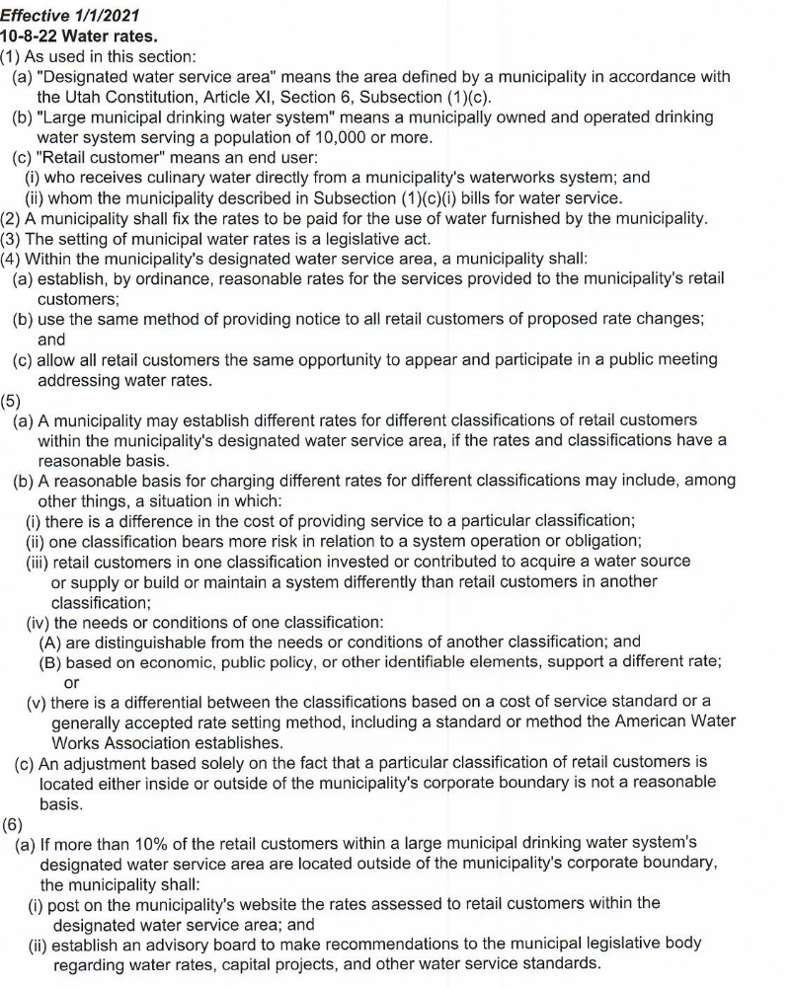
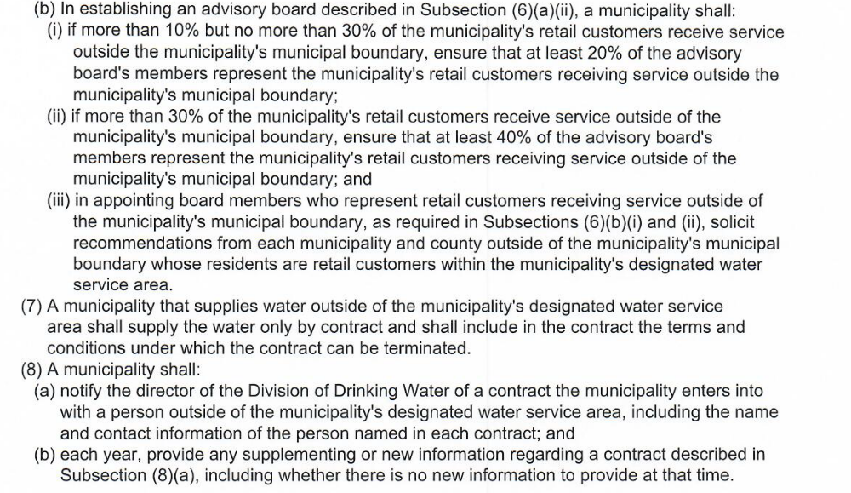

Kanosh Town Cleanup:
Councilmember Rodney Whatcott discussed the clean up with Town Employee Lorin Shumway to insure he would not feel overwhelmed in proceeding with the cleanup, Mr. Shumway stated there would be no problem where he is concerned. We could ask the Treasurer Karen Crook to put a notification on the utility billings. Councilmember Brandon Stephenson motioned to continue with the Kanosh Town annual clean up beginning now and running until May 16th. Councilmember Rodney Whatcott provided a second to the motion, All Councilmembers voted in favor as noted below:
Mayor Frank Paxton: Aye
Council members
Rodney Whatcott: Aye
Neil Shumway: Aye
Brandon Stephenson: Aye
Hayden George: Aye

Public Comments:
None at this time.

Old Business:It was noted that the Ball diamond is full of weeds. Councilmember Hayden George expressed his plan to have is sprayed and then he will drag it.

The roadsides have been sprayed with more of a Round-Up rather than a broadleaf spray. Concern was expressed that the bare ground could now become a breeding ground for goat-heads. Councilmember Stephenson will follow up with Beaver Lawnscape.

Co-sponsorship letter for CCI
Councilmember Brandon Stephenson attended the April 7th, Millard County Commission meeting where the commissioners decided that the county will not be a sponsor for this project. Commissioner Jackson's understanding of the project was different than what CCI had hoped that the County would do. Efforts were made to provide an explanation, however, they continued to decline co-sponsorship. Councilmember Stephenson explained that the grant would cover the cost for accounting services so if the town wanted to go forward with being the sponsor a private company could be hired for this purpose if needed. Originally, we had a cosponsor letter it would have to change to become a sponsor letter if we want to continue to support this project. Attorney Justin Wayment has a call into Pat Finlinson in reference to this matter, however, Pat has not yet returned the call.

Councilmember Brandon Stephenson motioned to move into a closed session for the purpose of discussing pending or reasonably imminent litigation, Councilmember Hayden George provided a second to the motion, all Councilmembers voted in favor as noted below through a roll call vote:
Mayor Frank Paxton: Aye
Council members
Rodney Whatcott: Aye
Neil Shumway: Aye
Brandon Stephenson: Aye
Hayden George: Aye

Council members resumed the regular session of this council meeting through motion by Councilmember Hayden George and seconded by Councilmember Rodney Whatcott, All Councilmembers voted in favor as noted below:
Mayor Frank Paxton: Aye
Council members
Rodney Whatcott: Aye
Neil Shumway: Aye
Brandon Stephenson: Aye
Hayden George: Aye

No action determined from the closed session; any action is pending continuing legal consultation.

There being no further business to come before the board, the meeting adjourned.

Frank Paxton Cindy Turner
Kanosh Town Mayor Kanosh Town Clerk

