Kanosh Town Corporation held the regular council meeting on Wednesday, February 12, 2020, in the town office at 7:00 p.m.

Members present:
Mayor Frank Paxton, Councilmember's: Brandon Stephenson, Rodney Whatcott, Neil Shumway Kanosh Town Treasurer: Karen Crook and Kanosh Town Clerk: Cindy Turner. Councilmember Hayden George is excused.

Others in attendance: Planning and Zoning: Ed Phillips. Fire Chief/Kanosh Town Employee John Hogan, Lorin Shumway K: Geri Minton, Scott and Myrna Watts, Scott Macdonald, Steven Crabb, Dawn Cummings, David and Ilene Hatton, Clella and Art Flemming,
Mayor Frank Paxton explained the Kanosh Town government is that of a five-member Council, a Mayor and four Councilmembers, Kanosh Town does not operate under the same form of government as Fillmore City or Richfield, we are classified as a Town.
Note: see Utah code 10-3b-402. Mayor in a five-member council form of government.
(1) | The mayor in a municipality operating under a five-member council form of municipal government:
  (a) | is a regular and voting member of the council;
  (b) | is the chair of the council and presides at all council meetings;
  (c) | exercises ceremonial functions for the municipality;
  (d) | may not veto any ordinance, tax levy, or appropriation passed by the council; and
  (e) | except as modified by ordinance under Subsection 10-3b-403(2), has the powers and duties described in Section 10-3b-104.

(2)
  (a) | If the mayor is absent or unable or refuses to act, the council may elect a member of the council as mayor pro tempore, to:
    (i) | preside at a council meeting; and
    (ii) | perform, during the mayor's absence, disability, or refusal to act, the duties and functions of the mayor.
  (b) | The municipal clerk or recorder shall enter in the minutes of the council meeting the election of a council member as mayor pro tempore under Subsection (2)(a).
Councilmember Rodney Whatcott led everyone in attendance in a moment of reverence.
Councilmember Neil Shumway led everyone in attendance in the pledge of Allegiance.

Minutes of the January 8, 2020 meeting were approved as amended through motion by Councilmember Brandon Stephenson, Councilmember Rodney Whatcott provided a second to the motion, all Councilmember's in attendance voted in favor as noted below:
Mayor Frank Paxton: Aye
Council members
Rodney Whatcott: Aye
Neil Shumway: Aye
Brandon Stephenson: Aye

Warrants for February 2020 were read discussed and approved to be paid through a motion by Councilmember Rodney Whatcott, Councilmember Neil Shumway seconded the motion, all Councilmember's in attendance voted in favor as noted below:
Mayor Frank Paxton: Aye
Council members
Rodney Whatcott: Aye
Neil Shumway: Aye
Brandon Stephenson: Aye
Councilmember Brandon Stephenson extended his appreciation to the local service members who work on our vehicles, shop, etc., anything that is done to help out our community.

Kanosh Town Fire Chief John Hogan:
*Fire Chief Hogan reported having the ISO inspection last Tuesday, we ended up with a 5 rating. The same rating as it was 4 years ago. Salt Lake City is probably a 2. The inspection was quite educational. The rating would be better if the military truck was undercover in a heated building, it affects the response time. Right now the truck is empty, but if we had a fire where the military truck was needed to respond you would have to go to the hydrant, fill it up, make sure it worked, close all the valves, etc., so it isn't efficient. There was also discussion about homes within 5 miles firehouse, or within 1000 feet of a fire hydrant, resulting in a good rating. The people out on Sandhill Road, Crooked Lane, etc., end up paying more for their fire insurance. It was a great inspection, they were impressed with all of our equipment.

*Things, for the most part, have been slow.

CERT: Commander Geri Minton
*Mrs. Minton reported that she has picked up the radios.
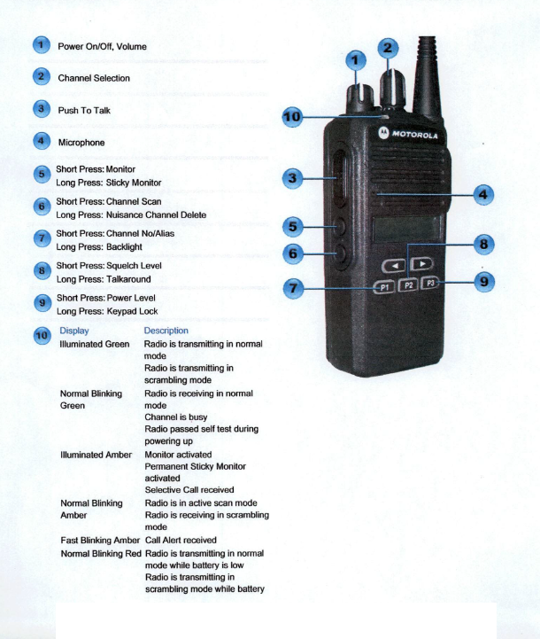

Each of the radios has been programmed and charged. Each of the radios will also have an ID # on the radio.
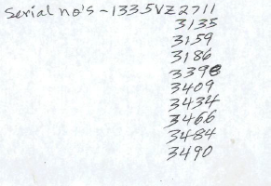

*The CERT team is working on a Mini-conference scheduled for the end of March.
Sheriff Jacobson will be a keynote speaker and plans to address school shootings as well as many other disasters that are plaguing our children.

Planning and Zoning Chairman Ed Phillips:
Mr. Phillips presented the Building Permit of Dawn and Bryant Cummings new home.
The Planning and Zoning Committee voted unanimously in support of the home project.

Cleve Christensen applied for building permits on behalf of the Town of Kanosh for the Park improvements:
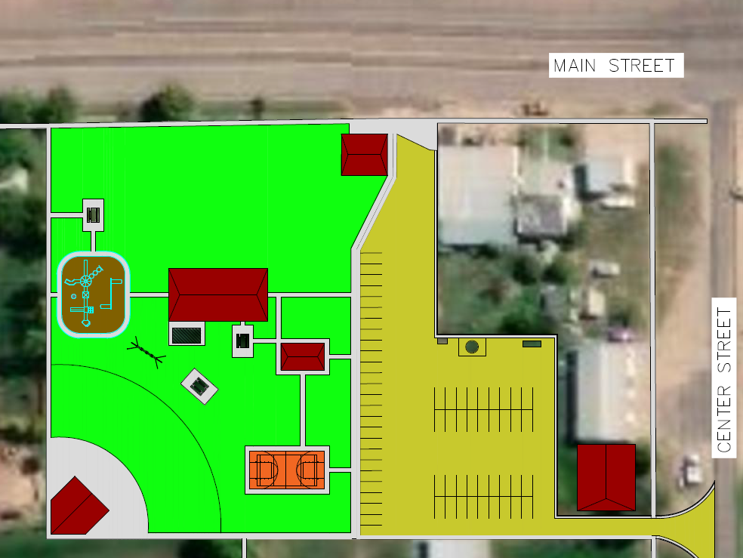

Councilmember Rodney Whatcott made the motion to approve each of the building permits as presented, Bryant and Dawn Cummings and the Kanosh Town Park, Councilmember Brandon Stephenson provided a second to the motion, all Councilmember's voted in favor as noted below:
Mayor Frank Paxton: Aye
Council members
Rodney Whatcott: Aye
Neil Shumway: Aye
Brandon Stephenson: Aye

Clella Flemming:
Clella spoke on behalf of her son Trampis Flemming. Clella cited that the property just north of Black Rock, which served as the old landfill, supposedly Clella’s father Milo, donated it to the Town for a landfill. Clella noted that she was under the impression that when it was no longer being used for a landfill it should be returned to the family. Clella stated that it is not in black and white so she doesn't "really know". Trampis is interested in the property and questioned what the city plans to do with it. Scott Watts (Clella's brother) noted it was Harvey Watts, not Milo Watts who donated it.

Mayor Frank Paxton stated that it is now the property of the Town of Kanosh and in the handbook on disposal of real property, it is quite complicated. Mayor Paxton encouraged each member of the Council to read the ULGT handbook. Note: The clerk will order copies for each Councilmember.

David Hatton: The Confusing of Laws
Mr. David Hatton addressed the Council with the following information: (a copy was emailed to the clerk and thus copied into these February 8,2020 minutes.)

John Dickinson, writing in 1767 against the confusion of the laws under which the Americans had to suffer, protested in these words:
"By the late act, the officers of the customs are "empowered to enter any HOUSE, warehouse, shop, or other place, in the British colonies or plantations in America, to search for or seize prohibited or unaccustomed goods," etc. on "writs granted by the superior or supreme court of justice, having jurisdiction within such colony or plantation respectively."
“I am well aware, that writs of this kind may be granted at home, (England) under the seal of the court of exchequer: But I know also, that the greatest asserters of the rights of Englishmen have always strenuously contended, that such a power was dangerous to freedom, and expressly contrary to the common law, which ever regarded a man's house as his castle, or place of perfect security.
If such power was in the least degree dangerous there, it must be utterly destructive to liberty here. For the people there have two securities against the undue exercise of power by the crown, which are wanting with us, if the late act takes place. In the first place, if any injustice is done there, the person injured may bring his action against the offender, and have it tried before INDEPENDENT JUDGES who are NO PARTIES IN THE COMMITTING OF THE INJURY. Here he must have it Tried before DEPENDENT JUDGES, being men WHO GRANTED THE WRIT.” (Empire and Nation, Letters from a Federal Farmer, John Dickinson, p. 54)

The late act spoken of by Mr. Dickinsen was the taxes upon woolen goods, iron, steel, glass and every other commodity manufactured in England from American natural resources. The writs of assistance mentioned above was the power of the crown to enter any property at will. The fourth, fifth and sixth amendments to the Constitution were inserted to prevent American Government from issuing writs of assistance.

Mr. Dickinsen continued:

“The second consideration above hinted at, is this. There is a confusion in our laws, that is quite unknown in Great Britain. As this cannot be described in a mire clear or exact manner, than has been done by the ingenious author of the history of New York, I beg leave to use his words. “ The state of our laws opens a door to much controversy. The uncertainty, with respect to them, RENDERS PROPERTY PRECARIOUS, and GRATLY EXPOSES US TO THE ARBITRARY DECISIONS OF BAD JUDGES. The common law of England is generally received, together with statutes such as were enacted before we had a legislature of our own; but our COURTS EXERCISE SOVEREIGN AUTHORITY, in determining what parts of the common and statue law ought to be extended; For it must be admitted, that the difference of circumstances necessarily requires us, in some cases, to REJECT the determination of both. In many instances, they have also extended even to acts of parliament, passed since we had a district legislature, which greatly adding to our confusion. The practice of our courts is no less uncertain than the law. Some of the English rules are adopted, others rejected. Two things therefore seem to be ABSOLUTELY NECESSARY for the PUBLIC SECURITY. First, the passing an act for settling the extent of the English laws. Secondly, that the courts ordain a general set of rules for the regulation of the practice.”

“How easy it will be, under this “state of our laws” for an artful judge in the most arbitrary manner, yet cover his conduct under specious pretenses; and how difficult it will be for the injured people to obtain relief, may be readily perceived. We may take a voyage of 3000 miles to complain; and after the trouble and hazard we have undergone, we may be told, that the collection of the revenue, and maintenance of the prerogative, must not be discouraged – and that if the misbehavior is so gross as to admit no justification, it may be said, that it was an error in judgment only, arising from the confusion of our laws, and the zeal of the King's servants to do their duty.” (Ibid p. 54-55)

I will now address the confusion in the laws of Kanosh Town.

The first Law we will review is Known as Ordinance No. 2 It declares;

“An ordinance requiring a building permit prior to any construction within Kanosh Town. Be it ordained by the board of trustees of Kanosh Town Corporation:
Section 1. Office of Building Inspector Established. There is hereby established the Office of Kanosh building official. Unless otherwise designated by resolution of the Kanosh town Board of Trustees, the Building official shall be the Kanosh Town of Trustees.
Section 2. Building Permit Required. It shall be unlawful for any person to construct, erect, enlarge, alter, repair, improve, move, or demolish any building or structure within the corporate limits of Kanosh Town without first obtaining a separate building permit for each building or structure from the Kanosh Building official as hereby provided.”

Signed by Grant Brunson Mayor and Arlene Turner Secretary This 13 day of May 1975.

In Contrast to this ordinance we have the Resolution of 2003 which reads:

Resolution addressing the building permit fees set previously through resolution 040102A: resolution # 100803

“Be it resolved by the Kanosh Town Council this 8th day of October 2003 That resolution 040102A is rescinded and replaced as follows:

All International Codes relating to Residential and Commercial Construction and amendments adopted by Utah pertaining to these codes be adopted for use within Kanosh Town Limits.

Furthermore: all monies received from the building application process be used to pay the fees required for the building inspection. All unexpended monies will be returned to the Capital Improvement Fund. Any building inspector cost incurred above the permit issuance fee will be billed to the property owner and must be paid prior to occupancy.” Close quote.

As one compares these two documents it is plain to see that they are not a bit compatible. The one requires a building permit for all buildings erected, modified, or torn down. The other applies only to residential and commercial building.

The resolution passed in 2012 exempting out building from the permit process was rescinded with these words:

“NOW BE IT RESOLVED, by the Town Council of Kanosh Town, that Kanosh Town Resolution 101012 is rescinded effectively immediately upon adoption of the Town Council and executed by the Mayor.

Passed and approved by the Town Council of Kanosh Town, Utah this 11 day of September, 2019.

Signed Frank Paxton, Mayor.

As the town used the word resolved one must note that it comes from the root word resolution.

Later on in the history of Kanosh we read of the Kanosh Town Plan. The idea that every county have a plan or constitution for these local governments was put forth by the State Government. Goals and objectives were handed to the town as a blue print to follow. Reading the town plan many believe that the objectives and goals are the town plan itself. But reading what was adopted is something different. Quote from the town Plan:

Land use ordinance;

“Public/Quasi Public:

Such uses include the government buildings, including the town hall, fire station(s), schools, libraries, etc, and cemetery, parks and recreation facilities, as well as property owned and/or used by religion, institutional, civic, and nonprofit organizations. Such uses should be encouraged for the use and benefits of the residents of the community, but should not be be considered to take precedence over productive private property.”

“Conclusion:

Public comments were heard on the Kanosh Town Revised Plan at a public hearing on ---- Subsequent minor changes were made and the plan was submitted to the Kanosh Town Council. Additional public input was received at the public hearing conducted by the Town. After the hearing, adjustments were made as a result of the public input, and the Revised General plan was formally adopted by the Town Council
10-9-13. This plan may be amended from time to time as the need arises. Any future amendment of the General Plan will follow the same procedure. The Planning and Zoning Commission will make ordinance recommendations to the Town Council which implement the General plan.”

Signed Scott Blackburn, Chairman Kanosh Planning Commission and Ray Whitaker, Mayor Kanosh Town.”

As can be clearly seen the power granted to Kanosh Town is a very short and clear list. Private, individual property is obviously absent.

I have been advised by town officials that only an ordinance can replace an ordinance and that resolutions do not accomplish the job. This is why the town still declares that ordinance 2 is valid and Resolution of 2003 is not the law. Yet the town enforces the International building code found therein, and the ordinance of 2013 adopting the Kanosh Town Plan is ignored.
Who can write international law? Only the U.N. claims the power. Listen to the Covenant on Human rights of the U.N.:

Human rights derive from the dignity of the Human person and are provided by the State. (Basic Document of the U.N.)

This resolution or law is enforced by Kanosh Town Council.

Contrast this law with the Declaration of Independence that declares that rights come from God. The Constitution declares that the people are sovereign and have all rights and powers. The founding fathers declare that the people were sovereign on their property with allodial land titles which means that they had supreme power, supreme ascendancy and all power over their property. The Founding Fathers declared that this Republican form of government was guarantied to every State in the Union yet Property rights in Utah declares that we are tenants (renters) on our own property.

Under the King of England, the Sovereign, all land belonged to him and all other occupiers of the land were tenants.
Karl Marx declared that all land was to belong to the state and all rents applied to public purposes.

In the Kanosh Town Plan it is recognized that the Millard County Sheriff's department will enforce the law and that citizens of Kanosh will use the county court system as the judiciary. Yet the Kanosh Town Council is enforcing the International building code and even searching the properties of private citizens without a search warrant to judge if they are out of compliance with the International Building code, in violation of the 4th amendment of the Constitution. Private property has been removed from the property of a citizen in his absence.
The founding fathers declared that if the three branches of government are accumulated into one, it is the very definition of tyranny.

Of the several laws, resolutions, ordinances, constitutions and charters, which one is the town council going to support or are they going to pick and choose from them all just the laws that they like? Picking in this manner is called the rule of men not the rule of law.

Dr. David Hatton,
Thomas Jefferson Dr. of Philosophy Constitutional Law Degree.

Note: all the capital or bold letters were in the original.

Mayor Paxton commented that every action taken by the council was done so through the advice of legal counsel. The written documents which were passed were written by legal counsel.
Mayor Paxton thanked Mr. Hatton for his comments.

Resolution# 021220 KANOSH TOWN TREE REMOVAL/TRIMMING
RESOLUTION 02082020 KANOSH TOWN TREE REMOVAL/TRIMMING
Address/Location of the tree: _______________________________________________ (circle)
Is the tree a current or potential hazard to town property? YES NO

Is the tree on Kanosh Town Property or on private property? TOWN PRIVATE

Does the tree need to be cut down or trimmed? Cut Down Trimmed
Explain/Describe:___________________________________________________________
Name of the property owner of tree:___________________________________________________

Has the property owner been contacted? YES NO

Property owners approval of tree removal or trimming
_______________________________________________ ____________________
Signature Date

Kanosh Town Council or Mayor Approval of Tree Removal
________________________________________________ ____________________
Signature Date
**No tree shall be cut down or trimmed without this document signed by the Kanosh Town Mayor or Town Council.
***If permission is not granted from the property owner a council decision will need to be made before proceeding further.
Councilmember Neil Shumway Motioned to adopt and approve Resolution 021220 KANOSH TOWN TREE REMOVAL/TRIMMING, Councilmember Brandon Stephenson seconded the motion, all in favor.

Deposits: Karen Crook
Kanosh Town Treasurer Karen Crook stated that Zions Bank has contacted her about deposits. They have a scanner available for a minimal fee of $10/month wherewith the checks could be scanned and sent to the bank. We would have to keep the hard copy of the checks for a certain period of time. Another problem is that 50% of the deposits are cash and they have to be taken into the bank anyway. Council and Mrs. Crook agreed to proceed as we have in the past since this avenue presents no real benefit to our Town.

Electrical Dept.
Flowell is still trying to get an electrical meter for the Crabbs', Councilmember Neil Shumway will stay on top of all developments.

Road Department:
*Councilmember Brandon Stephenson reported we have put the new snow box to the test with the most recent storm. Implementing the use of the snow box saved the town employees roughly 50% of their time, with results like this it will pay for itself!

*Councilmember Stephenson questioned if there would be a chance or a way we could have the roads plowed before 7:00 am. Town employees assured those in attendance they would do their best.

Councilmember Brandon Stephenson made the council aware that there is a drainage issue near the new Batt residence. They are getting drainage from the east side of the main street, the water goes under main street and over to the Batt home, it is pooling by the telephone pole, it doesn't make it into the irrigation ditch. Councilmember Brandon Stephenson and Town Employee John Hogan will work together on alleviating the problem.

Water Department:
*Councilmember Rodney Whatcott reported that everything tested good on the water.

*The Rural Water Conference will take place Mon, Feb 24 – Fri, Feb 28, Town Employee Lorin Shumway will attend and John Hogan will go down only for one day. Councilmember
Rodney Whatcott will be unable to attend this year.

Cemetery:
Mayor Frank Paxton informed the council of the fact that Cemetery roads are within the town limits. The law now states that everything in the Town has to be contiguous, but when the cemetery was built that was not the law and therefore the cemetery and the cemetery roads are in the Town limits.

Review of Delinquencies:
Councilmembers reviewed the monthly delinquency list. It was determined, again, to handle those accounts in arrears according to established Town policy.

Kanosh Town Treasurer, Karen Crook presented the name of Matthew Tuttle as being eligible to receive his meter deposit refund, in two years he has never been on the utility delinquency list. Refunds are according to policy and procedure and therefore do not require the vote of the council.

Public comment:
Councilmember Brandon Stephenson took a moment to acknowledge our youth in Kanosh for exceeding in their wrestles, swim, their service, academics etc., our youth represents Kanosh very well.

Park update:
Mr. Ed Phillips commented that the new playground equipment has been ordered and paid for, it should be here by mid-March. It will be installed as quickly as possible! There is a swing set, teeter-totter and a slide. See below:

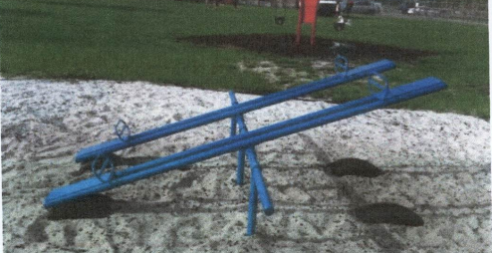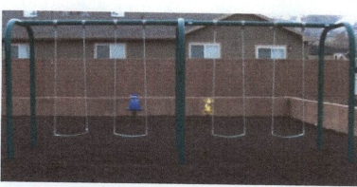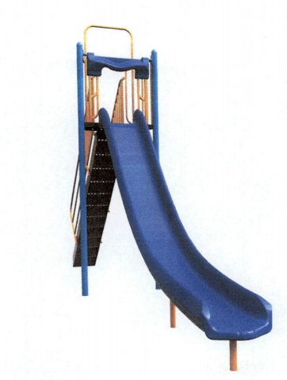

There being no further business to come before the board, the meeting adjourned.

Frank Paxton Cindy Turner
Kanosh Town Mayor Kanosh Town Clerk

