City of Hyde Park
Ordinance 20-04

An Ordinance Streamlining the Process for the Minor Subdivision
Requirements and Procedures

13.40 Minor Subdivision Requirements And Procedures
13.40.010 Purpose
13.40.020 Procedures
13.40.030 Flowchart Table
13.40.040 ConceptPlan
13.40.050 Record Survey
13.40.060 Construction Drawings
13.40.070 Final Plat
13.40.080 Performance Bond And Fees
13.40.010 Purpose
The City recognizes based on current ordinances, that many smaller parcels of land exist within the residential areas of Hyde Park City that have adequate road frontage and acreage to potentially be split into additional building lots. This section allows the subdivision of smaller parcels of land into four (4) building lots or less, with the existing residence to be located on one (1) of the lots.
13.40.020 Procedures
This section provides the procedures required for a minor subdivision by Hyde Park City, for submitting a concept plan, preparing a “record survey”, and preparing construction drawings. THE ENTIRE PARCEL WITHIN THE SAME OWNERSHIP MUST BE INCLUDED IN THE MINOR SUBDIVISION.
The intent of a Minor Subdivision is to streamline the approval process only, all required subdivision improvements, as outlined in all the other chapters of the Subdivision Ordinance, will be followed and constructed as outlined. Any changes requested by the developer that do not conform to the ordinance can only be approved by the City Council.
13.40.030 Flowchart Table
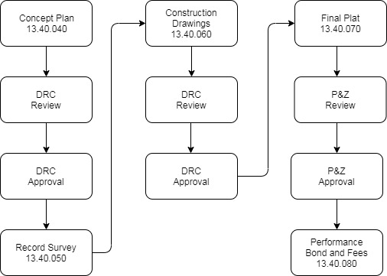
13.40.040 Concept Plan
The sub divider shall digitally submit a copy of a concept plan to the LUA (reference chart 12.40.080) for review. Plans shall be drawn to scale showing all lot dimensions being requested. Copies shall be submitted five (5) working days prior to scheduling a meeting with the LUA, and copies not submitted beforehand shall not be considered until the LUA has had a minimum of seven (7) working days to consider the plan.
The plan shall include the following items:
- General lot layout and frontages.
- The property boundaries of the proposed new lots.
- Names of adjacent property owners.
- Number of lots proposed and street frontage for each.
- Total acreage of each lot based on present zoning.
- Approximate location of all existing utilities that will service the lots.
The LUA will review the concept plan with the developer and determine if it meets the requirements of a Minor Subdivision in accordance with the ordinance. The LUA will also review all the required infrastructure improvements that will need to be constructed by the developer in order to proceed with the subdivision.
13.40.050 Record Survey
Following the review, if the concept plan is approved, the developer shall have a “record survey” prepared by a licensed engineer. The record survey shall clearly show the division of the proposed lots and shall include all dimensions, square footages, and metes and bounds descriptions. The record survey shall be prepared in accordance with the standards established by the county surveyor and include a signature line for the Planning Commissioner and the City Attorney to sign for acceptance and approval of the record survey.
13.40.060 Construction Drawings
The developer shall prepare construction drawing showing all improvements required by the subdivision ordinance, including but not limited to:
- water and sewer connections
- curb and gutter
- sidewalk
- road extensions
- storm water control
- secondary water extensions and improvements
Construction drawings also need to contain a place for the LUA to indicate its approval and acceptance of the record survey.
The construction drawings will be reviewed and approved by the DRC.

13.40.070 Final Plat
Once all the above requirements are presented and approved by the DRC they shall be forwarded to the Planning and Zoning Commission for final approval. All adjacent property owners will be notified of the meeting when Planning & Zoning Commission reviews the proposed minor subdivision. Based on the approval of the Planning Commission the developer shall have their engineer file the record survey and have prepared those deeds required to have the new lots recorded with the County Recorder by Hyde Park City. Said deeds shall include the words “approved and accepted by Hyde Park City” with a signature line for a designated representative of Hyde Park City to sign.
13.40.080 Performance Bond And Fees
No construction improvements shall begin on the Minor Subdivision until the developer has furnished the city with a form of security, as outlined in HPMC 13.50, to insure the proper and prompt installation of all improvements as required.
Any and all persons requesting a Minor Subdivision shall first have paid all fees set forth by the most recent prevailing fee schedule adopted by resolution of the Hyde Park City council. The approved Minor Subdivision will require the payment of inspection fees as also outlined by the city prior to any work beginning.

ADOPTED and PASSED by the Hyde Park City Council this 26th day of February 2020.

HYDE PARK CITY CORPORATION

Sharidean Flint, Mayor

ATTEST:

Donja Wright, City Recorder

