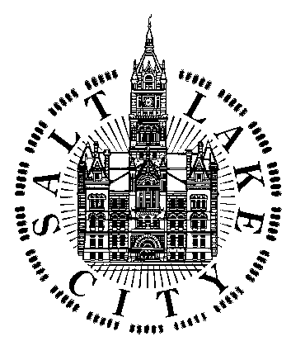

Citizens’ Compensation Advisory Committee (CCAC)

MEETING AGENDA

A meeting of the CCAC will be held Monday, February 24, 2020 from 3:30 PM
to 5:30 PM at 349 South 200 East – 6th Floor,
Engineering Services Division conference room,
Salt Lake City, UT 84111.,

This meeting is open to the public.

1. Meeting Open & Welcome, establish quorum

2. Review & adopt February 20, 2020 meeting minutes

3. Public Comment: The chair of the committee invites interested individuals and group representatives to speak during this section of the meeting. Remarks, comments or questions will be limited to a maximum of 3-5 minutes. Submission of written comments for this part of the meeting is acceptable.

              - 4. Discussion of topics and recommendations to be included in 2020 annual
                - report, including but not limited to:

- Local area benchmark market data analysis
- AFSCME jobs survey by Mercer
- Salt Lake County living wage data
- WorldatWork 2019-20 salary budget forecast
- SLC employee turnover and recruitment data statistics
- 2019 SLC employee benefits study
- Other data, reports, and information relevant to response to city council letter dated 2/7/2019

5. Unfinished business: (none)

6. Confirm next meeting date(s): May 14, 2020, 4:00 5:00 PM (as needed); October 8, 2020, 4:00-5:00 PM.

7. Adjourn Meeting

