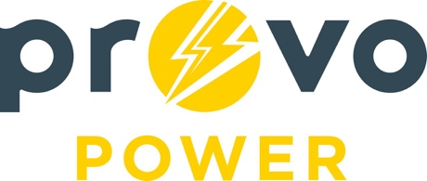
AGENDA
ENERGY BOARD MEETING PROVO POWER
Monday, February 3, 2020
4:00 P.M.

- Welcome & Introductions - Chairman Ned Hill
- Review & Approval of Minutes – October & November Meetings.
- Financial Report – Charlie Fuller
- KPI Report – Charlie Fuller
- Forestry Division & Street Tree Reports – Chaz Addis
- Manager Report – Travis Ball
  - Clean Energy Sourcing Update and Goals
  - Strategic Plan Status

- Calendar & Scheduling
- Energy Board 2020 Meeting Calendar
- UMPA Annual Meetings
March 25-27, 2020 (St. George Utah)
- APPA National Conference
June 5-10, 2020 (Long Beach California)

A copy of the agenda was posted in the Civic Center, and the Provo City Library, on January 29, 2020 and also delivered to the Mayor,
City Council Members, required news media, and adjacent cities in
compliance with the Utah Code 52-4-202

