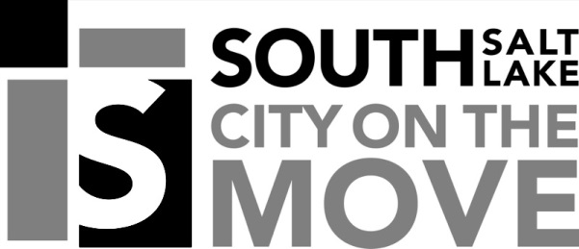

SOUTH SALT LAKE CITY NOTICE OF PUBLIC MEETING

Public notice is hereby given that the South Salt Lake City Community and Economic Development Department will hold a public meeting in the Council Chambers located in City Hall at 220 East Morris Avenue on Thursday, January 23, 2020 at 1:30 PM, or as soon thereafter as possible for the purpose of receiving public comment on the following:

Conditional use approval for a Craftsman Industrial Business located at 224 W Plymouth Ave, #3. Application is made by Kendall Johnson.

Notice is further given that the public is invited to attend and present oral and/or written testimony regarding this petition to the Department of Community Development. In compliance with Americans with disabilities act, individuals needing auxiliary communicative aids or other services for this meeting should contact Taylor Greenwell at 801.412.3225 or tgreenwell@sslc.com, giving at least 24 hours’ notice.
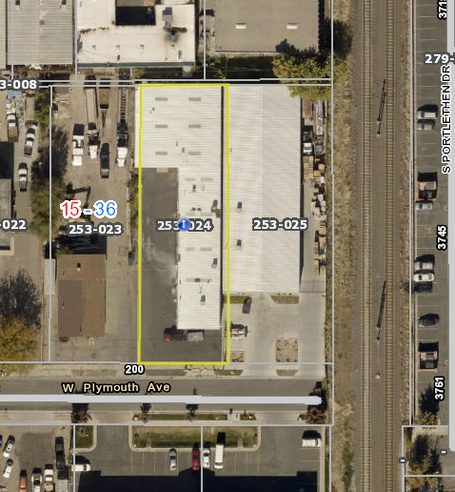
Approximate Business Location

