CACHE COUNTY FAIRGROUNDS ADVISORY BOARD

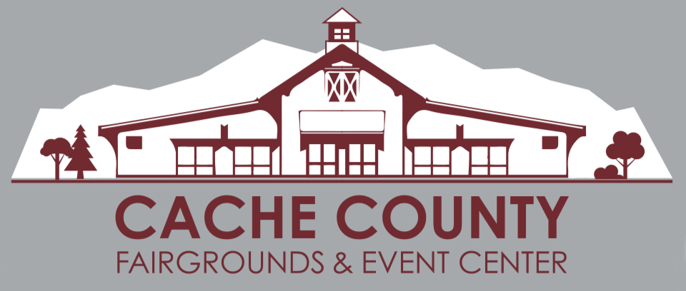
VOTING MEMBERS ADVISORY MEMBERS
Craig W Buttars, County Executive, Chair Bart Esplin, Fairgrounds Manager
Paul Borup, County Council Ron Bjorkman, CCEC Marketing Director
David Erickson, County Council Cassidy Nemelka, CCEC Asst Marketing Director
Gina Worthen, County Council Julie Hollist-Terrill, Visitors Bureau Director
Scott Williams, USU Extension (4-H) James Swink, Cache County Attorney’s Office
Cameron Jensen, County Finance Director Bartt Nelson, Cache County IT Director
Lane Parker, County Fair Manager
LaMont Poulsen, County Rodeo Manager

CACHE COUNTY FAIRGROUNDS ADVISORY BOARD MEETING
October 22, 2019

AGENDA

The Cache County Fairgrounds Advisory Board will meet Tuesday, October 22, 2019 commencing at 11:00 a.m. in the Cache County Historic Courthouse, 199 North Main, County Council Conference Room, Logan, Utah 84321.

Call to Order

Approval of Minutes (September 24, 2019)

Discussion Items

1. Review of Fairgrounds Projects

2. Fairgrounds Master Plan

3. Event Center Rental Fees for County Employees

4. Charge Account for Spanish Translation of Fairgrounds Contract

5. Christmas Decorations for Event Center

6. Open Items

Next Scheduled Meeting

Tuesday, November 26, 2019 at 9:00 a.m.

Adjourn

