Kanosh Town Corporation held the regular council meeting on Wednesday, December 11, 2019, in the town office at 7:00 p.m.

Members present:
Mayor Frank Paxton, Councilmember's: Cleve Christensen, Rodney Whatcott, Bart Whatcott, Neil Shumway Kanosh Town Treasurer: Karen Crook and Kanosh Town Clerk: Cindy Turner.

Others in attendance: Fire Chief/Kanosh Town Employee John Hogan, Councilmember Elect Hayden George, Councilmember Elect Brandon Stephenson, CERT Captain Geri Minton, Kristen Gamble, Zachary Rawlings
Councilmember Neil Shumway led everyone in attendance in a moment of reverence. Councilmember Bart Whatcott led everyone in attendance in the pledge of Allegiance.

Minutes of the November 2019 meeting were approved as amended through motion by Councilmember Cleve Christensen, Councilmember Shumway provided a second to the motion, all Councilmember's in attendance voted in favor as noted below:
Mayor Frank Paxton: Aye
Council members:
Bart Whatcott: Aye
Cleve Christensen: Aye
Rodney Whatcott: Aye
Neil Shumway: Aye

Warrants for December 2019 were read discussed and approved to be paid through a motion by Councilmember Bart Whatcott, Councilmember Rodney Whatcott seconded the motion, all Councilmember's in attendance voted in favor as noted below:
Mayor Frank Paxton: Aye
Council members:
Bart Whatcott: Aye
Neil Shumway: Aye
Cleve Christensen: Aye
Rodney Whatcott: Aye
CERT:
*CERT Captain Geri Minton stated continuing to work on the purchase of radios, she has a meeting scheduled with Bryant in January to determine if an FCC license is necessary, or what type of license we need.

*The CERT online training is being set up. Mrs. Minton has been in contact with James Rey, an outreach specialist for emergency preparedness at the Division of Emergency Management Department of Public Safety. The hands-on training can be done throughout the year in their regular meetings.

*Councilmember Bart Whatcott and his wife have been working with CERT in Heading up an Emergency planning program for Kanosh. They have been compiling a list of local resources. Kanosh Town Hall and the Kanosh Fire Station are each equipped with generator power in the case of a power outage. Through the approval of the Mayor and Council, the Kanosh Town Hall will be used as a staging area. We can also make use of the fire station, both locations can be operated at the same time at full capacity. Through the use of our tower, internet service would also be available. John Hogan pointed out that Kanosh has two-way radios, which would be of additional benefit if they were located in the Town Hall. The Kanosh channel is in all city vehicles and the fire trucks, the base station is located in the city hall.

Kanosh Fire Department:
Fire Chief John Hogan took an opportunity to recognize Kristen Gamble for her billing and data collection efforts for the fire department.

Chief Hogan requested that the Council members appoint him to serve as a voting member of the Millard County Fire District in the interim. Council members unanimously approved the following appointment:
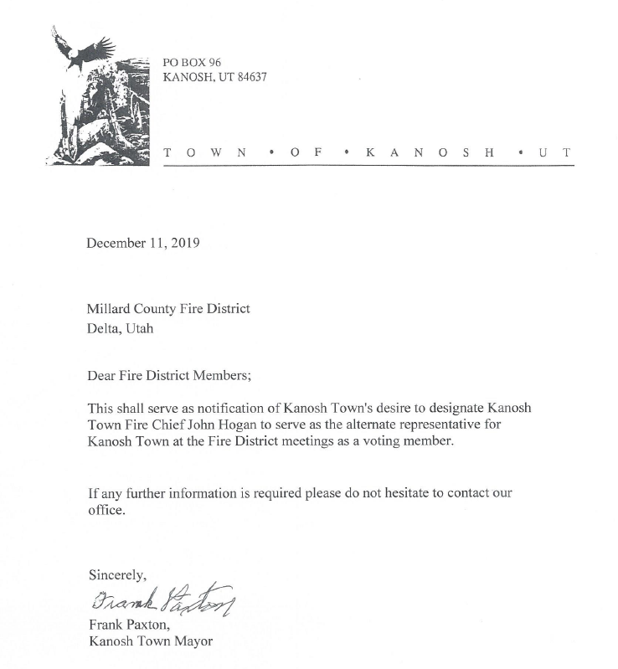

This will be addressed and appointments will be assigned in the January meeting when the new Councilmembers assume office.

Planning and Zoning:
Planning Commission spokesman sent word that the Commission had nothing new to report at this time.

Zach Rawlings:
*Zach Rawlings has been chosen to attend the Hugh Obrien Youth Leadership Conference at Snow College, at the end of May. Each spring, 10,000 high school sophomores from across the country join one of HOBY’s 70 State Leadership Seminars to hone their leadership talents and apply them to become effective, ethical leaders in their home, school, workplace, and community HOBY has inspired young people to make a difference and become catalysts for positive change in their home, school, workplace, and community. As America’s foremost youth leadership organization, HOBY has a long history of successfully motivating young people to develop into outstanding leaders. HOBY stresses volunteerism, integrity, excellence, diversity, and community partnership. Emphasizing these key organizational values, executing motivation and empowering young adults. Through understanding and action, based on effective, compassionate, and service-driven leadership, students learn to make a positive difference within our global society.

*Zach asked the Town of Kanosh to sponsor his attendance at the conference, at the cost of
395.00. Mr. Rawlings then offered 40 hours of community service to offset the sponsorship.
*Councilmember Bart Whatcott commented he has had the opportunity to present a patriotic presentation at some of these leadership conferences at Snow College and when the participants complete the seminars they are much better citizens with good basic values. Councilmember Bart Whatcott motioned to sponsor Zack Rawlings in the HOBY leadership conference/training at Snow College, contingent on when Zach completes the conference he will come and report to the Council providing a Readers Digest version of what was covered and how it helped him. Councilmember Cleve Christensen seconded, all Councilmember's in attendance voted in favor as noted below:
Mayor Frank Paxton: Aye
Council members:
Bart Whatcott: Aye
Cleve Christensen: Aye
Rodney Whatcott: Aye
Neil Shumway: Aye

Planning and Zoning Commission Appointment:
Mayor Frank Paxton presented the name of Mrs. Paulette Staples to serve on the planning and zoning commission.
Councilmember Rodney Whatcott motioned to confirm Mrs. Paulette Staples for the interim appointment on the Planning and Zoning Commission. Councilmember Bart Whatcott provided a second to the motion, all Councilmember's in attendance voted in favor as noted below:
Mayor Frank Paxton: Aye
Council members:
Bart Whatcott: Aye
Cleve Christensen: Aye
Rodney Whatcott: Aye
Neil Shumway: Aye
The following demonstrates the current Planning and Zoning Commission members:
Committee members: Completion of Service:
Blaine Blad 2020
Jens Christensen 2020
Cornell Atkinson 2020 Geri Minton replaced Cornell Atkinson 12.18
Ed Phillips 2022
Hayden George 2022 Paulette Staples replaced Haden George 1.1.20

AUDIT Corrective Action plan:
The clerk presented the following Corrective Action Plan from the Audit for the approval of the Council.
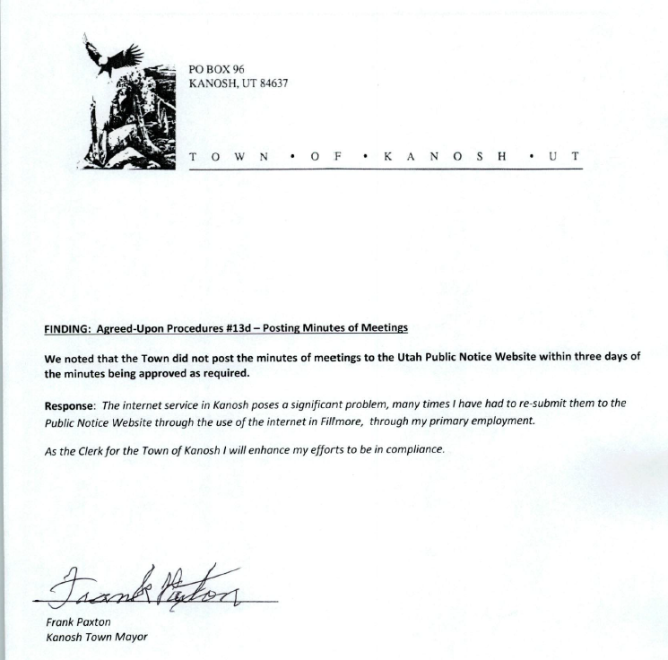
Councilmember Cleve Christensen motioned to approve the corrective action plan as presented, Council Neil Shumway provided a second to the motion, all Councilmember's in attendance voted in favor as noted below:
Mayor Frank Paxton: Aye
Council members:
Bart Whatcott: Aye
Neil Shumway: Aye
Cleve Christensen: Aye
Rodney Whatcott: Aye
Councilmember Bart Whatcott and Councilmember Cleve Christensen expressed their gratitude to each of the Town Employees, praising the efforts of each.

Park Department:
*Councilmember Bart Whatcott reported on the Park Project: Right now the progress on the project is weather contingent, however, they are hoping to have the park project complete by the 24th of July, 2020.

*Town Employee John Hogan will contact Kasey Penney to come and trim the trees back.

*Councilmember Cleve Christensen has met with Sunrise Engineering and has drawn up a contract for the conceptual plan of the project. This contract will be presented to the Council members following a meeting with and approval of the committee members.

*Kanosh Town will be accepting bids for all surplus equipment purchased with public funds.
NOTICE: KANOSH TOWN CORP. accepting seal bids of the following surplus item: 25.00 Minimum bid on each item.. with the requirement that the successful bidder must pay for and remove purchased equipment within ten days of award of bid. All equipment is as is, whereas with no guarantees of any type. Equipment can be inspected by calling John Hogan the town employee supervisor at 435-691-3501 and he will take you to the storage location. All equipment is in non-running condition except for the slide, swing set, and climbing dome.
Last Day to submit a bid is January 6, 2020
Bid Opening and award during the regular
January 8, 2020, Council meeting.
Posted this 18th Day of December 2019.
Cindy Turner
Kanosh Town Clerk
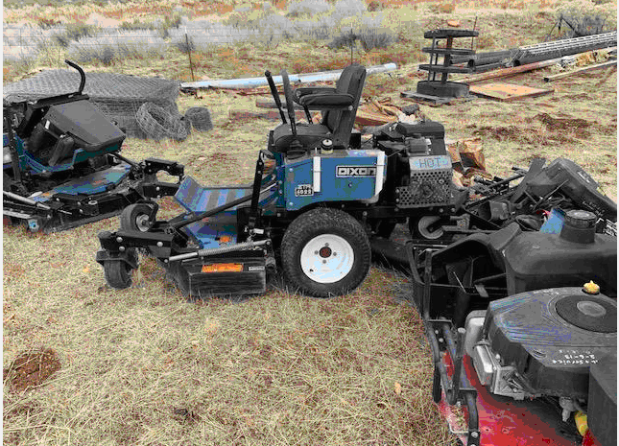 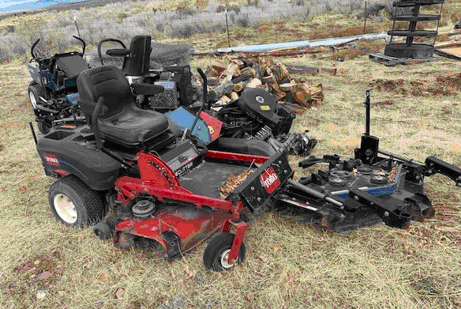 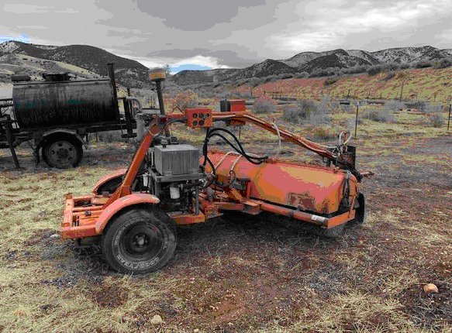

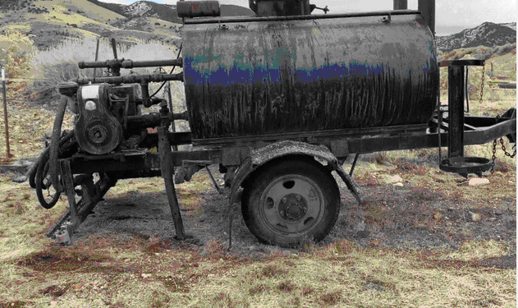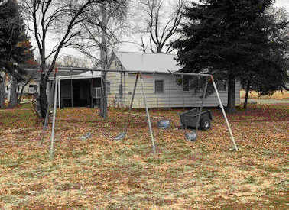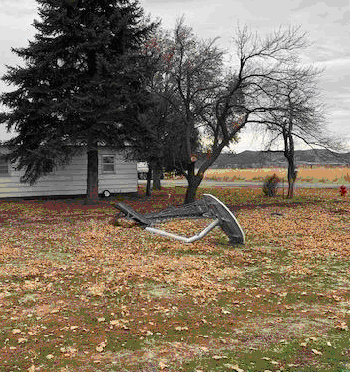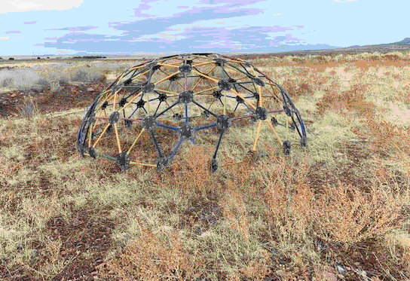

Cemetery:
The Cemetery is looking good, continuing with the rod iron fence, working on getting the race white letters cut out and attached to the fence.

There are Two Eagle projects currently underway as previously approved. However, there could be a safety issue at the cemetery some of the large headstones weighing in at several hundred pounds are broken off at the base. There continues to be a lot of work needed to be done at the cemetery.

Electrical Department:
Councilmember Neil Shumway and Town Employee John Hogan have been talking on tree removal in the electrical lines. We have a big pine tree here in town next to a line. Councilmember Shumway expressed he is a little hesitant to spend town money on private property to move trees, but, if that tree goes over we will have a much bigger problem. Councilmember Shumway stated he doesn't know as a general rule that we want to do this. Councilmember Shumway and Town Employee Hogan have talked about getting pictures of the trees in the lines, emailing the pictures to the Council members and getting a case by case approval for such things might be the best idea. The pine tree in question may not be on private property it may be on Town property. Councilmember Shumway questioned if there has ever been any luck in trying to split the cost with the property owner, Councilmember's and others in attendance were unaware of any cost split. The big pine tree is presumed to be hollow or rotten with a small root base. When Kasey was asked if they would drill the stump out he commented that because there is a small root base the Town employees could just use the backhoe for removal, relieving the Town from a significant cost. When the tree goes over it would be ugly.
Note: pictures of the pine tree in question.

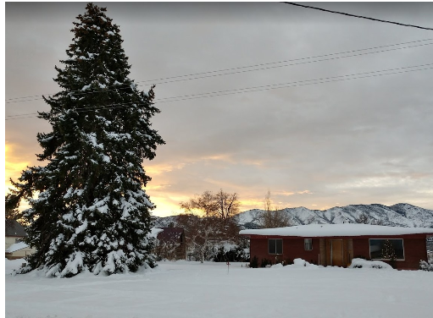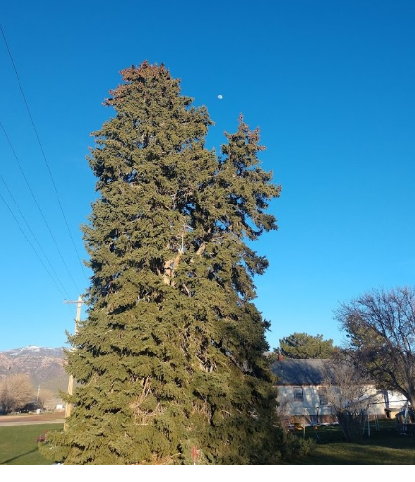

Councilmember Neil Shumway questioned if Mr. Neville had gotten his electrical service upgraded as requested. To date, the upgrade has not taken place.

*In reference to the Carbon-free power project, now is the time to drop out of phase 1 if the Council chooses. Councilmember Rodney Whatcott feels like we are still in a good spot and there is no reason to drop out at this point. There is very good potential. If we choose to drop out now it would cost us about $2,000 if we drop out in March it would be about $4,000. Their initial budget did have to go up as they did some of their research.

Roads Department:
Councilmember Cleve Christensen stated the road department has nothing new to report at this time.

Mayor Frank Paxton mentioned that Council members Bart Whatcott and Cleve Christensen are continuing to work on the park project, even though they will not be serving on the Town Council after the first of the year, they will continue working on the park project until its completion. Mayor Paxton then spoke for the residents of Kanosh Town in expressing appreciation for the service of Council members Bart Whatcott and Cleve Christensen over the last 4 years.

Water Department:
*Councilmember Rodney Whatcott and Town Employee John Hogan have been working on some of the meter upgrades and talking about getting a meter for the overflow.

*Councilmember elect Hayden George noted that the Irrigation Company is working on a grant for a hydropower station. More information will be reported as it becomes available.

*Mayor Paxton noted that our Right of ways are now formalized. The Judge signed the order granting the easements in accordance with the surveyor. If we need to access the springs we can remove the barriers and do what we need to do. Town Employee John Hogan has been in contact with the work crew to schedule a time when they can come down.

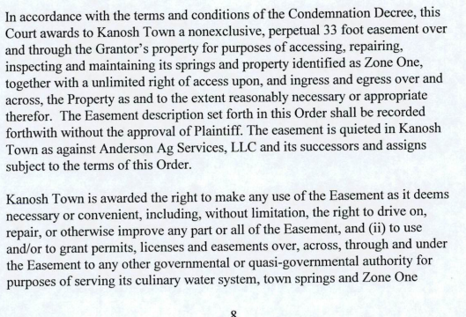
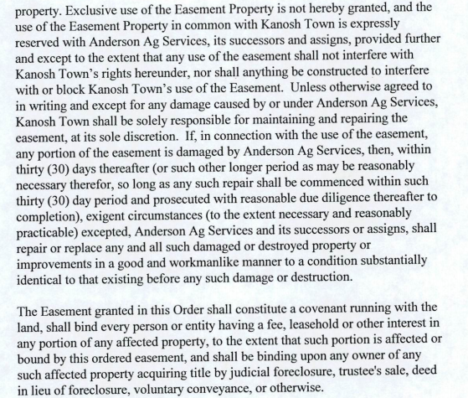

Review Utility Delinquencies:
Council members reviewed the monthly delinquency list. It was determined again to handle those accounts in arrears according to established Town policy.

Public comments:
None.

There being no further business to come before the board, the meeting adjourned.

Frank Paxton Cindy Turner
Kanosh Town Mayor Kanosh Town Clerk

