Utah Cannabinoid Product Board
January 14, 2020
9-11 am
Utah Department of Health, Room 125
288 N 1460 W, Salt Lake City, UT 84114

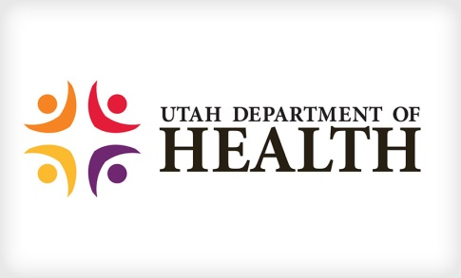
Call In Option: 877-820-7831
Participant Code: 273600

Agenda

- Welcome and Introductions (5 min)– Dr. Redd
- Guidelines For the Use of Medical Cannabis Discussion (2 hours)
  - Dr. Smitha Sadik and Dr. Gary Garner to join in discussion
  - Assignments (10 min) – Various members
- Wrap up/Next Steps – Dr. Redd
- Public Comment - All
Notes:

