TOQUERVILLE CITY
ORDINANCE 2020.XX
BUILDING PERMIT PROCESS

An Ordinance amending Title 10, Chapter 6-1 Submittal Requirements, Table 2 to eliminate the Building permit, concept review and the word final review in order to streamline the building permit process.

RECITALS

WHEREAS, Toquerville City (“City”) is an incorporated municipality duly organized under the laws of the State of Utah; and

WHEREAS, pursuant to Utah State Code 15A-1-202, the State of Utah recognizes the City of Toquerville as a local regulator that is empowered to engage in the regulation of construction, alteration, remodeling, building, repair and other activities to the code; and

WHEREAS, Toquerville is responsible for providing a process to obtain a building permit; and

WHEREAS, the amendments proposed will be consistent with the current practices of the building permit process and requirements.

ORDINANCE

NOW THEREFORE, BE IT HEREBY ORDAINED by the City Council of Toquerville City, State of Utah, as follows:
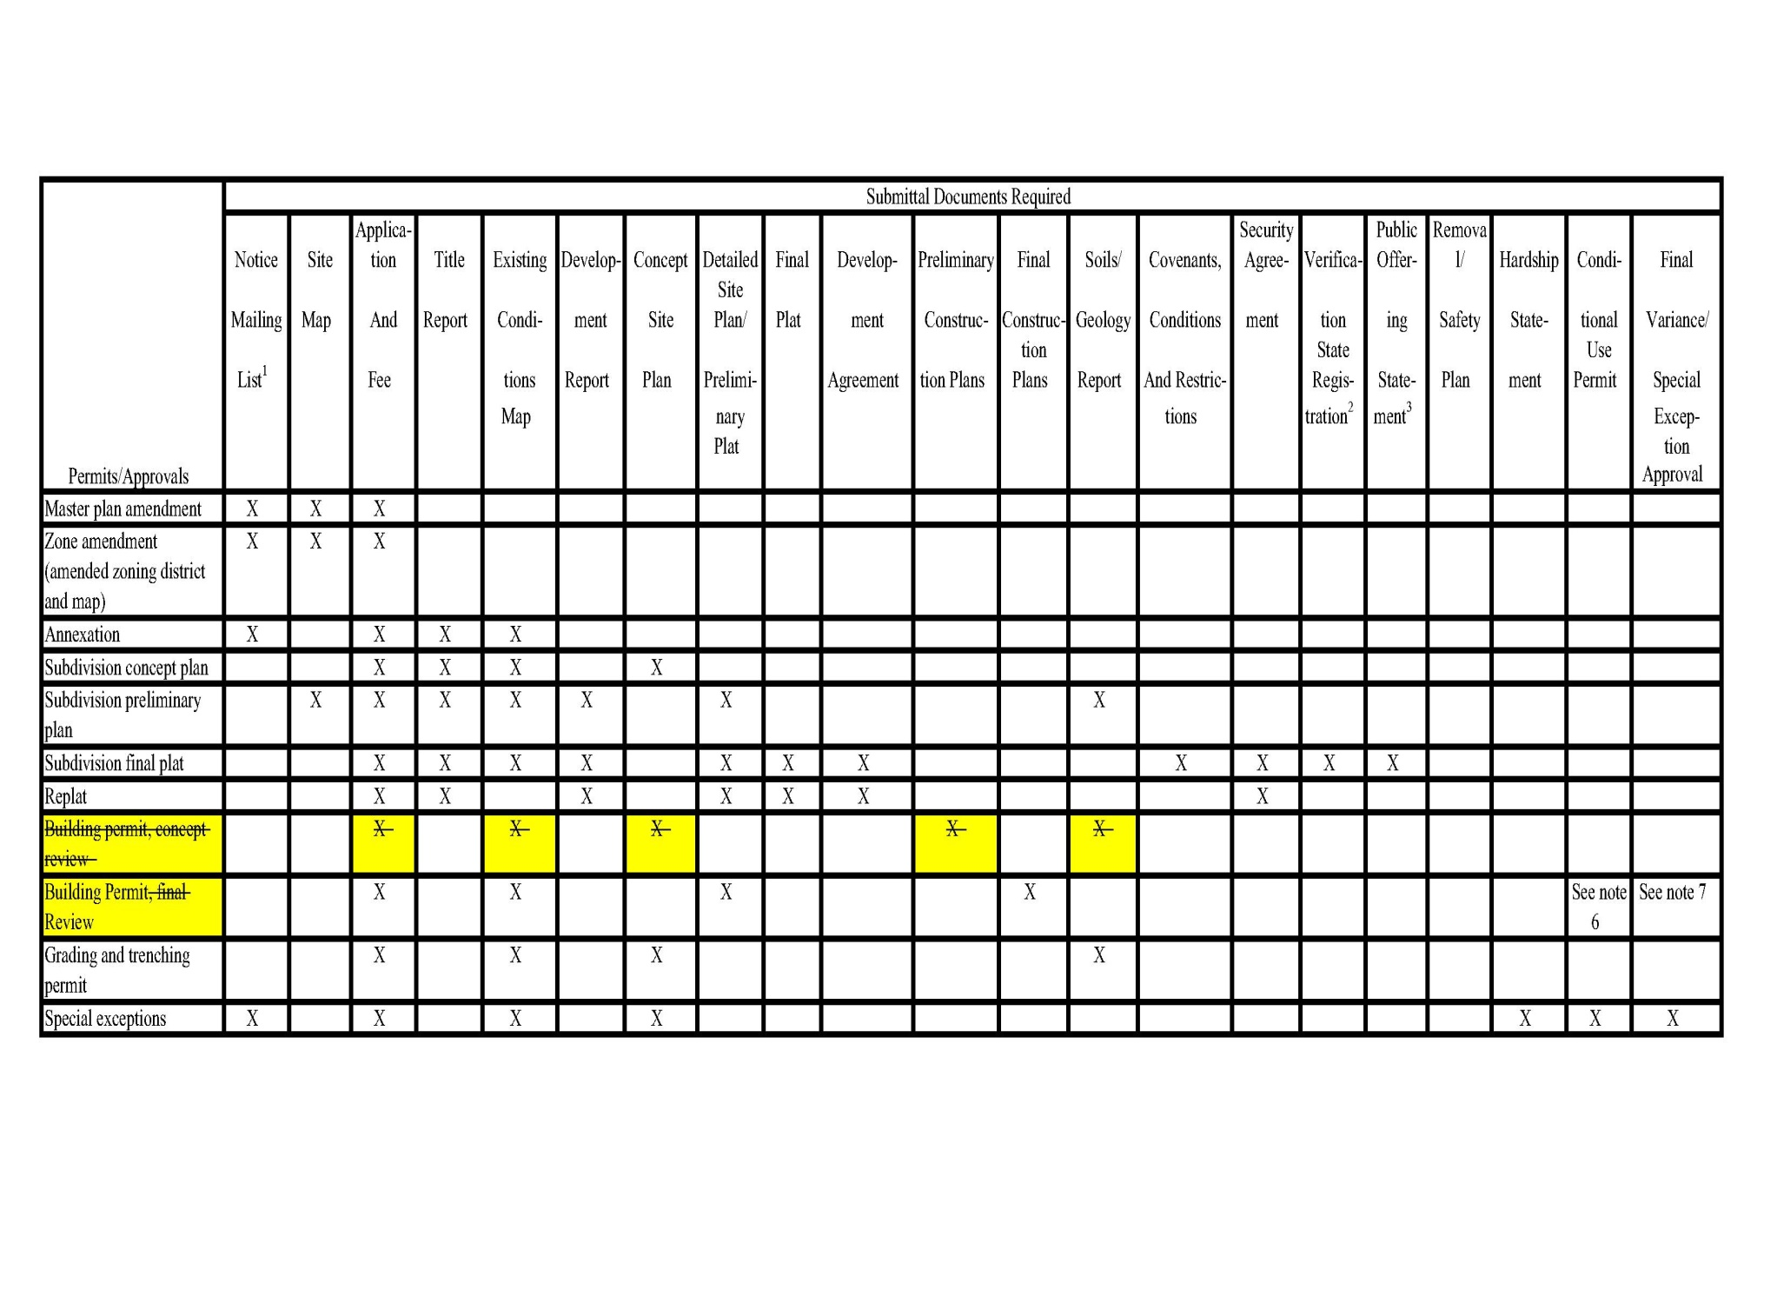
REPEALER: This Ordinance shall repeal and supersede all prior ordinances and resolutions governing the same.

SAVINGS CLAUSE: If any provision or clause in this Ordinance or the application thereof to any person or circumstance is held to be unconstitutional or otherwise invalid by any court of a competent jurisdiction, such invalidity shall not affect other sections, provisions, clauses, or applications hereof which can be implemented without the invalid provision, clause, or application hereof, and to this end the provisions and clauses of this Ordinance are declared to be severable.

EFFECTIVE DATE: This Ordinance shall take effect immediately upon approved by the City Council.

PASSED AND APPROVED THIS _____ DAY OF JANUARY 2020.

Justin Sip Aye ___ Nay ____ Abstain/Absent____
Ty Bringhurst Aye ___ Nay ____ Abstain/Absent____
Keen Ellsworth Aye ___ Nay ____ Abstain/Absent____
Chuck Williams Aye ___ Nay ____ Abstain/Absent____
Gary Chaves Aye ___ Nay ____ Abstain/Absent____

CITY OF TOQUERVILLE
a Utah Municipal Corporation

______________________________________ _______________________
Lynn Chamberlain, Mayor Date

______________________________________
Attest: Ruth Evans, City Recorder

