1

VIRGIN TOWN

ORDINANCE # 2019-44

AN ORDINANCE AMENDING CHAPTER FIFTEEN OF THE VIRGIN UNIFORM LAND USE ORDINANCES (“VULU”).

RECITALS

WHEREAS, Utah Code provides for the adoption and amendment of Town land use ordinances by the Land Use Authority, which in Virgin is the “Town Council with recommendation by the Planning and Zoning Commission” ; and

WHEREAS, the Virgin Land Use Authority finds that the existing Virgin Town Code (VULU) Chapter Fifteen, and the various sub sections found within, require updating to meet the changing needs of the town; and

WHEREAS, the Virgin Land Use Authority finds that, to accommodate the towns desire to provide clarity and continuity within VULU; and

WHEREAS, the Virgin Town Planning and Zoning Commission held properly noticed Public Hearings on these amendments on December 11, 2019, and voted to recommend its draft amendment ordinance to the Virgin Town Council at a regular meeting on December 18, 2019;

NOW, THEREFORE BE IT ORDAINED by the Land Use Authority of Virgin, Utah
that, in order to provide for the health, safety and general welfare of the citizens of Virgin, Utah, the VULU Ordinance is hereby amended to incorporate the following changes:

ORDINANCE

NOW THEREFORE be it ordained by Virgin Town, Washington County, State of Utah, acting by and through the Town Council:

Current Wording

CHAPTER 15: ZONES
15.1. ESTABLISHMENT OF ZONING DISTRICTS.
For the purposes of this ordinance, the territory of the Town of Virgin to which this ordinance applies is divided into the following zoning districts:
R Residential.........................................................
RR Rural Residential...............................................
MH MOBILE HOME..............................................
AG Agricultural.....................................................
C Commercial.........................................................
RD Restricted Development-Overlay ZONE.......................
RZ Resort ZONE.....................................................................
HRZ Highway Resort ZONE..................................................
OP OPEN SPACE DISTRICT................................................

15.3. SUPPLEMENTARY REGULATIONS TO ALL ZONING DISTRICTS
The Town of Virgin shall require corrective action by responsible parties to control the impacts on Town image and neighboring properties of negligence in upkeep, as described in Chapter 4.19., Property Maintenance.

Proposed Wording

CHAPTER 15: ZONES AND USES
15.1. ESTABLISHMENT OF ZONING DISTRICTS.
For the purposes of this ordinance, the territory of the Town of Virgin to which this ordinance applies is divided into the following zoning districts:
R Residential.........................................................
RR Rural Residential...............................................
MH MOBILE HOME..............................................
AG Agricultural.....................................................
C Commercial.........................................................
RD Restricted Development-Overlay ZONE.......................
RZ Resort ZONE.....................................................................
HRZ Highway Resort ZONE..................................................
OP OPEN SPACE DISTRICT................................................

15.3. SUPPLEMENTARY REGULATIONS TO ALL ZONING DISTRICTS
The Town of Virgin shall require corrective action by responsible parties to control the impacts on Town image and neighboring properties of negligence in upkeep, as described in Chapter 4.19., Property Maintenance.

15.6 Uses Chart
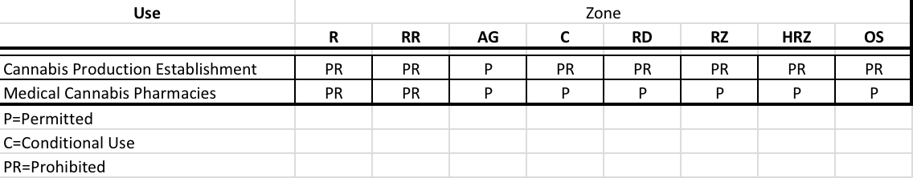

- Severability. If any section, clause or portion of this Ordinance is declared invalid by a court of competent jurisdiction, the remainder shall not be affected thereby and shall remain in full force and effect.

ORDINANCE ___________
Chapter ____ Section ___________
APPROVED: __________________

2

- Conflicts/Repealer. This Ordinance repeals and supersedes the provisions of any prior ordinance in conflict herewith.

- Effective Date. This Ordinance shall become effective immediately upon adoption by the Virgin Town Council and execution by the Virgin Town Mayor.

ADOPTED AND APPROVED BY THE VIRGIN TOWN COUNCIL ORDINANCE NUMBER 2019-44 will become effective on this ___ day of _________, 2019 based upon the following vote:

Council Member:
Dan Snyder AYE___ NAE___
LeRoy Thompson AYE___ NAE___
Kevin Stout AYE___ NAE___
Jay Lee AYE___ NAE___
Matthew Spendlove, Mayor AYE___ NAE___

VIRGIN TOWN
a Utah municipal corporation

Matthew Spendlove, Mayor

ATTEST:

Monica Bowcutt, Town Clerk
ORDINANCE ___________
Chapter ____ Section ___________
APPROVED: __________________

