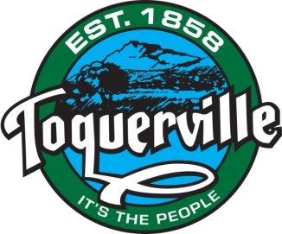
2019 Unofficial Municipal Election Results
Candidates for City Councilmembers (4 year term) - 3 open seats
Ty Bringhurst 274
Keen Ellsworth 245
John C. ‘Chuck’ Williams 204
B. Kent Havens 175

Candidates for City Councilmembers (2 year term) - 1 open seat
Wendi Merritt 96
Gary Chaves 228

A Special Meeting of the Toquerville City Council to Canvass and Accept the Official 2019 Toquerville Municipal Election Results will be held on NOVEMBER 14, 2019 at 212 North Toquerville Boulevard (City Hall), and will commence at 6:00 p.m.
On Election Day 338 ballots were counted. 7 absentee ballots and 11 provisional ballots are pending.

Posted this 6th day of November 2019 by the Toquerville City Recorder, Dana M. McKim.

