For Review
Chapter 15 - Zones

Current wording

Proposed Wording
CHAPTER 15: ZONES

15.6 Uses Chart
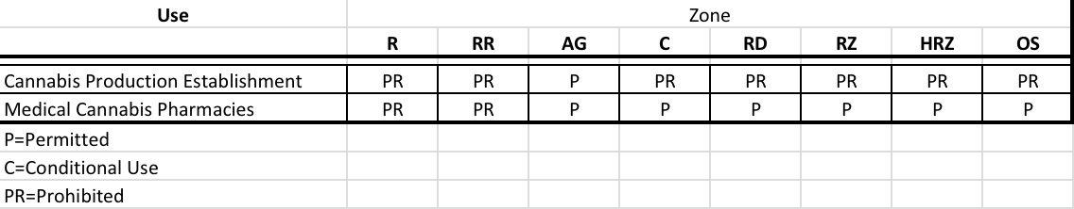

Reasons for proposed changes

- A quick reference for business owners to find what uses are allowed in each zone.

