Kanosh Town Corporation held the regular council meeting on Wednesday, October 9, 2019, in the town office at 7:00 p.m.

Members present:
Mayor Frank Paxton, Councilmember's: Cleve Christensen, Rodney Whatcott, Bart Whatcott, Kanosh Town Treasurer: Karen Crook and Kanosh Town Clerk: Cindy Turner. Councilmember Neil Shumway was unable to attend tonight's meeting.

Others in attendance: Lorin Shumway, David Hatton, Ilene Hatton, Luke DeGraffenried, Ed Phillips, Lene Cram, Jay Cram, Planning and Zoning Spokesman Ed Phillips, CERT Commander Geri Minton.
Councilmember Rodney Whatcott led everyone in attendance in a moment of reverence. Councilmember Bart Whatcott led everyone in attendance in the pledge of Allegiance.

Minutes of the September 2019 meeting were approved as amended through motion by Councilmember Rodney Whatcott, Councilmember Bart Whatcott provided a second to the motion, all Councilmember's in attendance voted in favor as noted below:
Mayor Frank Paxton: Aye
Council members:
Bart Whatcott: Aye
Cleve Christensen: Aye
Rodney Whatcott: Aye
Warrants for September 2019 were read discussed and approved to be paid through a motion by Councilmember Cleve Christensen, Councilmember Bart Whatcott seconded the motion, all Councilmember's in attendance voted in favor as noted below:
Mayor Frank Paxton: Aye
Council members:
Bart Whatcott: Aye
Cleve Christensen: Aye
Rodney Whatcott: Aye
CERT:
CERT Commander Geri Minton reported that CERT members can now complete the CERT training Online:

CERT Course Delivery Instructions: https://drive.google.com/drive/folders/17FSwFgIXDaL5cgwaJ-niVpIgQSAXAnqO

Students sign up: https://medicine.utah.edu/rmcoeh/about-us/outreach/cert.php

FREE Online CERT Course: https://cert.hazready.com

This online Basic CERT course is a comprehensive lecture portion of all 9 units of the nationally standardized curriculum and is hoped to prepare the student as well as possible for the practical hands-on portion which will be planned and delivered by the local registered CERT program.
The local registered CERT program has students sign up on the course of the program registration portal and afterward provides the students the information to take the course online. The students then go to this website, http://tiny.cc/certonline, and follow the directions to start the online course, and takes the lecture portion of the course online (about 12 hours), learning at their own pace and convenience. Once completed the student will be prompted to print and submit a certificate of online portion completion to their local registered CERT program. The registered CERT program will plan a practical day (about 16 hours) where they will conduct, and the student will pass off, all the hands-on skills in the course, learn about local plans, and
participate in a disaster simulation. The local program determines the parameters for this practical portion. The in-person practical portion may be completed in 16 hours but must be adequate to complete each required practical for a certificate of full course completion to be given.

The 16 hours of hands-on practical training will be conducted during the regular monthly CERT training. There are 4 individuals in the County who can provide this training.

Mrs. Minton has compiled the following cost estimates for needed CERT team radios:
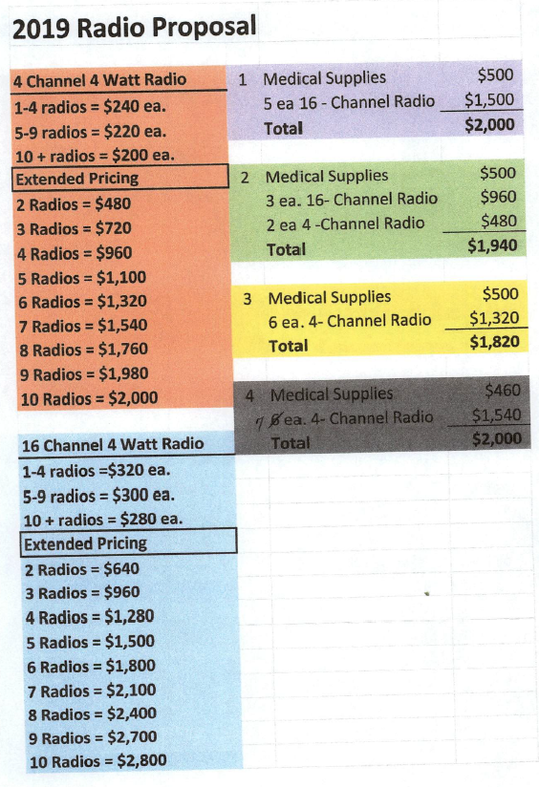
The purchase of radios is vital, the purchase may be funded through their CERT account.

Currently, Kanosh has 10 active CERT team members.

Fire Department:
*Fire Chief John Hogan addressed the Council members reporting that the Kanosh Fire Department responded to the Meadow Creek Fire in the process Kanosh Department lost 8 tires.
There was a problem with the brush truck, as it turned out there was a broken ground cable that cut all communications to the computer. It is now back in service!
The Meadow Creek fire has burned 4,321 acres. The Meadow Creek Fire cost over 4 million dollars.
*Kanosh Fire Department has a new member, Dave Olsen. We now have 3 active volunteer firefighters who reside at Cove Fort, Alan Peacock, Ben Pratt, and Dave Olsen.
*The Kanosh Fire Department has been very busy. Down on Turkey Track Lane, there was a human-caused fire last night, Meadow fire department aided Kanosh in the extinguishing of the fire.
* Todd Macfarlane presented the following letter to Chief Hogan and the volunteer firemen:

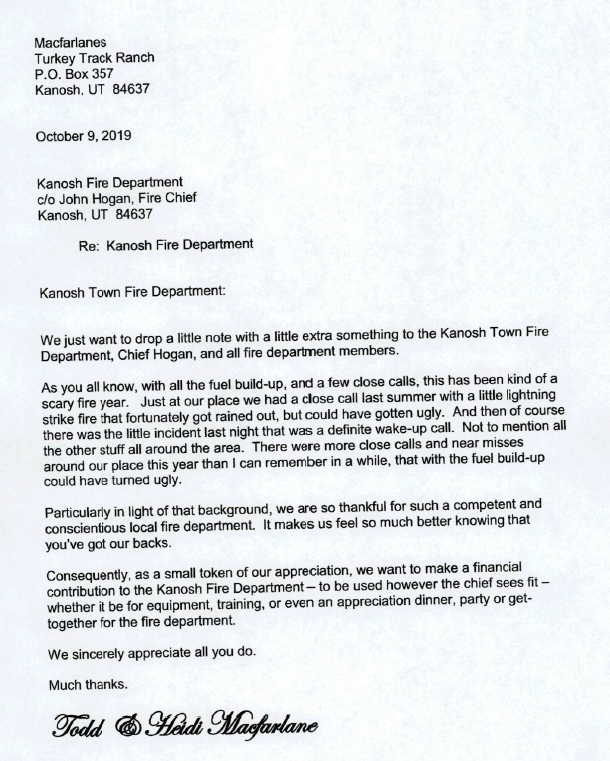
He also included a contribution check for $1,000.00, made out to the department.
* Chief Hogan reported that the first annual Fire Prevention open house, had a good response, with about 150 people in attendance. The department will do it again next year.
*At the District meeting, Chief Hogan learned that there is a State program referred to as Title 3 grant, which has not been used before. This funding can be used to purchase some much-needed equipment for the departments. Chief Hogan will submit a request for the Kanosh Fire Department and continue to keep the Council members updated on the progress of his efforts.
The Ready-Set-Go program will also be presented and implemented:
..READY: Be ready. Take personal responsibility and prepare long before the threat of a fire so your property is ready to sustain the threat. Create defensible space by clearing brush away from structures. Use fire-resistant landscaping and harden structures using fire-safe construction measures. Assemble emergency supplies and belongings in a safe place. Plan escape routes and make sure all those staying on the property are aware of these plans.
..SET- Be alert. Put together a ‘go kit'. Learn how to receive and stay aware of the latest news and information on the fire from local media, fire departments, and public safety agencies. Prepare your personal fire action plan.
...GO-Act early! Follow your personal fire action plan. Doing so will not only support your safety but will allow firefighters to best maneuver resources during response.
Planning and Zoning: Ed Phillips
Planning and Zoning Spokesman Ed Phillips stated there is nothing new to report or present to the council at this time.

Luke Degraffenreid:
Mr. Degraffenreid is working on his Eagle Project, he plans to work on old gravestones at the cemetery which require repair. Councilmember Bart Whatcott met with Luke and his father, they went through several gravestones which are unstable currently on a sandstone base. Luke will be first leveling up the headstone, putting a cement apron around the headstone (which will help when mowing or weed eating around them), there are 23 markers in need of work. Some of the older markers have been broken in half and wired together. Councilmember Whatcott is continuing to research the best way to preserve the markers (another eagle project). The project will require about 25 bags of cement. Councilmember Bart Whatcott motioned to approve the eagle scout project to cementing and refurbishing some of the graves at the cemetery, Councilmember Rodney Whatcott seconded, all Councilmember's in attendance voted in favor as noted below:
Mayor Frank Paxton: Aye
Council members:
Bart Whatcott: Aye
Cleve Christensen: Aye
Rodney Whatcott: Aye
*Ed Phillips improvements to the Town Park:
Mr. Ed Phillips addressed the council stating the fact that he has stewardship over funding that can be utilized for the benefit of the Town of Kanosh. There have already been some significant improvements at the cemetery, with the leadership of Councilmember Bart Whatcott. There have been some improvements funded by the same to the Townhall. Plans are underway for improvements to the maintenance building. Something that has been on the back burner, are improvements to the Town Square, the park and town property. One thing that has been a focal point for Mr. Phillips would be to establish a stage, that could be utilized for special events. As ideas for improvements have been discussed, a committee has been formed consisting of Geri Minton, Ed Phillips, Bart Whatcott, Thayne Christensen, and Cleve Christensen. From the funding standpoint, it will be paid for, however: first they will talk about it, then they will come to the council and talk about what the next step will be to get approval and then they will proceed. It is privately funded, therefore we are not required to go through a bidding process. The committee members hope to have the project completed before the next 24th of July.

The committee discussed the following things which need to take place:
- Get property boundaries established for all of Kanosh owned property on this block, or the Town Square. Councilmember Cleve Christensen has contacted Sunrise Engineering. Established markings.
- Over time the cabin fell in a state of disrepair and an eyesore. Councilmember Bart Whatcott made arrangements for the Cabin to be moved or relocated to a nice home. The Cabin has been added to the Territorial State Park Pioneer Village in Fillmore, they will refurbish it and make it structurally sound.
- Fencing, parking areas
- Dance hall will be revamped into a nice kitchen reunion ready complete with a place for storage.
- Some trees will be removed
- New restroom facilities
- At least one and possibly two new athletic courts. (tennis, pickleball, squash, etc)
The Power line that services the Town Hall, the Perkins shop and the Crab is in poor shape, Councilmember Bart Whatcott has been in contact with Flowell Electric about going underground.
The items the park improvement committee would like approved to proceed included the survey of the property, the underground power project, whatever they could get done on the fence, removal of the trees and the demolition of the existing tennis court or "leftovers" of the dance hall. Councilmember Bart Whatcott motioned in approval of moving forward with the items discussed, Councilmember Cleve seconded, all Councilmember's in attendance voted in favor as noted below:
Mayor Frank Paxton: Aye
Council members:
Bart Whatcott: Aye
Cleve Christensen: Aye
Rodney Whatcott: Aye
Councilmember Bart Whatcott motioned to include an amendment to the aforementioned motion to include the following: when the Council member term of service for Councilmember Bart Whatcott and Councilmember Cleve Christensen concludes, each will continue to serve on the park improvement committee until the completion of the project. The new Councilmember who takes office on 1/1/20 and is over the park department will also serve on the committee. , Councilmember Cleve seconded, all Councilmember's in attendance voted in favor as noted below:
Mayor Frank Paxton: Aye
Council members:
Bart Whatcott: Aye
Cleve Christensen: Aye
Rodney Whatcott: Aye
Mr. Phillips also stated that the focus of all the improvements will be on low or no maintenance.

It should also be noted that the individual who left this money in Mr. Phillips stewardship, specified that the money to be used to continue to improve the town and for the benefit of the community.

Lene Cram:
Mrs. Cram addressed the Council members for the purpose of requesting a Business license to run a small dog kennel. Mrs. Cram owns 4 French bulldogs, and would like to sell puppies. The dogs primarily live inside. Council members discussed various concerns ie. neighbors, barking, etc. Councilmember Rodney Whatcott motioned to approve a business license for a small dog kennel for Lene Cram, Councilmember Cleve Christensen provided a second to the motion, all Councilmember's in attendance voted in favor as noted below:
Mayor Frank Paxton: Aye
Council members:
Bart Whatcott: Aye
Cleve Christensen: Aye
Rodney Whatcott: Aye
Council Reports:
*Park Department:
Councilmember Bart Whatcott reported that things are starting to wind down, noting the waterlines should be winterized and shut down. Councilmember Whatcott expressed his appreciation for all that the employees have done and continue to do.

*Road Department:
Councilmember Cleve Christensen stated that the window is gone to do the chip sealing for this fall, so we will be looking at the spring to take care of the chip sealing project.

*Water Department:
Councilmember Rodney Whatcott stated that they are working on a few little things in the water department but nothing new to report at this time.

Review Utility Delinquencies:
Council members reviewed the monthly delinquency list. It was determined again to handle those accounts in arrears according to established Town policy:

Public Comment:
David Hatton: requested a copy of 1975 building permit ordinance, Ordinance #2.
He also stated that the Constitution Study Class would like to have a meet the candidates night, inviting the public and will need a place to meet. Would like to meet 2 weeks from tomorrow night and would like to use the Town Hall. Council members welcomed Mr. Hatton to use the Town Hall, however, there may be a need for more room. If that is the case Mr. Hatton will ask Fire Chief John Hogan if they would use the fire station. Mr. Hatton extended an invitation to all in attendance to attend his Constitution and Study Class tomorrow in his home at 8:00, the topic of discussion will be the 15th amendment, The 15th Amendment to the Constitution granted African American men the right to vote by declaring that the "right of citizens of the United States to vote shall not be denied or abridged by the United States or by any state on account of race, color, or previous condition of servitude." And the 16th amendment The 16th Amendment gives Congress the right to impose income tax.

Old Business:
The clerk ask the Town employees if they will set up the Election booths for the election on November 5. The town employees indicated they would indeed set them up.

There being no further business to come before the board, the meeting adjourned.

Frank Paxton Cindy Turner
Kanosh Town Mayor Kanosh Town Clerk

