Lindon City Council
Staff Report



Prepared by Lindon City
Administration

December 3, 2019

REVISED - Notice of Meeting of the
2
l
Lindon City Counci

The Lindon City Council will hold a meeting beginning at 7:00 p.m. on Tuesday, December 3, 2019 in the Lindon

City Center Council Chambers, 100 North State Street, Lindon, Utah. The agenda will consist of the following:
REGULAR SESSION – 7:00 P.M. - Conducting: Jeff Acerson, Mayor Pledge of Allegiance: By Invitation
Invocation: Randi Powell
Scan or click here for link to download agenda & staff report materials:


(Review times are estimates only)

- Call to Order / Roll Call (2 minutes)
- Presentations and Announcements (5 minutes)
  - Comments / Announcements from Mayor and Council members.

- Approval of minutes: The regular City Council meeting of November 19, 2019, will be reviewed. (5 minutes)

- Open Session for Public Comment (For items not on the agenda) (10 minutes)

- Consent Agenda — (Items do not require public comment or discussion and can all be approved by a single motion.) (5 minutes)
  - Officer Involved Critical Incident Protocol Agreement. All the cities in Utah County had public safety and legal teams agree to this protocol. Staff recommends approval by the Council.
  - Employee Merit Increase. The Mayor and City Council will review for approval the 2.5% merit increase for employees. In the FY2019-20 budget the City Council approved a 2.5% merit increase for employees (based upon year-end employee performance evaluation scores). The merit increase will be effective January 1, 2020. Per past practice, the City evaluates mid-fiscal year budget constraints and economic indicators to determine if recommended merit increases are still financially prudent. Given a healthy economic outlook, strong revenues, and healthy General Fund reserves the City Administration recommends the merit increase be applied as approved in the budget.

- Concept Review – South Haven Development – 531 N. State Street. South Haven Development requests concept review of a proposal to allow for 99 residential units on approximately 6 acres of the Linden Nursery property. Parcel #45:244:0001. A Concept Review allows applicants to receive Planning Commission feedback and comments on proposed projects. No formal approvals or motions are given, but general suggestions or recommendations are typically provided. (20 minutes)

- Anderson Farms Plat E Major Subdivision Approval and Anderson Farms Boulevard road dedication – Ivory Development, LLC. Request for major subdivision approval of a 60-lot single family residential subdivision located in the Anderson Farms Planned Development (AFPD) zone. The request also includes the dedication of the north section of Anderson Boulevard from 500 N. to 700 N. The subdivision and road dedication are part of a master development agreement with Ivory Development. (20 minutes)

- Public Hearing — Lindon City Water Conservation Plan; Resolution #2019-29-R. The Mayor and City Council will hear for possible adoption, the Water Conservation Plan as required by the State to be updated and adopted every 5-years. The plan will be presented by City Engineer, Noah Gordon. (15 minutes)

- Discussion Item — Lindon Days finances and fundraising. Heath Bateman, Parks & Recreation Director will present an overview of 2019 Lindon Days events and expenditures and discuss future fundraising. (20 minutes)

- Review & Action — Safety Incentive Award Program; Resolution #2019-30-R. The City’s insurance carrier is asking its members to adopt an Employee Safety Incentive Program to help reduce workplace accidents and injuries. The insurance provider will provide discounts on premiums that off-set potential costs of the program. If approved, the program will be incorporated into the Employee Policies & Procedures Manual. (15 minutes)

Council Reports:
- MAG, COG, UIA, Utah Lake Comm., ULCT, NUVAS, IHC Outreach, County Board of Health - Jeff Acerson

- Police/Fire/EMS, Emergency Mgmt., Irrigation Co. Representative/Board member, City Buildings - Van Broderick
- Public Works/Engineering, Historic Commission, Administration, Building Const. & Inspection - Randi Powell
- PG/Lindon Chamber of Commerce, Economic Development, Lindon Days - Carolyn Lundberg
- Planning Commission/BOA, Planning/Zoning, General Plan, Transfer Station/Solid Waste Board - Mike Vanchiere
- Parks, Trails, and Recreation, Cemetery, Tree Advisory Board - Jake Hoyt

Administrator’s Report (10 minutes)
Adjourn
All or a portion of this meeting may be held electronically to allow a council member to participate by video conference or teleconference. Staff Reports and application materials for the agenda items above are available for review at the Lindon City Offices, located at 100 N. State Street, Lindon, UT. For specific questions on agenda items our staff may be contacted directly at (801)785-5043. City Codes and ordinances are available on the City web site found at www.lindoncity.org. The City of Lindon, in compliance with the Americans with Disabilities Act, provides accommodations and auxiliary communicative aids and services for all those citizens in need of assistance. Persons requesting these accommodations for city-sponsored public meetings, services programs or events should call Kathy Moosman at 801-785-5043, giving at least 24 hours-notice.

CERTIFICATE OF POSTING:
I certify that the above notice and agenda was posted in three public places within the Lindon City limits and on the State (http://pmn.utah.gov) and City (www.lindoncity.org) websites.
Posted by: /s/ Kathryn A. Moosman, City Recorder
Date: November 26, 2019; Time: 1:30 p.m.; Place: Lindon City Center, Lindon Police Dept., Lindon Community Center

REGULAR SESSION – 7:00 P.M. - Conducting: Jeff Acerson, Mayor Pledge of Allegiance: By Invitation
Invocation: Randi Powell

Item 1 – Call to Order / Roll Call

December 3, 2019 Lindon City Council meeting.
Jeff Acerson Van Broderick Jake Hoyt
Carolyn Lundberg Randi Powell Mike Vanchiere

Staff present:

Item 2 – Presentations and Announcements

- Comments / Announcements from Mayor and Council members.

Item 3 – Approval of Minutes

- Review and approval of City Council minutes: November 19, 2019

2 The Lindon City Council held a regularly scheduled meeting on Tuesday, November 19, 2019, beginning with a work session at 6:00 pm in the Lindon City Center, City
4 Council Chambers, 100 North State Street, Lindon, Utah.

6 WORK SESSION – 6:00 P.M. - Conducting: Jeff Acerson, Mayor

8 At this time Adam Cowie, City Administrator, directed the Council to amend the agenda order to move to agenda item #15 to go into a closed session. Mayor Acerson
10 called for a motion to amend the agenda order.

12 COUNCILMEMBER HOYT MADE A MOTION TO AMEND THE AGENDA ORDER TO MOVE TO AGENDA ITEM 15 AND GO INTO A CLOSED SESSION.
14 COUNCILMEMBER VANCHIERE SECONDED THE MOTION. ALL PRESENT VOTED IN FAVOR. THE MOTION CARRIED.
16
15. Closed Session — Closed Executive Session. The Mayor and City Council
18 pursuant to Utah Code 52-4-205 may vote to enter into a closed executive session for the purpose of discussing pending or reasonably imminent litigation. This
20 session is closed to the general public.

22 COUNCILMEMBER BRODERICK MADE A MOTION TO ENTER INTO A CLOSED EXECUTIVE SESSION FOR THE PURPOSE OF DISCUSSING PENDING
24 OR REASONABLY IMMINENT LITIGATION. THIS SESSION IS CLOSED TO THE GENERAL PUBLIC PER UTAH CODE 52-4-205. COUNCILMEMBER LUNDBERG
26 SECONDED THE MOTION. THE VOTE WAS RECORDED AS FOLLOWS: COUNCILMEMBER LUNDBERG AYE
28 COUNCILMEMBER BRODERICK AYE COUNCILMEMBER HOYT AYE
30 COUNCILMEMBER VANCHIERE AYE THE MOTION CARRIED UNANIMOUSLY.
32
COUNCILMEMBER LUNDBERG MADE A MOTION TO CLOSE THE
34 EXECUTIVE SESSION AND MOVE INTO THE REGULARLY SCHEDULED WORK SESSION. COUNCILMEMBER VANCHIERE SECONDED THE MOTION.
36 ALL PRESENT VOTED IN FAVOR. THE MOTION CARRIED.

38 WORK SESSION – 6:00 P.M. - Conducting: Jeff Acerson, Mayor

40 1. Discussion Item: Employee Compensation.
The Lindon City Staff will review and discuss with the council various
42 aspects of employee compensation.

44 Adam Cowie, City Administrator, led this discussion item by reviewing the typical employee benefits and compensation bullet points followed by discussion:
46 • Competitive Salary Ranges

2 • Utah State Retirement (URS) pension plan
o Retire with annual pension until death (amounts based on salary and years of
4 service);
o Vested after 4 years in system.
6 o Death benefit (URS pays 75% of annual salary in lump sum)
o Survivor/spouse pension benefit after 15 years
8 • 401k contribution = 1.5% of current wage. If employee contributes additional 1.5% the City will match that contribution (total of 3% from city)
10 • Health insurance premiums 100% paid by City. No current employee participation on monthly premiums. Choice of traditional PPO or HSA through PEHP / Mountain Star
12 hospital networks.
- Dental = 50% premium paid by City for family coverage.
14 • Annual life insurance = $50,000 for employee. Additional insurance options available at employee expense.
16 • 12 paid holidays per year (11 holidays + one personal day)
- 96 hours sick leave accrued per year
18 • 80 hrs. vacation accrued annually years 1-10; 120 hrs accrued in yrs 11-20; 160 hours in yrs 21+
20 • Sick leave buy-back program: sell back up to 24 hours of sick leave after accruing minimum 288 hours of sick time (about 3 yrs of sick leave). Makes for a nice Christmas
22 bonus as it’s paid the end of November.
- One-time merit bonus pays for those maxed-out on salary range: If an employee has
24 topped out on their pay scale this program allows the employee to receive a merit increase lump bonus at the end of the calendar year. It’s not added as a salary increase.
26 • Differential Pay for specific professional certifications
- Long-term disability coverage paid by City
28 • Eye coverage available at employee expense
- Cafeteria Plan available for tax-exempt health/medical expenses
30 • Workers compensation coverage paid by City
- FICA/Social Security contributions
32 • $150 per year uniform allowance for specific positions
- Annual Aquatics Center 30 punch pass. Additional passes discounted for employees
34 • Access to cardio/weight room at Community Center
- Up to 4 free facility rentals per year (pavilions, community center, etc.)
36 • As needed: Assigned work vehicles for specific positions (not take-home)
- As needed: City-paid cell phone, tablet/laptop, and other computer equipment
38 • Well maintained facilities/offices
- Good work relationships. Supportive elected officials. Great political climate with
40 citizens (very rare community/political turmoil).
- Challenging projects of growing city
42
Ideas for possible consideration to attract and retain employees:
44 • Continue to monitor pay amounts and pay ranges to stay above average compared to similar positions in other cities/counties. We’ve attempted to keep pay ranges a little
46 above market average – but not leading the market in wage compensation.
o Many positions appear to be falling below average compensation and will likely need
48 adjustments in pay ranges this coming budget year (FY2020-2021)
- Lifeguards, public works operators, seasonal laborers, etc.

2 o An updated salary study will be prepared spring of 2020
- Continue offering high quality benefit package
4 • Apprentice program: hire senior high school and/or tech college or university students as PT employees, and if certain benchmarks achieved, they’ll be offered FT employment
6 once graduated and/or trained.
o Incentivize with tuition payment and/or reimbursement programs
8 o Must commit to certain number of years on the job
- Tuition reimbursement (post-graduation)/scholarship (pre graduation)
10 • Lump sum bonuses for years-on-the job. Incent to stay until a certain date in order to get bonus
12 • Referral bonus/finder’s fee: offer cash for any employee who refers an applicant that gets hired and works for min amount of time
14 • Employee recognition or misc. perks: food, gift cards, bonuses, awards, time off, social activities
16
Following the discussion, Mr. Cowie stated he will run some numbers on
18 the 12-step proposal and bring it back before the council.
Mayor Acerson called for any further comments or discussion from the Council.
20 Hearing none he moved on to the regular session.

22 REGULAR SESSION – 7:15 P.M.

24 Conducting: Jeff Acerson, Mayor Pledge of Allegiance: Mike Vanchiere
26 Invocation: Carolyn Lundberg

28 PRESENT EXCUSED
Jeff Acerson, Mayor
30 Carolyn Lundberg, Councilmember Jacob Hoyt, Councilmember
32 Van Broderick, Councilmember Mike Vanchiere, Councilmember
34 Adam Cowie, City Administrator Brian Haws, City Attorney
36 Mike Florence, Planning Director Kathryn Moosman, City Recorder
38
- Call to Order/Roll Call – The meeting was called to order at 7:00 p.m.
40
- Presentations/Announcements –
42 a) Comments/Announcements from Mayor and Council – There were no announcements at this time.
44
- Approval of Minutes – The minutes of the regular meeting of the City Council
46 meeting of October 15, 2019 were reviewed.

2 COUNCILMEMBER HOYT MOVED TO APPROVE THE MINUTES OF THE REGULAR CITY COUNCIL MEETING OF OCTOBER 15, 2019 AS AMENDED OR
4 CORRECTED. COUNCILMEMBER BRODERICK SECONDED THE MOTION. THE VOTE WAS RECORDED AS FOLLOWS:
6 COUNCILMEMBER LUNDBERG AYE COUNCILMEMBER HOYT AYE
8 COUNCILMEMBER BRODERICK AYE COUNCILMEMBER VANCHIERE AYE
10 THE MOTION CARRIED UNANIMOUSLY.

12 4. Open Session for Public Comment – Mayor Acerson called for any public comment not listed as an agenda item. There were no public comments.
14
- Consent Agenda Items – The following consent agenda item was presented for
16 approval.
- Resolution #2019-25-R; The City Council will review and adopt the 2020
18 Lindon City Meeting Schedule.
- Resolution #2019-26-R; The City Council will review for adoption the voter
20 participation area map as presented by the Utah County Elections Office in order to meet the requirements in HB119 related to initiatives, referenda and
22 other political activities.

24 COUNCILMEMBER VANCHIERE MOVED TO APPROVE THE CONSENT AGENDA ITEMS AS PRESENTED. COUNCILMEMBER LUNDBERG SECONDED
26 THE MOTION. THE VOTE WAS RECORDED AS FOLLOWS: COUNCILMEMBER LUNDBERG AYE
28 COUNCILMEMBER HOYT AYE COUNCILMEMBER BRODERICK AYE
30 COUNCILMEMBER VANCHIERE AYE THE MOTION CARRIED UNANIMOUSLY.
32
CURRENT BUSINESS
34

Review & Action — Interviews and appointment to fill City Council
36 Vacancy. The Mayor and City Council will interview individuals who have submitted an application to be considered for appointment to fill a vacant City
38 Council seat. After completion of the interviews one individual will be selected and appointed by motion of the Council to fill the vacancy until the first Monday
40 in January 2020, whereupon the position will then be filled by individuals elected in the 2019 municipal election.
42
Adam Cowie, City Administrator, led this discussion item by explaining Randi Powell
44 was the only person that submitted an application for appointment to fill the city council vacancy. Following the brief interview of Ms. Powell, the Council was in agreement to
46 appoint Randi Powell to fill the city council vacancy until the first Monday in January

2 2020 whereupon the position will then be filled by the individual elected in the 2019 municipal election (Randi Powell).
4 Mayor Acerson called for any further comments or discussion from the Council. Hearing none he called for a motion.
6
COUNCILMEMBER BRODERICK MOVED TO APPROVE THE
8 APPOINTMENT OF RANDI POWELL TO FILL THE CITY COUNCIL VACANCY UNTIL THE FIRST MONDAY IN JANUARY 2020 WHEREUPON THE POSITION
10 WILL THEN BE FILLED BY THE INDIVIDUAL ELECTED IN THE 2019 MUNICIPAL ELECTION. COUNCILMEMBER LUNDBERG SECONDED THE
12 MOTION. THE VOTE WAS RECORDED AS FOLLOWS: COUNCILMEMBER LUNDBERG AYE
14 COUNCILMEMBER HOYT AYE COUNCILMEMBER BRODERICK AYE
16 COUNCILMEMBER VANCHIERE AYE THE MOTION CARRIED UNANIMOUSLY.
18

Oath of Office for Newly Appointed City Councilmember — The Oath of
20 Office will be administered by City Recorder, Kathryn Moosman. The appointed Councilmember will fill the Council vacancy for the remainder of the open term
22 ending the first Monday in 2020.

24 Mr. Cowie stated now that Randi Powell has been appointed to fill the city councilmember vacancy, the City Recorder will administer the oath of office. Following
26 the oath of office, the Mayor and Council congratulated and welcomed Councilmember Powell to the Council.
28 Mayor Acerson called for any further comments or discussion from the Council. Hearing none he moved on to the next agenda item.
30

Review & Action — Mayor pro tem & Councilmember assignments;
32 Resolution #2019-27-R. This is a request by Mayor Acerson for the Council’s consent to update the 2019 Mayor pro tem and other Councilmember liaison
34 duties and appointments as assigned by the Mayor, including appointment of all Council members as Board members of the Lindon City Redevelopment Agency
36 (RDA).

38 Mr. Cowie opened this discussion by stating this is a request by Mayor Acerson for the Council’s consent to update the 2019 Mayor pro tem and other Councilmember
40 liaison duties and appointments as assigned by the Mayor, including appointment of all Council members as Board members of the Lindon City Redevelopment Agency (RDA).
42 Mr. Cowie pointed out this is just for the remainder of this year and will be updated in January. Following some brief discussion, the Council was in agreement to approve the
44 assignment changes as presented.
Mayor Acerson called for any further comments or discussion from the Council.
46 Hearing none he called for a motion.

2
COUNCILMEMBER BRODERICK MOVED TO APPROVE RESOLUTION
4 #2019-27-R UPDATING THE 2019 MAYOR PRO TEM, RDA BOARD APPOINTMENTS AND COUNCILMEMBER LIAISON ASSIGNMENTS AS
6 PRESENTED. COUNCILMEMBER POWELL SECONDED THE MOTION. THE VOTE WAS RECORDED AS FOLLOWS:
8 COUNCILMEMBER LUNDBERG AYE COUNCILMEMBER HOYT AYE
10 COUNCILMEMBER BRODERICK AYE COUNCILMEMBER VANCHIERE AYE
12 COUNCILMEMBER POWELL AYE THE MOTION CARRIED UNANIMOUSLY.
14

Public Hearing — Amendment to the Lindon City Development Manual for
16 a new public street cross-section; Ordinance #2019-19-O. Lynn Walker requests Ordinance Amendment approval to amend the Lindon City Development
18 Manual to create a new public street cross section option for Lindon’s local streets.
20
COUNCILMEMBER POWELL MOVED TO OPEN THE PUBLIC HEARING.
22 COUNCILMEMBER HOYT SECONDED THE MOTION. ALL PRESENT VOTED IN FAVOR. THE MOTION CARRIED.
24
Mike Florence, Planning Director, led this discussion by stating the applicant
26 Lynn Walker is in attendance to request Ordinance Amendment approval to amend the Lindon City Development Manual to create a new public street cross section option for
28 Lindon’s local streets.
Mr. Florence explained that Mr. Walker is proposing an alternative public street
30 cross-section that would be available for all new local streets. He noted Mr. Walker owns the property at approximately 850 East Center Street and would like to use the proposed
32 cross-section for a future residential subdivision. The proposed cross-section design includes an 8-foot park strip between the back of the street curb and the sidewalk.
34 Mr. Florence went on to say in the proposed cross-section, the private property line will be two feet behind the back of the curb. The remaining six feet of park strip and
36 the 5-foot sidewalk will be within a sidewalk and limited easement. The limited easement is for minor utilities that won’t have an impact on trees that will be planted. A number of
38 cities in Utah County have adopted this cross-section as a development option. He pointed out the public still has the same access rights as if the sidewalk were in the public
40 right-of-way.
Mr. Florence then referenced a table comparing the city’s current street standards
42 with the proposed cross-section requirements. Mr. Florence noted Mr. Walker’s application proposal gave staff an opportunity to evaluate a number of factors regarding
44 street widths. First was the ability of the public to be able to safely travel on Lindon roads and to provide for sufficient emergency service access. He stated that currently, Lindon
46 City has approximately 55 miles of public roads that service both commercial and

2 residential uses. For local residential streets, Lindon’s typical pavement widths vary from 28-34 feet for typical sub local neighborhood residential streets and 50 feet for local
4 residential neighborhoods collector streets.
Mr. Florence also showed a map that staff put together showing where those street
6 cross-sections are located throughout the community. Staff also provided a number of photos that shows asphalt widths throughout the community and how traffic access
8 functions. Mr. Florence mentioned when evaluating Mr. Walker’s proposal, it would provide sufficient two-way access with parking for personal vehicles and access for
10 public safety vehicles. A second factor to consider is long-term road and asphalt maintenance. While reviewing this proposal, city staff wanted to better understand the
12 budgetary effects that the difference in four-feet of street road width over a one block length (660 ft) would have on long-term city maintenance and construction costs.
14 Mr. Florence indicated that factoring in crack seal, seal coat, pothole repair, mill and overlay over a 40-year period it was determined that the difference in four feet of
16 asphalt width over a one block length costs between $120,000 - $180,000 in maintenance and construction costs every 40 years. He clarified the proposed cross-section amendment
18 to the Development Manual would provide future developments in Lindon the opportunity to implement alternative street requirements. A slightly narrower road and
20 larger sidewalks, that are separated from the road, do increase pedestrian comfort and safety in neighborhoods that implement the proposed cross-section.
22 Mr. Florence pointed out from an aesthetics perspective, the neighborhood using this profile would also have a tree lined street on both sides. However, the proposed
24 cross-section would have to be evaluated with each new development to determine how future right-of-way infrastructure coordinates together. In some cases, the City would
26 decide that the standard 50-foot right-of-way with 34 feet of asphalt is better to meet city infrastructure requirements.
28 Mr. Florence then presented the Proposed Development Manual Cross-Section Amendments, Proposed development location, Pictures of varying residential roadway
30 asphalt widths and road width map, Current adopted development manual cross-sections, Ordinance and Planning Commission meeting minutes. There was then some general
32 discussion regarding this street widths/profiles and issue of parked vehicles. Mayor Acerson called for any public comment at this time.
34 Dallin King, resident in attendance, pointed out that very rarely are there two vehicles parked on that street and if they are a car can still pass. Kaylene Lewis asked if this
36 is a proposal for narrowing all streets in the city. Mr. Florence stated it if for future development in residential areas.
38 Mayor Acerson called for any further public comments. Hearing none he called for a motion to close the public hearing.
40
COUNCILMEMBER POWELL MOVED TO CLOSE PUBLIC HEARING.
42 COUNCILMEMBER BRODERICK SECONDED THE MOTION. ALL PRESENT VOTED IN FAVOR. THE MOTION CARRIED.
44
Mayor Acerson called for any further comments or discussion from the Council.
46 Hearing none he called for a motion.

2
COUNCILMEMBER VANCHIERE MOVED TO APPROVE ORDINANCE
4 AMENDMENT #2019-19-O AMENDING THE LINDON CITY DEVELOPMENT MANUAL REGARDING STREET CROSS SECTIONS FOR LINDON’S LOCAL
6 STREETS AS PRESENTED. COUNCILMEMBER LUNDBERG SECONDED THE MOTION. THE VOTE WAS RECORDED AS FOLLOWS:
8 COUNCILMEMBER LUNDBERG AYE COUNCILMEMBER HOYT AYE
10 COUNCILMEMBER BRODERICK AYE COUNCILMEMBER VANCHIERE AYE
12 COUNCILMEMBER POWELL AYE THE MOTION CARRIED UNANIMOUSLY.
14

Public Hearing — Amendment to City Code 17.48 to increase the allowable
16 building height limit for the Planned Commercial-1 zone; Ordinance #2019- 20-O. Miller Family Real Estate, LLC requests Ordinance Amendment approval
18 to increase the allowable building height in the Planned commercial-1 zone from 48 feet to 60 feet and related technical amendments.
20
Mr. Florence stated this item has been placed on hold at the request of the applicant
22 and will be continued to a future meeting.
Mayor Acerson called for any comments or discussion from the Council. Hearing
24 none he moved on to the next agenda item.

26 11. Public Hearing — Amendment to the Lindon City Standard Land Use Table and other relative zoning codes; Ordinance #2019-17-O. Amendments to
28 include Medicinal Cannabis production establishments thus, allowing the city to determine the most appropriate location for this use.
30
COUNCILMEMBER HOYT MOVED TO OPEN THE PUBLIC HEARING.
32 COUNCILMEMBER BRODERICK SECONDED THE MOTION. ALL PRESENT VOTED IN FAVOR. THE MOTION CARRIED.
34
Mr. Florence opened this discussion by stating Lindon City is requesting an
36 amendment to the Standard Land Use Table and relative zoning codes to include Medicinal Cannabin production establishments in order to allow the city to determine the
38 most appropriate location for this use as required by State law. He noted the Planning Commission was unanimous in their recommendation to approve the proposed ordinance
40 to the city council.
Mr. Florence explained the Utah State Legislature has enacted Chapter 41a of
42 Title 4 of the Utah Code, allowing for the establishment of Cannabis Production Establishments and requiring municipalities to allow Cannabis Production Establishment
44 to be maintained as a permitted use in at least one agricultural or industrial zone and has set specific requirements associated with such a use.

2 He further explained the Utah State Legislature has enacted Chapter 61a of Title 26 of the Utah Code, requiring municipalities to allow Medical Cannabis Pharmacies to
4 be maintained as a permitted use in any zone not established primarily for residential use and has set specific requirements associated with such use. Chapter 41a of Title 4 and
6 Chapter 61a of Title 26 of the Utah Code allows Lindon City to enact regulations and conditions upon Cannabis Production Establishments and Cannabis Pharmacies and to
8 specify which zoning district will be designated for Cannabis Production Facilities as a permitted use.
10 Mr. Florence indicated the City is proposing to create a new overlay zone titled Light Industrial – West Overlay, and is proposing that Cannabis Production
12 Establishments will be permitted within this overlay. If the City does not adopt an ordinance designating at least one zone where Cannabis Production Facilities are
14 permitted uses, then, by default under the state law, Cannabis Productions Facilities are deemed to be permitted uses in all industrial and agricultural zones within the city.
16 Mr. Florence stated City staff are proposing an amendment to the Standard Land Use Table, and Chapters 17.18, 17.40, 17.49, 17.25, 17.79 establishing the Light
18 Industrial West zoning district. State code allows municipalities to regulate or limit outdoor cultivation of cannabis in industrial zones and city staff are proposing that
20 outdoor cultivation be prohibited in the Light Industrial - West overlay. He noted the City sent notices to all property owners within this proposed zoning overlay designation area.
22 Mr. Florence then presented an Aerial Photo of the proposed Light Industrial West Overlay area, Current Zoning Map, and the Proposed zoning map change with the
24 Light Industrial West Overlay followed by discussion. Mr. Florence noted the Planning Commission felt that 200 South was a better boundary and easier to identify so they felt
26 like that was an appropriated area so we are not pigeonholing the businesses in there. He noted that businesses in the area were noticed.
28 Brian Haws, City Attorney stated this cannot be located within 600 ft. of a residential zone or within 1,000 ft. of those community locations (schools, parks,
30 churches etc.); they measure that by a pedestrian route (walking distance). He indicated the zone they are creating on the west side of I15 won’t come anywhere near the 1,000 or
32 600 ft. to any of these types of locations.
Mr. Haws explained the State is only giving out eight licenses at this point. It
34 must be approved through the state and the application is $70,000. There are seven regional districts and the goal is to get one dispensary in each of those seven districts.
36 They are trying to disburse them and if there is more than one in the city you can go and take your case to the State and they will take that into consideration in the licensing.
38 There is no guarantee, but there are provisions that allows the municipality to get zoning approval to address that; frankly getting one in is probably what we will see and if there
40 is an issue, we can enforce it.
Mayor Acerson called for any public comments. Hearing none he called for a
42 motion to close the public hearing.

44 COUNCILMEMBER HOYT MOVED TO CLOSE PUBLIC HEARING. COUNCILMEMBER POWELL SECONDED THE MOTION. ALL PRESENT VOTED
46 IN FAVOR. THE MOTION CARRIED.

2
Mayor Acerson called for any further comments or discussion from the Council.
4 Hearing none he called for a motion.

6 COUNCILMEMBER POWELL MOVED TO APPROVE ORDINANCE AMENDMENT #2019-17-O AMENDING THE LINDON CITY STANDARD LAND
8 USE TABLE AND OTHER RELATIVE ZONING CODES AS PRESENTED. COUNCILMEMBER BRODERICK SECONDED THE MOTION. THE VOTE WAS
10 RECORDED AS FOLLOWS: COUNCILMEMBER LUNDBERG AYE
12 COUNCILMEMBER HOYT AYE COUNCILMEMBER BRODERICK AYE
14 COUNCILMEMBER VANCHIERE AYE COUNCILMEMBER POWELL AYE
16 THE MOTION CARRIED UNANIMOUSLY.

18 12. Public Hearing — Amendment to the Lindon City Zoning Map to create the Light Industrial West Overlay zone; Ordinance #2019-18-O. Lindon City
20 requests approval for a zoning Map Amendment to apply the Light Industrial West Overlay zone to all properties currently zoned Light Industrial which are
22 located West of I-15.

24 COUNCILMEMBER HOYT MOVED TO OPEN THE PUBLIC HEARING. COUNCILMEMBER BRODERICK SECONDED THE MOTION. ALL PRESENT
26 VOTED IN FAVOR. THE MOTION CARRIED.

28 Mr. Florence noted this is just a follow up to the item just approved. This action will adopt the overlay zone for the area shown on the map (North of 200 South and West
30 of I15). He noted everything was covered in the previous presentation and he doesn’t feel the need to discuss it further.
32 Mayor Acerson called for any public comments. Hearing none he called for a motion to close the public hearing.
34
COUNCILMEMBER BRODERICK MOVED TO CLOSE PUBLIC HEARING.
36 COUNCILMEMBER POWELL SECONDED THE MOTION. ALL PRESENT VOTED IN FAVOR. THE MOTION CARRIED.
38
Mayor Acerson called for any further comments or discussion from the Council.
40 Hearing none he called for a motion.

42 COUNCILMEMBER BRODERICK MOVED TO APPROVE ORDINANCE #2019-18-O AMENDING THE LINDON CITY ZONING MAP TO CREATE THE
44 LIGHT INDUSTRIAL WEST OVERLAY ZONE AS PRESENTED. COUNCILMEMBER VANCHIERE SECONDED THE MOTION. THE VOTE WAS
46 RECORDED AS FOLLOWS:

2 COUNCILMEMBER LUNDBERG AYE COUNCILMEMBER HOYT AYE
4 COUNCILMEMBER BRODERICK AYE COUNCILMEMBER VANCHIERE AYE
6 COUNCILMEMBER POWELL AYE THE MOTION CARRIED UNANIMOUSLY.
8
At this time Mr. Cowie, directed the Council to amend the agenda order to move
10 to agenda item #14 in order for the applicant to arrive. Mayor Acerson called for a motion to amend the agenda order.
12
COUNCILMEMBER HOYT MADE A MOTION TO AMEND THE AGENDA
14 ORDER TO MOVE TO AGENDA ITEM #14 AND RESUME THE AGENDA ORDER TO ITEM #13. COUNCILMEMBER BRODERICK SECONDED THE MOTION.
16 ALL PRESENT VOTED IN FAVOR. THE MOTION CARRIED.

18 14. Review & Action — Canvass & Certification of 2019 General Election Results; Resolution #2019-28-R. The City Council, acting as the Board of
20 Canvassers, will canvass the results from the November 5, 2019 General Election and then, by motion, officially certify the results of the Canvass.
22
Mr. Cowie led this discussion by stating the City Recorder recommends that the
24 City Council complete the canvass and, by motion, certify the November 5, 2019 Municipal General Election results. He noted pursuant to State law, the General Election
26 Canvass must be conducted between seven and fourteen days after completion of the ballot. However, it cannot be held prior to thirteen days if there are outstanding
28 military/overseas ballots.
He went on to say that Lindon City contracted with Utah County to have the
30 County administer a vote-by-mail election as was done in the 2017 election. The hope was to increase ease of voting and thus increase voter turn-out. Lindon’s preliminary
32 voter turn-out thus far is a 35.19%, the second highest voter turn-out in the last six municipal elections. He noted vote-by-mail appears to significantly increases voter
34 participation in Lindon.
Lindon voter turnout by percentage as follows: 36 2019 –35.19% (preliminary) as of 11.8.19
2017 –40.69%
38 2015– 21.5%
2013 –27%
40 2011 –27%
2009–24%
42 The City Recorder then presented the final tabulated results of the Lindon City 2019 municipal election to the Board of Canvassers. Following review of the results the
44 Board unanimously certified the final results and declared the winning candidates as Carolyn Lundberg, Mike Vanchiere and Randi Powell.

2 Mayor Acerson called for any further comments or discussion from the Council. Hearing none he called for a motion.
4 COUNCILMEMBER BRODERICK MOVED TO APPROVE RESOLUTION #2019-28-R CERTIFYING THE CANVASS OF THE 2019 MUNICIPAL GENERAL
6 ELECTION PRESENTED BY THE CITY RECORDER IN COORDINATION WITH UTAH COUNTY ELECTIONS OFFICE AS PRESENTED. COUNCILMEMBER
8 HOYT SECONDED THE MOTION. THE VOTE WAS RECORDED AS FOLLOWS: COUNCILMEMBER LUNDBERG AYE
10 COUNCILMEMBER HOYT AYE COUNCILMEMBER BRODERICK AYE
12 COUNCILMEMBER VANCHIERE AYE COUNCILMEMBER POWELL AYE
14 THE MOTION CARRIED UNANIMOUSLY.

16 13. Discussion Item — Ivory Homes/Anderson Farms Development Concept Plans. The City Council will review and discuss the Anderson Farms
18 Development concept plan with Ivory Homes.

20 Mr. Florence opened this discussion by stating this item is a continuation of prior discussions on possible changes to the Anderson Farms residential development with
22 consideration for possible increases in moderate income housing and extended reservation of possible commercial property on the north end of the development. He
24 noted that he appreciates Ivory providing the updated plans. He then turned the time over to Mr. Chris Gamvroulas and Ken Watson with Ivory Development for their presentation.
26 Mr. Gamvroulas led the discussion by running through the two options. He indicated they have kept the smaller lots in Plat D and reduced the number of lots in
28 Parcel A on the north side and made the lots larger. In Plat G and Plat H the units stay the same from what’s currently approved with an increase in 50 apartment units. He
30 noted he was able to confirm from the architect that they were able to stay within the height guidelines of the development agreement. There will be more one bedroom and
32 less two bedrooms but they will keep the same parking ratios. To confirm, they are willing to set 15 of those aside for under 80% area median income (if approved). On Plat
34 D they increased the number of units from 68 to 76 units and they would take 10 of the smaller lots and put those in their workforce housing (first responders, teachers, city
36 employees, medical personnel, active duty military, veteran’s etc.).
Mr. Gamvroulas further explained in the next option everything is the same of
38 what was just looked at with the exception of the area set aside to enlarge the commercial zone; in the future this is Plan B. He noted he discussed this with Clark Ivory yesterday
40 and Mr. Ivory is willing to extend an additional five years on top of the five years already put in. You will end up with 10 years and we will stamp pad anything residential there to
42 give some time, resources, and energy towards getting a commercial user there. If not, and this is how it works out, it’s because we would have already built the road and they
44 will already have given up the townhomes then wait an additional five years. There was then some lengthy discussion on the options presented. Mr. Gamvroulas stated he is
46 anxious to move on and to know if they should invest the time and if this is something the

2 Council would like to see happen. They will invest more time and resources into this if there is an interest. He wants to know if the Council is invested in creating some
4 moderate-income housing options.
At this time, Mayor Acerson called for the Councilmembers thoughts and opinions
6 on the options and updated concept plan presented by Ivory Development and to let them know where the Council stands.
8 Councilmember Hoyt commented this is a pretty significant change from the original plan (density wise). If we agree to this, that is 50 additional apartments and 83
10 townhomes; a total of 133 for sure that we are signing up for. He appreciates Ivory going to the plate and looking at getting more time on the commercial parcel. When he breaks it
12 down, we get 5 more years on the parcel and 15 rent-controlled units and 10 sales units, which are great things. What we give up is 50 additional units, the density and we really
14 sign off on 83 townhomes which is a key point. By signing this we would give them and additional 133 units of what we consider high density. As he weighs those two issues, he is
16 just not there without some additional time added on to the commercial parcel. It will be interesting to see what happens in a year and a half; he is getting closer than he was but
18 he’s still not there yet.
Councilmember Powell expressed that she is appreciative of this product in the city
20 and even though this is high density. She stated for the record, that she has a hard time with in-fill options on the east side of Geneva Road, but she likes what Ivory has to offer.
22 However, she does have a problem with the additional apartments, but that being said, she is very excited about this and to see what may happen; but she is still on the fence at this
24 point as she still has questions and concerns.
Councilmember Vanchiere commented that he wasn’t privy to the previous
26 conversations as he was not on the Council then, but his sense is that some of these objections are almost visceral with a fundamental lack of desire for higher density which
28 may have something to do with the history. Personally, he would vote in favor of this as he feels no one in the city, or county for that matter, would notice the higher density as he
30 feels it provides far more opportunities than disadvantages and it makes perfect sense and he would vote yes; however, he does respect everyone’s opinions.
32 Councilmember Lundberg expressed her appreciation for them coming and listening to their comments. Her initial reaction with Parcel D and getting those smaller
34 units was enlarging the park, and now they have kept lots on the park and put in the density. She likes the idea of having something for first responders, employees, military
36 etc., to have an option to come into our city, but she is not comfortable with the tradeoff but she is open to still look at a trade. She does not want to see a big swath go into an ICO
38 product line and wants an HOA protection in place with CC&R’s and home ownership that gives us more vested community residents. If the 5-year option is the best we can get she
40 would want some language in there that states we have an option to purchase and preserve it before they pull the trigger to build homes. We can get somewhere together but she is not
42 sure she is good with this current proposal. She wants to discuss it with Council and digest it; she appreciates some of these elements and feels we are going in the right direction.
44 Councilmember Broderick commented that this discussion has been good and he appreciates the comments, feelings and concerns heard tonight from the full Council which
46 is all very good in this process. The request he had the last time they met was exactly what

2 was Ivory willing to do and that is what they brought here tonight. This is a complicated issue and for him he wants to process this and to talk specific numbers; he may need
4 another week or so. He appreciates that the bulk of it is in the apartments to reach the affordable housing and also the commercial extension. He would like it written up and
6 spelled out clearly to make sure nothing is misunderstood or misconstrued.
Mr. Gamvroulas clarified Parcel A goes from 60 to 49 units (reduction of 11 units),
8 Parcel D is an increase of 13 units (net of 2 units) and 50 in the apartments is what they are currently suggesting. And also based upon the commercial staying with the extra depth. In
10 essence that is the proposal; at the end of the day they are talking about 52 units and 5 more years on the commercial. He added what is his Plan B if he commits to this; what can he
12 repurpose the land for? He noted they will take the comments and concerns heard tonight under consideration and bring something back in writing and circle back; we can figure this
14 out to make something work.
Mayor Acerson called for any further comments or discussion from the Council.
16 Hearing none he moved on to the next agenda item.

18 COUNCIL REPORTS:

20 Councilmember Lundberg – Councilmember Lundberg reported she attended the Utah Republican women event where Lt. Governor Cox was in attendance. She also reported a
22 resident who lives on 400 North inquired about a sidewalk being installed as the gravel is getting to be a problem. She also asked about putting a gate up by the water tank stating
24 “no motorized vehicles” as apparently there is some nefarious activity going on up there. Mr. Cowie said he will check into it. She also mentioned the teachers awards noting 24
26 applications were received. She questioned if we should increase the grant or change the parameters in some fashion.
28
Councilmember Hoyt – Councilmember Hoyt reported the PG/Lindon Chamber of
30 Commerce had a ribbon cutting for Taylor Drug that was a nice event and well attended. He also reported the Christmas Tree Lighting will be held on December 2nd at 6:00 pm.
32 Lindon Elementary will be providing the music. He also had the opportunity to go to VirTra training with the police department noting it is a great resource and great way to
34 train our officers.

36 Councilmember Broderick – Councilmember Broderick reported a resident asked if there could be a stop sign put on the Murdock Canal trail. Mr. Cowie explained we have
38 already bought flashing signs for the trail. Councilmember Broderick also mentioned we need to follow-up on the ditch cleaning at Phil Brown’s residence.
40
Councilmember Vanchiere – Councilmember Vanchiere reported on the Parks &
42 Recreation Dept. noting they awarded the contract to MHGN Engineering. There have been two meetings with the public committee with really good feedback and they are
44 impressed with this company as they are doing a thorough job. They are also trying to get the general plan survey out to the public and it is moving along very well. The landfill

2 board meeting was last night and they approved the budget where some adjustments were made on fees.
4 Councilmember Powell – Councilmember Powell reported a resident reached out about the electronic sign at Oak Canyon Jr. High School being very bright. Mr. Haws stated
6 they would have to comply with the light ordinance. Mr. Cowie stated they will look into the issue. She also asked Chief Adams about the flags needing to be replaced on
8 crossings. Chief Adams said new flags have already been ordered.

10 Mayor Acerson – Mayor Acerson reported that Utah County is increasing property tax (doubling) noting they have had several open houses on this issue. He reported the Utah
12 Lake Commission had a meeting on the preservation element of land where owners are wanting to dedicate property for a reserve. He also mentioned the UTA budget is out
14 there and is now public information.

16 Administrator’s Report: Mr. Cowie reported on the following items followed by discussion.
18

Misc. Updates:
20 • December newsletter article: Mike Vanchiere - Article due to Kathy Moosman by end of November
22 • 2800 West 600 N (west of PG interchange) traffic signal under design; construction in Summer 2020
24 • 2000 West 700 N traffic signal warrant study to be conducted by UDOT within the next few Weeks
26 • Misc. Items

Upcoming Meetings & Events:
28 • November 28th – Mayor’s Thanksgiving Day Dinner
- November 28th & 29th – Thanksgiving Holiday - City offices closed
30 • December 2nd – Annual Christmas Tree Lighting
- December 12th – Employee Christmas Party
32 • December 23rd – City offices close at noon
- December 24th -25th – Christmas Holiday – City offices closed
34
Mayor Acerson called for any further comments or discussion from the Council.
36 Hearing none he called for a motion to adjourn.

38 Adjourn –
COUNCILMEMBER POWELL MOVED TO ADJOURN THE MEETING AT
40 10:30 PM. COUNCILMEMBER BRODERICK SECONDED THE MOTION. ALL PRESENT VOTED IN FAVOR. THE MOTION CARRIED.
42
Approved – December 3, 2019
44

46 Kathryn Moosman, City Recorder

2 Jeff Acerson, Mayor

Item 4 – Open Session for Public Comment (For items not on the agenda - 10 minutes)

Item 5 – Consent Agenda – Consent agenda may contain items which have been discussed beforehand and/or do not require significant discussion, or are administrative in nature, or do not require public comment. The Council may approve all Consent Agenda items in one motion, or may discuss individual items as needed and act on them separately.

- Officer Involved Critical Incident Protocol Agreement. All the cities in Utah County had public safety and legal teams agree to this protocol. Staff recommends approval by the Council.
- Employee Merit Increase. The Mayor and City Council will review for approval the 2.5% merit increase for employees. In the FY2019-20 budget the City Council approved a 2.5% merit increase for employees (based upon year-end employee performance evaluation scores). The merit increase will be effective January 1, 2020. Per past practice, the City evaluates mid-fiscal year budget constraints and economic indicators to determine if recommended merit increases are still financially prudent. Given a healthy economic outlook, strong revenues, and healthy General Fund reserves the City Administration recommends the merit increase be applied as approved in the budget.

Sample Motion: I move to (approve, deny, continue) the consent agenda item(s) (as presented, or with changes).

Utah County Law Enforcement Executives
Contractual Agreement for
Officer Involved Critical Incident Protocol



Revised November 2019

TABLE OF CONTENTS

TOPIC PAGE
CONTRACTUAL AGREEMENT AND RECITALS 4
- General Purpose 5
- Definitions 5
  - Advisory Board
  - Investigating Agency
  - Office Involved Critical Incident
  - Employee
  - Actor
  - Injured
  - Protocol Member Agency
  - Venue Agency
  - Employer Agency
  - Criminal Investigators
  - Administrative Investigators
  - Incident Manager
  - Crime Scene Supervisor
  - Interview Supervisor
  - Case Officer
  - Task Force Manager/Commander
  - Task Force Command

- OICI Task Force Jurisdiction 7
- Property Acquisition 7
- Consideration 7
- Counterparts 7
- Binding Agreement 7
- Captions, Recitals 7
- Severability 7
- Interpretation 8
- Notice 8
- Governmental Immunity. 8
- Ethical Standards 8
- Assignment 8
- Responsibility for Task Force Members 9
- Insurance. 9
- Effective Date 9
- Term 9
- Termination by Any Party 9
- Claims and Disputes 9
- Integration 9
- Rights and Remedies 9
- Modification 10
- Additional Parties 10
- Invocation of Protocol 10
- Investigative Agencies, Formats and Responsibilities 10
- Criminal Investigation 11
28. Venue Determination . . . . . . . . . . . . . . . . . . . . . . . . . . . . . . . . .. . . . . . . . . . . . .
11
- Scene Security 12
- Notifications 14
- Appointment of Investigators by Member Agency 15
- Transporting, Sequestering, and Interviewing of Involved Officers 15
- Video Evidence 16
- Reports 16
- Equipment 17
- Autopsy 17
- County Attorney’s Office 17
- Administrative Investigation 18
- Report Writing 19
- News Media Relations 19
- Reporting to Board and Training 19
- Protocol Organizational Flow Chart 21
- Callout Flow Chart 22

UTAH COUNTY
OFFICER INVOLVED CRITICAL INCIDENT TASK FORCE CONTRACTUAL AGREEMENT

THIS CONTRACTUAL COOPERATION AGREEMENT (“Agreement”) is entered
into this day of 2019, by and between the following entities for and on behalf of their respective law enforcement agencies: Alpine City, American Fork City, Brigham Young University Police, Highland City, Lehi City, Lindon City, Mapleton City, Orem City, Payson City, Pleasant Grove City, Provo City, Salem City, Santaquin City, Spanish Fork City, Saratoga Springs City, Springville City, Utah County, Utah Valley University, Utah Highway Patrol, Utah Department of Public Safety, Utah Department of Corrections, Utah Transit Authority, Adult Probation and Parole, Utah Division of Fish and Game, Utah State Parks or any Police Department or Department of Public Safety of any city or town located in Utah County for the purpose of facilitating the establishment of the Utah County Officer Involved Critical Incident Task Force hereby now referred to as OICI Task Force. The parties to this Agreement are sometimes referred to collectively as the “Parties” or individually as a “Party.”

R E C I T A L S:

  - UTAH CODE ANN. §76-2-408 (the“OICI Statute”) sets forth requirements for the Investigation of Officer Involved Critical incidents (“OICI”) delineated in the statute.

  - The OICI Statute requires every law enforcement agency to adopt and post by December 31, 2015, (1) the policies and procedures the agency has adopted to select the investigating agency that will investigate an OICI that occurs in its jurisdiction when one or more of its officers are alleged to have caused or contributed to the OICI; and (2) the protocols the agency has adopted to ensure that every OICI investigation conducted in its jurisdiction is conducted professionally, thoroughly, and impartially.

  - The Parties have determined that the formation of a Utah County OICI Task Force that will serve as the investigating agency for OICIs that occur in Utah County will ensure that any investigation of an OICI will be conducted professionally, thoroughly and impartially.

  - The Parties have determined that the OICI Task Force will be governed by the Utah County OICI Protocol established to provide uniform procedures for the investigation of OICI’s.

  - The utilization of a Utah County OICI Task Force to investigate OICI’s is beneficial to the Parties, the citizens of Utah County and the officers who are involved in OICI’s.

NOW, THEREFORE, in consideration of the mutual covenants and undertakings of the Parties hereto, and for other good and valuable consideration, the sufficiency of which is hereby acknowledged, the Parties hereto agree as follows:

- General Purpose. The purpose of this Contractual Agreement is to form a Utah County OICI Task Force to meet the requirements set forth in the OICI Statute and to provide improved OICI investigations while avoiding conflicts of interest. The Parties declare that there is a county-wide need for an OICI Task Force.

Definitions.
  - Actor. Any person whose act or actions result in an Officer Involved Critical Incident as defined herein.
  - Administrative Investigators. Those investigators assigned by the Employer Agency to conduct an administrative investigation of the incident.
  - Advisory Board. The Advisory Board that shall govern the administration of the OICI Protocol shall include the County Attorney or designee thereof, two City Attorney’s from Participating Agencies who have been nominated and agreed upon by a majority of the members of the Advisory Board, and a designee from each Participating Agency.
  - Case Officer. The task force investigator assigned by the incident manager to organize and supervise the collection of reports, and write a comprehensive incident report of the incident and investigation.
  - Crime Scene Supervisor. The task force investigator assigned by the incident manager to supervise the crime scene(s).
  - Criminal Investigators. Those investigators, from protocol task force members, assigned by the County Attorney’s Office and the Venue Agency, to conduct an investigation of the incident.
  - Employee. Unless otherwise indicated the word “employee” as used herein refers to the following employees of those agencies participating in this protocol:
    - Full-time, part-time, and hourly sworn peace officers, whether on or off- duty and acting for a law enforcement or private purpose at the time of the incident.
    - Reserve peace officers who, at the time of the incident, are on-duty or are acting actually, apparently, or purportedly for a law enforcement purpose.

    - Temporary employees and volunteers, paid or unpaid, who, at the time of the incident are on-duty or are acting actually, apparently, or purportedly for a law enforcement purpose.
    - Informants: This Protocol does not intend to create an employer-employee relationship between an informant and any agency participating in this Protocol. For the sole purpose of determining when an Officer Involved Critical Incident has occurred and whether the incident will be investigated, informants are considered employees when they are working under the immediate direction, control, and supervision of a peace officer.
  - Employer Agency. The agency by whom the involved police employee is employed or with which he/she is affiliated. In many cases the Venue Agency will also be the Employer Agency.
  - Incident Manager. The task force investigator assigned by the Task Force Manager/Commander and the Venue Agency Chief to manage the investigation of the incident.
  - Injured. Any person who is injured by the act or actions of the actor which results in an Officer Involved Critical Incident. When used in this protocol, the word injured does not imply the existence or commission of a crime, but is used simply to designate the person or persons injured.
  - Interview Supervisor. The task force investigator assigned by the incident manager to organize and supervise the interviews of witnesses and involved officers.
  - Investigating Agency. The Protocol Task Force is composed of officers from multiple law enforcement agencies.
  - Officer Involved Critical Incident. An incident which occurs in any city, town, or unincorporated area of Utah County and involves any employee of the participating agencies and includes but is not limited to, the following:
- The use of a Dangerous Weapon by an Officer against a person that causes injury to any person;
- Death or serious bodily injury to any person, except the Officer, resulting from the use of a motor vehicle by an Officer while on duty, or use of a government vehicle while the Officer is off duty;
- The death of a person who is in law enforcement custody, but not including deaths that are the result of disease, natural causes, or conditions that have been medically diagnosed prior to the person's death.
- Death or serious bodily injury to a person resulting from the efforts of an officer attempting to prevent a person's escape from custody, make an arrest, or otherwise gain physical control of a person; and
- The use of deadly force by an officer against a person that causes damage to property but not death or serious bodily injury. However, in this situation, unless the chief executive of the Venue Agency or the County Attorney request an investigation, none will be performed.

  - Protocol Member Agency. Any law enforcement agency operating in Utah County and which has committed to participation in this protocol.
  - Task Force Command. Advisory Board and designated task force supervisors from participating agencies.
  - Task Force Manager/Commander. A command level task force investigator assigned to manage/supervise a task force investigation. This person is nominated and voted on by the Advisory Board. There may be up to three task force manager/commanders.
  - Venue Agency. The agency or agencies within whose geographical jurisdiction the incident occurs.

- OICI Task Force Jurisdiction. The OICI Task Force shall have jurisdiction throughout Utah County to investigate OICI’s. Each Party to this Agreement hereby expressly consents to allow the OICI Task Force to act as the Investigating Agency to investigate OICIs that occur in its jurisdiction when one or more of its officers are alleged to have caused or contributed to the OICI.

- Property Acquisition. No real or personal property shall be acquired jointly by the Parties as a result of this Agreement. To the extent that a Party acquires, holds or disposes of any real or personal property for use in the joint undertaking contemplated by this Agreement, such Party shall do so in the same manner that it deals with other property of such Party.

- Consideration. The consideration for this Agreement consists of the mutual benefits and exchange of promises provided herein.

- Counterparts. This Agreement may be executed in counterparts by the Parties. All signed counterparts shall be deemed to be one original.

- Binding Agreement. This Agreement shall be binding upon and shall inure to the benefit of the successors and assigns of the respective Parties hereto.

- Captions, Recitals. The headings used in this Agreement are inserted for reference purposes only and shall not be deemed to define, limit, extend, describe, or affect in any way the meaning, scope or interpretation of any of the terms or provisions of this Agreement or the intent hereof. The recitals form an integral part of this Agreement and are hereby incorporated.

- Severability. The provisions of this Agreement are severable, and should any provision hereof be void, voidable, unenforceable or invalid, such void, voidable, unenforceable or invalid provision shall not affect the other provisions of this Agreement.

- Interpretation. This Agreement shall be interpreted, construed and enforced according to the substantive laws of the state of Utah, without giving effect to any choice or conflict of law provision or rule (whether of the state of Utah or any other jurisdiction).

- Notice. All notices and other communications provided for in this Agreement shall be in writing and shall be sufficient for all purposes if: (a) sent by email to the address a Party may designate, or by fax to the fax number a Party may designate, and concurrently sent by first class mail to the Party and the Party’s legal office; (b) personally delivered; or (c) sent by certified United States Mail addressed to the Party at the address the Party may designate, return receipt requested. Any notice or other communication required or permitted to be given hereunder shall be deemed to have been received (a) upon personal delivery or actual receipt thereof, or (b) within three (3) days after such notice is deposited in the United States mail, certified mail postage prepaid and addressed to the Parties at their respective addresses.

- Governmental Immunity. All Parties are governmental entities under the Governmental Immunity Act of Utah, UTAH CODE ANN. §§ 63G-7-101 to -904 (2011), as amended (the “Act”). Subject to and consistent with the terms of the Act, each Party shall be liable for its own negligent acts or omissions, or those of its authorized employees, officers, and agents while engaged in the performance of the obligations under this Agreement, and no Party shall have any liability whatsoever for any negligent act or omission of any other Party, its employees, officers, or agents. No Party waives any defenses or limits of liability available under the Act and other applicable law. All Parties maintain all privileges, immunities, and other rights granted by the Act and all other applicable law.

- Ethical Standards. The Parties to this Agreement each represent that they have not: (a) provided an illegal gift or payoff to any officer or employee, or former officer or employee, or to any relative or business entity of an officer or employee, or relative or business entity of a former officer or employee of any of the Parties; (b) retained any person to solicit or secure participation in this Agreement upon an agreement or understanding for a commission, percentage, brokerage or contingent fee, other than bona fide employees of bona fide commercial agencies established for the purpose of securing business; (c) breached any of the ethical standards set forth in State statute; or (d) knowingly influenced, and hereby promise that they will not knowingly influence, any officer or employee or former officer or employee of any Party to breach any of the ethical standards set forth in State statute.

- Assignment. No Party may assign any of its rights or delegate any performance under this Agreement. Any attempt to assign any rights or delegate any performance under this Agreement shall be void.

- Responsibility for Task Force members. Each Participating Agency shall fund all salaries, benefits, and other obligations for its representatives assigned to the OICI Protocol Task Force.

- Insurance. Each Participating Agency shall be solely responsible for providing workers’ compensation and benefits for its own employees who provide services under this Agreement. Each Participating Agency shall obtain insurance, become a member of a risk pool, or be self-insured to cover the liability arising out of negligent acts or omissions of its own personnel rendering services under this Agreement.

- Effective Date. This Agreement shall become effective when at least two Parties named above each execute an original or copy of the Agreement as required by law.

- Term. The term of this Agreement shall be three (3) years from the effective date, unless the Parties agree in writing to terminate the Agreement prior to the expiration of the initial term of the Agreement. Renewals shall occur automatically thereafter every three (3) years, for a period of up to fifty (50) years, unless the Parties agree in writing that the Agreement shall not be renewed.

- Termination by Any Party. Any Party to this Agreement may terminate its involvement with the Utah County OICI Task Force at any time prior to the expiration of the term of the Agreement. Such termination shall be provided via written notice to the Advisory Board and shall be effective upon delivery to the Advisory Board. Notwithstanding such termination, any terminating Party will agree to complete its involvement in any investigations that are open at the time that written notice to terminate is delivered.

- Claims and Disputes. Claims, disputes and other issues between the Parties arising out of or related to this Agreement shall be decided by litigation in the Fourth Judicial District Court of Utah County, Utah. Unless otherwise terminated pursuant to the provisions hereof or otherwise agreed in writing, each of the Parties shall continue to perform its obligations hereunder during the pendency of such dispute.

- Integration. This Agreement constitutes the entire agreement between the Parties pertaining to the subject matter hereof, and supersedes all prior agreements and understandings concerning the subject matter of this Agreement.

- Rights and Remedies. The rights and remedies of the Parties shall not be mutually exclusive, and the exercise of one or more of the provisions of this Agreement shall not preclude the exercise of any other provision(s) hereof.

- Modification. This Agreement may be modified only by a writing signed by all parties hereto.

- Additional Parties. Any entity within Utah County which is subject to the provisions of the OICI Statute may apply in writing to become a Party to this Agreement. The applicant shall become a Party to this Agreement upon (a) the approving vote of at least seventy-five (75) percent of the members of the OICI Advisory Board; and (b) the approved applicant's execution and delivery of a counterpart of this Agreement whereby under the approved applicant agrees to be bound by all of the terms and conditions of this Agreement. Subject to the foregoing, the Parties’ formal amendment to this Agreement for the purposes of admitting an applicant as an additional Party shall be unnecessary.

Invocation of Protocol.
This protocol is effective immediately upon the occurrence of an Officer Involved Critical Incident.
- In the event of an Officer Involved Critical Incident as defined by UCA 76-2-408, this protocol is automatically effective.
- The Chief Executive of the Venue Agency shall immediately notify the County Attorney’s Office of an Officer Involved Critical Incident.
- The Venue Agency is required to immediately contact the Task Force Commander indicating the Protocol has been invoked.
- The Chief Executive of the Venue Agency, the Utah County Attorney, and the Task Force Manager shall:
  - Jointly designate the task force personnel to investigate the Officer Involved Critical Incident; and
  - Designate which law enforcement agency is the lead investigative agency, if the Officer Involved Critical Incident involves multiple investigations.
- The lead investigating agency may not be the law enforcement agency employing the officer who is alleged to have caused or contributed to the Officer Involved Critical Incident.
- Optional: Each member agency, in the capacity of a Venue Agency or employer agency, may request activation of the Protocol upon the occurrence of any Officer Involved Critical Incident involving an employee. The Task Force Command will consider the circumstances of the incident when determining whether or not to invoke the Protocol. Upon this optional invocation, the matter will be investigated under the provisions of the Protocol.
- This section does not preclude the Employer Agency from conducting an internal administrative investigation.

- Investigative Agencies, Formats and Responsibilities. To properly recognize and accommodate the various interests and the various rules of law which may be

involved in an incident, investigations may be performed under two separate investigative formats: the criminal investigation and the administrative investigation.

Criminal Investigation.
  - Designation of Investigators
  - A criminal investigation that commences pursuant to the invocation of this protocol has priority over any parallel administrative investigation and will begin immediately following the incident for which this protocol is invoked.
  - The criminal investigation of an Officer Involved Critical Incident commences with the invocation of this protocol, whether that invocation occurs automatically or at the direction of the department head of the Venue Agency. Upon the invocation of this protocol the department head of the Venue Agency and the Task Force Manager will select an Incident Manager. Such selection will be from a list of investigators constituted and maintained by protocol member agencies. The selection of an Incident Manager may be made without respect to the rank or title of other investigators on the list who may also be asked to participate in the investigation.
  - The department head of the Venue Agency or his/her designee and the Task Force Manager shall inform the Incident Manager of the facts of the Officer Involved Critical Incident. The Incident Manager shall then assemble a task force of additional investigators of sufficient numbers to thoroughly and properly investigate the incident for which the protocol has been invoked. The selection of additional investigators by the Task Force Manager and the Incident Manager shall also be from the list of specifically designated police officers constituted and maintained by protocol member agencies.
  - Among those investigators selected to constitute the task force conducting the criminal investigation there shall be one representative of the Employer Agency. The Incident Manager shall not be from the Employer Agency. One Deputy Utah County Attorney shall also be designated a member of the task force by the Incident Manager as well an investigator from the Utah County Attorney’s Office.

Venue Determination.
  - When an Officer Involved Critical Incident occurs in part in two or more jurisdictions, each of those jurisdictions is a Venue Agency and the respective department heads shall jointly appoint the task force Incident Manager.
  - When an Officer Involved Critical Incident occurs on the boundary of two jurisdictions, or under circumstances that make determination of the Venue Agency difficult or places venue in dispute the Venue Agency shall be:
    - The Employer Agency if the Actor is employed by either boundary agency;
    - Both boundary agencies if Actors are employed by both; or
    - The agency which has the greater interest in the case by virtue of having the predominant police involvement in the incident or by virtue of having had the majority of acts leading up to the incident occur within its jurisdiction.

    - The Advisory Board shall be the authority to resolve any Venue Agency investigative issues.
  - Custodial deaths:
    - A subject who dies in police or corrections custody falls under the Protocol. If the death was anticipated and the result of a medical condition under the care of a physician, it will be considered an attended death and the Protocol Task Force should not respond in accordance with UCA §76-2-408.
    - If the death occurred at a correctional facility, police agency building, or holding area, the Venue Agency is the agency having control of the facility, building, or holding area.
    - If the death occurred outside a correctional facility, the agency having jurisdiction in the area will act as the Venue Agency. The Employer Agency would be the agency that had custody of the subject. Using this scenario, the Venue Agency and employer agency could be the same.
    - Custodial Death Scenes: When an incident occurs in a correctional facility, holding facility or other location and other inmates may be witnesses, those inmates should be identified, and if possible, separated, pending interviews by Protocol Investigators.

Scene Security.
  - The Venue Agency is responsible for immediately securing the scene of an Officer Involved Critical Incident. This responsibility includes the preservation and integrity of the scene(s) and its contents, access, control, and the identification and sequestration of witnesses. Responsibility for scene security may change as the investigation continues and the Incident Manager assumes responsibility for the criminal investigation. If, in the judgment of the senior representative of the Venue Agency, weather, or other factors make it imperative that evidence collection begins prior to the designation of the Incident Manager and constitution of the investigative team, such steps may be taken at the direction of and under the supervision of that representative of the Venue Agency.
    - The following crime scene procedures and priorities will be observed as fully as circumstances permit:
      - The scene shall be controlled to prevent further injury or criminal activity.
      - Emergency life saving measures have first priority.
      - Injured persons transported to a hospital will be accompanied, in the same vehicle if possible, by a police officer from the Venue Agency who will:
        - Identify, locate, preserve, and take custody of physical evidence which may leave the scene with the injured person.
        - Note and record as accurately as possible any spontaneous or excited utterances or statements which would describe the person’s previous mental or physical state or any dying declaration.

        - Maintain custody of the injured person if that person has been arrested.
        - Provide information as may be known, which is necessary for the medical treatment of the injured person.
        - Coordinate and communicate as necessary with investigators at the scene.
        - Provide all information acquired to the Crime Scene Supervisor or Incident Manager.
      - If a firearm or other deadly instrument was used in the Officer Involved Critical Incident, procedures at the scene shall be as follows:
        - If the area is secure, loose firearms or other deadly instruments shall be left in place and undisturbed until removal is directed by the Crime Scene Supervisor or Incident Manager.
        - If the area is not secure the senior representative of the Venue Agency shall decide whether any loose firearms or deadly instruments can be safely left in place or whether immediate removal is necessary. If it is determined that the item or items must be removed immediately all efforts shall be made to photograph the item in place and establish its location with reference to other fixed points.
        - If any officer still has personal possession of a firearm discharged in the course of an Officer Involved Critical Incident, the senior representative present of the Venue Agency shall assign a peer support officer to the officer that discharged his/her weapon to insure the evidentiary value of the weapon is not compromised. When appropriate as deemed by the Venue Agency, and for safety and evidentiary purposes, the firearm, holster/case and duty belt may be taken as a unit without removing the firearm from the holster/case. As deemed appropriate by the Employee Agency the involved officer may be given a replacement firearm and duty belt as soon as practical. The items taken shall be immediately secured in a manner consistent with their preservation as items of evidence. The items shall be so maintained until further disposition is ordered by the Crime Scene Supervisor or Incident Manager. The venue representative to whom the firearms are surrendered shall document facts pertinent to the collection of the items, specifically the make and caliber of the firearm, the person from whom it was received, the item’s location at the time it was received, the condition of the item and an indication of how it was used in the incident under investigation. Unless necessary for safety, no attempt shall be made to change the condition of the firearm at the time of its surrender. It shall not be unloaded nor cleared of a jam. The firearm may be made safe to handle by lowering the hammer or putting on the safety so long as those actions taken to make the firearm safe are documented fully by the person taking the actions.

      - Law Enforcement Employee Clothing: As deemed appropriate by the Incident Manager, Crime Scene Supervisor, or Interview Supervisor, any officer who discharged a firearm during the course of an Officer Involved Critical Incident, may be required to surrender his or her uniform and any outer-wear worn during the time of the incident.
      - Recording Devices (any device designed to capture audio, video or photographic data or images, including but not limited to body cameras, dash cameras, video cameras, cameras, cell phones, audio recorders, etc.) shall be handled in accordance with the following:
        - If any involved or witness officer(s) has personal possession of a recording device during the course of an Officer Involved Critical Incident, the on-scene supervisor or senior representative of the Venue Agency, will insure the recording device is made available to the Incident Manager or his/her representative upon arrival or as soon as practical.
        - The supervisor or senior representative will not review any recordings made on the device unless necessary for the safety of others (any review of a recording device may change the recording’s metadata).
        - At a minimum the supervisor or senior representative shall document the collection of the recording device, including the make and model of the recording device, the person from whom it was received, the time and location it was received, the condition of the device and an indication of how it was used in the incident under investigation.
        - The supervisor or senior representative, prior to reviewing or downloading the device’s contents, will release the device to the Incident Manager or his/her representative. The Incident Manager (or his/her designee) will download or oversee the download of the contents of the recording device and will provide a copy of the downloaded contents to the Venue Agency as soon as practicable. When practical the recording device will be maintained by the Incident Manager until further disposition is ordered by the County Attorney or his/her designee.
      - Other evidence and the identity of all witnesses shall be preserved.

- Notifications. Upon identification of an occurrence as an Officer Involved Critical Incident, the Venue Agency shall make the following notifications as promptly as possible:
  - Intra-department officers as required by the agency’s procedures;
  - The Employer Agency, if applicable and if not yet aware;
  - The Task Force Manager and the County Attorney or designee; and
  - The Medical Examiner or designated Investigator upon confirmation of a fatality consistent with the requirements of Utah Code.

Appointment of Investigators by Member Agency.
  - Each member agency shall designate at least one of its most experienced criminal investigators to be available to participate in the investigation of an Officer Involved Critical Incident. A list of those officers so designated shall be maintained by the Task Force Manager and be updated semi-annually. A copy of the list shall be provided to each member agency and it is from this list that the department head of the Venue Agency and Task Force Manager shall designate the Incident Manager and from which the task force conducting the criminal investigation of any Officer Involved Critical Incident shall be assembled.
  - When assembling the Task Force Investigative team for an OICI the Venue Agency and the Task Force Manager will, in an effort to avoid creating too much work load for any one agency, take into consideration the number of investigators assigned from any one Member Agency.
  - In designating investigators to be listed as available to participate in an Officer Involved Critical Incident investigation, member agencies should consider the following qualifications, characteristics, and attributes of those designated:
    - Experience in homicide investigations as well as other crimes against persons.
    - The ability to effectively interview people of various backgrounds including police officers.
    - Good working knowledge of physical evidence collection and preservation techniques and an appreciation of the use and limitations of scientific evidence.
    - Good knowledge of police operational procedures and the criminal justice system.
    - Excellent report writing and communication skills.
    - Good organizational and supervisory skills.
    - Respected professionally by those whom he or she works for being competent, thorough, objective, fair, and honest.
    - Ability to both participate in and direct a complicated investigation.

Transporting, Sequestering, and Interviewing of Involved Officers.
  - Officers who were present at the scene at the time of an Officer Involved Critical Incident, whether as Actors or witnesses, will be relieved of their duties at the scene as promptly as possible and shall be sequestered at their own police station unless other suitable and agreeable arrangements are made for them. Officers from the Venue Agency not involved in the Incident shall be assigned to accompany involved officers and remain with them to ensure their privacy, accommodate their needs, and preserve the integrity of each witness officer’s report as they may be gathered later. It is highly recommended that certified peer support officers be used during this time.

  - If circumstances prohibit removal of all witnessing and involved officers from the scene at one time, those officers who can be identified as Actors as defined herein should be relieved first.
  - Task Force Investigators, witnesses and involved officers should be allowed to contact spouses and family members and should be encouraged to relax.Involved officers are allowed legal assistance and/or representation prior to and during interviews.
  - Generally speaking involved officers will not be interviewed for at least forty-eight hours after the incident in order to provide the best opportunity for recall (two sleep cycles). The involved officer’s interview will be transcribed and serve as the officer’s report.

Video Evidence.
  - If an Officer Involved Critical Incident is captured on video, the review of this video by the officer is permitted prior to any report writing or interviews. Prior to the involved officer reviewing the video, the task force investigator will read the following advisory:
    - Video Advisory:
“You are about to view a camera recording of a use-of-force event. Understand that while this recording depicts visual information from the scene, the human eye and brain are highly likely to perceive some things in stressful situations differently than a camera records them, so this photographic record may not reflect how the involved officer actually perceived the event.
The recording may depict things that the officer did not see or hear. The officer may have seen or heard things that were not recorded by the camera. Depending on the speed of the camera, some action elements may not have been recorded or may have happened faster than the officer could perceive and absorb them. The camera has captured a 2-dimensional image, which may be different from an officer’s 3-dimensional observations. Lighting and angles may also have contributed to different perceptions. And, of course, the camera did not view the scene with the officer’s unique experience and training.
Hopefully, this recording will enhance your understanding of the incident. Keep in mind, though, that these video images are only one piece of evidence to be considered in reconstructing and evaluating the totality of the circumstances. Some elements may require further exploration and explanation before the investigation is concluded.”

- Reports. Inasmuch as Officer Involved Critical Incidents are of intense interest to the public, expeditious and thorough investigation and resolution of these matters is

necessary. Prompt completion and distribution of reports is essential. All involved agencies and investigators will submit reports to the Incident Manager or his/her designee as soon as possible after an Officer Involved Critical Incident. The case officer will assemble all individual reports and write a comprehensive incident report and submit this report and case file to the Incident Manager for approval. The Incident Manager will then submit this report and the case file to the Utah County Attorney or designee. Upon request the County Attorney’s Office will provide copies of the complete case file to the heads of all police agencies having officers involved in an incident as Actors or witnesses.

- Equipment. Each member of this protocol task force will provide equipment as requested by the Incident Manager whether or not officers from that department are involved in either the criminal or administrative investigation. Officers from the department providing equipment may retain custody and operation of the equipment if it appears the interests of the investigation will be served.

Autopsy.
  - At least one member of the task force’s primary investigative team shall be assigned by the Incident Manager to attend the autopsy. Investigators representing task force agencies including the administrative investigators, may also attend.
  - The task force investigator assigned to attend the autopsy will brief the medical examiner prior to the post mortem examination. This briefing will be as complete as possible.

County Attorney’s Office.
  - The County Attorney’s Office has the following roles in Incident Investigations:
    - With the Chief Executive of the Venue Agency and the Task Force Manager jointly designate the task force personnel to investigate the Officer Involved Critical Incident and designate which law enforcement agency is the lead investigative agency.
    - Assign at least one Attorney from the Utah County Attorney’s Office and at least one Investigator from the Utah County Attorney’s Office to the investigative team.
    - Participate co-equally with other members of the task force performing the criminal investigation.
    - Assist and advise the task force on the various criminal law issues which may arise during the investigation.
    - The County Attorney’s Office will strive to complete its report and findings within two weeks of the completion of the Protocol Investigation. However, this cannot be guaranteed, depending on the complexity of the incident.

    - Upon completion of the criminal investigation, analyze the facts of the incident as well as the relevant law to determine if criminal laws have been violated. If so, prosecute as appropriate or arrange for a special prosecutor.
    - The County Attorney has his or her own independent investigative authority. When deemed appropriate, the County Attorney may conduct an independent investigation of an Officer Involved Critical Incident separate but simultaneous with any other investigation.

Administrative Investigation.
  - This policy recognizes the need of the administrative investigators to acquire information about the Incident for the following non-criminal purposes:
    - Internal Affairs and determination of whether or not employees have violated department policy or regulation.
    - Agency improvement and determination of whether or not department policies, procedures, programs, equipment, and training are adequate.
    - Acquiring sufficient information concerning an Officer Involved Critical Incident to appropriately inform its parent governmental body and be responsive to the public and the news media.
    - To adequately address claims for damages and prepare for civil litigation that may be initiated by or against the Employer Agency.
  - While both the criminal and administrative investigations are important and should be aggressively pursued, investigative conflicts between the two formats shall be resolved by allowing the criminal investigation to have priority. It is intended that this prioritization will preclude competition between the two investigative formats for access to witnesses, physical evidence, and the involved parties and will prevent the criminal investigation from being compromised by an untimely exercise of the Employer Agency’s control of the scene, evidence, or witnesses.
  - The initiation of an Administrative Investigation and the extent of that investigation is solely the responsibility of the Employer Agency. If an Administrative Investigation is being conducted the Employer Agency should immediately assign administrative investigators upon being notified of the Officer Involved Critical Incident. Administrative investigators will be identified to the Incident Manager at the earliest possible opportunity. In addition to gathering information for the Employer Agency, it is anticipated that administrative investigators will act as a liaison between the Incident Manager and the Employer Agency even if no actual investigation is being conducted by the Employer Agency.
  - Interview statements, physical evidence, toxicology test results, and investigative leads which are obtained by administrative investigators by ordering police employees to cooperate shall not be revealed to criminal investigators without the prior approval of the County Attorney following a determination of need and evaluation of the applicable law.

  - The Incident Manager will periodically brief the administrative investigators on the progress of the criminal investigation. The administrative investigators will have access to briefings, the incident scene, physical evidence, and witness statements. Unless, for good reason it is determined otherwise, the County Attorney’s Office will provide to the Employer Agency his or her findings of fact and a complete copy of the case file prepared by the task force investigators. A copy of the County Attorney’s findings of fact will also be provided to the Incident Manager.

Report Writing.
  - The Incident Manager will decide which investigator is responsible for a particular report. Investigators should not write more than one report on an interview or event, regardless of the number of interviews involved. Protocol investigators are responsible for the final report of the Task Force Investigation. Prior to submitting a law enforcement (employee) interview report, the involved employee should have the opportunity to review the report. All protocol investigators shall coordinate with the Task Force Commander to write a final report which documents their participation in the investigation.
  - Prompt completion and distribution of reports is essential. All agencies and investigators will strive for report completion and distribution as soon as possible while ensuring all information is obtained accurately prior to completion.

News Media Relations.
  - The interests of the news media must be balanced with the requirements of the investigation and with the rights of the involved individuals.
  - While any agency cannot be prohibited from making statements to the news media about an incident, these guidelines are established:
    - The department head of the Venue Agency or designee has the responsibility for making press releases about the Incident and its investigation until such time as the matter is referred to the County Attorney’s Office.
    - The Incident Manager will provide the Venue Agency with information from which a press release can be made.
    - Other participants in the investigation should refrain from making separate press releases or discussing the investigation with the press. If the Employer Agency is not also the Venue Agency, fewer problems will arise, especially at the early stages of the investigation, if the Employer Agency limits its comments to information which has been cleared for release by the Venue Agency.

Reporting to Board and Training.
  - The Task Force Manager(s) will report to the Advisory Board once per quarter at the monthly Chief Law Enforcement Executives meeting. This report will include

but not be limited to, ongoing investigations, trainings held and to be held for team members, personnel issues and other needs.
  - The Task Force Manager(s) will hold quarterly trainings for Task Force members on; policy, investigative techniques, best practices, court findings and other necessary matters.
  - Task force members are required to attend two of the four trainings, however it is preferred that 100% attendance is maintained.

Protocol Organizational Flow Chart
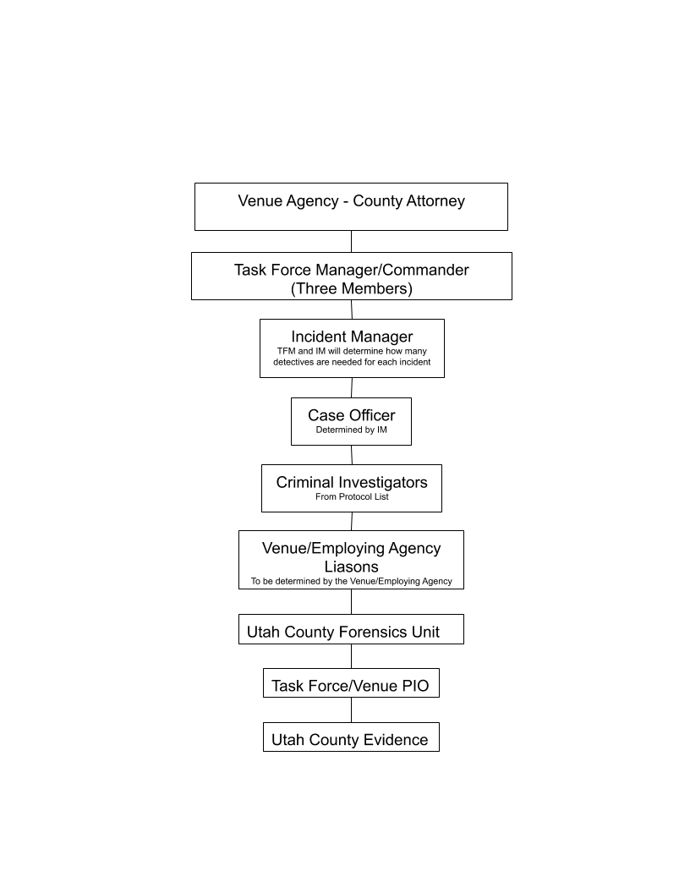

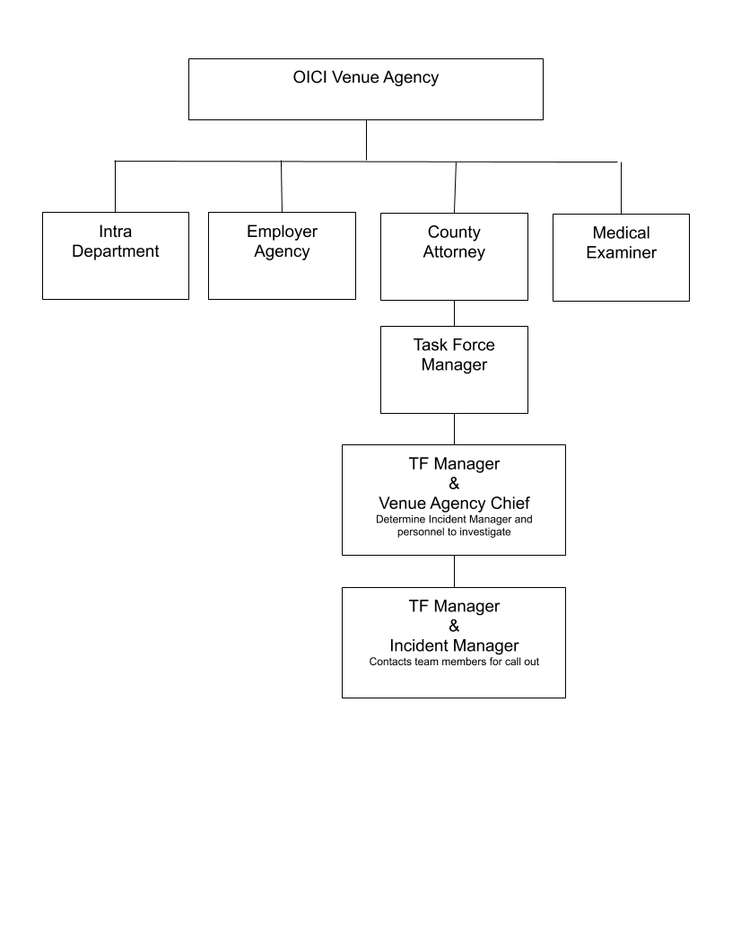
Callout Flow Chart

IN WITNESS WHEREOF, each Party has caused this Agreement to be executed on its behalf by its duly authorized representative.

[Remainder of page intentionally left blank - SIGNATURE PAGES of Parties follow]

Signature Page pertaining to the “Utah County Law Enforcement Executives Contractual Agreement for Officer Involved Critical Incident Protocol” between Alpine City, American Fork City, Brigham Young University, Highland City, Lehi City, Lindon City, Mapleton City, Orem City, Payson City, Pleasant Grove City, Provo City, Salem City, Santaquin City, Spanish Fork City, Saratoga Springs City, Springville City, Utah County, Utah Valley University, Utah Highway Patrol, Utah Department of Public Safety, Utah Department of Corrections, Utah Transit Authority, Adult Probation and Parole, Utah Division of Fish and Game, Utah State Parks or any Police Department or Department of Public Safety of any city or town located in Utah County

City of Lindon

By

Its


M E M O R A N D U M

To: Mayor Acerson and City Council Members From: Kristen Colson
Date: November 26, 2019

Re: Recommendation for Employee Merit Increases

The 2019 -2020 Lindon City Budget included funding a 1.5% Cost of Living Allowance (COLA) increase effective July 1, 2019 and a 2.5% merit increase effective January 1, 2020. The City Council asked that the merit increase be reevaluated when we could evaluate our June 30, 2019 financial situation and ascertain if economic trends would continue into the 2019-2020 fiscal year as anticipated.

Lindon City’s June 30, 2019 Financial Situation

The 2018-2019 fiscal year unaudited financial statements show revenue exceeding expenses by $739,151 in the General Fund. T he General Fund reserves are healthy with a fund balance of $3,310,357.

Economic Trends

Indications show that the economy is stable. Lindon City’s sales tax revenue is expected to meet our projections. According to the U.S. Department of Labor, the Consumer Price Index (CPI) has increased 1.8% from October 2018 to October 2019. The Utah Department of Workforce Services (DWS) reported a 3.3% increase in employment statewide and in Utah County. The statewide unemployment rate is 2.5% and the unemployment rate in Utah County is 2.0%.

Recommendation for Merit Increase
In light of these financial indicators, I recommend that the City Council approve a merit increase for city employees. The merit increase would only be for employees who qualify through their performance | Cost of Merit  Fund Increase  General Fund $76,713
evaluations and would be a maximum of a one-step | Water Fund | 6,141
increase on the wage schedule or 2.5% for employees | Sewer Fund | 3,365
that are not a step, but in the mid-high range. The | Storm Water Fund | 1,897
increase would be effective January 1, 2020. The | Recreation Fund | 5,529
maximum fiscal impact of the merit increase on both wages and benefits is listed in the table to the right. | Total | $93,646

6. Concept Review – South Haven Development – 531 N. State Street. South Haven Development requests concept review of a proposal to allow for 99 residential units on approximately 6 acres of the Linden Nursery property. Parcel #45:244:0001. A Concept Review allows applicants to receive Planning Commission feedback and comments on proposed projects. No formal approvals or motions are given, but general suggestions or recommendations are typically provided. (20 minutes)

See attached materials from the Planning Department.

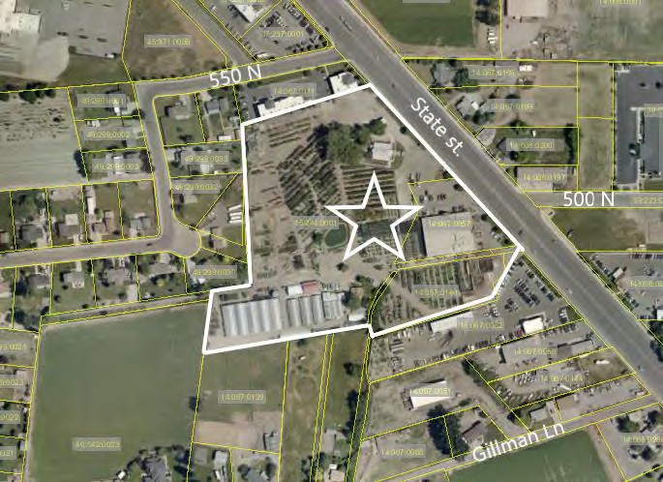Concept Review — South Haven Development 531 N. State St.
Date: December 3, 2019 Applicant: South Haven Development
Presenting Staff: Mike Florence

Location: 531 N. State St. General Plan: Commercial Current Zone: Commercial General
Size: 9 acres

Type of Decision: None
Council Action Required: No

Overview
- Concept reviews are to provide general feedback only and no decision will be made or voted on at the meeting.
- The applicant is seeking concept review feedback for a proposed multifamily project on the Linden Nursery property at 531 North State Street.
- The concept plan includes 99 residential units in mostly 12-plex and 6-plex buildings on about 6 acres.
- The plan also provides 209 parking stalls and amenities that include sports courts, a pool, a clubhouse, a tot lot, and open space.
- Staff has reviewed this proposal and found that the City currently does not have a zone that would support this development proposal.
- The council should carefully consider how the proposed use would be compatible as a transition from commercial to low density residential.
- The City has a number of deep commercial lots on State Street where commercial may not fully develop and should be studied further for the correct development types.
- The Planning Commission meeting minutes are attached for city council review.

Future Project Entitlement
If the council and commission decide to give direction to move forward with this development the applicant, at a minimum, will need to apply for the following entitlements as part of the development review process:
- An ordinance amendment and zone change to create a new zone, or an ordinance amendment to modify an existing zone, that will allow for multifamily buildings. The Ordinance Amendment will also need to include regulations regarding lot dimensions, setbacks, landscaping, density and other relevant aspects of multifamily developments.
- Subdivision Approval.
- Site Plan Approval.

Exhibits
- Concept Plan
- Aerial Image
- Planning Commission Minutes

51

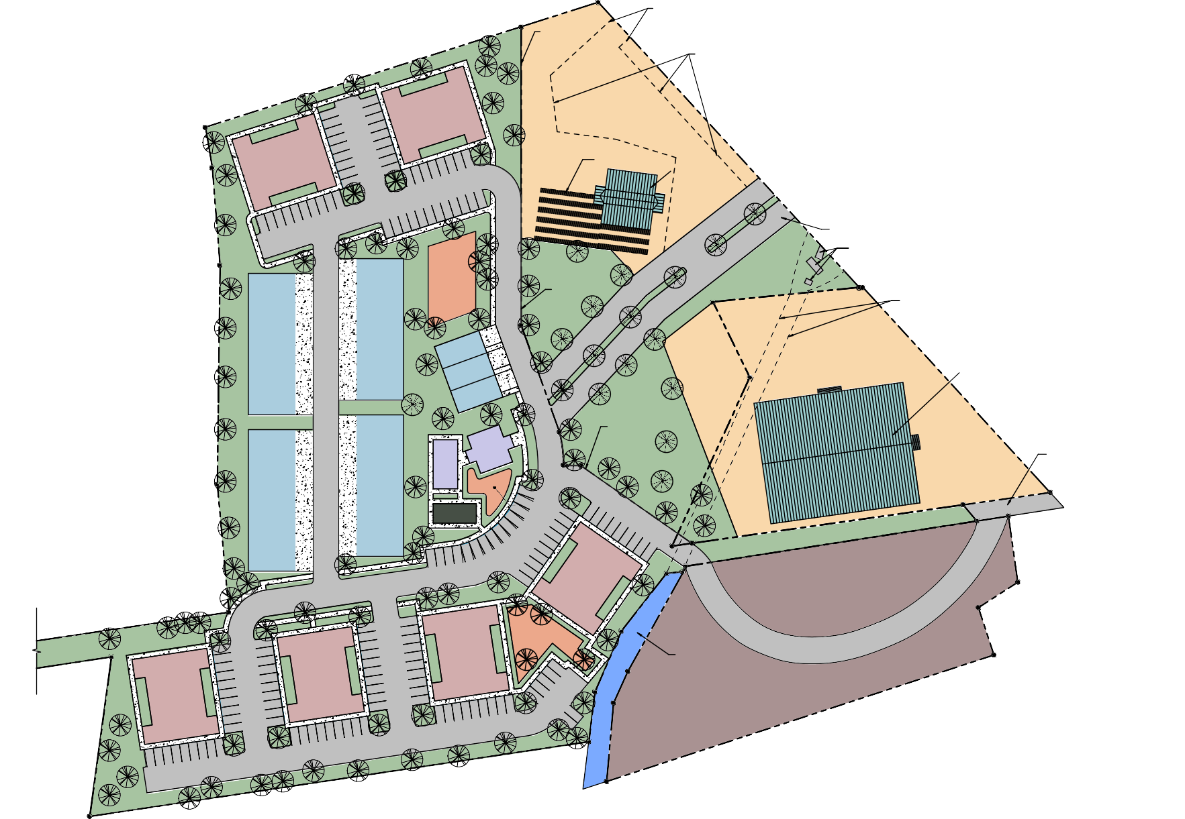

1 2 3 4 5
 | UNIT COUNT
 | TOTAL UNITS | 99
 | PARKING
 | PARKING REQUIRED | 198 TOTAL STALLS
 | PARKING PROVIDED | 209 TOTAL STALLS
 | LOT SIZE
 | TOTAL ACREAGE | 6.68 ACRES

EXISTING ENTRANCE

NEW PROPERTY LINE

EXISTING PARKING LOT

A

18

8

12

10

TOT LOT
6-
PLEX

6-
PLEX

B

24

RETAIL PAD
1.18 ACRES

EXISTING TRELLIS
EXISTING BARN

NEW PROPERTY LINE

6

EXISTING ENTRANCE EXISTING IRRIGATION

BELOW GROUND IRRIGATION

EXISTING NURSERY BUILDING
EXISTING RETAIL

BARN CLUBHOUSE
6-
PLEX

6-
PLEX

POOL

24
NEW PROPERTY LINE

EXISTING ENTRANCE

PICKLEBALL
C COURT

KID'S
AREA 9
10

20
Y:\5D Projects\2019\19-059 South Haven Homes - Lindon\03 Drawings\02 Revit\South Haven Homes - V2.rvt

20

9
D
9



D1 ARCHITECTURAL SITE PLAN
10/1/2019 11:29:39 AM

14

PARK

7

9

EXISTING STREAM

EXISTING NURSERY

AS101

F I V E D E G R E E S D E S I G N
1457 EAST 840 NORTH
OREM, UTAH 84097
801.850.4583
chris@fivedegreesdesign.com
DATE: 01 OCTOBER 2019
PROJECT #: 19-059
DRAWN BY: RDW
CHECKED BY: BCH
REVISIONS
PROJECT
SOUTH HAVEN HOMES
ADDRESS:
535 NORTH STATE STREET LINDON, UT 84042
ARCHITECTURAL
ARCHITECTURAL SITE PLAN
AS101

SCALE: 1" = 40'-0"
1 2 3 4 5

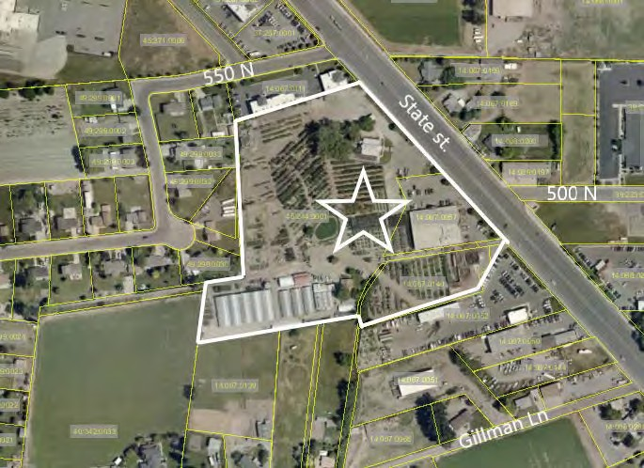
52

2 The Lindon City Planning Commission held a regularly scheduled meeting on Tuesday,
November 12, 2019 beginning at 7:00 p.m. at the Lindon City Center, City Council
4 Chambers, 100 North State Street, Lindon, Utah.

6 REGULAR SESSION – 7:00 P.M.

8 Conducting: Rob Kallas, Vice Chair Invocation: Jared Schauers, Commissioner
10 Pledge of Allegiance: Scott Thompson, Commissioner

12 PRESENT EXCUSED
Sharon Call, Chairperson
14 Mike Marchbanks, Commissioner – arrived 8:10pm Rob Kallas, Commissioner
16 Steven Johnson, Commissioner Scott Thompson, Commissioner
18 Jared Schauers, Commissioner Renee Tribe, Commissioner
20 Mike Florence, Planning Director Anders Bake, Associate Planner
22 Kathy Moosman, City Recorder

24 1. CALL TO ORDER – The meeting was called to order at 7:00 p.m.

26 2. APPROVAL OF MINUTES –The minutes of the regular meeting of the Planning Commission meeting of October 22, 2019 were reviewed.
28
COMMISSIONER THOMPSON MOVED TO APPROVE THE MINUTES OF
30 THE REGULAR MEETING OF OCTOBER 22, 2019 AS PRESENTED. COMMISSIONER SCHAUERS SECONDED THE MOTION. ALL PRESENT
32 VOTED IN FAVOR. THE MOTION CARRIED.

34 3. PUBLIC COMMENT – Chairperson Call called for comments from any audience member who wished to address any issue not listed as an agenda item.
36 There were no public comments.

38 CURRENT BUSINESS –
40 4. Public Hearing – A recommendation to the Lindon City Council to amend City Code 17.48 to increase the allowable building height limit for the
42 Planned Commercial -1 zone – Miller Family Real Estate LLC. Miller Family Real Estate, LLC requests Ordinance Amendment approval to increase the
44 allowable building height in the Planned commercial-1 zone from 48 feet to 60 feet and related technical amendments.
46

26
2 make that change but Doterra is committed to doing that. He then explained the colors noting they are recommending just the gray color (showed color) that is different than all
4 the other grays and they feel this will cap the building off. He also referenced the updated second rendering with the new colors that shows the new color scheme. This is what they
6 are seeking approval for.
Following some general discussion, the Commission expressed their appreciation
8 on the work Doterra has done in complying with their requests noting it looks much nicer than it did before and it is a change for the better.
10 Vice Chair Kallas called for any further comments or discussion from the Commission. Hearing none he called for a motion to continue.
12
COMMISSIONER JOHNSON MOVED TO APPROVE THE APPLICANTS
14 REQUEST FOR AMENDED SITE PLAN APPROVAL WITH THE CHANGE IN COLORS AND FENCING MATERIALS AS PRESENTED. COMMISSIONER
16 THOMPSON SECONDED THE MOTION. THE VOTE WAS RECORDED AS FOLLOWS:
18 CHAIRPERSON CALL AYE COMMISSIONER KALLAS AYE
20 COMMISSIONER JOHNSON AYE COMMISSIONER MARCHBANKS AYE
22 COMMISSIONER THOMPSON AYE
COMMISSIONER SCHAUERS AYE
24 COMMISSIONER TRIBE AYE THE MOTION CARRIED UNANIMOUSLY.

6. Concept Review – South Haven Development – 531 N. State Street
28 South Haven Development requests concept review of a proposal to allow for 99 residential units on approximately 6 acres of the Linden Nursery property. Parcel
30 #45:244:0001. A Concept Review allows applicants to receive Planning Commission feedback and comments on proposed projects. No formal approvals
32 or motions are given, but general suggestions or recommendations are typically provided.
34
Anders Bake, Associate Planner, led this discussion by giving a brief overview of
36 this item explaining the applicant is seeking concept review feedback for a proposed multifamily project on the Linden Nursery property at 531 North State Street. He noted
38 the concept plan includes 99 residential units in mostly 12-plex and 6-plex buildings on about 6 acres. The plan also provides 209 parking stalls and amenities that include sports
40 courts, a pool, a clubhouse, a tot lot, and open space.
Mr. Bake noted staff has reviewed this proposal and found that the City currently
42 does not have a zone that would support this development proposal. In addition, the commission and council should carefully consider how the proposed use would be
44 compatible as a transition from commercial to low density residential. He pointed out the City has a number of deep commercial lots on State Street where commercial may not
46 fully develop and should be studied further for the correct development types.

2 Mr. Bake indicated if the Council and Commission decide to give direction to move forward with this development the applicant, at a minimum, will need to apply for
4 the following entitlements as part of the development review process as follows:
- An Ordinance Amendment to create a new zone, or modify an existing zone, that
6 will allow for several multifamily buildings on a single property. The Ordinance Amendment will also need to include regulations regarding lot dimensions,
8 setbacks, landscaping, parking, and other relevant aspects of multifamily developments.
10 2. A Zone Map amendment to apply a new multifamily zone to the subject property.
- Subdivision Approval.
12 4. Site Plan Approval.

14 Mr. Bake then presented the Concept Plan and an Aerial Image followed by some general discussion. He then turned the time over to the applicants for comment.
16 Mr. Jeff Southard and Mr. Ben Platt (Lindon Nursery) were in attendance representing this item. Mr. Southard noted they are here looking for feedback. He
18 explained as they looked at this parcel and as the market has shifted and changed, we are not building a lot of homes in Lindon so all of that property west of the frontage was used
20 to grow and store their landscaping materials. So, as things have shifted it doesn’t make sense (tax wise) to keep the back of the property to grow trees and shrubs. He pointed out
22 this commercial zone applied to that parcel is significantly deeper than the parcels around it.
24 Mr. Southard stated they are basically asking for the back portion (if it had been done on a 500 ft depth or similar) that this probably would have been zoned residential.
26 But when the zoning was applied along state street it was just applied based on how the parcel shapes were. All of the front would stay nursery and would be retail use by the
28 nursery, but they don’t need everything in the back.
Mr. Southard stated this would have to be a mix of density to make it worthwhile
30 to development it. They need to sell it at a certain price, but they can’t build it without a certain density. He noted these would be market rate, for sale housing not apartments.
32 They would not be low income tax credit or anything like that it would just be whatever the market would bear. But they would be affordable compared to the single family
34 residential that is typical in Lindon; something that younger couples and families could afford. This would be a mix of townhomes and condos. They are just trying to figure out
36 what would make sense density wise; this can be a lengthy process but this is how it starts and they are just looking for feedback.
38 Commissioner Tribe asked if the townhomes will be two-story. Mr. Southard confirmed they will be two-story with garages. These will also have a private fenced
40 backyard to provide some personal space. These would be managed by an HOA, but individually owned. Commissioner Thompson asked about the use of the Red Barn as an
42 event center and if that will continue as the city recently updated the noise ordinance. Mr. Platt stated they were leasing the barn out but now they have taken over
44 ownership. They know they want to remain as Lindon Nursery but looking at development and strategy being a 12-acre nursery on state street is not sustainable. They
46 can shift the inventory to match what homeowners are asking for. But they have to look at their property to see what the highest best us of the property is. The barn is such a

2 historical and iconic part that they want the barn to stay for sure, but how they use the barn they are still debating that as a family.
4 Mr. Southard stated this is probably the 5th concept plan he has had with them where we didn’t have the barn, or moved the barn so it is his understanding they want to
6 keep the barn so they have tried to incorporate that into the concept plan.
Mr. Southard stated today the condos would be in the $235,000 to $240,000 range
8 and the townhomes would be in the $265,000 to $270,000 range; what it would be tomorrow is hard to tell.
10 Chairperson Call expressed her concerns with the high density. She noted the candidates that just won election have indicated that this is exactly what they don’t want.
12 They want in-fill areas to go in, and they are not opposed to having some spread throughout the city to fill that requirement, but they don’t want a lot of density in one
14 specific area; they are not opposed to in-fill areas. When the Ivory Development was approved it was on the basis that it would be that one area only with that type of product.
16 She can’t imagine residents would be happy with this type of development in their neighborhood. Maybe twin homes or 4-plexes spread throughout would work better
18 so it wouldn’t have the impact. She is not saying we don’t need to put some things in Lindon but to have them scattered was a big issue with the Council. However, she is not
20 saying this isn’t a nice concept just not in that area. Mr. Southard stated he will be meeting with the Council with this concept.
22 Commissioner Thompson commented that 99 units will bring a lot of traffic and the neighbors will not be happy with the additional traffic without a traffic signal there.
24 They will also be overlooking an elk farm and this may pose an issue with noise etc.; there are a variety of issues. However, he does like the idea of more affordable housing.
26 Commissioner Tribe suggested some nice twin homes for less density may work. Mr. Southard stated that doesn’t pencil out (highest and best use) and this is not a good
28 location for high end homes; it’s really not a great piece of property.
Mr. Platt stated one of the reasons they reached out to Mr. Southard is because
30 they had been studying this proposal as they want to define who their neighbors will be. Lindon Nursery is still a long-term strategy for his family. They love the nursery business
32 and they want to stay in it but they want to define who their neighbors are. So, it is highly in their best interest to help shape and define this, so they are proactively working
34 through proposals etc.
At this time, Vice Chair Kallas asked the commissioners to give their comments
36 on this concept.
Commissioner Johnson commented that he is probably a little different than the
38 other commissioners. He feels we don’t have the rooftops to support retail on state street. In his opinion we need something like this so state street will develop otherwise business
40 won’t be viable. His personal opinion is we need something like this and it makes perfect sense. It may be a little higher density than he would like, but these are weird shape
42 properties; he is in favor of the concept but the density is a little high for him. Lindon needs more rooftops as we are out of land.
44 Commissioner Schauers commented he is generally in favor to develop in this area and he is okay with the higher density. He questioned the road going in and out. Mr.
46 Southard explained the entrances and exits noting the road would be wide enough to have a left-hand turn.

2 Commissioner Tribe mentioned this may be a lifestyle place where younger people can live and build their careers. She appreciates that the applicants are
4 conscientious of Lindon as they live here and are conscience of how we want it to look and feel. However, she does feel the density is a little high.
6 Commissioner Thompson likes the fact that this is off of state street and he is not opposed with something coming off of state street. He likes the concept if the city says
8 they want the density; there would be issues to deal with.
Commissioner Marchbanks commented in concept he is open to the idea and feels
10 this is an option that should be explored.
Commissioner Kallas stated he has concerns with all the traffic on the one road
12 that would be a real safety and traffic issue with 99 units. He thinks this may be an uphill battle. Personally, he doesn’t like to see code amendments just to make something work.
14 Vice Chair Kallas stated he hopes the comments have helped the applicants tonight and reminded them the council will have further questions.
16 Vice Chair Kallas called for any further comments or discussion from the Commission. Hearing none he moved on to the next agenda item.
18
- New Business: Reports by Commissioners – Vice Chair Kallas called for any
20 new business or reports from the Commissioners.

22 Chairperson Call mentioned an email received from Jeremy Washburn with information on the proposed storage units. Concerned that no more storage units are
24 allowed. Commissioner Johnson mentioned and email about building rentals for employees followed by discussion.
26
- Planning Director Report –
28 • General City Updates

30 Vice Chair Kallas called for any further comments or discussion. Hearing none he called for a motion to adjourn.
32

ADJOURN –
34
COMMISSIONER THOMPSON MADE A MOTION TO ADJOURN THE
36 MEETING AT 9:00 PM. COMMISSIONER MARCHBANKS SECONDED THE MOTION. ALL PRESENT VOTED IN FAVOR. THE MOTION CARRIED.
38
Approved – November 26, 2019
40

42

Sharon Call, Chairperson
44

46 Michael Florence, Planning Director

- Anderson Farms Plat E Major Subdivision Approval and Anderson Farms Boulevard road dedication – Ivory Development, LLC. Request for major subdivision approval of a 60-lot single family residential subdivision located in the Anderson Farms Planned Development (AFPD) zone. The request also includes the dedication of the north section of Anderson Boulevard from 500 N. to 700 N. The subdivision and road dedication are part of a master development agreement with Ivory Development. (20 minutes)

See attached materials from the Planning Department.

Anderson Farms Major Subdivision Approval – Parcel A and Plat dedication for Anderson Boulevard
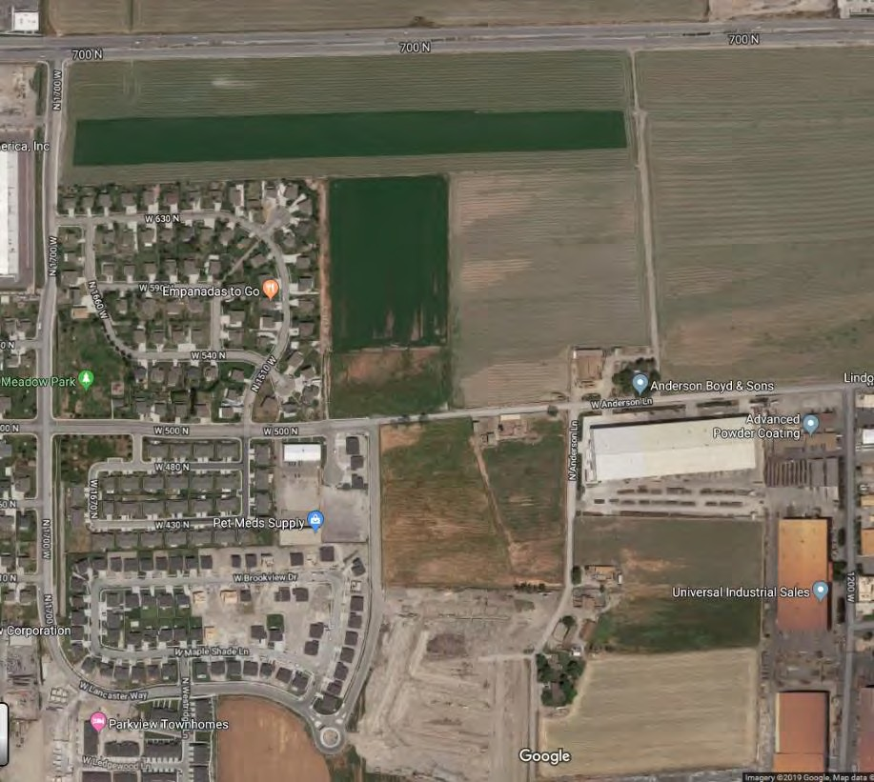
Date: December 3, 2019

Project Location: Parcel A, Anderson Farms Planned Development Zone

Applicant: Ivory Development, LLC
Property Owner: Ivory Homes

General Plan: Residential High Current Zone: Anderson Farms Planned Development Zone

Size: 14.87 acres

Type of Decision: Administrative

Summary of Key Issues
- The city council will be reviewing two plats with this application;
- Ivory Development, LLC is seeking Parcel A/Plat E preliminary subdivision approval for a 60-lot single family home development;
- Ivory Development, LLC is petitioning for preliminary plat approval to dedicate the remaining portion of Anderson Farms Boulevard from 500 N. to 700 N.

Overview
- Parcel A will be the 5th phase of the Anderson Farms development;
- In 2016, the City Council signed a Master Development Agreement with Ivory Development;
- As a summary, the development agreement addresses items such as the total number of units, types of units for each phase, setbacks, park space and development infrastructure;
- As the city council is aware, there are ongoing discussions regarding amending the master development agreement which would increase and re-arrange the overall development density in order to dedicate units for affordable housing. If negotiations workout, then the subject parcel, Parcel A/Plat E, would be reduced to 49 lots. If the council approves the plat with 60 lots and then amends the development agreement, the applicant will need to return to the planning commission and city council to amend their subdivision approval.

60
Motion
I move to recommend (approval, denial, or continue) of the applicant’s request for preliminary approval of Anderson Farms subdivision Plat E. with 60 lots and the Anderson Boulevard road dedication plat with the following conditions:
- The applicant will continue to work with the City Engineer to make all final corrections to the engineering documents and plat;
- Developer submittals shall meet requirements found in the Lindon City Land Development Policies, Standards Specifications and Drawings unless otherwise specified in the master development agreement;
- The applicant will comply with all bonding requirements;
- Plat E be approved at 60 lots;
- Side yard lot line configurations are approved as proposed in Plat E;
- Detention basin #2 that services Parcel A and the roundabout will be landscaped with this phase
- All items of the staff report.

Surrounding Zoning & Land Use
North: Lindon Village Commercial Zone – agriculture
South: Anderson Farms PD zone and R1-12 – Single family residential and agriculture
East: Anderson Farms PD zone – agriculture
West: R3 zone – Single family residential

Lot Size Analysis

Lots sizes | 6,720 to 16,567
Average lot size | 8,324
Density | 4 units per acre

Subdivision Requirements

Required | Compliant
No single lot shall be divided by municipal or county boundary lines, roads, alleys, or other lots. | Yes
All residential lots shall front on a public street. | Yes
Side lot lines shall be at right angles to street lines unless approved by planning commission and/or city council | No. Not all lot lines are at right angles. Staff has included approval of this item in the conditions of approval
The street layout shall conform to the master plan | Yes. The proposed street matches the road cross-sections of the development agreement
Minimum right-of-way width for Minor streets: | Yes. meets development agreement. Anderson Blvd ROW is 85’. Interior  residential streets are 55’
Minor streets maximum grade: 12% | Yes. 2%
Sidewalks, curbs and gutters shall be provided on both sides of all streets to be dedicated to the public | Yes. The improvements on the westside of Anderson Blvd will go in with Parcel E. The eastside improvements will go in with  Parcel G. All interior street improvements will be installed with Parcel A.
Easements shall follow rear and side lot lines whenever practical and shall have a minimum total width of 15  feet apportioned equally in abutting properties. | Yes. Easements are narrower for this development but are provided on the plat
Underground utilities and piped sanitary sewerage shall be provided by the subdivider. | Yes. Provided as shown in engineering plans.
Streetlights | Yes. Plans will need to be updated with  calls out per city development manual

61

Development Agreement Requirements for Parcel A/Plat E

(a) Recording of the first plat will require the following  concurrent improvements: | Compliance
(i) Anderson Blvd. from 700 North to the 500 North  connection including all curb and gutter and improvements and  Landscaping within the right of way identified as the “North Anderson Blvd Improvements” on Exhibit J; | Yes
(ii) The connection from 500 North to Anderson Blvd. as  shown in Exhibit J; | Yes
(iii) Full northern roundabout improvements, including landscaping, will be completed; | Yes. Roundabout is in but the landscaping has not been installed. Landscaping will be  required as part of this phase.
(iv) Full storm water basin detention improvements, including landscaping, will be completed for the basin that will serve this Parcel; and | Yes. The detention basin has been installed but not landscaped. Landscaping will be required as part of this  phase.
(v) Pressurized irrigation system, including source, for the  Project and a connection to the existing City pressurized irrigation system subject to Section 9.8. | No. Developer is still working on the pressurized irrigation system. Most if not all of the construction is complete but the system was not functioning when the city turned off the water for winter. A functioning PI system will be required as  part of this phase.
(b) Staging area for the Anderson Farm equipment cannot impede  construction of street improvements and utility infrastructure. | Yes
(c) Sewer will be designed to allow flow to the future Sewer/Ground Water Lift Station when that facility is online. Sewer connection in  500 North is only temporary until future lift station is online. | Yes
(i) If Developer elects not to temporarily connect Parcel A  units to Lindon’s existing sewer system, building permits may be issued prior to the construction of the Sewer/Ground Water Lift Station, but certificates of occupancy for any Single Family Unit will not be issued until the Sewer/Ground Water Lift Station, with its associated Off-Site improvements, is substantially completed  and functional. | Yes

62
Exhibits
Aerial photo
Parcel A/Plat E subdivision plan Anderson Farms road dedication plat Anderson Farms development layout Road Cross-section
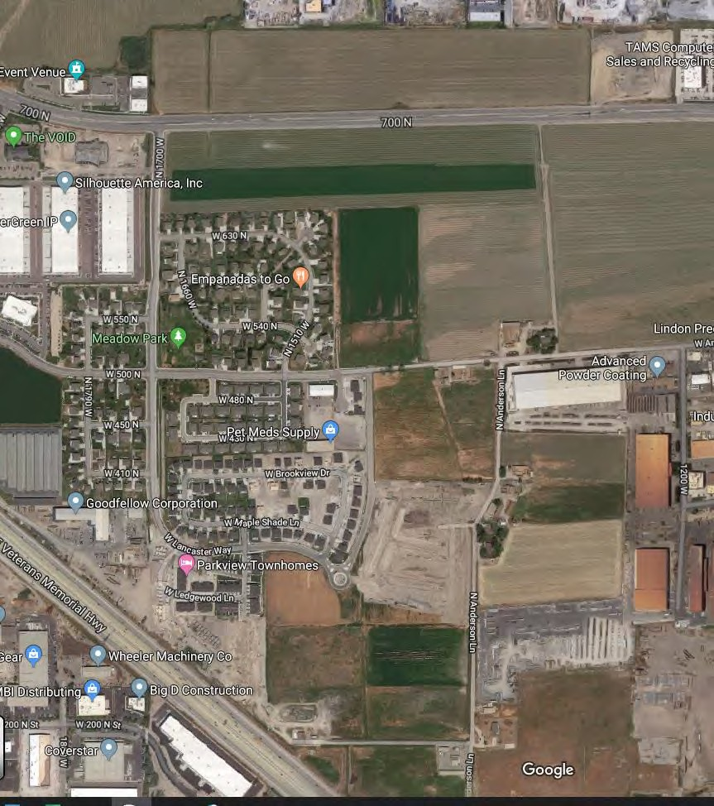

PROJECT LOCATION
ANDERSON FARMS PLAT E

PREPARED FOR:
ENGINEERING AND SURVEYING, LLC
6949 S. HIGH TECH DRIVE SUITE 200 MIDVALE, UTAH 84047 PH: (801) 352-0075
www.focusutah.com
IVORY HOMES
LOCATED IN:
LINDON, UT
700 NORTH
Sheet List Table
Sheet  Number | Sheet Title
C1 | COVER
C2 | PRELIM PLAT
C2.1 | PRELIM PLAT
C3 | EXISTING CONDITIONS
C4 | SITE PLAN
C5 | GRADING & DRAINAGE PLAN
C6 | OVERALL DRAINAGE PLAN

VICINITY MAP

ENGINEER'S NOTES TO CONTRACTOR
  - THE EXISTENCE AND LOCATION OF ANY UNDERGROUND UTILITY PIPES, CONDUITS OR STRUCTURES SHOWN ON THESE PLANS WERE OBTAINED BY A SEARCH OF THE AVAILABLE RECORDS, TO THE BEST OF OUR KNOWLEDGE, THERE ARE NO EXISTING UTILITIES EXCEPT AS SHOWN ON THESE PLANS. THE CONTRACTOR IS REQUIRED TO TAKE DUE PRECAUTIONARY MEASURES TO PROTECT THE UTILITY LINES SHOWN ON THESE DRAWINGS. THE CONTRACTOR FURTHER ASSUMES ALL LIABILITY AND RESPONSIBILITY FOR THE UTILITY PIPES, CONDUITS OR STRUCTURES SHOWN OR NOT SHOWN ON THESE DRAWINGS. IF UTILITY LINES ARE ENCOUNTERED DURING CONSTRUCTION THAT ARE NOT IDENTIFIED BY THESE PLANS, CONTRACTOR SHALL NOTIFY ENGINEER IMMEDIATELY.

  - CONTRACTOR AGREES THAT HE SHALL ASSUME SOLE AND COMPLETE RESPONSIBILITY FOR JOB SITE CONDITIONS DURING THE COURSE OF CONSTRUCTION OF THIS PROJECT, INCLUDING SAFETY OF ALL PERSONS AND PROPERTY; THAT THIS REQUIREMENT SHALL APPLY CONTINUOUSLY AND NOT BE LIMITED TO NORMAL WORKING HOURS; AND THAT THE CONTRACTOR SHALL DEFEND, INDEMNIFY AND HOLD THE CITY, THE OWNER, AND THE ENGINEER HARMLESS FROM ANY AND ALL LIABILITY, REAL OR ALLEGED, IN CONNECTION WITH THE PERFORMANCE OF WORK ON THIS PROJECT, EXCEPTING FOR LIABILITY ARISING FROM THE SOLE NEGLIGENCE OF THE OWNER OR THE ENGINEER.

////

//// ////

////

  - UNAUTHORIZED CHANGES & USES: THE ENGINEER PREPARING THESE PLANS WILL NOT BE RESPONSIBLE FOR, OR LIABLE FOR, UNAUTHORIZED CHANGES TO OR USES OF THESE PLANS. ALL CHANGES TO THE PLANS MUST BE IN WRITING AND MUST BE APPROVED BY THE PREPARER OF THESE PLANS.

  - ALL CONTOUR LINES SHOWN ON THE PLANS ARE AN INTERPRETATION BY CAD SOFTWARE OF FIELD SURVEY WORK PERFORMED BY A LICENSED SURVEYOR. DUE TO THE POTENTIAL DIFFERENCES IN INTERPRETATION OF CONTOURS BY VARIOUS TYPES OF GRADING SOFTWARE BY OTHER ENGINEERS OR CONTRACTORS, FOCUS DOES NOT GUARANTEE OR WARRANTY THE ACCURACY OF SUCH LINEWORK. FOR THIS REASON, FOCUS WILL NOT PROVIDE ANY GRADING CONTOURS IN CAD FOR ANY TYPE OF USE BY THE CONTRACTOR. SPOT ELEVATIONS AND PROFILE ELEVATIONS SHOWN IN THE DESIGN DRAWINGS GOVERN ALL DESIGN INFORMATION ILLUSTRATED ON THE APPROVED CONSTRUCTION SET. CONSTRUCTION
EXPERTISE AND JUDGMENT BY THE CONTRACTOR IS ANTICIPATED BY THE ENGINEER TO COMPLETE

113

112

114

115

116

117

118

119

120

121

122

123

124

125

126

127
ANDERSON BOULEVARD
ANDERSON FARMS PLAT E
LINDON, UT
COVER

BUILD-OUT OF THE INTENDED IMPROVEMENTS.

GENERAL NOTES
- CONTRACTOR TO FIELD VERIFY HORIZONTAL AND VERTICAL LOCATIONS OF ALL EXISTING UTILITIES PRIOR TO COMMENCEMENT OF

111
160 159 158 157 156 155 154 153 152 151 150
128

CONSTRUCTION, AND REPORT ANY DISCREPANCIES TO THE ENGINEER.

- ANY AND ALL DISCREPANCIES IN THESE PLANS ARE TO BE BROUGHT TO THE ENGINEER'S ATTENTION PRIOR TO COMMENCEMENT OF CONSTRUCTION.

- ALL CONSTRUCTION SHALL ADHERE TO LINDON STANDARD PLANS AND SPECIFICATIONS. LINDON STANDARD SPECIFICATIONS AND DRAWINGS APPLY TO CONSTRUCTION OF PUBLIC IMPROVEMENTS THAT WILL BE OWNED OR MAINTAINED BY LINDON CITY AND TAKE PRECEDENCE OVER OTHER
110

109
141
142
143
144
145
146
147
148
149

131
STREET D

130

129

STANDARDS.

- ALL UTILITIES AND ROAD IMPROVEMENTS SHOWN ON THE PLANS HEREIN SHALL BE CONSTRUCTED USING REFERENCE TO SURVEY CONSTRUCTION STAKES PLACED UNDER THE SUPERVISION OF A PROFESSIONAL LICENSED SURVEYOR WITH A CURRENT LICENSE ISSUED BY THE STATE OF UTAH. ANY IMPROVEMENTS INSTALLED BY ANY OTHER VERTICAL OR HORIZONTAL REFERENCE WILL NOT BE ACCEPTED OR CERTIFIED BY THE ENGINEER OF RECORD.
108

107

139

138 137
136
135 134 133 132

5. THIS DRAWING SET IS SCALED TO BE PRINTED ON A 24" X 36" SIZE OF PAPER (ARCH. D). IF PRINTED ON A SMALLER PAPER SIZE, THE DRAWING WILL NOT BE TO SCALE AND SHOULD NOT BE USED TO SCALE MEASUREMENTS FROM THE PAPER DRAWING. ALSO USE CAUTION, AS THERE MAY BE TEXT OR DETAIL THAT MAY BE OVERLOOKED DUE TO THE SMALL SIZE OF THE DRAWING.

NOTICE
BEFORE PROCEEDING WITH THIS WORK, THE CONTRACTOR SHALL CAREFULLY CHECK AND VERIFY ALL CONDITIONS, QUANTITIES, DIMENSIONS, AND GRADE ELEVATIONS, AND SHALL REPORT ALL DISCREPANCIES TO THE ENGINEER.
106 140

105

104
DESCRIPTION
103

Z:\_2019\19-0386 Anderson Farms Parcel A\design 19-0386\dwg\sheets\prelim\C1-COVER.dwg

101
102

CONTACTS
////
1 ----
----
----
----
----
----
----
----
----
----
----
2
3
4
5
6 ----

SITE MAP

ENGINEER & SURVEYOR
REVISION BLOCK
# DATE
FOCUS ENGINEERING & SURVEYING, LLC 6949 S. HIGH TECH DRIVE SUITE 200 MIDVALE, UTAH 84047
(801) 352-0075
PROJECT MANAGER: JACKSON WATERS SURVEY MANAGER: SPENCER LLEWELYN

COVER

OWNER/DEVELOPER IVORY DEVELOPMENT LLC
3340 NORTH CENTER STREET LEHI, UTAH 84070
(801) 407-6800

Scale:
Date: Sheet:

NTS 11/12/19

Drawn: Job #:

JRW 19-0386

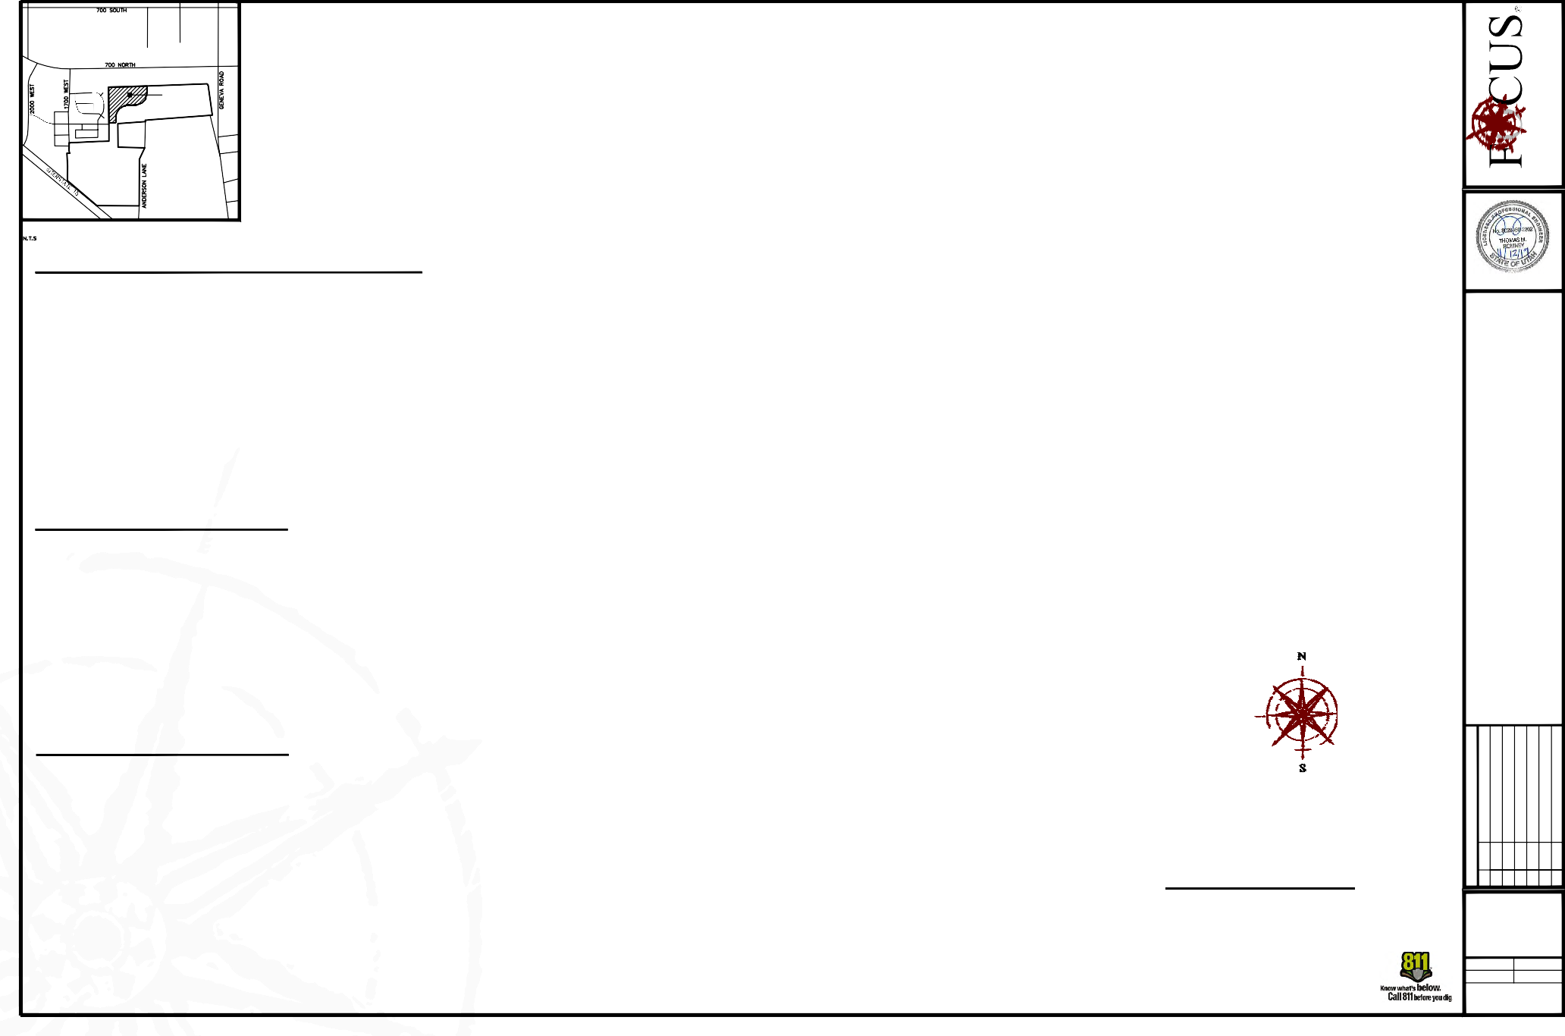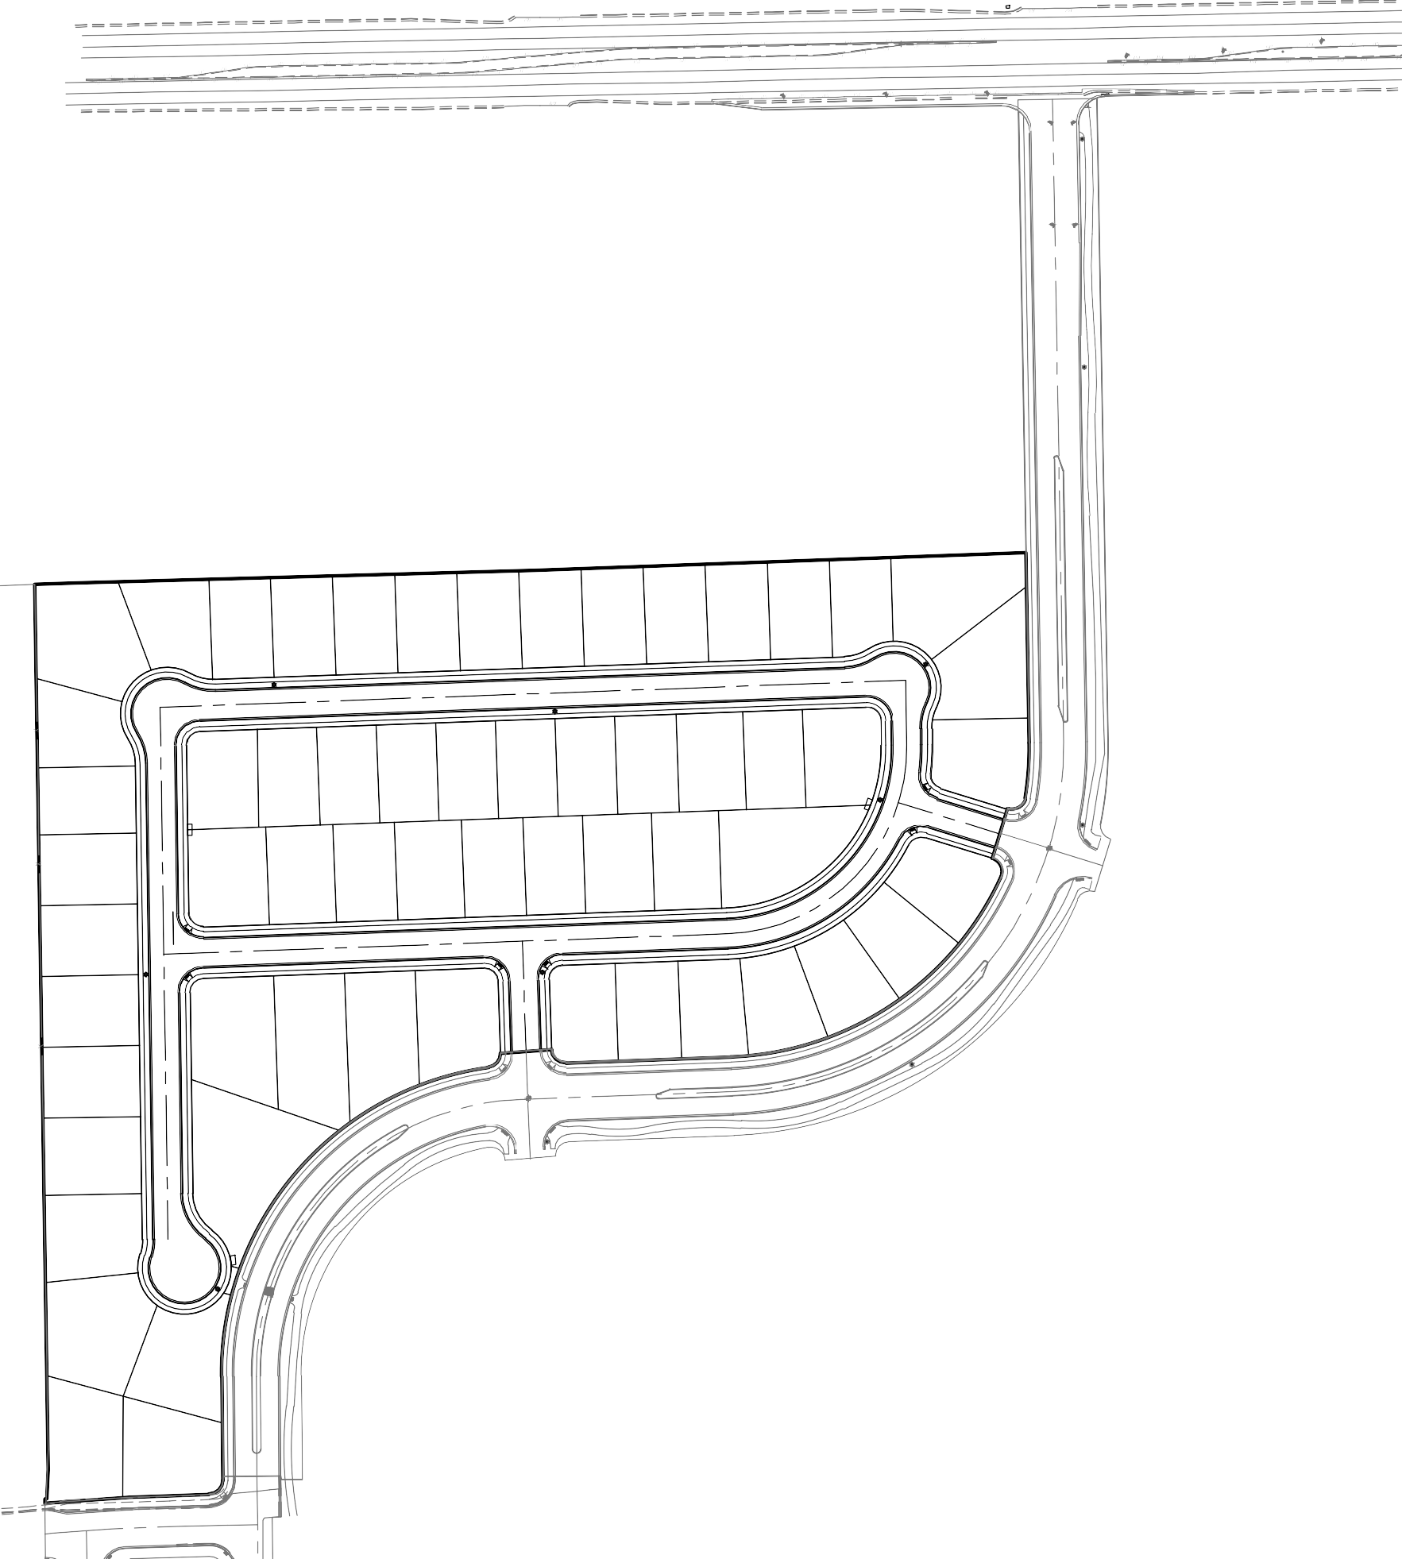CONTACT: KEN WATSON C1

N88°07'40"E 45.00'

113
101.01'
12308 sqft

114
66.69'
7995 sqft

115
7097 sqft
107.71'

116
7135 sqft
N2°03'42"W 107.26'

117
7100 sqft
106.73'

118
7064 sqft
106.20'
SURVEYOR'S CERTIFICATE
I, SPENCER W. LLEWELYN, DO HEREBY CERTIFY THAT I AM A PROFESSIONAL LAND SURVEYOR, AND THAT I HOLD CERTIFICATE NO. 10516507 IN ACCORDANCE WITH TITLE 58, CHAPTER 22, OF UTAH STATE CODE. I FURTHER CERTIFY BY AUTHORITY OF THE OWNER(S), THAT I HAVE COMPLETED A SURVEY OF THE PROPERTY DESCRIBED ON THIS PLAT IN ACCORDANCE WITH SECTION 17-23-17 OF SAID CODE, AND HAVE SUBDIVIDED SAID TRACT OF LAND INTO LOTS, BLOCKS, STREETS, AND EASEMENTS, AND THE SAME HAS, OR WILL BE, CORRECTLY SURVEYED, STAKED, AND THE MONUMENTED ON THE GROUND AS SHOWN ON THIS PLAT, AND THAT THIS PLAT IS TRUE AND CORRECT.

SPENCER W. LLEWELYN DATE
PROFESSIONAL LAND SURVEYOR CERTIFICATE NO. 10516507

L4

112
95.70'

7898 sqft

105.00' S89°08'14"W

C48

N2°03'42"W
MATCH LINE SEE SHEET C2.1

159 158 157 156
2.85'
60.02'
27.50'
105.02' S0°51'46"E
BOUNDARY DESCRIPTION
A portion of the SW1/4 of Section 29 and the NW1/4 of Section 32, Township 5 South, Range 2 East, Salt Lake Base & Meridian, located in Lindon, Utah, more particularly described as follows:
Beginning at a point on the Easterly line of NEWBURY BUSINESS PARK, Plat “A” Subdivision, according to the Official Plat recorded February 21, 2008 as Entry No. 20505:2008 in the Office of the Utah County Recorder, located S00°11'45"E along the Section line 594.57 feet and East 534.71 feet from the Northwest Corner of Section 32, T5S, SLB&M; thence N00°13'52"W along said plat 4.52 feet to a point on the Southerly line of Plat “A”, CREEKSIDE VILLAGE, according to the Official Plat recorded May 10, 2007 as Entry No. 69129:2007 in the Office of the Utah County Recorder; thence along said plat the following 3 (three) courses: 1) N84°33'03"E 2.01 feet; 2) N02°42'51"E 30.90 feet; 3) N00°51'46"W 950.52 feet; thence N88°07'40"E 45.00 feet; thence N88°23'43"E 491.43 feet; thence N87°56'18"E 528.04 feet; thence S00°59'39"E 204.22 feet; thence along the arc of a curve to the right with a radius of
332.00 feet a distance of 59.75 feet through a central angle of 10°18'44" Chord: S04°09'43"W 59.67 feet to a point of

Curve Table
N2°03'42"W
111
7560 sqft
72.00'

160
7987 sqft 6792 sqft 6720 sqft

12' x 5' POSTAL EASEMENT
105.00' S89°08'14"W
72.00'
STREET D

(PUBLIC 55' ROW)
90.33'

6720 sqft 6720 sqft
compound curvature; thence along the arc of a curve to the right having a radius of 15.00 feet a distance of 25.59 feet
through a central angle of 97°45'53" Chord: S58°12'02"W 22.60 feet; thence S16°59'25"W 55.00 feet; thence
Southeasterly along the arc of a non-tangent curve to the right having a radius of 15.00 feet (radius bears: S17°04'58"W) a distance of 25.56 feet through a central angle of 97°38'42" Chord: S24°05'41"E 22.58 feet to a point of compound curvature; thence along the arc of a curve to the right with a radius of 332.00 feet a distance of 366.27 feet through a central angle of 63°12'38" Chord: S56°19'59"W 347.98 feet; thence S87°56'18"W 177.11 feet; thence along the arc of a curve to the right with a radius of 15.00 feet a distance of 23.56 feet through a central angle of 90°00'00" Chord: N47°03'42"W 21.21 feet; thence S86°04'27"W 55.03 feet; thence Southwesterly along the arc of a non-tangent curve to the right having a radius of 15.00 feet (radius bears: S87°56'18"W) a distance of 22.04 feet through a central angle of 84°10'40" Chord: S40°01'38"W 20.11 feet to a point of reverse curvature; thence along the arc of a curve to the left having a radius of 332.00 feet a distance of 478.79 feet through a central angle of 82°37'43" Chord: S40°48'07"W

WEST 1/4 CORNER OF SECTION 29, T5S, R2E, SLB&M
CURVE | RADIUS | DELTA | LENGTH | CHORD DIRECTION | CHORD LENGTH
C1 | 199.50 | 70°51'20" | 246.71 | N52°30'38"E | 231.29
C2 | 199.50 | 18°04'37" | 62.94 | N08°02'40"E | 62.68
C3 | 50.00 | 31°47'18" | 27.74 | N72°02'39"E | 27.39
C4 | 50.00 | 32°08'03" | 28.04 | N72°13'01"E | 27.68
C5 | 50.00 | 54°17'47" | 47.38 | S64°34'04"E | 45.63
C6 | 50.00 | 62°56'49" | 54.93 | S05°56'46"E | 52.21
C7 | 50.00 | 15°27'11" | 13.49 | S17°48'03"W | 13.44
C8 | 50.00 | 11°04'06" | 9.66 | S04°32'25"W | 9.64
C9 | 227.00 | 7°57'44" | 31.55 | S02°59'13"W | 31.52
C10 | 15.00 | 79°53'07" | 20.91 | S32°58'28"E | 19.26
C11 | 2533.00 | 1°45'57" | 78.07 | N86°04'23"E | 78.06
C12 | 2533.00 | 2°05'29" | 92.46 | N88°00'06"E | 92.45
C13 | 332.00 | 15°15'15" | 88.39 | N07°06'53"E | 88.13
C14 | 50.00 | 93°58'38" | 82.01 | S79°35'26"W | 73.12
C15 | 50.00 | 47°29'23" | 41.44 | N29°40'34"W | 40.27
C16 | 50.00 | 23°15'48" | 20.30 | N05°42'02"E | 20.16
C17 | 50.00 | 18°11'42" | 15.88 | N08°14'05"E | 15.81
C18 | 50.00 | 51°40'47" | 45.10 | S28°09'11"E | 43.59
C19 | 50.00 | 53°07'48" | 46.36 | S27°25'40"E | 44.72
C20 | 332.00 | 31°57'37" | 185.19 | N35°54'18"E | 182.80
C21 | 15.00 | 88°48'04" | 23.25 | S43°32'16"W | 20.99
C22 | 15.00 | 90°00'00" | 23.56 | N47°03'42"W | 21.21
C23 | 332.00 | 13°17'22" | 77.01 | N75°28'17"E | 76.83
C24 | 332.00 | 14°41'25" | 85.12 | N61°28'54"E | 84.89
C25 | 332.00 | 2°15'05" | 13.05 | N53°00'39"E | 13.04
C26 | 50.00 | 31°47'18" | 27.74 | N16°45'25"W | 27.39
C27 | 50.00 | 47°47'42" | 41.71 | N08°45'13"W | 40.51
C28 | 50.00 | 54°31'47" | 47.59 | N42°24'32"E | 45.81
C29 | 50.00 | 50°03'11" | 43.68 | S85°17'59"E | 42.30
C30 | 50.00 | 28°40'52" | 25.03 | S74°36'50"E | 24.77
C31 | 15.00 | 90°00'00" | 23.56 | S42°56'18"W | 21.21
C32 | 332.00 | 3°15'43" | 18.90 | N86°18'27"E | 18.90
C33 | 227.00 | 3°05'22" | 12.24 | S86°23'37"W | 12.24
C34 | 227.00 | 15°09'25" | 60.05 | S77°16'13"W | 59.88
C35 | 332.00 | 15°08'55" | 87.78 | N77°06'08"E | 87.52
C36 | 332.00 | 15°08'14" | 87.71 | N61°57'34"E | 87.46
C37 | 227.00 | 15°09'25" | 60.05 | S62°06'48"W | 59.88
C38 | 227.00 | 15°09'25" | 60.05 | S46°57'23"W | 59.88
C39 | 332.00 | 15°07'38" | 87.65 | N46°49'38"E | 87.40
C40 | 227.00 | 12°10'49" | 48.26 | S33°17'16"W | 48.17
C41 | 332.00 | 14°32'09" | 84.23 | N31°59'45"E | 84.00
C42 | 15.00 | 79°53'07" | 20.91 | S67°08'25"W | 19.26
C43 | 15.00 | 91°11'56" | 23.88 | S46°27'44"E | 21.43
C44 | 15.00 | 88°48'04" | 23.25 | S43°32'16"W | 20.99
C45 | 172.00 | 67°04'28" | 201.36 | N54°24'04"E | 190.05
C46 | 172.00 | 21°51'29" | 65.62 | N09°56'06"E | 65.22
C47 | 15.00 | 91°04'03" | 23.84 | N46°31'40"W | 21.41
C48 | 50.00 | 3°06'26" | 2.71 | N89°29'31"E | 2.71
C49 | 50.00 | 34°54'55" | 30.47 | S15°08'40"W | 30.00
C50 | 332.00 | 5°10'58" | 30.03 | S17°20'00"W | 30.02

1955 UTAH COUNTY MONUMENT

30 29
110
7980 sqft
76.00'
141
8894 sqft
76.00'

89.71'
142
7560 sqft
N2°03'42"W
143
6930 sqft
N2°03'42"W 105.00'
144
7560 sqft
N2°03'42"W 105.00'
145
6930 sqft
438.37 feet; thence S00°30'45"E 111.38 feet to a point on the Northerly line of Plat “B”, ANDERSON FARMS
SUBDIVISION, according to the Official Plat thereof recorded August 24, 2018 as Entry No. 81023:2018 in the Office of the Utah County Recorder; thence along said plat the following 3 (three) courses: 1) along the arc of a curve to the right with a radius of 15.00 feet a distance of 23.45 feet through a central angle of 89°33'35" Chord: S44°16'03"W
21.13 feet to a point of reverse curvature; 2) along the arc of a curve to the left having a radius of 2,533.00 feet a distance of 170.52 feet through a central angle of 03°51'26" Chord: S87°07'08"W 170.49 feet; 3) S85°11'25"W 5.76 feet to the point of beginning.

109
105.00' S89°08'14"W
950.52'
76.00'
7980 sqft
27.50'

OWNER'S DEDICATION
76.00'
27.50'
118.39'
Contains: 14.87 acres+/-

105.00' S89°08'14"W

108
BASIS OF BEARING: N0°10'09"W (SECTION LINE) 2,664.04
(NAD 27)
N0°51'46"W
76.00'
7980 sqft

139
105.00' S89°08'14"W
76.00'
462.26'
N0°51'46"W
93.22'
11431 sqft

138 137
11951 sqft 10654 sqft
143.43'
161.12'

136

9856 sqft
123.30'

ANDERSON FARMS
PLAT "A"
75.09'
DO HEREBY DEDICATE FOR PERPETUAL USE OF THE PUBLIC ALL ROADS AND OTHER AREAS SHOWN ON THIS PLAT AS INTENDED FOR PUBLIC USE. THE UNDERSIGNED OWNER(S) ALSO HEREBY CONVEY TO ANY AND ALL PUBLIC UTILITY COMPANIES A PERPETUAL, NON-EXCLUSIVE EASEMENT OVER THE PUBLIC UTILITY EASEMENTS SHOWN ON THIS PLAT, THE SAME TO BE USED FOR THE INSTALLATION, MAINTENANCE, AND OPERATION OF UTILITY LINES AND FACILITIES.

107
PLAT "A" CREEKSIDE VILLAGE
76.00'
7980 sqft

R=15.00' Δ=84°10'40"
L=22.04' CH=S40°01'38"W 20.11'
S89°08'14"W
76.00'

S86°04'27"W
55.03'
IN WITNESS WHEREOF
A.D. 20

CHRISTOPHER P. GAMVROULAS
HAVE HEREUNTO SET

RON K. ANDERSON
HAND THIS
DAY OF

R=332.00'
122.39'
PRESIDENT, IVORY DEVELOPMENT LLC
PRESIDENT, BOYD ANDERSON AND SONS, INC.

106
82.92'
82.92'

140
8707 sqft
16567 sqft
Δ=82°37'43" L=478.79'
CH=S40°48'07"W 438.37'

STATE OF UTAH S.S.
COUNTY OF
LIMITED LIABILITY ACKNOWLEDGMENT

ON THE
27.50'
105.00' S89°08'14"W

DAY OF

A.D. 20

PERSONALLY APPEARED BEFORE ME, THE

30 29
31 32

105
9260 sqft L3
93.79'
49.26'
48.78'
FUTURE DEVELOPMENT
UNDERSIGNED NOTARY PUBLIC, IN AN FOR THE COUNTY OF SALT LAKE, IN SAID STATE OF UTAH, CHRISTOPHER P. GAMVROULAS, WHO AFTER BEING DULY SWORN, ACKNOWLEDGED TO ME THAT HE IS THE PRESIDENT OF IVORY DEVELOPMENT LLC, A UTAH LLC AND THAT HE SIGNED THE OWNERS DEDICATION FREELY AND VOLUNTARILY FOR AND IN BEHALF OF SAID LIMITED LIABILITY COMPANY FOR THE PURPOSES THEREIN MENTIONED.

MY COMMISSION EXPIRES:

A NOTARY PUBLIC COMMISSIONED IN UTAH
NORTHWEST CORNER OF SECTION 32, T5S, R2E, SLB&M 1955 UTAH COUNTY MONUMENT

C49 C50

12' x 5'
Line Table

MY COMMISSION No.
RESIDING IN
COUNTY

104
99.98'
POSTAL
EASEMENT
PARCEL A
0.01 acres 224 sqft
LINE
L1 L2 L3
L4
DIRECTION
S74°51'20"E S74°51'20"E N30°07'52"W
N46°27'44"W
LENGTH
8.67
9.82
35.79
10.50
PRINTED FULL NAME OF NOTARY

ACCEPTANCE BY LEGISLATIVE BODY
THE CITY COUNCIL OF LINDON CITY, COUNTY OF UTAH, APPROVES THIS SUBDIVISION AND HEREBY ACCEPTS THE DEDICATION OF ALL STREETS, EASEMENTS, AND OTHER PARCELS OF LAND INTENDED

12108 sqft
FOR PUBLIC PURPOSES FOR THE PERPETUAL USE OF THE PUBLIC THIS
DAY OF

103
S0°11'45"E 594.57'
10006 sqft

L5 N56°11'08"E
L6 N87°56'18"E
L7 N87°56'18"E
14.25
84.09
72.00
, 20 .

OCCUPANCY RESTRICTION NOTICE
IT IS UNLAWFUL TO OCCUPY ANY BUILDING

N2°42'51"E
30.90'

101
9930 sqft
101.12'

102
9833 sqft
L8 L9 L10 L11 L12 L13
N87°56'18"E N87°56'18"E N87°56'18"E N87°56'18"E N87°56'18"E N87°56'18"E
66.00
72.00
66.00
64.00
74.00
72.00

CONDITIONS OF APPROVAL

CORPORATE ACKNOWLEDGMENT
APPROVED BY MAYOR APPROVED BY CITY ATTORNEY

APPROVED BY CITY ENGINEER ATTEST BY CITY RECORDER (SEE SEAL BELOW) (SEE SEAL BELOW)

PLANNING DIRECTOR

PHASE "A"
ANDERSON FARMS

LOCATED WITHIN THIS SUBDIVISION WITHOUT FIRST HAVING OBTAINED A CERTIFICATE OF OCCUPANCY ISSUED BY THE CITY.
N0°07'23"E
108.88'
62.00' 49.38'
S0°30'45"E 111.38'
N84°33'03"E
2.01' EAST 534.71'

R=15.00'
NOTES
- PUBLIC UTILITY EASEMENTS ARE 10' UNLESS NOTED OTHERWISE.
- #5 REBAR & CAP TO BE SET AT ALL REAR LOT CORNERS.
- NAIL TO BE SET IN TOP OF CURB AT PROJECTION OF SIDE LOT LINES.
STATE OF UTAH S.S.
COUNTY OF

ON THE

DAY OF

A.D. 20

PERSONALLY APPEARED BEFORE ME , THE
SUBDIVISION
LINDON CITY, UTAH COUNTY, UTAH

N0°13'52"W POINT4.O52F'
x 10 WBEGINNING

WEST 1/4 CORNER OF

S85°11'25"W 5.76'

ANDERSON FARMS PARCEL B
Δ=89°33'35" L=23.45'
CH=S44°16'03"W 21.13'
UNDERSIGNED NOTARY PUBLIC, IN AND FOR THE COUNTY OF , IN SAID STATE OF UTAH, RON K. ANDERSON, WHO AFTER BEING DULY SWORN, ACKNOWLEDGED TO ME THAT HE IS THE PRESIDENT OF BOYD ANDERSON AND SONS, INC. A UTAH INC. AND THAT HE SIGNED THE OWNERS DEDICATION FREELY AND VOLUNTARILY FOR AND IN BEHALF OF SAID COMPANY FOR THE PURPOSES THEREIN MENTIONED.

MY COMMISSION EXPIRES:
A NOTARY PUBLIC COMMISSIONED IN UTAH
SCALE: 1"=50'
SURVEYOR'S SEAL NOTARY PUBLIC SEAL CITY-COUNTY ENGINEER SEAL COUNTY RECORDER SEAL

31 32 SECTION 32, T5S, R2E, SLB&M
1960 UTAH COUNTY MONUMENT

MY COMMISSION No.
RESIDING IN
COUNTY

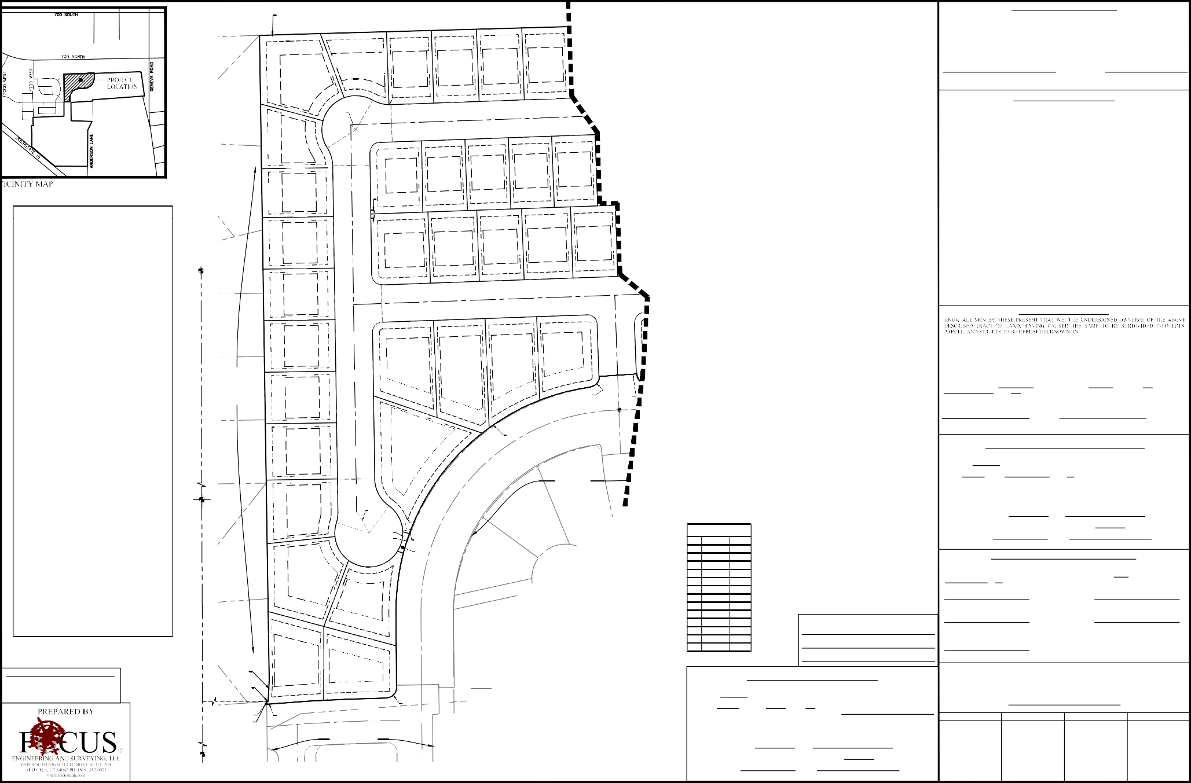
PRINTED FULL NAME OF NOTARY

Curve Table
36.82'

119
MATCH LINE SEE SHEET C2
CURVE | RADIUS | DELTA | LENGTH | CHORD DIRECTION | CHORD LENGTH
C1 | 199.50 | 70°51'20" | 246.71 | N52°30'38"E | 231.29
C2 | 199.50 | 18°04'37" | 62.94 | N08°02'40"E | 62.68
C3 | 50.00 | 31°47'18" | 27.74 | N72°02'39"E | 27.39
C4 | 50.00 | 32°08'03" | 28.04 | N72°13'01"E | 27.68
C5 | 50.00 | 54°17'47" | 47.38 | S64°34'04"E | 45.63
C6 | 50.00 | 62°56'49" | 54.93 | S05°56'46"E | 52.21
C7 | 50.00 | 15°27'11" | 13.49 | S17°48'03"W | 13.44
C8 | 50.00 | 11°04'06" | 9.66 | S04°32'25"W | 9.64
C9 | 227.00 | 7°57'44" | 31.55 | S02°59'13"W | 31.52
C10 | 15.00 | 79°53'07" | 20.91 | S32°58'28"E | 19.26
C11 | 2533.00 | 1°45'57" | 78.07 | N86°04'23"E | 78.06
C12 | 2533.00 | 2°05'29" | 92.46 | N88°00'06"E | 92.45
C13 | 332.00 | 15°15'15" | 88.39 | N07°06'53"E | 88.13
C14 | 50.00 | 93°58'38" | 82.01 | S79°35'26"W | 73.12
C15 | 50.00 | 47°29'23" | 41.44 | N29°40'34"W | 40.27
C16 | 50.00 | 23°15'48" | 20.30 | N05°42'02"E | 20.16
C17 | 50.00 | 18°11'42" | 15.88 | N08°14'05"E | 15.81
C18 | 50.00 | 51°40'47" | 45.10 | S28°09'11"E | 43.59
C19 | 50.00 | 53°07'48" | 46.36 | S27°25'40"E | 44.72
C20 | 332.00 | 31°57'37" | 185.19 | N35°54'18"E | 182.80
C21 | 15.00 | 88°48'04" | 23.25 | S43°32'16"W | 20.99
C22 | 15.00 | 90°00'00" | 23.56 | N47°03'42"W | 21.21
C23 | 332.00 | 13°17'22" | 77.01 | N75°28'17"E | 76.83
C24 | 332.00 | 14°41'25" | 85.12 | N61°28'54"E | 84.89
C25 | 332.00 | 2°15'05" | 13.05 | N53°00'39"E | 13.04
C26 | 50.00 | 31°47'18" | 27.74 | N16°45'25"W | 27.39
C27 | 50.00 | 47°47'42" | 41.71 | N08°45'13"W | 40.51
C28 | 50.00 | 54°31'47" | 47.59 | N42°24'32"E | 45.81
C29 | 50.00 | 50°03'11" | 43.68 | S85°17'59"E | 42.30
C30 | 50.00 | 28°40'52" | 25.03 | S74°36'50"E | 24.77
C31 | 15.00 | 90°00'00" | 23.56 | S42°56'18"W | 21.21
C32 | 332.00 | 3°15'43" | 18.90 | N86°18'27"E | 18.90
C33 | 227.00 | 3°05'22" | 12.24 | S86°23'37"W | 12.24
C34 | 227.00 | 15°09'25" | 60.05 | S77°16'13"W | 59.88
C35 | 332.00 | 15°08'55" | 87.78 | N77°06'08"E | 87.52
C36 | 332.00 | 15°08'14" | 87.71 | N61°57'34"E | 87.46
C37 | 227.00 | 15°09'25" | 60.05 | S62°06'48"W | 59.88
C38 | 227.00 | 15°09'25" | 60.05 | S46°57'23"W | 59.88
C39 | 332.00 | 15°07'38" | 87.65 | N46°49'38"E | 87.40
C40 | 227.00 | 12°10'49" | 48.26 | S33°17'16"W | 48.17
C41 | 332.00 | 14°32'09" | 84.23 | N31°59'45"E | 84.00
C42 | 15.00 | 79°53'07" | 20.91 | S67°08'25"W | 19.26
C43 | 15.00 | 91°11'56" | 23.88 | S46°27'44"E | 21.43
C44 | 15.00 | 88°48'04" | 23.25 | S43°32'16"W | 20.99
C45 | 172.00 | 67°04'28" | 201.36 | N54°24'04"E | 190.05
C46 | 172.00 | 21°51'29" | 65.62 | N09°56'06"E | 65.22
C47 | 15.00 | 91°04'03" | 23.84 | N46°31'40"W | 21.41
C48 | 50.00 | 3°06'26" | 2.71 | N89°29'31"E | 2.71
C49 | 50.00 | 34°54'55" | 30.47 | S15°08'40"W | 30.00
C50 | 332.00 | 5°10'58" | 30.03 | S17°20'00"W | 30.02

7029 sqft

120
7004 sqft
N2°03'42"W
S0°59'39"E

121
7002 sqft
N2°03'42"W

122
7002 sqft
N2°03'42"W 105.00'

123
7002 sqft
N2°03'42"W

124
7002 sqft
N2°03'42"W

125
N2°03'42"W 105.00'
N1°42'57"W 90.00'
6498 sqft

L5
126
11625 sqft

127
140.93'
204.22'
10215 sqft

N89°00'21"E 103.07'

155 154 153
105.00'
6720 sqft 6720 sqft 6930 sqft

152 151 150
S0°59'39"E 69.23'
7560 sqft 6720 sqft 8383 sqft
105.00'
105.00'
105.00'

12' x 5' POSTAL EASEMENT

128
25.93'
8942 sqft
16.85'
R=332.00' Δ=10°18'44" L=59.75'
CH=S4°09'43"W 59.67'
26.47'

R=15.00' Δ=97°45'53" L=25.59'
CH=S58°12'02"W 22.60'

146
6720 sqft

147
7770 sqft
105.00'

148
7560 sqft
N2°03'42"W 105.00'
N2°03'42"W

5.22'

149
12558 sqft

130
7706 sqft

129
8346 sqft
S16°59'25"W 55.00'

R=15.00' Δ=97°38'42" L=25.56'
CH=S24°05'41"E 22.58'

LINE L1 L2 L3 L4 L5 L6 L7 L8
L9
Line Table
DIRECTION S74°51'20"E S74°51'20"E N30°07'52"W N46°27'44"W N56°11'08"E N87°56'18"E N87°56'18"E N87°56'18"E
N87°56'18"E

LENGTH 8.67
9.82
35.79
10.50
14.25
84.09
72.00
66.00
72.00

134 133
7358 sqft 7139 sqft 7265 sqft
105.00'
135

R=15.00'

132
7747 sqft

R=332.00'

131
7725 sqft

GRAPHIC SCALE

( IN FEET )

L10 L11 L12

N87°56'18"E N87°56'18"E N87°56'18"E

66.00
64.00
74.00
Δ=90°00'00" L=23.56'
CH=N47°03'42"W 21.21'

FUTURE
Δ=63°12'38" L=366.27' CH=S56°19'59"W 347.98'
1 inch =
50 ft.

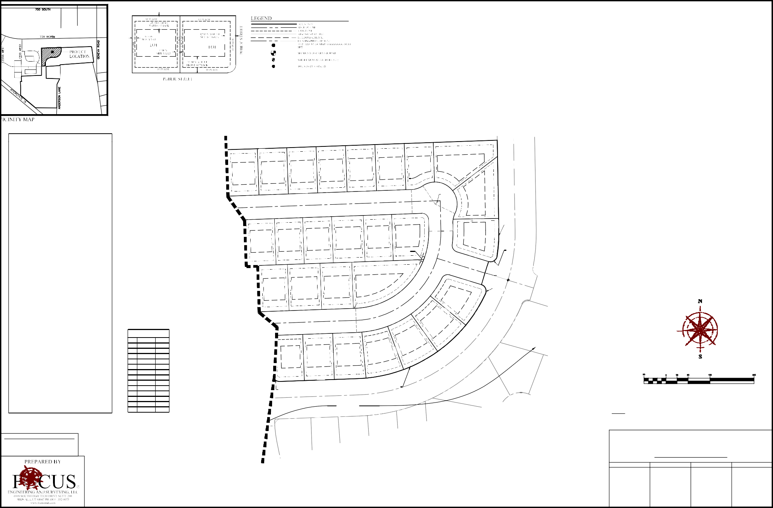

OCCUPANCY RESTRICTION NOTICE IT IS UNLAWFUL TO OCCUPY ANY BUILDING LOCATED WITHIN THIS SUBDIVISION WITHOUT FIRST HAVING OBTAINED A CERTIFICATE OF OCCUPANCY ISSUED BY THE CITY.
L13
N87°56'18"E
72.00
DEVELOPMENT
NOTES
- PUBLIC UTILITY EASEMENTS ARE 10' UNLESS NOTED OTHERWISE.
- #5 REBAR & CAP TO BE SET AT ALL REAR LOT CORNERS.
- NAIL TO BE SET IN TOP OF CURB AT PROJECTION OF SIDE LOT LINES.

PHASE "A"

ANDERSON FARMS
SUBDIVISION
LINDON CITY, UTAH COUNTY, UTAH SCALE: 1"=50'
SURVEYOR'S SEAL NOTARY PUBLIC SEAL CITY-COUNTY ENGINEER SEAL COUNTY RECORDER SEAL

SURVEYOR'S CERTIFICATE
I, SPENCER W. LLEWELYN, DO HEREBY CERTIFY THAT I AM A PROFESSIONAL LAND SURVEYOR, AND THAT I HOLD CERTIFICATE NO. 10516507 IN ACCORDANCE WITH TITLE 58, CHAPTER 22, OF UTAH STATE CODE. I FURTHER CERTIFY BY AUTHORITY OF THE OWNER(S), THAT I HAVE COMPLETED A SURVEY OF THE PROPERTY DESCRIBED ON THIS PLAT IN ACCORDANCE WITH SECTION 17-23-17 OF SAID CODE, AND HAVE SUBDIVIDED SAID TRACT OF LAND INTO LOTS, BLOCKS, STREETS, AND EASEMENTS, AND THE SAME HAS, OR WILL BE, CORRECTLY SURVEYED, STAKED, AND THE MONUMENTED ON THE GROUND AS SHOWN ON THIS PLAT, AND THAT THIS PLAT IS TRUE AND CORRECT.

SPENCER W. LLEWELYN DATE
PROFESSIONAL LAND SURVEYOR CERTIFICATE NO. 10516507

Curve Table
CURVE | RADIUS | DELTA | LENGTH | CHORD DIRECTION | CHORD LENGTH
C1 | 295.00 | 88°27'03" | 455.41 | N43°42'47"E | 411.51
C2 | 369.00 | 70°53'57" | 456.61 | N52°29'19"E | 428.03
C4 | 369.00 | 18°01'01" | 116.03 | S08°00'52"W | 115.56
C5 | 369.00 | 70°54'55" | 456.71 | N52°28'50"E | 428.11
C6 | 369.00 | 18°01'59" | 116.14 | S08°01'21"W | 115.66

GRAPHIC SCALE

( IN FEET )
1 inch = 50 ft.

MATCHLINE SEE SHEET C2.1
BOUNDARY DESCRIPTION
A portion of the SW1/4 of Section 29 and the NW1/4 of Section 32, Township 5 South, Range 2 East, Salt Lake Base & Meridian, located in Lindon, Utah, more particularly described as follows:
Beginning at a point on the Northerly line of Plat “B”, ANDERSON FARMS SUBDIVISION, according to the Official Plat thereof recorded August 24, 2018 as Entry No. 81023:2018 in the Office of the Utah County Recorder, located S00°11'45"E along the Section line 566.37 feet and East 725.54 feet from the Northwest Corner of Section 32, T5S, SLB&M; thence N00°30'46"W 107.37 feet; thence along the arc of a curve to the right having a radius of 332.00 feet a distance of 478.79 feet through a central angle of 82°37'43" Chord: N40°48'07"E 438.37 feet to a point of reverse curvature; thence along the arc of a curve to the left having a radius of
15.00 feet a distance of 22.04 feet through a central angle of 84°10'40" Chord: N40°01'38"E 20.11 feet; thence N86°04'27"E 55.03 feet; thence Southeasterly along the arc of a non-tangent curve to the left having a radius of 15.00 feet (radius bears: N87°56'18"E) a distance of 23.56 feet through a central angle of 90°00'00" Chord: S47°03'42"E 21.21 feet; thence N87°56'18"E 177.11 feet; thence along the arc of a curve to the left with a radius of 332.00 feet a distance of 366.27 feet through a central angle of 63°12'38" Chord: N56°19'59"E 347.98 feet to a point of compound curvature; thence along the arc of a curve to the left with a radius of 15.00 feet a distance of 25.56 feet through a central angle of 97°38'42" Chord: N24°05'41"W 22.58 feet; thence N16°59'25"E 55.00 feet; thence Northeasterly along the arc of a non-tangent curve to the left having a radius of 15.00 feet (radius bears: N17°04'58"E) a distance of

25.59 feet through a central angle of 97°45'53" Chord: N58°12'02"E 22.60 feet to a point of compound curvature; thence along the arc of a curve to the left with a radius of 332.00 feet a distance of 59.75 feet through a central angle of 10°18'44" Chord: N04°09'43"E
59.67 feet; thence N00°59'39"W 658.06 feet; thence Northwesterly along the arc of a non-tangent curve to the left having a radius of
19.00 feet (radius bears: S75°49'57"W) a distance of 12.96 feet through a central angle of 39°05'46" Chord: N33°42'57"W 12.71 feet; thence N28°09'30"E 11.08 feet; thence Westerly along the arc of a non-tangent curve to the left having a radius of 30.00 feet (radius bears: S33°34'44"W) a distance of 17.99 feet through a central angle of 34°22'03" Chord: N73°36'18"W 17.73 feet; thence S89°12'41"W 125.64 feet; thence S88°37'49"W 78.46 feet; thence S89°05'29"W 53.27 feet; thence N82°49'58"W 39.03 feet to the Southerly line of 700 North Street as defined by that Warranty Deed recorded as Entry No. 64718:2005 of the Official Records of Utah County; thence N88°54'21"E along said street 399.40 feet; thence S00°59'39"E 689.98 feet; thence along the arc of a curve to the right with a radius of 417.00 feet a distance of 88.70 feet through a central angle of 12°11'14" Chord: S05°05'59"W 88.53 feet to a point of reverse curvature; thence along the arc of a curve to the left having a radius of 15.00 feet a distance of 22.02 feet through a central angle of 84°06'38" Chord: S30°51'43"E 20.10 feet; thence S17°00'59"W 58.00 feet; thence Southwesterly along the arc of a non-tangent curve to the left having a radius of 15.00 feet (radius bears: S17°04'58"W) a distance of 22.04 feet through a central angle of 84°11'53" Chord: S64°59'02"W 20.11 feet to a point of reverse curvature; thence along the arc of a curve to the right having a radius of 417.00 feet a distance of 473.46 feet through a central angle of 65°03'12" Chord: S55°24'42"W 448.44 feet; thence S87°56'18"W
  - feet; thence along the arc of a curve to the left with a radius of 15.00 feet a distance of 23.56 feet through a central angle of 90°00'00" Chord: S42°56'18"W 21.21 feet; thence S85°08'33"W 55.07 feet; thence Northwesterly along the arc of a non-tangent curve to the left having a radius of 15.00 feet (radius bears: S87°56'18"W) a distance of 25.85 feet through a central angle of 98°43'37" Chord: N51°25'30"W 22.77 feet to a point of compound curvature; thence along the arc of a curve to the left with a radius of 247.00 feet a distance of 343.69 feet through a central angle of 79°43'26" Chord: S39°20'58"W 316.62 feet; thence S00°30'45"E 111.38 feet; thence S89°29'15"W 22.50 feet to a point on the Easterly line of said Plat “B”, ANDERSON FARMS SUBDIVISION; thence N00°30'45"W along said plat 4.01 feet; thence S89°29'15"W along said plat 62.50 feet to the point of beginning.
Contains: 4.13 acres+/-

OWNER'S DEDICATION

Line Table

30 29
WEST 1/4 CORNER OF SECTION 29, T5S, R2E, SLB&M
BASIS OF BEARING: N0°10'09"W (SECTION LINE) 2,664.04
(NAD 27)
1955 UTAH COUNTY MONUMENT

ANDERSON BLVD.
ROADWAY DEDICTATION
DO HEREBY DEDICATE FOR PERPETUAL USE OF THE PUBLIC ALL ROADS AND OTHER AREAS SHOWN ON THIS PLAT AS INTENDED FOR PUBLIC USE. THE UNDERSIGNED OWNER(S) ALSO HEREBY CONVEY TO ANY AND ALL PUBLIC UTILITY COMPANIES A PERPETUAL, NON-EXCLUSIVE EASEMENT OVER THE PUBLIC UTILITY EASEMENTS SHOWN ON THIS PLAT, THE SAME TO BE USED FOR THE INSTALLATION, MAINTENANCE, AND OPERATION OF UTILITY LINES AND FACILITIES.

IN WITNESS WHEREOF
LINE | DIRECTION | LENGTH
L1 | N72°58'37"W | 54.86
L2 | S72°57'39"E | 60.75
L3 | S02°03'42"E | 51.11
L4 | N02°03'42"W | 64.34

A.D. 20
HAVE HEREUNTO SET
HAND THIS
DAY OF

30 29
CHRISTOPHER P. GAMVROULAS PRESIDENT, IVORY DEVELOPMENT LLC
RON K. ANDERSON
PRESIDENT, BOYD ANDERSON AND SONS, INC.

31 32
NORTHWEST CORNER OF SECTION 32, T5S, R2E, SLB&M 1955 UTAH COUNTY MONUMENT

STATE OF UTAH S.S.
COUNTY OF
LIMITED LIABILITY ACKNOWLEDGMENT

ON THE

DAY OF

A.D. 20

PERSONALLY APPEARED BEFORE ME, THE

UNDERSIGNED NOTARY PUBLIC, IN AN FOR THE COUNTY OF SALT LAKE, IN SAID STATE OF UTAH, CHRISTOPHER P. GAMVROULAS, WHO AFTER BEING DULY SWORN, ACKNOWLEDGED TO ME THAT HE IS THE PRESIDENT OF IVORY DEVELOPMENT LLC, A UTAH LLC AND THAT HE SIGNED THE OWNERS DEDICATION FREELY AND VOLUNTARILY FOR AND IN BEHALF OF SAID LIMITED LIABILITY COMPANY FOR THE PURPOSES THEREIN MENTIONED.

MY COMMISSION EXPIRES:
A NOTARY PUBLIC COMMISSIONED IN UTAH

NOTES
    - #5 X 24" REBAR & CAP (FOCUS ENG) TO BE SET

MY COMMISSION No.
RESIDING IN
COUNTY

AT ALL LOT CORNERS. NAILS OR PLUGS TO BE SET IN TOP BACK OF CURB AT EXTENSION OF SIDE LOT LINES, IN LIEU OF REBAR AND CAPS AT FRONT LOT CORNERS.
566.37' S0°11'45"E
PRINTED FULL NAME OF NOTARY

ACCEPTANCE BY LEGISLATIVE BODY
THE CITY COUNCIL OF LINDON CITY, COUNTY OF UTAH, APPROVES THIS SUBDIVISION AND HEREBY ACCEPTS THE DEDICATION OF ALL STREETS, EASEMENTS, AND OTHER PARCELS OF LAND INTENDED

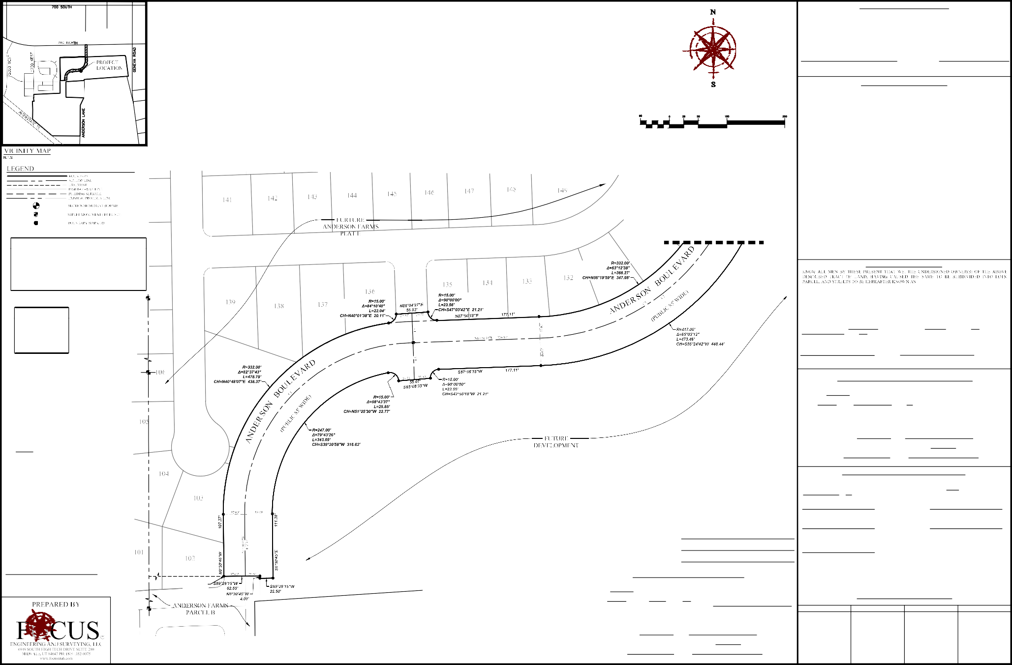
FOR PUBLIC PURPOSES FOR THE PERPETUAL USE OF THE PUBLIC THIS DAY OF
, 20 .

APPROVED BY MAYOR APPROVED BY CITY ATTORNEY
S0°11'45"E (SECTION LINE) MEASURED: 2,662.64

EAST 725.54'
OCCUPANCY RESTRICTION NOTICE IT IS UNLAWFUL TO OCCUPY ANY BUILDING LOCATED WITHIN THIS SUBDIVISION WITHOUT FIRST HAVING OBTAINED A CERTIFICATE OF OCCUPANCY ISSUED BY THE CITY.
 | CONDITIONS OF APPROVAL
 |  | APPROVED BY CITY ENGINEER ATTEST BY CITY RECORDER (SEE SEAL BELOW) (SEE SEAL BELOW)
 |  | PLANNING DIRECTOR
ANDERSON BLVD
ANDERSON FARMS
ROADWAY DEDICATION
CORPORATE ACKNOWLEDGMENT  STATE OF UTAH S.S.  COUNTY OF |  | ANDERSON BLVD  ANDERSON FARMS  ROADWAY DEDICATION
ON THE DAY OF A.D. 20 PERSONALLY APPEARED BEFORE ME , THE UNDERSIGNED NOTARY PUBLIC, IN AND FOR THE COUNTY OF , IN SAID STATE OF UTAH, RON K. ANDERSON, WHO AFTER BEING DULY SWORN, ACKNOWLEDGED TO ME THAT HE IS THE PRESIDENT OF BOYD ANDERSON AND SONS, INC. A UTAH INC. AND THAT HE SIGNED THE OWNERS DEDICATION FREELY AND VOLUNTARILY FOR AND IN BEHALF OF SAID COMPANY FOR THE PURPOSES THEREIN MENTIONED. |  | LINDON CITY, UTAH COUNTY, UTAH SCALE: 1"=50'  SURVEYOR'S SEAL NOTARY PUBLIC SEAL CITY-COUNTY ENGINEER SEAL COUNTY RECORDER SEAL
MY COMMISSION EXPIRES:
A NOTARY PUBLIC COMMISSIONED IN UTAH RESIDING IN COUNTY
MY COMMISSION No.
PRINTED FULL NAME OF NOTARY

POINT OF
BEGINNING

31 32

WEST 1/4 CORNER OF SECTION 32, T5S, R2E, SLB&M
1960 UTAH COUNTY MONUMENT

Curve Table

CURVE | RADIUS | DELTA | LENGTH | CHORD DIRECTION | CHORD LENGTH
C1 | 295.00 | 88°27'03" | 455.41 | N43°42'47"E | 411.51
C2 | 369.00 | 70°53'57" | 456.61 | N52°29'19"E | 428.03
C4 | 369.00 | 18°01'01" | 116.03 | S08°00'52"W | 115.56
C5 | 369.00 | 70°54'55" | 456.71 | N52°28'50"E | 428.11
C6 | 369.00 | 18°01'59" | 116.14 | S08°01'21"W | 115.66

Line Table

LINE | DIRECTION | LENGTH
L1 | N72°58'37"W | 54.86
L2 | S72°57'39"E | 60.75
L3 | S02°03'42"E | 51.11
L4 | N02°03'42"W | 64.34

NOTES
1. #5 X 24" REBAR & CAP (FOCUS ENG) TO BE SET AT ALL LOT CORNERS. NAILS OR PLUGS TO BE SET IN TOP BACK OF CURB AT EXTENSION OF SIDE LOT LINES, IN LIEU OF REBAR AND CAPS AT FRONT LOT CORNERS.

GRAPHIC SCALE

( IN FEET )
1 inch = 50 ft.

OCCUPANCY RESTRICTION NOTICE IT IS UNLAWFUL TO OCCUPY ANY BUILDING LOCATED WITHIN THIS SUBDIVISION WITHOUT FIRST HAVING OBTAINED A CERTIFICATE OF OCCUPANCY ISSUED BY THE CITY.

SURVEYOR'S SEAL
ANDERSON BLVD

ANDERSON FARMS
ROADWAY DEDICATION
LINDON CITY, UTAH COUNTY, UTAH SCALE: 1"=50'
CITY-COUNTY ENGINEER SEAL
NOTARY PUBLIC SEAL
COUNTY RECORDER SEAL

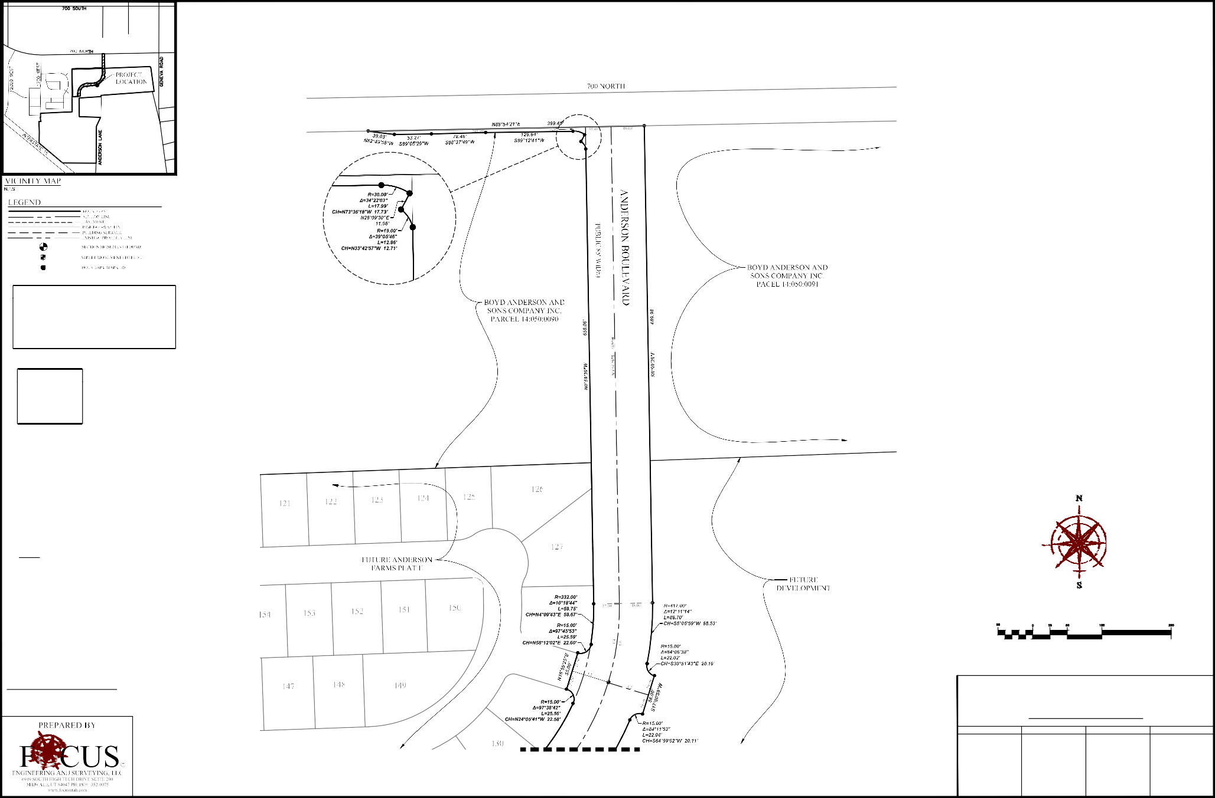

MATCHLINE SEE SHEET C2.1

- A Utah Corporation -

3 302 N. Main Street Spanish Fork, UT 84660 Phone: 801.798.0555
F a x : 8 0 1 . 7 9 8 . 9 3 9 3
o f f i c e @ l e i - e n g . c o m w w w . l e i - e n g . c o m

DETACHED SINGLE FAMILY
Parcel A
COMMERCIAL

ATTACHED SINGLE FAMILY

MULTI FAMILY
Parcel I

DETACHED SINGLE FAMILY
Parcel G
DETACHED SINGLE FAMILY
Parcel H
EXHIBIT B - PROPERTY CONCEPT PLAN

500 NORTH
ANDERSON FARMS
LINDON, UTAH

THORNE PARCEL
WEST
±11.91 AC
(NOT A PART)

DETACHED SINGLE FAMILY
1700
Parcel B

ATTACHED
SINGLE FAMILY
ANDERSON

Parcel C
LANE
ACTIVE
ADULTS COMMUNITY
Parcel F

REVISIONS
1 -

- -
2 -

REGIONAL PARK OPEN SPACE
DETACHED
SINGLE FAMILY
Parcel E
TEMPORARY AGRICULTURAL ACCESS

- - 3 -
LEGEND
PARCEL | AREA | LOTS/UNITS | DENSITY | PHASE
PARCEL "A" | 18.363  16.790  0.627  0.946
PARCEL "A" | 18.363  16.790  0.627  0.946
LOT AREA  PARCEL "A" | 18.363  16.790  0.627  0.946 | 60 | 3.27 | 3
STORAGE | 18.363  16.790  0.627  0.946
PARCEL "A" | 18.363  16.790  0.627  0.946
ACCESS ROAD | 18.363  16.790  0.627  0.946
PARCEL "B" | 22.180 | 78 | 3.52 | 1
PARCEL "C" | 12.634 | 125 | 9.89 | 1
REGIONAL PARK "D" | 10.020 | 0 | 0 | ALL
PARCEL "E" | 17.072 | 55 | 3.22 | 2
PARCEL "F" | 12.997 | 69 | 5.31 | 2
PARCEL "G" | 10.141 | 34 | 3.35 | 3
PARCEL "G1" | 0.918 | 8 | 8.71 | 3
PARCEL "H" | 5.618 | 22 | 3.92 | 4
PARCEL "H1" | 3.964 | 34 | 8.58 | 4
PARCEL "I" | 14.492  13.888 0.604
PARCEL "I"  LOT AREA | 14.492  13.888 0.604 | 380 | 26.22 | 4
PARCEL "I" | 14.492  13.888 0.604
ACCESS ROAD | 14.492  13.888 0.604
COMMERCIAL | 8.272 | 0 | 0
TOTAL | ±136.671 | 865 | 6.33

- - 4 -

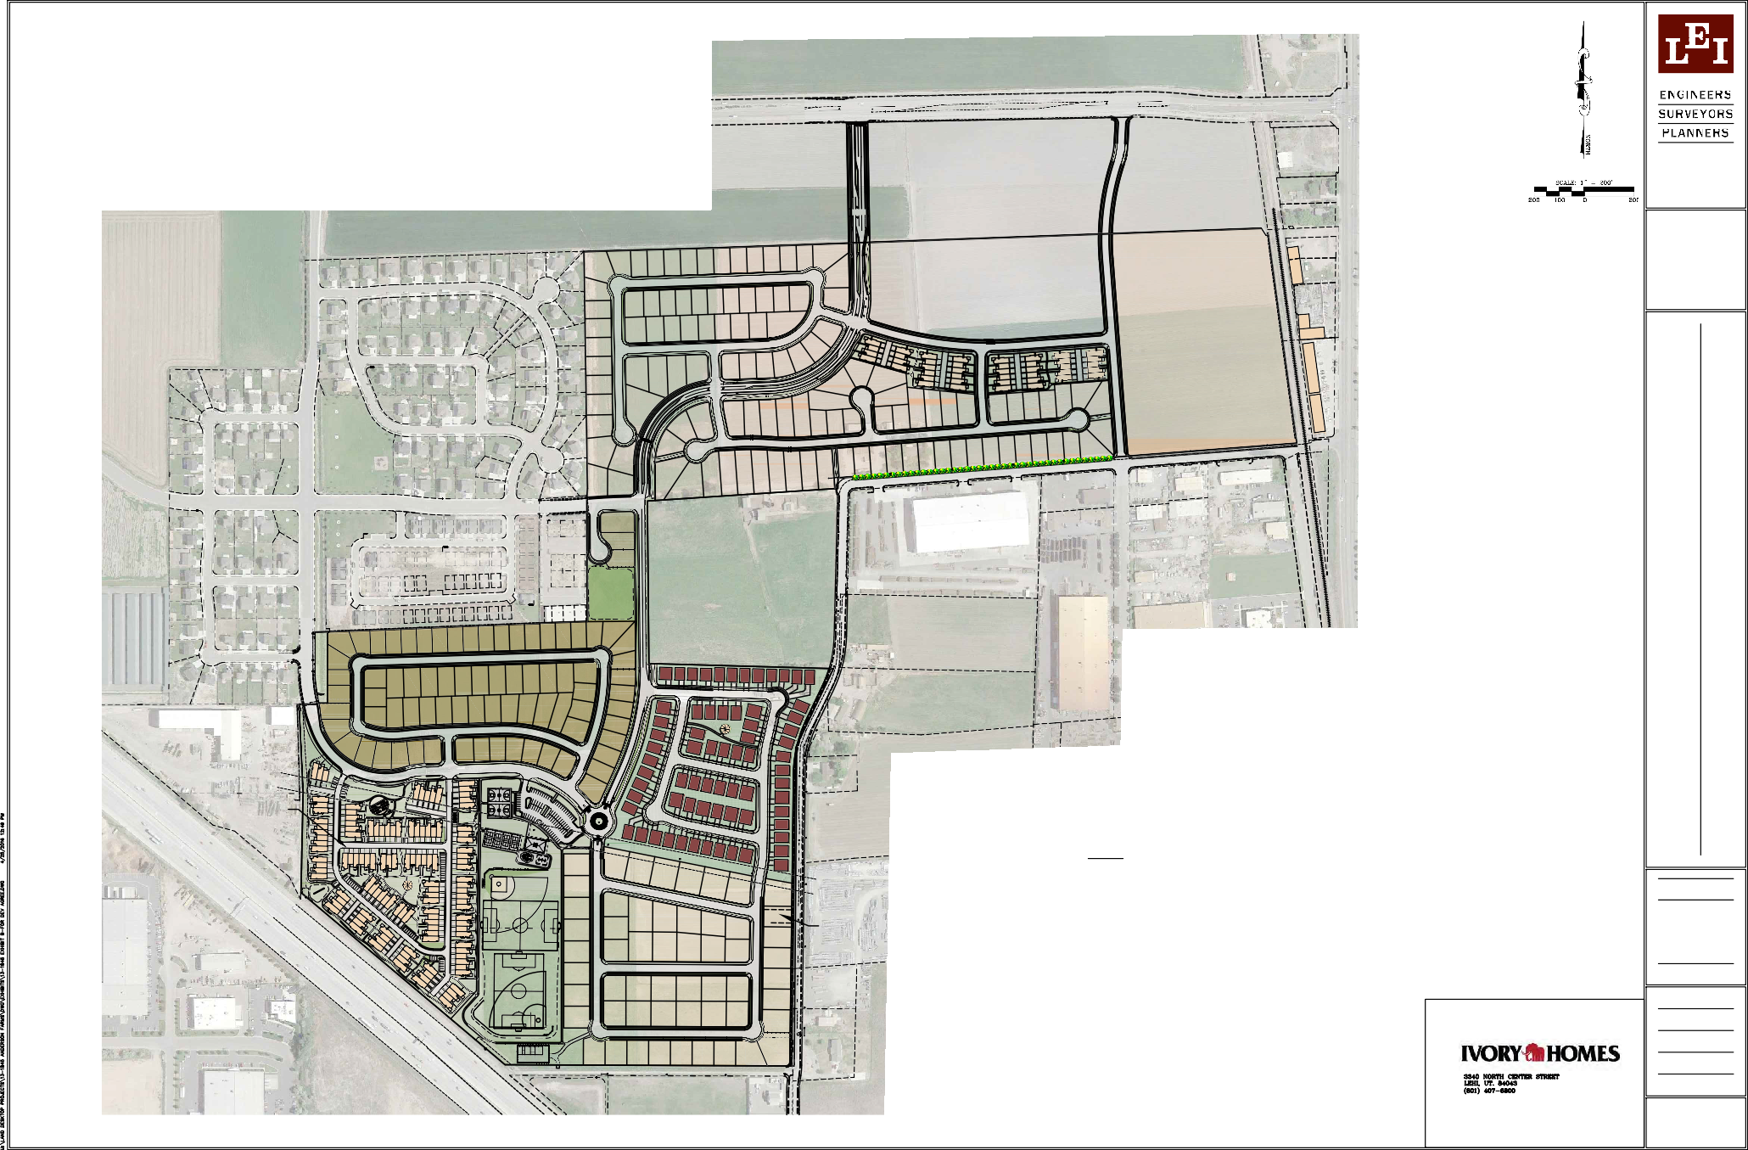
- -
5 -

- -
LEI PROJECT #:
2013-1845
DRAWN BY:
BLS
CHECKED BY:
GDM
SCALE:
1" = 200'
DATE:
5/2/2016
EXHIBIT

B

69

700 NORTH
- A Utah Corporation -

COMMERCIAL
3 302 N. Main Street Spanish Fork, UT 84660 Phone: 801.798.0555
F a x : 8 0 1 . 7 9 8 . 9 3 9 3
o f f i c e @ l e i - e n g . c o m w w w . l e i - e n g . c o m

MULTI FAMILY RESIDENTIAL

LEGEND
ANDERSON
LANE

EXHIBIT J-1, STREET CROSS SECTIONS
85' ROAD CROSS SECTION (NORTH ANDERSON BOULEVARD)
72' ROAD CROSS SECTION (SOUTH ANDERSON BOULEVARD)
53' ROAD CROSS SECTION (ANDERSON BLVD. AT THORNE PROPERTY)
58' ROAD CROSS SECTION (PARCEL I CONNECTION TO ANDERSON BLVD.)
64' ROAD CROSS SECTION (CONNECTION TO 1700 WEST)
66' ROAD CROSS SECTION (500 NORTH CONNECTION TO ANDERSON BLVD.)
55' ROAD CROSS SECTION (INTERIOR ROADS)

REVISIONS
1 -

- -
2 -

- -
3 -

28' ROAD CROSS SECTION (TOWNHOMES)
54' ROAD CROSS SECTION (500 NORTH INDUSTRIAL AREA)
47.5' ROAD CROSS SECTION (ANDERSON LANE)
- - 4 -
- - 5 -

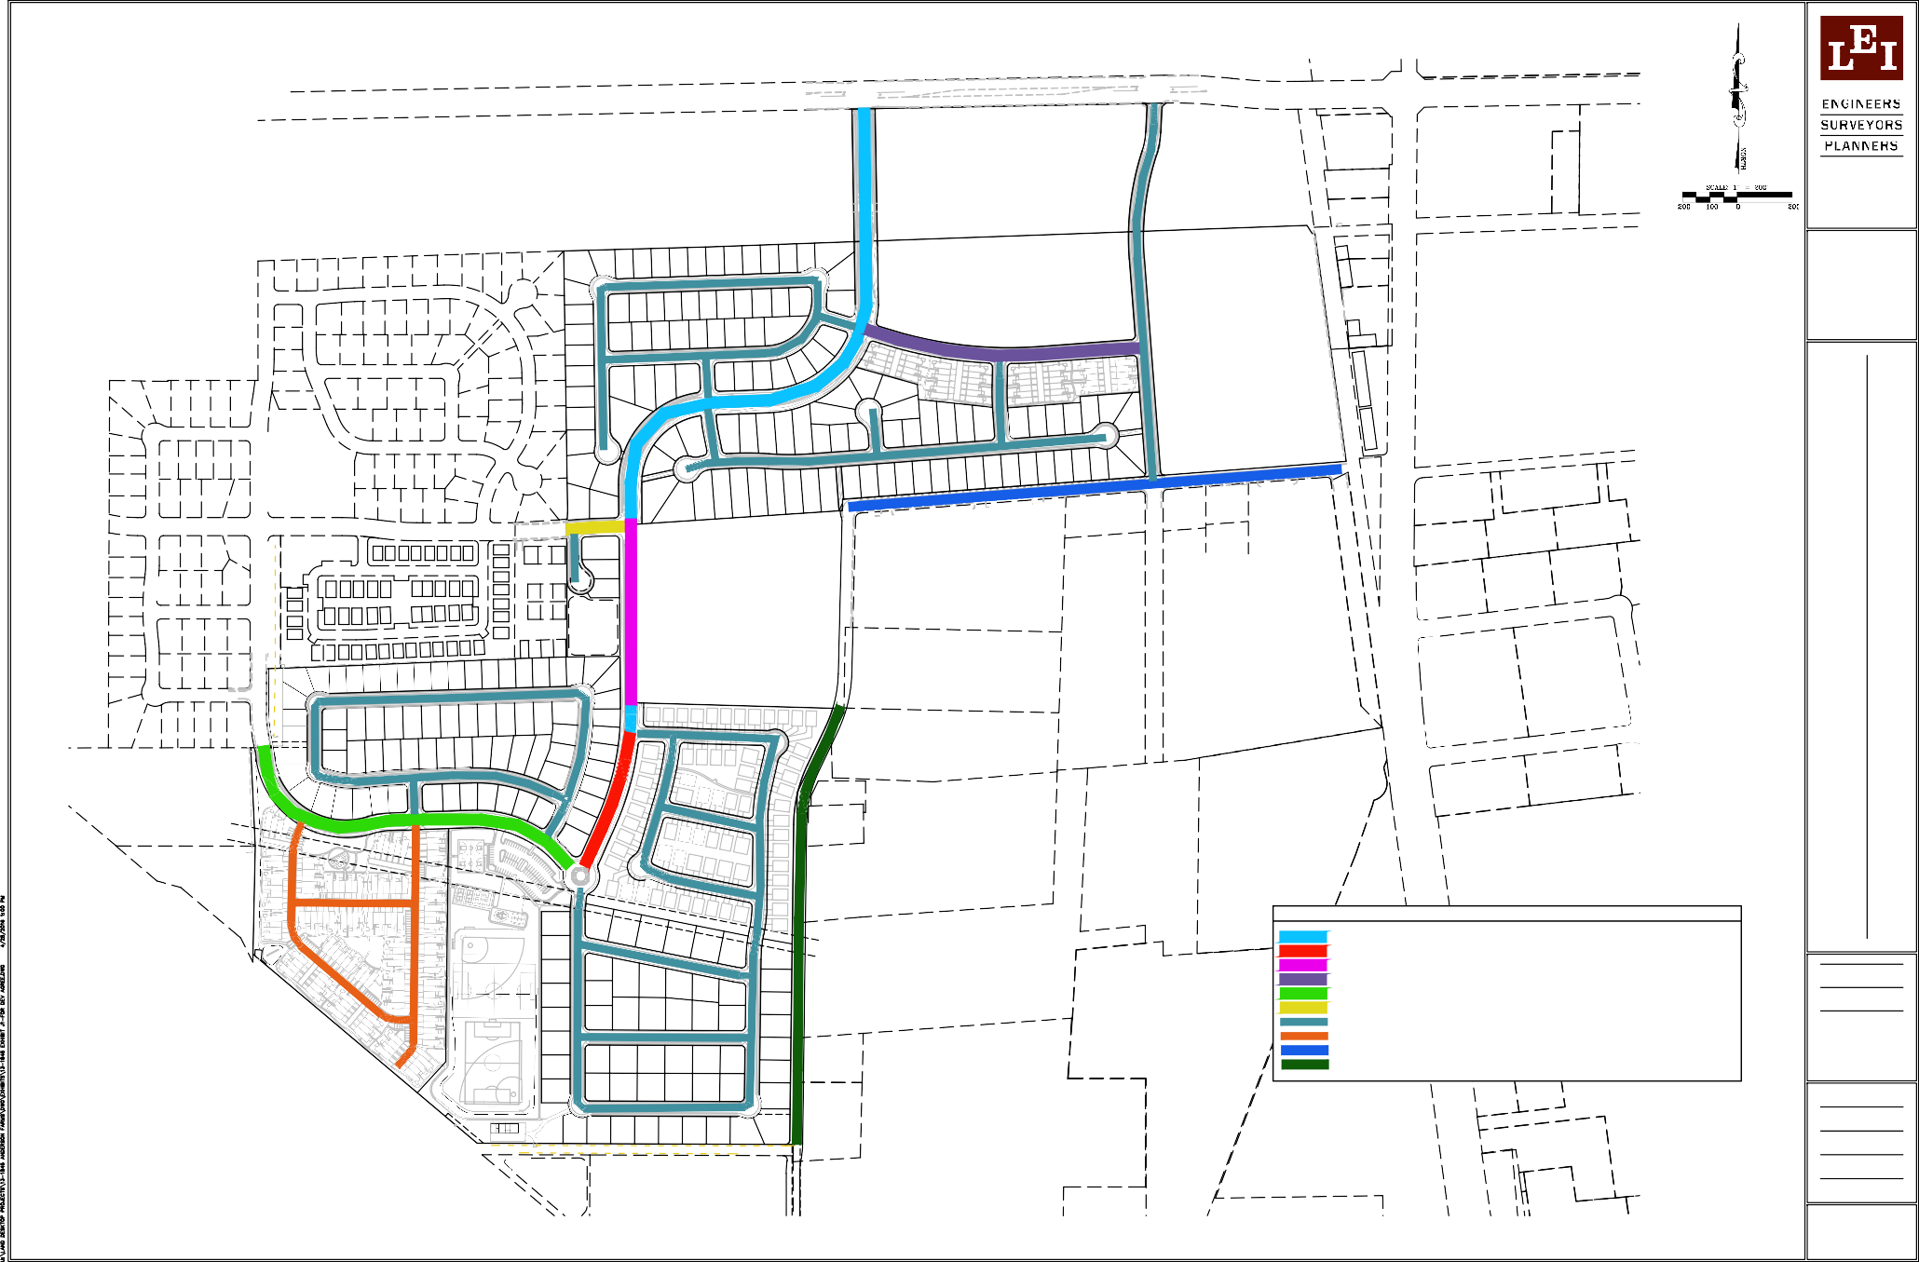
- -
500 NORTH
1700 WEST

ANDERSON FARMS
LINDON, UTAH
LEI PROJECT #:
2013-1845
DRAWN BY:
BLS
CHECKED BY:
GDM
SCALE:
1" = 200'
DATE:
5/2/2016
EXHIBIT

J-1

70

- A Utah Corporation -

3 302 N. Main Street Spanish Fork, UT 84660 Phone: 801.798.0555
F a x : 8 0 1 . 7 9 8 . 9 3 9 3
o f f i c e @ l e i - e n g . c o m w w w . l e i - e n g . c o m

72' ROAD CROSS SECTION SOUTH ANDERSON BOULEVARD
1
64' ROAD CROSS SECTION CONNECTION TO 1700 WEST
47.5' ROAD CROSS SECTION ANDERSON LANE

66' ROAD CROSS SECTION
IVORY HOMES
LINDON, UTAH
4
500 NORTH CONNECTION TO ANDERSON BOULEVARD
53' ROAD CROSS SECTION
ANDERSON BLVD AT THORNE PROPERTY
5
28' ROAD CROSS SECTION TOWNHOMES
58' ROAD CROSS SECTION
PARCEL I CONNECTION TO ANDERSON BLVD
EXHIBIT J-2, STREET CROSS SECTIONS
8

REVISIONS
1 -

- -
2 -

- -
3 -

- -
4 -

- -
5 -

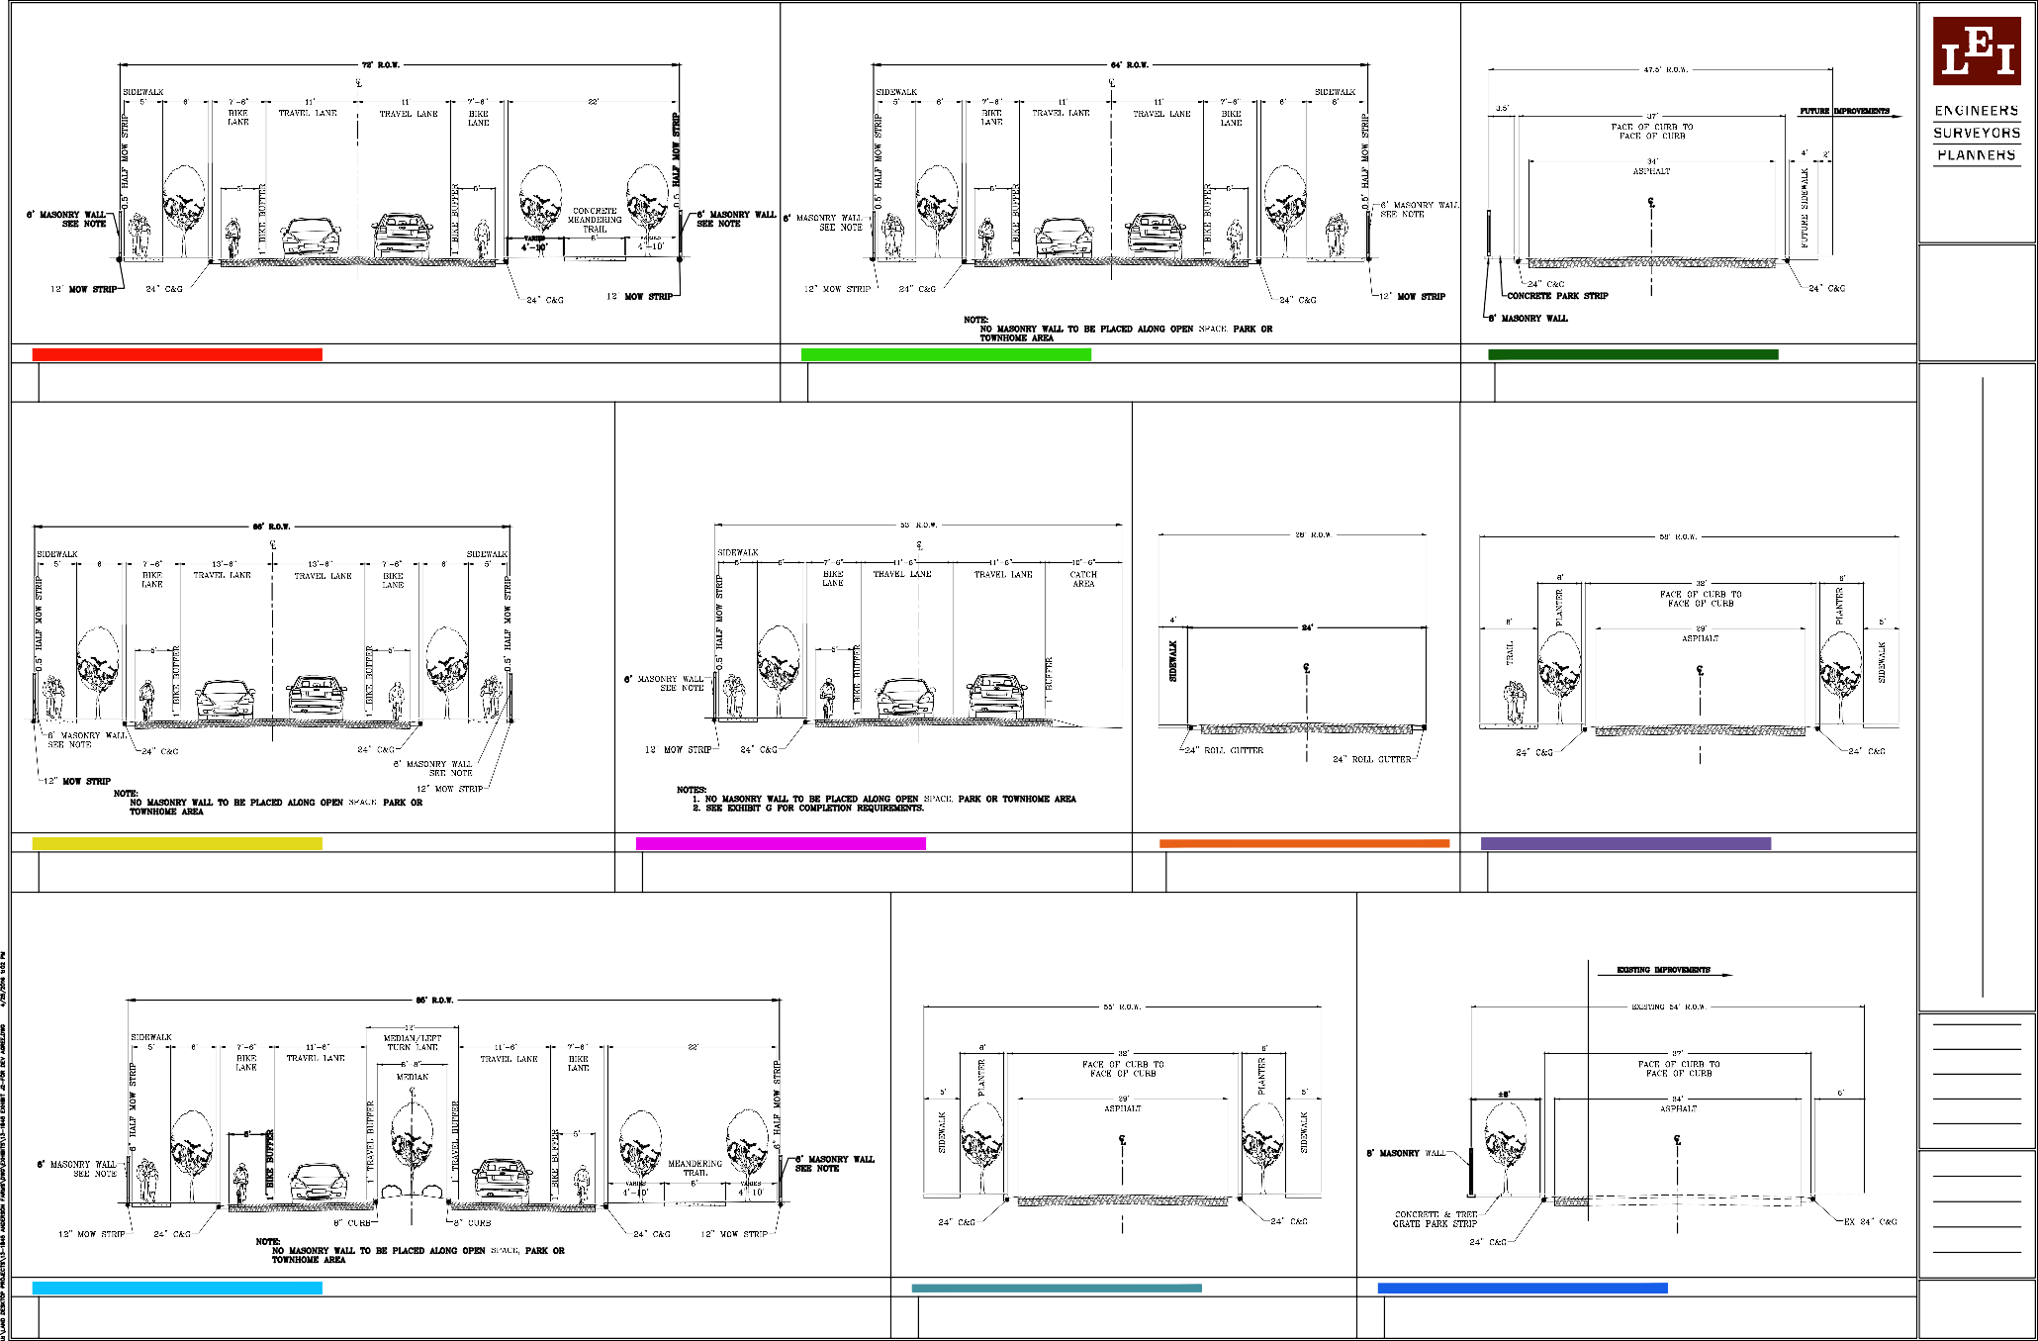
3
6
2

85' ROAD CROSS SECTION WITH MEDIAN NORTH ANDERSON BOULEVARD
7

55' ROAD CROSS SECTION INTERIOR ROADS
8

54' ROAD CROSS SECTION
500 NORTH INDUSTRIAL AREA
9

- -
LEI PROJECT #:
2013-1845
DRAWN BY:
BLS
CHECKED BY:
GDM
SCALE:
N.T.S.
DATE:
5/2/2016
EXHIBIT

J-2

- Public Hearing — Lindon City Water Conservation Plan; Resolution #2019-29-R. The
Mayor and City Council will hear for possible adoption, the Water Conservation Plan as required by the State to be updated and adopted every 5-years. The plan will be presented by City Engineer, Noah Gordon. (15 minutes)

See attached materials.

The following Water Conservation Plan is a requirement of the State that needs to be updated and adopted every five years. The plan in the Staff Report packet is a DRAFT that still has some updates that Noah Gordon, City Engineer, is completing this week. He will email you a final version of the plan as soon as he’s able before Tuesday.

At the meeting Noah will also provide an update on the secondary water metering reporting that will be sent to the State and inform you of another secondary water report that is annually submitted to Central Utah Water Conservancy District.

Sample Motion: I move to (approve, deny, continue) Resolution #2019-29-R adopting the Lindon City Water Conservation Plan (with changes as submitted by the City Engineer).

RESOLUTION NO. 2019-29-R

RESOLUTION APPROVING THE LINDON CITY WATER CONSERVATION PLAN FOR SUBMITTAL TO THE UTAH DIVISION OF WATER RESOURCES AS REQUIRED BY UTAH CODE 73-10-32, AND SETTING AN EFFECTIVE DATE.

WHEREAS, Utah Code 73-10-32 requires a Water Conservation Plan to be adopted by the City and revised every five years and re-submitted to the Division of Water Resources with the plan outlining specific water use reduction goals and conservation measures; and

WHEREAS, in 2005 Lindon City adopted Section 13.32 ‘Water Conservation Plan Ordinance’ into the Lindon City Code and adopted a Water Conservation Plan as required by the State; and

WHEREAS, Lindon City amended the Water Conservation Plan in 2014 (adopted in March 2015) as required by the State and said plan is required to be amended again in 2019; and

WHEREAS, a public hearing to accept comment on the plan was duly noticed and held on December 3, 2019; and

WHEREAS, the Municipal Council of Lindon City desires to adopt the amended 2019 Water Conservation Plan to ensure prudent use of its water resources for the wellbeing of its citizens.

NOW THEREFORE, BE IT RESOLVED by the City Council of Lindon City, Utah County, State of Utah, as follows:

Section 1: The 2019 Lindon City Water Conservation Plan is adopted as attached as ‘Exhibit A’; and
Section 2: This Resolution shall take effect immediately upon its passage by the Lindon City Council.

Passed and adopted by the Lindon City Council this 3rd day of December, 2019.

Jeff Acerson, Mayor
Attest:

Kathryn A. Moosman, City Recorder

SEAL

Lindon City Corporation WATER CONSERVATION PLAN



DRAFT

December 2019

Prepared by Lindon City Public Works

TABLE OF CONTENTS

INTRODUCTION 2
DESCRIPTION OF OUR CITY AND ITS WATER SYSTEMS 3
Inventory of Water Resources 4
Water Budgets 5
Present Water Use and Future Water Needs 6
WATER PROBLEMS, CONSERVATION MEASURES AND GOALS 9
Problems Identified 9
Water Conservation Goals 10
CURRENT CONSERVATION PRACTICES 10
POSSIBLE ADDITIONAL CONSERVATION MEASURES 15
COST ANALYSIS 16
IMPLEMENTING/UPDATING THE WATER CONSERVATION PLAN 17
APPENDIX A – Water Conservation Plan Ordinance 18
APPENDIX B – Alpine School District Water Conservation Plan 19

INTRODUCTION

Lindon City and its leaders have worked diligently, for many years, to insure adequate water for current and future residents, businesses, and institutions, and will continue to do so. The City owns and operates both a culinary water system and a pressure irrigation system. The culinary water system provides for all domestic water demands requiring a high quality of water and has limited use for outside watering in commercial and industrial areas. It also provides for fire protection. The pressure irrigation system provides for all other outside watering demands using raw water surface sources heretofore used for flood irrigation within the City. The culinary system has evolved over many years since the incorporation of Lindon in 1924. Construction of the pressure irrigation system occurred in 1992-93 and service began in late June of 1993.

Purpose

The purpose of this plan is to assess the water conservation alternatives available to Lindon City, to set reasonable and achievable goals to conserve water, and to identify the methods and measures which Lindon City will take to reach these goals. This plan includes detailed alternatives available to reduce the amount of water used by Lindon residents, businesses, and Lindon City Corporation.

The plan addresses future water needs and the City’s ability to meet these needs. Lindon City may choose the presented alternatives that best suit their interests, while attaining the predetermined goals. Once the conservation measures are implemented, the water system will be monitored to ensure that the methods are effective in promoting water conservation.

Plan Updates

Because we are in the second driest state in the nation, water conservation and the wise use of water has been a focal point on both a local and state level. The state legislature in 1998 passed the Utah Water Conservation Plan Act (House Bill 153), revised in the 1999 legislative session (Section 73-10-32 Utah Code Annotated) which was then revised again with the Water Conservation Plan Act of 2004 (House Bill 71, Section 73-10-32 Utah State Code Annotated). This water conservation plan addresses the concerns of leaders and citizens of both Lindon and the State of Utah and takes into consideration the revised Water Conservation Plan Act of 2004 and therefore will be readdressed again within five (5) years.

DESCRIPTION OF OUR CITY AND ITS WATER SYSTEMS

Lindon City is located in northern Utah County approximately 37 miles south of Salt Lake City. The city extends east to the Wasatch Mountains and west to Utah Lake. Lindon City is bounded on the north by Pleasant Grove City and on the South by Orem City and is 1 to 1-1/2 miles wide. The incorporated area of the city is 5,460 acres or approximately 8.5 square miles. In the past nearly 20 years Lindon has grown from a census population of 8,363 in 2000, to 10,070 in 2010, to an estimated current population of approximately 11,452 (2018). Meeting the future needs of a growing population remains an important concern.

Providing water to meet the needs of its citizens has always been a top priority of city leaders and planners. As a result, well maintained and operated culinary and pressure irrigation water systems provide the citizens of our City with water where and when needed. Growth in number of connections since 2009 is shown in Table 1.

Table 1

Potable Water System Connections
Year | Residential | Commercial | Industrial | Institutional | Total
2009 | 2,475 | 227 | 82 | 23 | 2,807
2010 | 2,641 | 266 | 88 | 25 | 3,020
2011 | 2,550 | 235 | 80 | 25 | 2,890
2012 | 2,512 | 222 | 73 | 24 | 2,831
2013 | 2,589 | 181 | 85 | 23 | 2,878
2014 | 2,714 | 184 | 112 | 29 | 3,039
2015 | 2,774 | 185 | 123 | 23 | 3,105
2016 | 2,792 | 179 | 123 | 23 | 3,117
2017 | 2,866 | 197 | 175 | 28 | 3,266
2018 | 2,866 | 205 | 178 | 25 | 3,274

Open space and preservation of a “Little Bit Of Country” is of high value to our leaders and citizens. Consequently, open space preservation has been a high priority. There are numerous existing and planned parks and other open space, as well as the City cemetery. There are also multiple public and charter schools, including a junior high school with their accompanying athletic fields, playgrounds, and other landscaped areas. Alpine School District operates and maintains the public schools in our city; their water conservation plan is included in the appendix.

Lindon City's potable water sources are Dry Canyon springs, east of the city and four deep wells located between State Street and 400 East and Center Street and 700 North. Lindon City installed a pressure irrigation system to accommodate the growing need for outside watering and to preserve the use of surface waters historically used to flood irrigate land that is being developed. The water supply for the pressure irrigation system comes primarily from the Provo River delivered through the Provo Bench Canal Company/North Union Irrigation Company canal and through the Alpine Aqueduct. This water is available because of the shares owned by Lindon City in the various irrigation/canal companies and in the Deer Creek project. The City also has 924 acre-feet of Contract Water from the Jordanelle Project of the Central Utah Project. This lesser quality surface water, that does not require treatment, conserves the higher quality water for the culinary water system.

Inventory of Water Resources

Lindon City supplied 1,392 acre-feet of water to their culinary water system in calendar year 2015; 1,824 acre-feet in 2016; 1,832 acre-feet in 2017; and 1,763 acre-feet in 2018. Wells will supply potable water for future growth. We presently have developed well capacity that will supply up to 6,215 acre-feet, 3.15 times the maximum yearly volume of potable water supplied between 2003 and 2018 (1973.21 acre-feet; see Table 4). Table 2 shows the City-Owned Culinary Water Rights.

Table 2

City-Owned Water Rights
Source Name/No. | Water Right # | CFS | Total CFS | Present Yield, AF
DRY CANYON SPRINGS | 55-6908 | 1.34 | 1.34 | 592.45
WELL NO. 1 | 55-416 | 1.1 | 1.1 | 806.559
WELL NO. 2 | 55-742 | 0.71 | 0.71 | 493.614
WELL NO. 3 | 55-4478 | 4.61 | 4.61 | 1,419.54
WELL NO. 4 | 55-4107 | 6.68 | 6.68 | 2,903.61
WELL | 55-2298 | 2.23 | 2.23 | 0
WELL | 55-2527 | 0.75 | 0.75 | 0
ALL WELLS | 55-1670 | 0.67 | 0.67 | 135.97
ALL WELLS | 55-1039 | 0.16 | 0.16 | 30.8
ALL WELLS | 55-1040 | 0.52 | 0.52 | 77.72
ALL WELLS | 55-9400 |  |  | 14
ALL WELLS | 55-7873 & 2520 |  |  | 90.38
ALL WELLS | 55-12048 |  |  | 5.6
ALL WELLS | 55-12066 |  |  | 12.92
ALL WELLS | 55-3206 |  |  | 50.4
ALL WELLS | 55-8998 |  |  | 30
ALL WELLS | 55-286 |  |  | 92.092
ALL WELLS | 55-3533 |  |  | 9.57
ALL WELLS | 55-3534 |  |  | 2.57
ALL WELLS | 55-12164 |  |  | 21.11
ALL WELLS | 55-12052 |  |  | 1
TOTAL |  |  |  | 6,789.91

Under current water rights, the City is entitled to withdraw more than 13,165 acre-feet annually from the wells shown in Table 2. We have rights that would yield about twice the present developed capacity. We anticipate that the amount of water needed for future growth will be well within the safe yield for the aquifer supplying the wells. The City no longer seeks nor accepts underground rights (with rare exceptions).

We require that new development turn in water shares from the various irrigation companies that have historically supplied water to land in Lindon. Diversion of this water historically is from streams, springs, shallow wells (artesian) and subsurface drains.

The City owns shares of stock in several local irrigation/canal companies and/or raw water providers. Water provided under these shares is, and will continue to be, used for irrigation of lawns, gardens, school athletic fields, playgrounds and other landscaped areas, church landscaped and recreation areas, city- owned parks, and other open spaces. Table 3 shows the City-owned shares listed by company.

Table 3
Water Budgets
Table 4 shows the amount of water delivered into the culinary water system and the
metered outflows to end-users for the years 2003 to 2018. The numbers shown for years between 2003 and 2009 are for the fiscal year, while the 2010 through 2018 numbers are for the calendar year.
Table 4

City-Owned Stock in Local Irrigation Companies
Irrigation Company | Shares | Acre-Feet
North Union Irrigation Company | 633.93 | 5,735.83
Provo Bench Canal | 92.18 | 1,559.06
Provo Reservoir Water Users
Orem District | 29.23 | 195.93
Alpine District | 69.99 | 469.11
Central Utah Project | 925.00 | 925.00
Provo River Water Users | 200.00 | 200.00
Hollow Water Users
Whole Stream | 301.48 | 865.25
Half Stream | 31.11 | 89.29
Cobbley Ditch Company | 212.30 | 390.63
Spring Ditch & South Field Irrigation Company | 32.05

 | Culinary Water Budget
 | Year | INFLOW (acre-feet) |  |  | METERED SALES (acre-feet)
 | Year | Wells | Springs | Total | Residential | Commercial | Industrial | Institutional | Total | %Diff.
Fiscal | 2003 | 1,310.5 | 75.2 | 1,385.7 | 672.4 | 187.2 | 189.7 | 17.1 | 1,066.3 | 23.1%
Fiscal | 2004 | 1,570.5 | 68.3 | 1,638.8 | 633.6 | 184.5 | 170.8 | 16.1 | 1,005.0 | 38.7%
Fiscal | 2005 | 1,271.4 | 122.8 | 1,394.2 | 682.0 | 199.2 | 192.7 | 17.3 | 1,091.1 | 21.7%
Fiscal | 2006 | 1,351.7 | 351.3 | 1,703.1 | 697.6 | 296.2 | 166.6 | 18.4 | 1,178.8 | 30.8%
Fiscal | 2007 | 1,510.2 | 274.7 | 1,784.9 | 861.3 | 296.1 | 201.3 | 22.7 | 1,381.4 | 22.6%
Fiscal | 2008 | 1,702.6 | 133.9 | 1,836.4 | 839.9 | 242.1 | 177.8 | 17.7 | 1,277.5 | 30.4%
Fiscal | 2009 | 1,834.6 | 115.8 | 1,950.4 | 821.7 | 394.0 | 152.6 | 25.7 | 1,394.1 | 33.9%
Calendar | 2010 | 1,479.2 | 138.9 | 1,618.1 | 728.5 | 266.3 | 126.0 | 18.9 | 1,139.7 | 42.0%
Calendar | 2011 | 1,686.5 | 286.7 | 1,973.2 | 756.3 | 376.6 | 128.0 | 18.1 | 1,278.9 | 54.3%
Calendar | 2012 | 1,636.9 | 200.9 | 1,837.7 | 825.6 | 261.1 | 152.4 | 14.0 | 1,253.2 | 46.6%
Calendar | 2013 | 1,665.1 | 112.6 | 1,777.7 | 852.4 | 253.0 | 149.1 | 17.6 | 1,272.2 | 39.7%
Calendar | 2014 | 1,529.8 | 71.0 | 1,600.8 | 744.7 | 173.2 | 112.0 | 17.1 | 1,047.0 | 52.9%
Calendar | 2015 | 1,338.5 | 54.0 | 1,392.5 | 745.2 | 180.9 | 125.7 | 12.9 | 1,064.7 | 30.8%
Calendar | 2016 | 1,780.5 | 43.8 | 1,824.3 | 750.0 | 180.9 | 133.5 | 14.6 | 1,078.9 | 69.1%
Calendar | 2017 | 1,778.4 | 53.1 | 1,831.5 | 972.9 | 320.4 | 245.8 | 11.8 | 1,550.9 | 18.1%
Calendar | 2018 | 1,717.2 | 45.7 | 1,762.9 | 764.2 | 308.5 | 284.7 | 11.5 | 1,369.0 | 28.8%

The pressure irrigation water supply is metered from each of the water sources delivering water to the system. The services have no meters and so no comparison for a water budget can be made. Table 5 shows the amount of water delivered to the pressure irrigation system for the years 1999 through 2018.

Table 5

Pressure Irrigation Source
Year | From North Union Canal |  | Salt Lake Aqueduct  (acre-ft) | Alpine 3 (acre-ft) | North Union Pump Station  (acre-ft) | Total (acre-ft)
Year | Gravity  (acre-ft) | Pumped  (acre-ft)
1999 |  |  |  |  |  | 2,913.46
2000 | 672.33 | 1,173.80 | 114.00 |  | 1,219.00 | 3,179.13
2001 | 842.14 | 1,275.00 | 201.00 |  | 1,529.00 | 3,847.14
2002 | 728.21 | 1,874.00 |  | 919.00 |  | 3,521.21
2003 | 807.72 | 1,932.00 |  | 1,093.00 |  | 3,832.72
2004 | 759.67 | 1,933.00 |  | 1,153.00 |  | 3,845.67
2005 | 751.17 | 1,344.00 |  | 1,262.00 |  | 3,357.17
2006 | 640.05 | 1,364.91 |  | 1,509.00 |  | 3,513.96
2007 | 1,008.91 | 1,691.72 |  | 1,787.00 |  | 4,487.62
2008 | 1,008.91 | 1,329.84 |  | 1,707.00 |  | 4,045.74
2009 | 908.02 | 1,187.01 |  | 1,526.00 |  | 3,621.03
2010 | 1,008.91 | 1,179.60 |  | 1,574.00 |  | 3,762.51
2011 | 1,008.91 | 1,099.16 |  | 1,396.00 |  | 3,504.06
2012 | 1,008.91 | 1,289.87 |  | 2,079.00 |  | 4,377.78
2013 | 1,008.91 | 899.70 |  | 1,862.00 |  | 3,770.61
2014 | 1,008.91 | 781.39 |  | 2,031.00 |  | 3,821.30
2015 | 1,008.91 | 1,050.71 |  | 1,671.00 |  | 3,730.62
2016 | 1,008.91 | 1,010.89 |  | 1,906.00 |  | 3,925.79
2017 | 1,008.91 | 1,010.89 |  | 1,324.00 |  | 3,343.79
2018 | 1,011.14 | 1,915.28 |  | 1,418.00 |  | 4,344.42

Present Water Use and Future Water Needs

All uses (residential, commercial, industrial, and institutional) of culinary grade water (approximately 1,763 ac-ft/year) divided by the number of people living in Lindon in 2018 (approximately 11,452 people) makes the average daily use approximately 137 gallons of water per capita per day (gpcd).

All uses of irrigation grade water in 2018 (approximately 4,344 ac-ft) divided by the number of people living in Lindon in 2018 makes the average daily use approximately 690 gallons of water per capita per day (gpcd) during the 2018 irrigation season of 179 days, which equates to an annual average irrigation use of 338 gpcd.

Adding the culinary and irrigation uses together gives a total average daily water use of 475 gallons of water per capita per day (gpcd) for our City.

Based on information provided by the Utah Division of Water Resources for 2010, the statewide average is 240 gpcd (185 culinary / 55 secondary) and 184 gpcd (total) nationally. The statewide and national numbers, however, do not consider all uses and so a direct comparison cannot be made. While a direction

comparison cannot be made, it appears that our culinary use is lower than the State’s average while the secondary use is significantly higher. Our per capita use is likely higher because of the large amount of green space discussed earlier and the larger size of residential lots (the typical lot is 20,000 to 24,000 square feet.) It also appears that users may be overwatering from the secondary system and need additional education in this area.

The total monthly water deliveries for the culinary system for 2018 from all sources is shown in Figure 1.

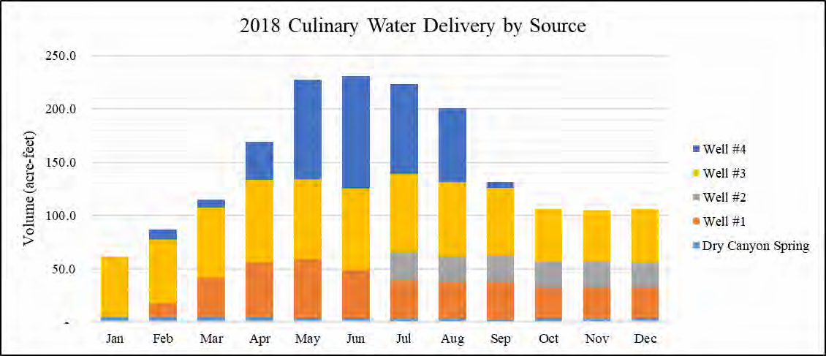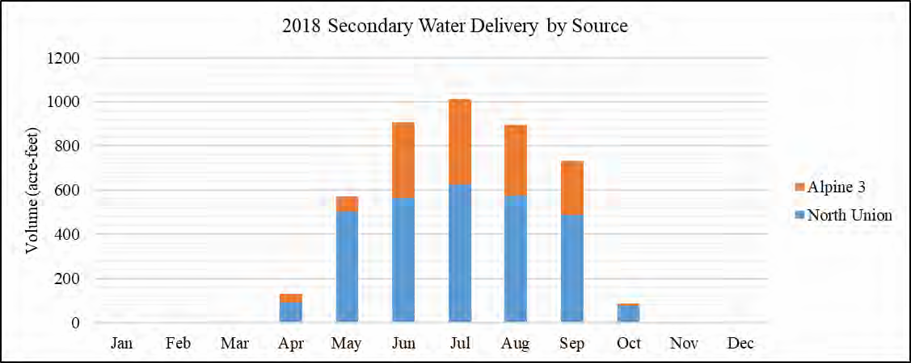Figure 1

The total monthly water use in the pressure irrigation system is shown in Figure 2. The system is “charged” around April 15 and drained between October 15 and October 30 each year.

Figure 2

Population

During the 1990’s, especially the last half of that decade, Lindon had an annual growth rate of about 8 percent. That rate slowed during the years of 2001 to 2005 to about 3 percent. Using a 2 percent annual growth rate resulted in the population projected to the year 2020. Figure 3 shows the population history and projections.

Figure 3
Lindon City Population, Acutal and Projected
1990-2040
16,000

14,000

12,000

10,000

8,000

6,000

4,000

2,000

0
1980 1990 2000 2010 2020 2030 2040
2050
Year
3,815

1990 Census
8,363
10,431

2000 Census

er Plan

ulinary Mast

2014 C
14,307
70
10,0

out Projection

Build

nsus

2010 Ce

WATER PROBLEMS, CONSERVATION MEASURES AND GOALS

Problems Identified

City Staff, in conjunction with their City Engineering Consultant, identified and prioritized several problems during the investigative phase of preparing this Water Conservation Plan.

  - Water not metered, accounted for, and/or billed, such as city-owned facilities, water used for flushing sanitary sewer and storm drain lines, and water used for street sweeping. This is evident by the inflow and metered sales shown in Table 4, Culinary Water Budget.

  - Contractor authorized use or unauthorized use of water for construction purposes. Authorized use is metered by a hydrant meter provided by the City, reported and billed separately. However, the usage is not included in the metered water sales. Unauthorized use is contractors obtaining water from hydrants without having notified the city.

  - Citizens lack understanding and fail to implement landscape water requirements and efficient water-use habits and practices. Few residences know how much water is required to maintain healthy landscaped areas and how to consistently use water efficiently indoors. Many
citizens’ irrigation and indoor practices are based on convenience rather than plant needs and water supply considerations.

  - Lindon residents have home landscapes with large areas of grass and other water intensive landscaping. Over watering of lawns, shrubs, and landscaped areas from the pressure irrigation system occurs due to water being un-metered to the user, combined with and poor watering practices.

  - The current culinary water pricing and billing system lacks incentives and sufficient information for residents and businesses to use water more efficiently. The current structure may not be adequate to cover expenses in the water enterprise fund. This will not be known until the water budget discrepancies are resolved.

Each of these problems represents an opportunity. Opportunities exist to solve the above problems through a combination of education, reduction in high water-use landscaping, better accounting of water delivered from the culinary and pressure irrigation systems, as well as implementation of a well-thought- out water-pricing program, including tiered water rate structure.

Opportunities also exist to educate and prepare a new generation of wise-water users. This can be assisted with a strong sustained water education program in the public and private schools.

Additional opportunities can also be found in two of the remaining problems. First, the City can implement increased enforcement, with appropriate fines, for unauthorized use of water by contractors and others. Second, the City can help promote guidelines for water-thrifty plants, shrubs, and landscaping concepts. In addition, planter areas along existing and future roads could be more easily maintained if low water-use shrubs, mulches, and decorative rock were used instead of traditional Kentucky Blue Grass mixes.

Installation of meters on the remaining unmetered culinary services to city-owned facilities and “billing” the appropriate fund for the water used rather than having the water fund carry the burden. Bill the appropriate funds for irrigation for parks and open space.

Water Conservation Goals

In pursuit of solutions to the problems identified previously, and in light of the variety of conservation measures available to solve these problems, the following goals have been identified:

GOAL #1
Continue to install water meters on all city-owned facilities that use culinary water. Metering these facilities will allow billing the appropriate fund for water use payable to the water fund. Meters have been installed at existing city-owned facilities except Creekside Park restrooms, and the Geneva Road landscaping from 200 South to Center Street.

GOAL #2
Continue to bill for water supplied from the pressure irrigation system to city parks and public properties. The operation and maintenance cost for parks, public properties are paid for from general funds, and that fund should pay the water fund for services rendered.

GOAL #3
Maintain financially-viable water systems. The water pricing system should encourage customers to reduce use without creating a revenue shortfall. City facilities and irrigation needs supplied by the culinary system be billed for water used.

GOAL #4
Continue education of water conservation practices. Continue the ongoing education program with emphasis on elementary grades 4 & 5. Continue to provide information on an annual basis regarding efficient use of water to all users of both systems.

CURRENT CONSERVATION PRACTICES
In order to solve the problems identified above and take advantage of the many associated opportunities, specific water conservation measures must be identified and evaluated. Lindon has already implemented several water conservation measures; these, along with additional measures that will effectively help us manage Lindon’s water systems, are discussed below.

Having both culinary and pressure irrigation systems provides flexibility in dealing with water conservation. Lindon’s current water conservation program is primarily directed at managing water shortages in the culinary system, such as during emergency events (such as losing a well) as well as providing useful material to educate residents to use water more efficiently indoors. To help with this education city representatives work with local elementary schools to help teach students fundamentals of water conservation. Lindon has also initiated a water meter-testing program to identify inaccurate or obsolete meters and replace them. We also continue to monitor our water rate structure with the goal of maintaining financially viable water systems while promoting conservation.

Our rates are automatically adjustment annually based the April Consumer Price Index (CPI).
Water conservation for the pressure irrigation system is directed at education and information sharing regarding the water available for a given water year. Through recent drought years, we have not had to eliminate outside watering.

Current measures include a water conservation contingency plan, water education program for outdoor and indoor water use, and consideration of a conservation-oriented water rate structure.

Water Conservation Contingency Plan
The city has a “Water Conservation Contingency Plan” that spells out climate and political realities related to water use during drought or other water supply shortages. Also addressed are the conservation measures that may be implemented during times of emergency. They are as follows:

Level 1 – Normal Supply

  - Eliminate outside watering on all property from 10 a.m. to 6 p.m.

  - Promote voluntary public conservation measures.

  - Issue information to all customers on conservation procedures each can accomplish around their own property and within their own homes.

Level 2 – 75% of Normal Supply

  - Educate the public on the water supply decreases.

  - Initiate mandatory public conservation measures.

  - Enforce outside watering restrictions including watering times and quantities.

Level 3 – 50% of Normal Supply

  - Strictly enforce all conservation policies with significant fines for non-compliance.

  - Physically restrict water supplies to (in order of priority):

    - All outside irrigation systems

    - Park properties and other non-essential support facilities

    - Commercial businesses, restricting largest users first

    - Residential areas

    - Any other “non-life support” areas, insuring water supplies to hospitals, hospices, and all other health care facilities, and controlled designated area water facilities.

Additional non-emergency water conservation measures are listed below.

Water Education Program

The following information on efficient outdoor and indoor water use is available to the citizens of Lindon through the City Center, Public Works, Elementary School Programs, Lindon Fair and is occasionally distributed with the water bill.

Outdoor Water Use:

- Use pressure irrigation system for landscaping, if available. Most residential and some commercial areas have the pressure irrigation system in Lindon.

- Water landscape only as much as required by the type of landscape, and the specific weather patterns of your area, including cutting back on watering times in the spring and fall.

- Do not water on windy days and/or rainy days.

- Do not water during the hours of 10:00 AM and 6:00 PM.

- Sweep sidewalks and driveways instead of using the hose to clean them.

- Wash your car from a bucket of soapy (biodegradable) water and rinse while parked on or near the grass or landscape so that all the water running off goes to beneficial use instead of running down the gutter to waste.

- Check for and repair leaks in all pipes, valves etc. for secondary, faucets, hoses etc. on culinary. Verify there are no leaks by turning everything off and checking your water meter to see if it is still running. Some underground leaks may not be visible due to draining off into storm drains, ditches, or traveling outside your property. Periodic checks by city on their secondary boxes for leaks.

- Adjust and repair sprinkler heads to maintain proper spray patterns and eliminate waste.

- Periodically check and adjust timers on sprinkling systems.

- Use mulch around trees and shrubs, as well as in your garden to retain as much moisture as possible. Areas with drip systems will use much less water, particularly during hot, dry and windy conditions.

- Keep your lawn well trimmed and all other landscaped areas free of weeds to reduce overall water needs of your yard. Discourage water fountains. Encourage low water landscaping at interchanges, planting strips, etc in the city.

Indoor Water Use:

About two-thirds of the total water used in a household is used in the bathroom. Concentrate on reducing your bathroom use. Following are suggestions for this specific area:

- Do not use your toilet as a wastebasket. Put all tissues, wrappers, diapers, cigarette butts, etc. in the trashcan.

- Check the toilet for leaks. Is the water level too high? Put a few drops of food coloring in the tank. If the bowl water becomes colored without flushing, there is a leak.

- If you do not have a low volume flush toilet, put a plastic bottle full of sand and water to reduce the amount of water used per flush. However, be careful not to over conserve to

the point of having to flush twice to make the toilet work. Also, be sure the containers used do not interfere with the flushing mechanism.

- Take short showers with the water turned up only as much as necessary. Turn the shower off while soaping up or shampooing. Install low flow showerheads and/or other flow restriction devices.

- Do not let the water run while shaving or brushing your teeth. Fill the sink or a glass instead.

- When doing laundry, make sure you always wash a full load or adjust the water level appropriately if your machine will do that. Most machines use 40 gallons or more for each load, whether it is two socks or a week’s worth of clothes.

- Repair any leak within the household. Even a minor slow drip can waste up to 15 to 20 gallons of water a day.

- Know where your main shutoff valve is and make sure that it works. Shutting the water off yourself when a pipe breaks or a leak occurs will not only save water, but also eliminate or minimize damage to your personal property.

- Keep a jar of water in the refrigerator for a cold drink instead of running water from the tap until it gets cold. You are putting several glasses of water down the drain for one cold drink.

- Plug the sink when rinsing vegetables, dishes, or anything else; use only a sink full of water instead of continually running water down the drain.

Water Rates

Designing an appropriate rate structure is a complex task. Rate design is a process of matching the costs of operating the water system to the unique economic, political, and social environments in which the city provides its service. The cost of delivering the service must be evaluated and understood. Each water system has unique assets and constraints. Based on the characteristics of the system, and past capital and operating costs, revenue requirements can be estimated.
Tables 6 and 7 show the current rate structure for culinary and pressure irrigation.

Table 6
Current Monthly Culinary Water Rates
Meter Size 1-inch 1 1/2-inch 2-inch 3-inch 4-inch 6-inch
Zone 2 & 3
Base Rate | $ 16.17 | $ 29.11 | $ 46.89 | $ 177.87 | $ 323.40 | $ 599.91
Base Allocation | 0 gal | 0 gal | 0 gal | 0 gal | 0 gal | 0 gal
Volume Charge (per 1Kgal) | $ 1.33 | $ 1.33 | $ 1.33 | $ 1.33 | $ 1.33 | $ 1.33
Zone 1
Base Rate | $ 17.51 | $ 31.52 | $ 50.78 | $ 192.61 | $ 350.20 | $ 649.62
Base Allocation | 0 gal | 0 gal | 0 gal | 0 gal | 0 gal | 0 gal
Volume Charge (per 1Kgal) | $ 1.40 | $ 1.40 | $ 1.40 | $ 1.40 | $ 1.40 | $ 1.40
Zone 0
Base Rate | $ 26.24 | $ 47.23 | $ 76.10 | $ 288.64 | $ 524.80 | $ 973.50
Base Allocation | 0 gal | 0 gal | 0 gal | 0 gal | 0 gal | 0 gal
Volume Charge (per 1Kgal) | $ 1.63 | $ 1.63 | $ 1.63 | $ 1.63 | $ 1.63 | $ 1.63

The reason for the different rates for different zones is pumping costs to boost the water up to higher developed areas of the city. The City does a Water Systems Rate Analysis about every 3 to 5 years. Based the results of the analysis the City Council may make changes. Also, in an effort to increase the accuracy of water billing, the water meters are read every month.

Table 7
Current Pressure Irrigation Service Size and Water Rates

Service Size Based on Lot Area
Service Size | Service Area
1-inch | 1 acre or less
1 1/2-inch | 1 to 2 acres
2-inch | 2+ acres

Water Rate Based on Lot Area
- Non-Agricultural -
Lot Area (SF) | Monthly Rate
0 to 11,000 | $8.00
11,001 to 21,000 | $10.00
21,001 to 28,000 | $15.00
28,001 to 40,000 | $20.00
40,001 to 60,000 | $30.00
60,001 to 80,000 | $40.00
80,001 to 87,120 | $50.00
2 acres or more | $50.00 + $3.00 per each 1/4 acre
- Agricultural -

Base Rate | $10.00
Each Additional Acre | $3.00 per acre

POSSIBLE ADDITIONAL CONSERVATION MEASURES

In order to effectively meet our city’s future water needs and solve all the water problems identified, additional and more specific water conservation measures will be required. These include water rates that are more stringent; meter replacement and leak repair improved efficiency of irrigation at city parks and other open spaces, education, and plumbing fixture replacement.

More Stringent Water Rate Structure

The current culinary water rates may need to be increased following implementation of the recommendations in Water Rates above. As part of the investigation, a different rate schedule designed to provide additional price incentives for efficient water use to show the customer how much water is needed each month and provide funding for water conservation assistance and
education. This rate schedule is called “Target Billing”.

This rate schedule is designed to meet revenue requirements while creating funding for the water conservation program from fees paid by those who waste water. Water users, who use water indiscriminately and fall into the most expensive tier, will experience a volume charge of $6.00/Kgal for the last block.

Table 8
Possible Water Rate Structure
Type: | Target Billing
Base Charge | $16.17
Base Allocation | 0 Kgal/month
% of Target | Rate
0 - 50% | $1.33/Kgal
51 - 100% | $1.46/Kgal
101 - 150% | $2.00/Kgal
151 - 200% | $3.00/Kgal
201% + | $6.00/Kgal

Meter Replacement and Leak Detection Program

Over time, all meters become less accurate in recording actual flows. This leads to lost revenue to the city and inaccurate data to citizens. For example, if a survey of sufficient randomly chosen meters revealed that nearly 10 percent of the water delivered is not being registered on the meters. City income from metered water is more than $1,060,000. The 10% not registering represents $106,000. When sewer revenues, which are calculated based on metered usage, are accounted for, total revenue lost dependent on metered deliveries is greater.

Education

Education of residents and businesses as to efficient use of water indoors and for irrigation will continue. Education will continue at the local schools. This process will result in a generation of responsible efficient water users.

Plumbing Fixture Replacement

Incentives to exchange old high water-use toilets and shower heads for new ones that are more efficient can be provided through city cost sharing using revenues generated by penalty tiers in the rate schedule. While it is difficult to calculate meaningful estimates of the benefits and costs of such programs on the water-use rate, there is ample evidence in the literature that such programs are effective. The Division of Water Resources estimated in 1995 that such programs could reduce residential indoor water use by 33 percent.

Many of the city’s homes and businesses have been built since 1992 when plumbing codes were revised to require low water-use toilets and low flow showerheads in new construction.

COST ANALYSIS

Our City reached the previous plan Goal #1 (Install water meters at the Lindon City Center, Public Works Complex, and City Park complexes that use culinary water) by June 30, 2005.

Benefit of Reaching Goal #1:

The result of installing water meters at the city-owned facilities and parks is more accurate accounting of the water used and a more correct water budget comparison to evaluate per capita use compared with State and National per capita use. Payment of revenues to the Water Fund from other funds receiving benefit of service from the water systems gives a more accurate basis on which to determine future water rates. Culinary use in most city parks is limited to rest rooms, drinking fountains, and hose spigots by the pavilions. All new parks will have meters installed.

Cost of Reaching Goal #1:

The cost incurred to achieve this goal is a one-time cost to install the meters. The labor and equipment will be provided by existing city personnel using city owned equipment. The costs are as follows:
  - Creekside Park - $1,000

  - Geneva Road Landscaping from 200 South to Center Street – $1,000

Benefit of Reaching Goal #2:

The result of billing for water supplied from the pressure irrigation system to city parks and public properties will be increased revenue to the water fund. The increased revenue will reduce the deficit in the water fund. The increased revenue will make evaluation of water rates more accurate and equitable. For example the monthly rate for Pioneer Park, 4-acres, is $98.00 for an annual total of
$1,176.

Cost of Reaching Goal #2:

In order to begin this billing process the irrigable area of each lot will need to be determined and an account set up in the billing system to which to bill using the non-agricultural - 2 acres or more rate in the pressure irrigation rate structure. The cost of this will be included with each new park constructed.

Benefit of Reaching Goal #3:

A financially viable water system will insure that the utility can provide service at a reasonable price to all of the users. The rate structure will encourage conservation and require the abusers of the system to pay a higher rate. All users, both public and private, will pay for water used.

Cost of Reaching Goal #3:

The next water systems rate analysis expected completion is April 30, 2015. The cost of the complete rate analysis will be $2,000 to $3,000. This will determine the adequacy of the rate structure and provide information regarding any adjustments needed.

Benefit of Reaching Goal #4:

Continuing the education program, particularly in elementary grades 4 and 5, will develop a generation of water conservation minded customers. This age group also has an impact on their parents as they learn and then observe the water use habits at their home. Water conservation is a part of a comprehensive approach to water resource management.

Cost of Reaching Goal #4:

The annual budget for this program varies, especially in difficult economic times. The City typically budgets $3,000 to $5,000 annually for this program. This includes preparation of information distributed to the students as well as information sent with the utility bill regarding conservation practices. Public Works has assigned these responsibilities to the administrative assistant to the Public Works Director.

APPENDIX A – Water Conservation Plan Ordinance

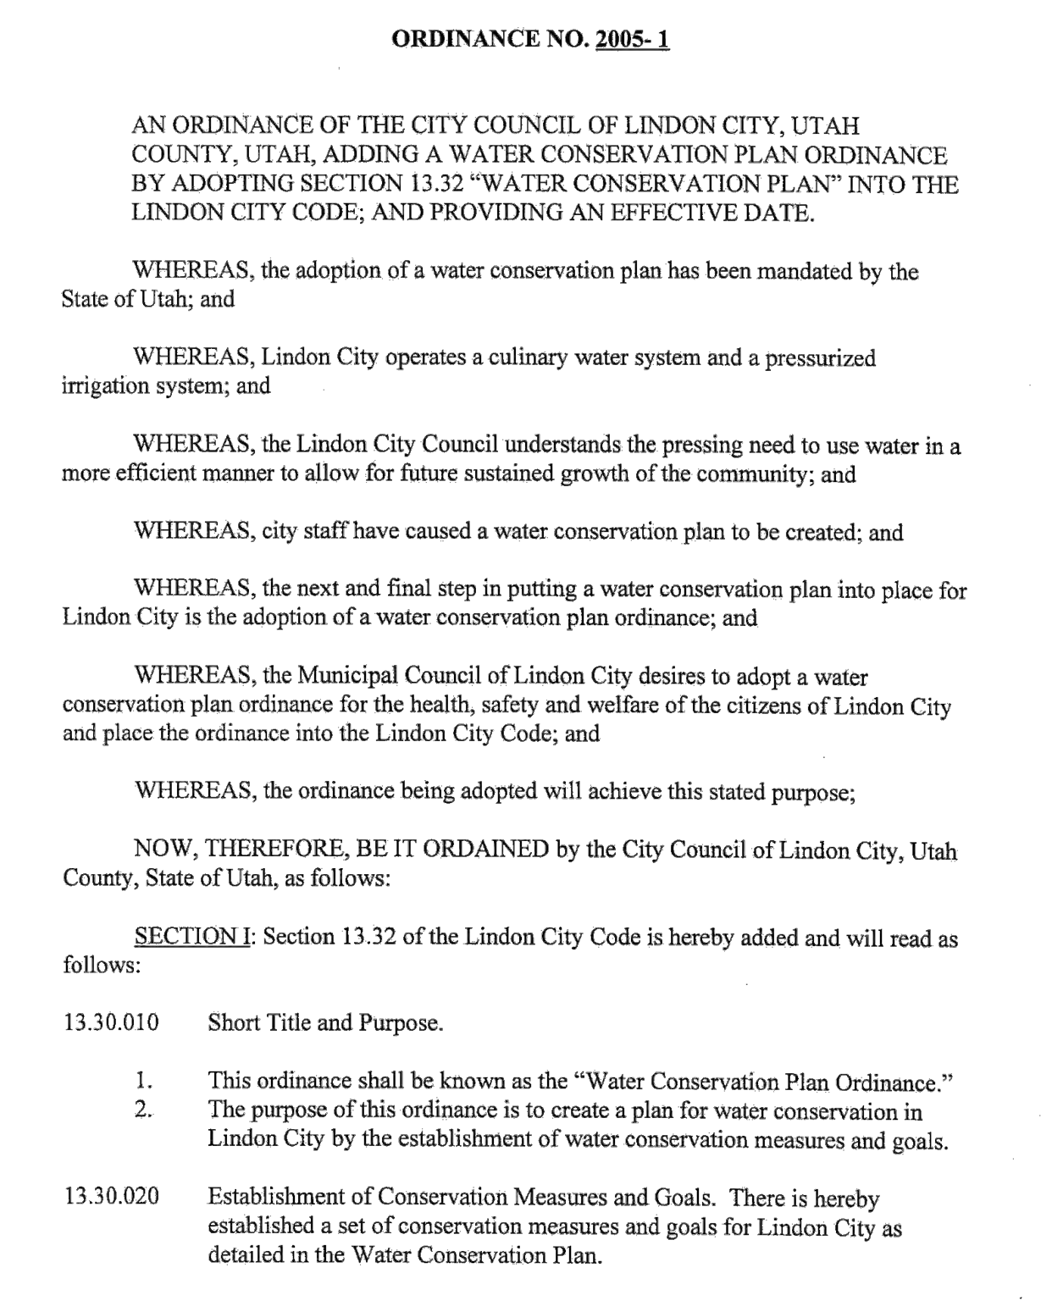

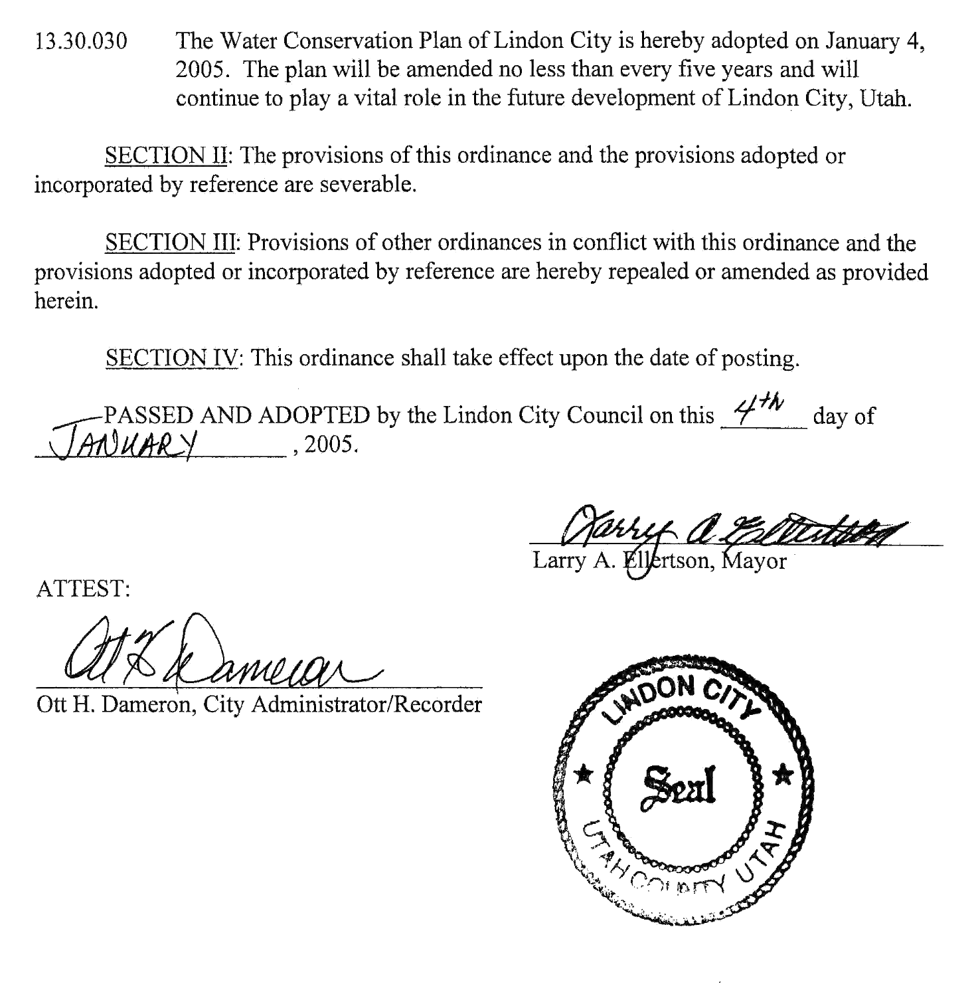

APPENDIX B – Alpine School District Water Conservation Plan

ALPINE SCHOOL DISTRICT WATER CONSERVATION PLAN MAY 4, 2004

Objective
Alpine School District is a major water user in Utah County due to the number of schools with their accompanying athletic fields, playgrounds and other landscaped areas. It is recognized that water conservation measures at these schools could significantly reduce the demand on municipal water systems during the watering season. It is the goal of Alpine School District to implement measures which will assure that grounds are maintained with the least amount of water necessary. Several areas of emphasis have been identified which could help in the water conservation effort. These include:
- Education of water users
- Maintenance of irrigation systems
- Monitoring of soil moisture
- Soil enhancement
- Drought tolerant landscaping
Education of water users
Administrators and custodians occasionally react to lawn and landscape watering by over watering. They do not recognize that too frequent watering of lawns prevents the development of healthy root systems, thus perpetuating the ongoing necessity for frequent watering. Under most circumstances, once weekly watering in warm weather and twice weekly watering in hot weather are sufficient. Less frequent, deep watering will help develop healthy root systems and should result in the need for less water.
Training for custodians has been, and will continue to be conducted through the maintenance department. Information on proper watering and maintenance of irrigation systems will be disseminated and guest speakers will present information on proper watering. They will also be expected to observe weather conditions and to turn off sprinkler systems during rainy weather.
Custodians will be required to set their time clocks to avoid watering in the middle of the day where possible. Typically this would include the hours between 10:00 a m. and 6:00 p.m.
Maintenance personnel and custodians are encouraged to attend Water Use Workshops sponsored by the Central Utah Water Conservancy District. Schedules for these classes will be distributed to the head custodians.
Maintenance of irrigation systems
Administrators and custodians will be required to monitor their sprinkler systems on a regular basis to identify water leaks and malfunctioning sprinkler heads. This should help reduce water waste and to assure that all areas are receiving the proper amount of water. Recent changes in the summer cleaning program will allow more custodial hours in the schools during the summer months. Recommendations will be made to head custodians to use some of these additional custodial hours in assigning specific responsibility for an individual to regularly inspect the sprinkler system to assure that it is functioning properly. It is expected that the system be thoroughly inspected at least weekly during the irrigation season.
All custodians who perform ground maintenance should be trained to identify watering problems and report them immediately to the head custodian, who should in turn either repair the problem with his/her own forces or issue a work order to the maintenance department. Maintenance department will give priority to the repair of malfunctioning sprinkler systems.

Monitoring of soil moisture
The maintenance department currently has a pilot soil monitoring program in place at a junior high school. The effectiveness of this system in reducing water usage will be evaluated. Based on the results of this pilot program additional monitoring systems will be installed and specified in new school construction. The maintenance department will pursue matching grants for soil monitoring systems as grant funds become available. There may be funds available through the Central Utah Water Conservancy District after July 1, 2004.
Soil enhancement
The maintenance department has an ongoing program to analyze soil conditions and provide soil enhancement where necessary. This includes aeration, applying compost and fertilizer, and applying materials to increase the ability of the soil to retain moisture.
Drought tolerant landscaping
Consideration will be given to the use of drought tolerant landscaping, where practical. This includes the use of grasses and plants which require less water. In areas where turf lawns are not necessary, consideration will be given to zeroscape designs which require little or no watering.
Water Use Workshops
May 25, 2004
June 15, 2004
9:00 a.m. to 3:00 p.m.
$10.00 fee
Call Lori Johnson at 435-797-2255 to register
Central Utah Water Conservancy District 355 West University Parkway Orem. Utah 84058
801-226-7100
Additional information
Contact the Utah Division of Water Resources at 801-538-7254. Web page: www. conservewater.utah.gov

2 Mayor pro tern Bean called for any fu1ther comments or dtscussion from the Coun ci l. Hearing none he called for a motion.
4
COUNCILMEMBER BRODERICK MOVED TO APPROVE THE REQUEST
6 FOR COMPENSATlONI AMENDMENTS FOR LIFEGUARD POSITIONS FOR LIFEGUARD POSITIONS. COUNCILMEMBER LUNDBERG SECONDED THE
8 MOTION. THE VOTE WAS RECORDED AS FOLLOWS: COUNCILMEMBER BEAN AYE
10 COUNCILMEMBER LUNDBERG AYE COUNCILMEMBER BRODERICK AYE
12 COUNCILMEMBER HOYT AYE THE MOTION CARRIED UNANIMOUSLY.
14
- Review & Action - Municipal Wastewater Planning Program (MWPP)
16 2018 Annual Report; Resolution# 2019-15-R. The City Council will review and consider approval the Municipal Wastewater Planning Program (MWPP)
1 8 2018 Annual Report which has been submitted to the state Division of Water Quality. The Public Works Director, Brad Jorgensen, City Engineer, Noah
20 Gordon, and Wastewater Supervisor, Kevin Muhlstein will present.

22 Public Works Director, Brad Jorgensen and Wastewater Supervisor, Kevin Muhlstein were in attendance to present the Municipa l Wastewater Plam1ing Program
24 (MWPP) 2018 Annual Report which has been submitted to the state Division of Water Quality . Mr. Jorgensen stated part of the requirements of this evaluation for any monies
26 from the state is that they present this to the Council for their approval of the findings and then submit the rep01i to the state.
28 Following some general discussion regarding the summary repo1i, the Council thanked Mr. Jorgensen and Mr. Muhlstein for the presentation and valuable information
30 and for their good works for the city.
Mayor pro tern Bean called for any further conunents or discussion from the
32 Council. Hearing none he called for a motion.

34 COUNCILMEMBER BRODERICK MOVED TO APPROVE RESOLUTION #2019-15 -R APPROVING THE 2018 MUNICfPAL WASTEWATER PLANNING
36 PROGRAM (MWPP) ANNUAL REPORT WITH RECOMMENDED CHANGES AS DISCUSSED. COUNCILMEMBER LUNDBERG SECONDED THE MOTION. THE
38 VOTE WAS RECORDED AS FOLLOWS: COUNCILMEMBER BEAN AYE
40 COUNCILMEMBER LUNDBERG AYE COUNClLMEMBER BRODERICK AYE
42 COUNCJ LMEMBER HOYT A YE
THE MOTJ ON CA RR I ED UNANIMOUSLY.
44
- Discussio11 Hem - Secondary· w ater l\1ctering Rcqu frcmcnt s. The C i t y
46 Coun cil wil1oe presented with informa ₁₀ ₁₁ abou the fu ture of secondary water met erin g and di s cuss the i m pl i c at i ons of SB 52 passed in the last legis lat i ve

2 session.

4 Mr . Cowie gave a b1ief upda te stati ng SB52 just passed through the last legislative sessi on and part of the requi remen t is that we ha ve to submit a report by the
6 end of this calendar year tlrnt outlines how we are going to implement citywide secondary wate r 111ete1ing including costs, when it will be done and how it will be funded. The state
8 wi ll then take the data from these entities and reports and pin the city down for an
implementation date . Mr. Cowie indicated there is a sense of urgency to get state funding

l O as more entities will be competing for the funding. He noted this issu,e more in the next several months.
¥ill be discussed

12 Public Works Director, Brad Jor gens en and City Eng in eer, Noah Gordon were in
atten dance for this discussion item. Mr. Gordon gave his presentation with infonnation
14 about the future of secondary water mete1ing and discussed the implications of SB 52 passed in the last legislative session as follows:
16 Mr. Gordon explai ned that meters wi ll be requi red on all new services designe d after April 1 , 2020 (no mandate to mete r existing system as yet). The mete1ing plan by
18 the city will be required to be filed with th e Div ision of Vlater Resources by December 31, 2019, to in clude the following:
20 • Cost of full mete ring .
- How long it will take to complete including start date and completion date.
22 • How the city will finance the metering.

24 Mr. Gordon stated a study by the Utah Water Task Force (DWR) of issues related to metering secondary water within Utah to be reported by mid-November 2019. T he
26 report will need to include the following:
- Cost
28 • Timing
- Need for exempti ons
30 • Resources to pay for the mete1ing
- Any other relevant issues
32
Mr. Gordon noted an annual repo1t by the ci t y will be submitted each year by
34 March 31 st to the DWR and will inclllde the foll owi ng:
- Volume of Water used
36 o Number of meters
a Service boundary description
38 o Number of cmmections
o Volume received from sources
40
Mr. Gordon sta ted beginning J u l y 1, 2019· the Board of Wa ter Re source s may
42 make up to $10,000,000 in low i nterest loans avail a ble each year as follows:
o 1 6% of 1 % sales ta x i ncrease
44 Payback i nterest oC l%

2 Mr. Gordon stated Meters requi red on all new servi ces in design and ves ted after April 1 , 2020 a re as follows:
4 • Ande rson Fanns is alr eady i nstallin g meters
- City is alread y requiri ng meter setters wi t h "jumpers" ready fore me ters on all
6 new projects.

8 Mr. Gordon stated the cost of full metering is as follows:
- 2404 existing secondary water connections without meters
10 o Anderson Fanns is installing meters
- $1 500 -$2000 cost to retro-fit and in s tall the meter on an existing connection= 12 $3.6M - $4.8M

1 4 Mr. Go rdon stated the Timing and Financ ing of foll Metering is as follows:
- How long it will take Lindon to complete full metering?
16 o Start date
o Completion date
18 • How will Lindon finan ce full met ering?
o Water fund balance
20 o Grants
o Low- interest loan
22 o Bond
o Other
24
Following the prese ntat ion, ther e was some general discussion regarding the
26 infonnation presented. Mr. Cowie stat ed tl1e city currently has the funds to pay for this but has concerns that the city may not get the stated funding . Councilmember Hoyt
28 stated he is not ready to move forward until it is mandated and not commit to a loan if there are grants available .
30 Mr. Cowie asked the council, i11 general, if we are preparing the report, are we looking at 5, 10 or 20 years . The Council agreed on tJ1e 10 -15-year range. Mr. Cowie
32 pointed out th ere will be some citizens paying for secondary me te rs and some who are not. Councilmember Lundberg stated we need to figure out what is conservative use vs.
34 excessive use and try to get a baseline.
Mr. Cowie stated he is hearing if staff put s a plan together to present to the
36 Coun cil, they are agreeing on the I 0-1 5-year wi ndow} finance options and using the
" smart ' ' metering option. The Council agrees that wo uld accomplish the goal and a good
38 startin g point.
Following discussion, th e Counc i l thanked Mr. Jorgensen and Mr. Gordon for th e
40 presentati on and valua ble infornrnti on and for their servi ce to th e city.
Mayor pro tem Bean called fo r any further comments or discussion from the
42 Council. Hea ring none he mo ved on to the next age nda item.

44 COUNCIL REPORT S:

46 Co1111cilmemb er Hoyt - Coun ci l member H oyt aske d who he would forward an emai l recei ved from the U tah Coal i ti on A gain st Sex ual Assa u lt about d oi ng a 4k Run in the

Enrolled Copy S.B. 52

- SECONDARY WATER REQUIREMENTS
- 2019 GENERAL SESSION
- STATE OF UTAH

Chief Sponsor: Jacob L. Anderegg

House Sponsor: Timothy D. Hawkes
6

LONG TITLE
- General Description:
- This bill addresses the metering of pressurized secondary water.

Highlighted Provisions:
- This bill:
- ► defines terms;
- ► requires a secondary water provider that begins design work for new secondary
14 water services to certain users on or after April 1, 2020, to meter the use of water;
15 requires a secondary water supplier to develop a plan related to metering for
►
16 submission to the Division of Water Resources;
17 requires reporting;
►
18 ► requires a study of issues related to metering secondary water by a task force within
19 the Department of Natural Resources and reporting its findings; and
20 permits loans to fund metering of secondary water.
►

Money Appropriated in this Bill:
- None

Other Special Clauses:
- None

Utah Code Sections Affected:
- ENACTS:
- 73-10-34, Utah Code Annotated 1953
28

S.B. 52

- Be it enacted by the Legislature of the state of Utah:
- Section 1. Section 73-10-34 is enacted to read:

73-10-34. Secondary water metering.
- (1) As used in this section:

Enrolled Copy

- (a) (i) "Commercial user" means a secondary water user that is a place of business.
- (ii) "Commercial user" does not include a multi-family residence, an agricultural user,
- or a customer that falls within the industrial or institutional classification.
- (b) (i) "Industrial user" means a secondary water user that manufactures or produces
- materials.
- (ii) "Industrial user" includes a manufacturing plant, an oil and gas producer, and a
- mining company.
- (c) (i) "Institutional user" means a secondary water user that is dedicated to public
- service, regardless of ownership.
- (ii) "Institutional user" includes a school, church, hospital, park, golf course, and
- government facility.
- (d) (i) "Residential user" means a secondary water user in a residence.
- (ii) "Residential user" includes a single-family or multi-family home, apartment,
- duplex, twin home, condominium, or planned community.
- (e) "Secondary water" means water that is:
- (i) not culinary or water used on land assessed under Title 59, Chapter 2, Part 5,
- Farmland Assessment Act; and
- (ii) delivered to and used by an end consumer for the irrigation of landscaping or a
- garden.

- (f) "Secondary water supplier" means an entity that supplies pressurized secondary

- water.
- (2) A secondary water supplier that begins design work for new service on or after

- April 1, 2020, to a commercial, industrial, institutional, or residential user shall meter the use

Enrolled Copy S.B. 52

- of pressurized secondary water by the users receiving that new service.
- (3) (a) A secondary water provider that provides pressurized secondary water to a

- commercial, industrial, institutional, or residential user shall develop a plan for metering the
- use of the pressurized water in accordance with this Subsection (3).
- (b) The plan required by this Subsection (3) shall be filed with the Division of Water

- Resources by no later than December 31, 2019, and address the process the secondary water
- supplier will follow to implement metering, including:
- (i) the costs of full metering by the secondary water provider;

- (ii) how long it would take the secondary water provider to complete full metering,

- including an anticipated begin date and completion date; and
- (iii) how the secondary water supplier will finance metering.

- (4) (a) The Department of Natural Resources shall oversee a study by the Utah Water
- Task Force within the Department of Natural Resources of issues related to metering secondary
- water in the state including cost, timing, the need for exemptions, resources to pay the cost of
- metering, and any other issues the Department of Natural Resources finds relevant.
- (b) The Department of Natural Resources shall report the results of the study to the
- Natural Resources, Agriculture, and Environment Interim Committee by no later than the
- November interim meeting of 2019.
- (5) A secondary water supplier shall on or before March 31 of each year, report to the

- Division of Water Rights:
- (a) for commercial, industrial, institutional, and residential users whose pressurized
- secondary water use is metered, the number of acre feet of pressurized secondary water the
- secondary water supplier supplied to the commercial, industrial, institutional, and residential
- users during the preceding 12-month period;
- (b) the number of secondary water meters within the secondary water supplier's service
- boundary;
- (c) a description of the secondary water supplier's service boundary;

S.B. 52
Enrolled Copy

- (d) the number of connections in each of the following categories through which the
- secondary water supplier supplies pressurized secondary water:
- (i) commercial;
- (ii) industrial;
- (iii) institutional; and
- (iv) residential;
- (e) the total volume of water that the secondary water supplier receives from its
- sources; and
- (f) the dates of service during the preceding 12-month period in which the secondary
- water supplier supplied pressurized secondary water.
- (6) (a) Beginning July 1, 2019, the Board of Water Resources may make up to

- $10,000,000 in low-interest loans available each year:
- (i) from the Water Resources Conservation and Development Fund, created in Section 96 73-10-24; and
- (ii) for financing the cost of secondary water metering.
- (b) The Division of Water Resources and the Board of Water Resources shall make
- rules in accordance with Title 63G, Chapter 3, Utah Administrative Rulemaking Act,
- establishing the criteria and process for receiving a loan described in this Subsection (6), except
- the rules may not include prepayment penalties.

- Discussion Item — Lindon Days finances and fundraising. Heath Bateman, Parks & Recreation Director will present an overview of 2019 Lindon Days events and expenditures and discuss future fundraising.
(20 minutes)

See attached materials. Heath Bateman, Parks & Recreation Director, will discuss Lindon Days expenditures from 2019 events and review possible changes to fund raising and/or booklet preparation for Lindon Days 2020. The Council should provide feedback and guidance.

No motion is necessary.

Lindon Days "New Traditions"
2019 FINANCIAL REPORT

Date | Activity | Sponsor | Revenue | Expense | Net Increase (Decrease)
 | Magazine | Advertisers | $13,525.00 | $ 7,963.81 | $ 5,561.19
Mon, 8/5 | Car Show  (Not including donation to police) | LHM Lexus | $ 6,125.00 | $ 9,624.00 | $ (3,499.00)
Tue, 8/6 | Pinewood Derby | Total Water | $ 350.00 | $ - | $ 350.00
Tue, 8/6 | Block Party | Big D Construction, Marco's Pizza,  Republic Services | $ 645.00 | $ 1,101.87 | $ (456.87)
Tue, 8/6 | City Council Ice Cream Social |  | $ - | $ 466.61 | $ (466.61)
Tue, 8/6 | Movie: "How to Train Your Dragon:  Hidden World" | Bank of Utah | $ - | $ 35.51 | $ (35.51)
Wed, 8/7 | Bingo | Walmart, Fleet Services,  Les Olson, Sunroc | $ 300.00 | $ 865.37 | $ (565.37)
Wed, 8/7 | Grandparents Night Out |  | $ - | $ 646.31 | $ (646.31)
Wed, 8/7 | Huck Finn Fishing |  | $ - | $ 894.92 | $ (894.92)
Thu, 8/8 | Foam Party | Low Book Sales | $ 225.00 | $ 1,019.57 | $ (794.57)
Thu, 8/8 | Family Arena Events | Les Schwab Tires | $ 1,126.00 | $ 1,336.65 | $ (210.65)
Thu, 8/8 | Mayor's Candy Scramble |  | $ - | $ 1,008.03 | $ (1,008.03)
Thu, 8/8 | Teen Pool Party | Crumbl, Quick Quack Car Wash,  Wicked Audio | $ (300.00) | $ 121.31 | $ (421.31)
Fri, 8/9 | Video Game Tournament |  | $ - | $ 108.76 | $ (108.76)
Fri, 8/9 | Grand Parade | Roofer's Supply | $ 325.00 | $ 2,031.68 | $ (1,706.68)
Fri, 8/9 | Improv Show |  | $ - | $ 3,097.63 | $ (3,097.63)
Sat, 8/10 | Lindon Days 5K | American Fork Hospital | $ 1,370.92 | $ 1,964.64 | $ (593.72)
Sat, 8/10 | Mayor's Breakfast | Mountain Point Medical | $ 1,453.00 | $ 1,395.46 | $ 57.54
Sat, 8/10 | Cardboard Boat Regatta |  | $ - | $ 732.89 | $ (732.89)
Sat, 8/10 | Free Swim Day, Court of Mermaids |  | $ - | $ 306.60 | $ (306.60)
Sat, 8/10 | Dime Dive | Bank of Utah | $ - | $ 231.00 | $ (231.00)
Sat, 8/10 | Belly Flop Competition | Coconut Cove | $ - | $ 426.12 | $ (426.12)
Sat, 8/10 | KenDucky Derby |  | $ - | $ 343.24 | $ (343.24)
Sat, 8/10 | Food Truck Round Up | doTerra | $ 100.00 | $ - | $ 100.00
Sat, 8/10 | Face Painting & Balloon Artist | doTerra | $ - | $ 255.00 | $ (255.00)
Sat, 8/10 | Pre-Show: Scales and Tails |  | $ - | $ 630.56 | $ (630.56)
Sat, 8/10 | Concert | Central Bank, Rock Canyon Bank | $ 3,366.00 | $ 10,383.22 | $ (7,017.22)
Sat, 8/10 | Fireworks |  |  | $ 7,000.00 | $ (7,000.00)
Miscellaneous Revenue (Unassigned contributions) |  |  | $ - |  | $ -
Miscellaneous Exp (staff food, general exps, volunteer appreciation, purch. for next yr) |  |  |  | $ 2,467.97 | $ (2,467.97)
 | TOTALS |  | $ 28,610.92 | $ 56,458.73 | $ (27,847.81)

- Review & Action — Safety Incentive Award Program; Resolution #2019-30-R. The City’s insurance carrier is asking its members to adopt an Employee Safety Incentive Program to help reduce workplace accidents and injuries. The insurance provider will provide discounts on premiums that off-set potential costs of the program. If approved, the program will be incorporated into the Employee Policies & Procedures Manual.
(15 minutes)

See attached materials.

Sample Motion: I move to (approve, deny, continue) Resolution #2019-30-R (as presented, or with changes).

RESOLUTION NO. 2019-30-R

A RESOLUTION APPROVING THE LINDON CITY EMPLOYEE SAFETY INCENTIVE AWARD PROGRAM, TO BE INCLUDED IN THE LINDON CITY POLICIES AND PROCEDURES MANUAL, AND SETTING AN EFFECTIVE DATE.

WHEREAS, Lindon City’s insurance provider for liability and workers compensation coverage, Utah Local Governments Trust (ULGT), has found team based safety appreciation and recognition programs an effective method in reducing losses of liability and workers compensation claims; and

WHEREAS, ULGT encourages adoption and enactment of city created safety incentive programs and will provide insurance premium discounts to members that adopt said programs to help offset awards or program costs; and

WHEREAS, the Lindon City Employee Safety Incentive and Award Program has been drafted and will enhance City safety policies and should be incorporated into Section 2 - RISK MANAGEMENT/SAFETY RULES & REGULATIONS of the Lindon City Policies and Procedures Manual; and

WHEREAS, the creation of the new policies will benefit the City and the public for which it serves by helping to reduce accidents and work losses and associated costs.

THEREFORE, BE IT RESOLVED by the Lindon City Council as follows:

Section 1. The Lindon City Policies and Procedures Manual is hereby amended and approved to include the Lindon City Employee Safety Incentive Award Program as included in Exhibit A.

Section 2. This resolution shall take effect immediately upon passage.

Adopted and approved this 3rd day of December, 2019.

Attest:
By Jeff Acerson, Mayor

By
Kathryn A. Moosman, City Recorder SEAL:

Lindon City Employee Safety Incentive Award Program

The safety award program is created to recognize City employees who go for an entire year (1) with no “at-fault” accidents, injuries or claims and (2) who have not been determined to be responsible for violation of a safety rule, policy, regulation or practice. The goal of this program is to minimize employee injuries / workers comp claims, promote greater attention to safety work practices, control accident costs and maintain a strong safety culture within Lindon City. The initial award year is from Dec. 1, 2019 through Nov. 30, 2020 and will repeat each year as approved within the City Budget.

For purposes of the awards, employees are divided into three (3) Risk Categories with quarterly award amounts as listed:

Risk Category | Positions Included | Potential Award / quarter
High Risk | staff with higher work-related injury risks such as emergency vehicle operation, heavy equipment operators, utility laborers, etc. Examples – police officers, parks laborers, public works  laborers, heavy equipment operators, etc. | $12.50  ($50/yr)
Medium Risk | staff with medium risk work duties. Examples – recreation  staff, lifeguards, facilities maintenance, janitor, inspectors, etc. | $7.50  ($30/yr)
Low Risk | staff with low risk work duties. Examples – office clerk,  cashiers, attorney, dept heads/management, etc. | $2.50  ($10/yr)
Temporary part-time and Seasonal Employees are eligible for a pro-rated safety incentive award based on number of months worked (3-month minimum required).

Team Based Qualification:
Employees are divided into teams to promote encouragement among team members to follow safe work practices. Work related ‘at-fault’ preventable accidents or safety policy violation from any individual within a team will disqualify all of the team members from being eligible for the award for that quarter. Two or more work related accidents within a team per year will disqualify all of the team members from being eligible for the award for the remaining of the program year.

Teams:
- Finance, Administration, Legal, Justice Court, facilities
- Community Development (planning & building depts)
- Parks & Rec Director, Parks & Rec office staff, senior center staff, Rec Supervisor, Rec staff
- Parks Supervisor, Parks laborer, parks seasonal help
- Aquatics Manager, lifeguards, Aquatic center staff
- Public Works management, clerks, engineers, inspectors
- Public Works streets and utility divisions (streets, water, sewer, storm water), PW seasonal help
- Police Chief, Lieutenant, secretary, office clerks, detectives, emergency manager
- Sergeant 1, patrol staff under assigned Sergeant
- Sergeant 2, patrol staff under assigned Sergeant

Individual Qualification:
In addition to the Team Based qualifications as listed above in order to receive the Safety Incentive Award, individual employees shall also participate in a minimum of two safety trainings per program year. These safety trainings may include department safety training meetings, city-wide trainings, conference safety trainings, on-line training, or other appropriate safety trainings as approved by the

Department Head. To receive credit for safety training participation individual employees must sign a training attendance log to be kept by each Department.

Supervisor Oversight:
Supervisors are charged with the responsibility to assure that employees that do not perform their duties safely do not qualify for the safety incentive award. After consultation with Department Heads, Supervisors have discretion to determine the level of awards or to deny an award to an employee based on individual performance.

Safety violations, serious incidents and chargeable accidents may not only result in the total loss of the safety achievement recognition, but may subject an employee to progressive disciplinary action according to Lindon City policy.

Supervisors will verify training dates, topics and attendance and recommend those that have earned awards to the Department Head, who will then certify the recommendation and forward to the Personnel Director by the end of each program year.

Eligibility:
Full-time employees, permanent part time employees, and seasonal employees are eligible to receive a safety incentive award if they have been employed with the City for a minimum of 3 months. Temporary part-time and Seasonal Employees are eligible for a pro-rated safety incentive award based on number
of months worked (3-month minimum required).

Recordable Accident or Safety Violation:
For purposes of this program, a recordable accident or safety violation consists of any of the following:
  - An injury or event which required an employee to receive medical attention and/or results in limitations placed on their job duties (i.e., light work duty). An injury, accident or illness which occurred while on the job must require treatment beyond first aid: such as special medical care by a physician, registered nurse, therapist, paramedic, etc. (Example: For purposes of this program, a small cut received during work that is fixed with a band-aid is not considered a recordable accident. However, a cut that requires stitches or becomes infected and requires medical attention is a recordable accident.); or
  - A lost time accident that occurs when an employee is injured, harmed or becomes ill while on the job and results in the employee missing one or more days beyond the day of the accident; or
  - Physical injury, property damage, equipment or vehicle damage or accident that is deemed preventable by the Risk Management Committee; or
  - Any violation or non-compliance with the safety practices, procedures and policies adopted by the Department and/or City. Safety violations may be written and issued after an incident/accident investigation. Recommendations for a safety violation may be offered by others, but must be issued by the individual employee’s supervisor or Department Head.

Failure to Report an Incident/Accident/Injury: Anyone failing to report to a Supervisor or Department Head any property damage accident or an injury that exceeds minor first aid treatment as soon as possible (during the shift or if on a call-out, at the start of the next scheduled shift) will automatically lose their entire incentive reward for that fiscal year.

Interpretation and application of this policy will be made on a case by case basis by the Personnel Director in coordination with the Risk Management Committee as needed.





U T A H LOCAL GOVERNMENTS TRUST •
,)·
..11 111 11 , ,, , ', 1, • I " I 1.,1.. '-'' llh l
, , 801.936.6400 t 800 .748 .l-44 0 t 801.936.0300 , , ·v utahtrust,gov l

November 14, 2019

Lindon City
100 N. State St reet Lindon, UT 84042

RECEIVED
NOV I 9 2019
lJ N OO t\l CITY

RE: $1,000,000 BOARD APPROVED - PREM I UM RELIEF CREDI T

Dear M em ber,

The Trust Board of Directors recently approved a $1,000,000 Premium Relief Credit for members. The amount of this premium credit ranges from 0% to 7% of your liabil it y premium and 0% to 7% of your workers compensation premium. You r credi t is based on your performance and longevity with the Trust.

I am pleased to report that Lindon City is eligible to receive $3,909.00 of this $1,000,000 Premium Relief Credit. Thi-s amount is 1% of your 2019 liabil it y premi{lm and 6% of your 2019 workers compensation premium. Your credit will appear on the renewal statement for your 2020 policy and be applied aut om at ically . It will read: Trust Premium Relief Credit- Liability $422.00 and/or Trust Premium Relief Credit- Workers Comp $3,487.00.

Thank you for your individua l and collect ive role in making this dividend possible. Your effort to reduce loss and injury is evident.

In our experience, an effective method in reducing losses and improving results is the ""-/ _, i mplem ent at ion of a Team Apprec iat ion and Recognition Program. Effective programs
-f< are: Simple, Visible, an d/Consiste nt, and designed around accountability. Please call for
assistance. A--pplZN,1 - .,,,.1t,14 1\k 5# /0 d·,°;\ c CJ -A ' Wo ./"
rv· ,\) , l,A \u...
We compliment dozens of members for implementing Team Appreciation and
"'\. / Recognition Programs that work. Many have experienced a 50% or more reduction in loss frequency, at the same t ime improving employee morale. Special recognition to: Alpine , Alt a, Bear Ri ver Assoc i at ion of Govern ment s, Bluffdale, Box Elder Mosquito Ab at ement, Br ian Head, Cache County, Cache Valley Transit, Car bon County, Cli nt on,

Cottonwood Heights Parks & Recr eati on, Davis Mosquito Abat em ent , En och, Ephraim, Grand County, Heber , Herriman, Hoope r, Housing Connect, Hurricane , Hyrum, Kearns Improvement, Lone Peak Public Sa f et y, Mantua, Midvale, Midvalley Impro vem ent,
Millcr eek, Moab, Mountain Regional Water, Morgan, Naples, North Pa rk Police Agency, Ogden Preparatory Academy, Payson, Perry , Price, Price River Water Improvement, Providence, Ri verdale , Riverton, R oosevelt , Roy, Santa Cla r a, Saratoga Springs, South Ogden, South Salt Lake M osquit o Abatement, South Valley Sewer, Spanish Fork, Springdale, Springville, St. Georg e, Summit County, Su nset , Tooele County, Tremonton, Uintah Mosquit o, Unified Fi r e Aut horit y, Utah County, Utah Local Governments Trust, Vernal, Wasatch Front Waste & Recycling District, Wasatch Mental Health Se rvices, Washington, Washington County Solid Wast e, Willard, and Woods Cross.

Thank you for your innovation, leader ship, and acc ount ability. Your effort makes a diff erenc e. We appreciate your commitment to more than 565 members of the Utah Local Governments Trust. We value our partnership and look forward to a strong and energetic 2020.

Best Wishes fo r a Safe and Happy Holiday Season! Sincerely,

Steven A. Hansen, CEO

cc: Council, Mayor, Commissioner, Manager, Director

Council Reports: (20 minutes)
- MAG, COG, UIA, Utah Lake Comm., ULCT, NUVAS, IHC Outreach, County Board of Health - Jeff Acerson
- Police/Fire/EMS, Emergency Mgmt., Irrigation Co. Representative/Boardmember, City Buildings - Van Broderick
- Public Works/Engineering, Historic Commission, Administration, Building Const. & Inspection - Randi Powell
- PG/Lindon Chamber of Commerce, Economic Development, Lindon Days - Carolyn Lundberg
- Planning Commission/BOA, Planning/Zoning, General Plan, Transfer Station/Solid Waste Board - Mike Vanchiere
- Parks, Trails, and Recreation, Cemetery, Tree Advisory Board - Jake Hoyt

Administrator’s Report (10 minutes)

Misc. Updates:
  - January newsletter article: Mike Florence - Article due to Kathy Moosman by end of December
  - Reminder that there’s NO curb side pick-up for Christmas Trees
  - Any items, issues, or topics you feel you need more training or background on? Anything we can be doing better to help you stay informed on issues or events?
  - Misc. Items

Upcoming Meetings & Events:
  - November 28th – Mayor’s Thanksgiving Day Dinner
  - November 28th & 29th – Thanksgiving Holiday - City offices closed
  - December 2nd @ 6:30pm – Annual Christmas Tree Lighting at Community Center
  - December 12th @ 6:30pm – Employee Christmas Party
  - December 23rd – City offices close at noon
  - December 24th -25th – Christmas Holiday – City offices closed
  - January 1st – New Years Holiday – City offices closed
  - January 7th – Oath of Office administered to newly elected Council members
  - January 20th – Martin Luther King Holiday – City offices closed
  - January 29th – ULCT Local Officials Day with Legislature

ADJOURN

