Disabilities Advisory Council

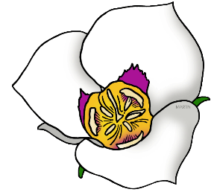
Meeting: Disabilities Advisory Council
Date: 11/19/2019
Start Time: 2:00 P.M.
End Time: 4:00 P.M.
Location: Multi-Agency State Office Building
Division of Services for People with Disabilities 195 North 1950 West, Room 1020 B
Salt Lake City, UT 84116

Call-in option number: 1-877-820-7831, participant code: 396008

Welcome and Announcements:

Presenter:

- The Council Chair will open the meeting Chair, Amber Foster

New Business Items: Presenter:

Presenters may present out of order due to scheduling constraints

- Rape Prevention and Education Jessica Stahle, DSPD
- Settings Rule / PCSP Workgroup Amy Huppi, DSPD
- NCAPPS Saska Rajcevic, DSPD
- SELN Bob Downing, DSPD
- SIS Replacement Workgroup Anne Stephens, DSPD

Public Comments: Public in Attendance
- Attending members of the public are invited to present items for discussion

Discussion of Future Topics/Setting Next Agenda: Council Members

The next meeting is TBD in the first quarter of 2020 from 2 to 4 pm at the Multi-Agency State Office Building Individuals needing special accommodations (including auxiliary communicative aids, services, etc.) are encouraged to contact Anna Owen at 801-538-4092 or aowen@utah.gov.

DSPD= Division of Services for People with Disabilities
DOH= Utah Department of Health
DHS= Department of Human Services

