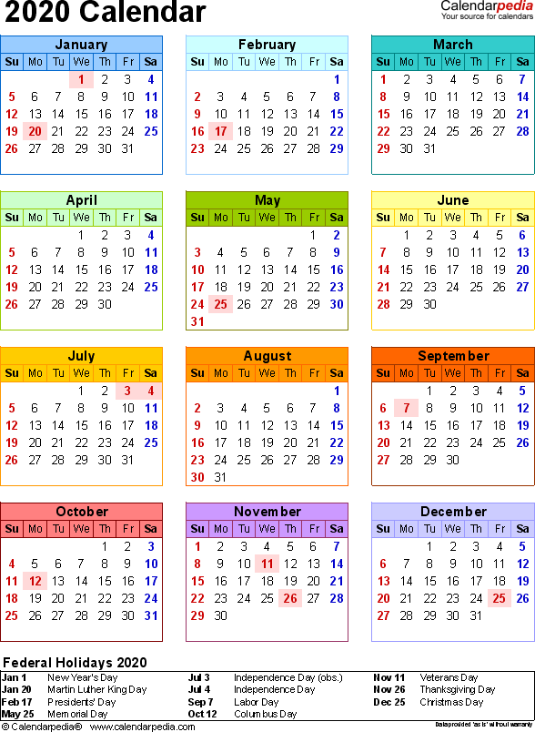
-Holiday -TC Meetings

-P & Z Meetings -Pay Day

