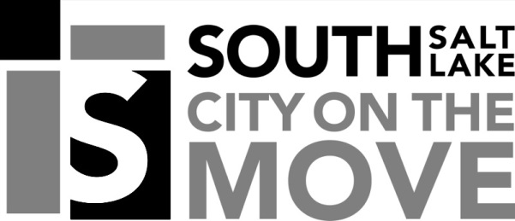

SOUTH SALT LAKE CITY NOTICE OF PUBLIC MEETING

Public notice is hereby given that the South Salt Lake City Community and Economic Development Department will hold a public meeting in the Council Chambers located in City Hall at 220 East Morris Avenue on Monday, November 18, 2019 at 2:30 PM, or as soon thereafter as possible for the purpose of receiving public comment on the following:

Conditional use approval for an indoor automobile dealership located at 3565 S Main Street. Application is made by Saied Hajizadeh.

Notice is further given that the public is invited to attend and present oral and/or written testimony regarding this petition to the Department of Community Development. In compliance with Americans with disabilities act, individuals needing auxiliary communicative aids or other services for this meeting should contact Taylor Greenwell at 801.412.3225 or tgreenwell@sslc.com, giving at least 24 hours’ notice.

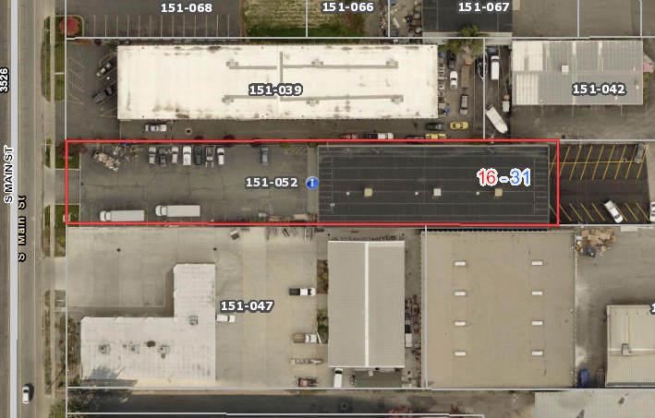

Business location

