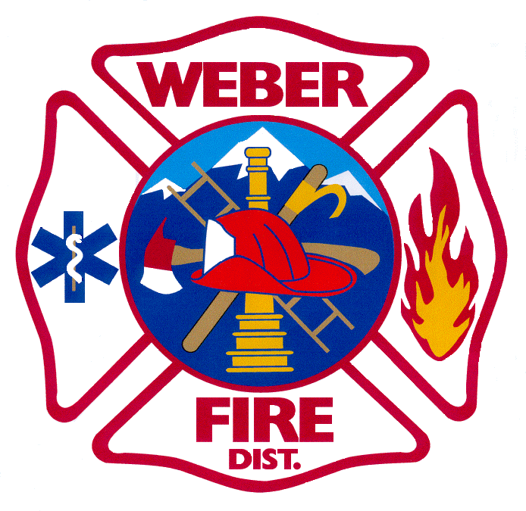

WEBER FIRE DISTRICT

NOTICE OF PUBLIC HEARING

Notice is hereby given that the Board of Trustees of Weber Fire District will meet on Tuesday, November 12, 2019 at 5:30 p.m. in the Board Room of the Weber Fire District Station 61, Administrative Offices, 2023 West 1300 North, Farr West City, Utah.
At 6:01 p.m. a public hearing will be held on the Tentative 2020 Budget. The purpose of the public hearing is to hear comments regarding the District’s proposed 2020 Budget. A copy of the 2020 tentative budget will be on file for public inspection at the Administrative Office.
In compliance with the American Disabilities Act, Weber Fire District provides accommodations, auxiliary communicative aids, and services for those citizens in need of assistance. Persons requesting these accommodations for District-sponsored public meetings should call 801-782-3580 at least three days before the meeting.

