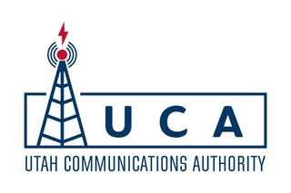
PUBLIC NOTICE OF
The Meeting of the Utah Communications Authority Governing Board

Tuesday, November 5, 2019 at 1:00 p.m.
Telephone Bridge: 877-806-9883; PIN : 633478

Anchor Location: 1835 Convention Center Drive, St. George, Utah 84790

AGENDA
- Welcome;
- Roll Call;
- Motion to Approve Minutes of September 18, 2019 meeting;
- Director’s Report and Update;
- Appointment of UCA Audit Committee;
- Presentation of September Income Statement;
- Adoption of Latest Version of Strategic Plan;
- Report from the Public Safety Advisory Committee;
- Report from the PSAP Advisory Committee;
  - Motion to Amend Minimum Standard Number 7.
- Notification of PSAP Maintenance Payments;
- Report on 35 bids (18 sites) and Motion to Amend Budget Related Thereto;
- Motion to Amend Budget re: Warehouse Expenses;
- Introduction and Communications re: VECC/SLC911 CAD Grant;
- Motion to Close Meeting to Discuss Pending or Reasonably Imminent Litigation and Attorney Client Communications;
- Motion re: Request from VECC/SLC911 to Approve Replacement CAD Project as Qualifying for Utilization of Cad Funds and Related Issues;
- General Public Comments; and
- Motion to adjourn.

