Kanosh Town Corporation held the regular council meeting on Wednesday, September 11, 2019, in the town office at 7:00 p.m.

Members present:
Mayor Frank Paxton, Councilmember's: Cleve Christensen, Neil Shumway, Rodney Whatcott, Bart Whatcott, Kanosh Town Treasurer: Karen Crook and Kanosh Town Clerk: Cindy Turner.

Others in attendance: Town Employees Lorin Shumway and Jim Cannon, Planning and Zoning spokesman Geri Minton, David Hatton, Ilene Hatton, Stan Koyle, Scott McDonald, Dan Neville, TJ Lavato, Dale Prows, Dale & Suzie Kelsch, and Suzie Perkins.
Councilmember Bart Whatcott led everyone in attendance in a moment of reverence. Councilmember Cleve Christensen led everyone in attendance in the Pledge of Allegiance.

Minutes of the August 2019 minutes were approved as amended through motion by Councilmember Cleve Christensen, Councilmember Neil Shumway provided a second to the motion, all Councilmember's voted in favor as noted below:
Mayor Frank Paxton: Aye
Council members:
Bart Whatcott: Aye
Neil Shumway: Aye
Cleve Christensen: Aye
Rodney Whatcott: Aye
Warrants for September 2019 were read discussed and approved to be paid through a motion by Councilmember Bart Whatcott, Councilmember Rodney Whatcott seconded the motion, all Councilmember's voted in favor as noted below:
Mayor Frank Paxton: Aye
Council members:
Bart Whatcott: Aye
Neil Shumway: Aye
Cleve Christensen: Aye
Rodney Whatcott: Aye

Fire Department:
Fire Chief John Hogan could not be in attendance at this meeting, he and other Kanosh volunteer firefighters are responding to the Meadow Creek fire.

CERT:
CERT Commander Geri Minton reported that at the last meeting, they discussed the possibility of purchasing new radios and needed medical supplies.

Planning and Zoning Spokesman:
Mrs. Geri Minton stated there was no action to be addressed this month.

Bid opening for the chip seal project:
Councilmember Cleve Christensen reported receiving only one bid that being from Hales Sand and Gravel in the amount of $123,600.00. They are the same people who did our chip sealing project last year. They are extremely busy right now but have committed to completing the project within our fiscal year at the bid price.
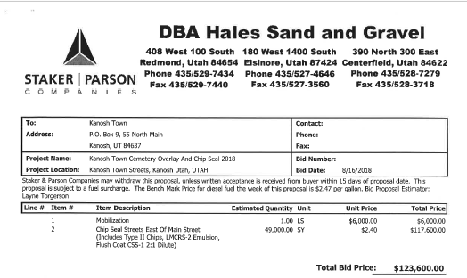
Councilmember Cleve Christensen motioned to accept the bid from Hales Sand and Gravel on the chip sealing project, Councilmember Neil Shumway provided a second to the motion, all Councilmember's voted in favor as noted below:
Mayor Frank Paxton: Aye
Council members:
Bart Whatcott: Aye
Neil Shumway: Aye
Cleve Christensen: Aye
Rodney Whatcott: Aye

Review: modification of or rescinding of land use Resolution 101012 Building Permit Exemption for Certain Agricultural and other Outbuildings
Note: Before this scheduled meeting a public hearing was held to hear public comments. Mr. Justin Wayment prepared the following Memo for the public hearing:
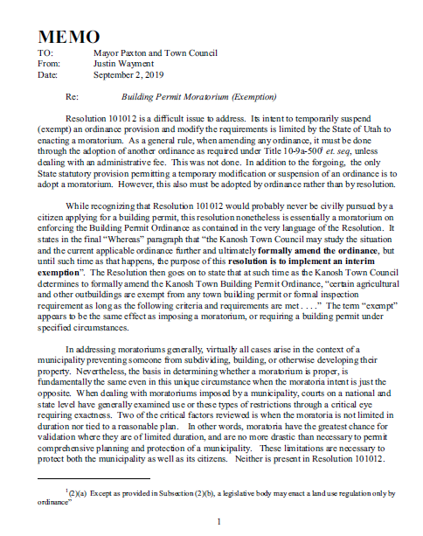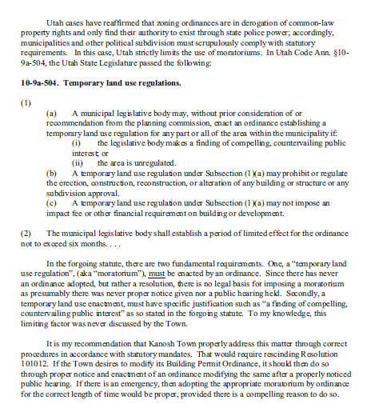

Councilmember Cleve Christensen motioned in approval of Resolution 91119 a resolution rescinding resolution 101012 Building Permit Exemption for Certain Agricultural and other Outbuildings through adoption of, Councilmember Bart Whatcott provided a second to the motion, Councilmember's voted by roll call vote as noted below:
Mayor Frank Paxton: Aye
Council members:
Bart Whatcott: Aye
Neil Shumway: Aye
Cleve Christensen: Aye
Rodney Whatcott: Aye
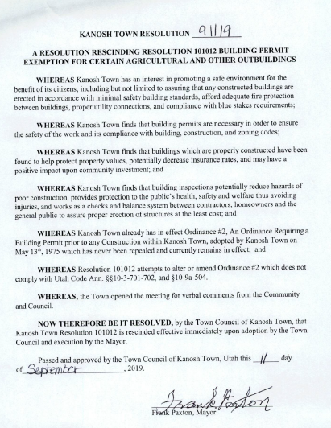

Department reports:

*Cemetery Report:
Councilmember Bart Whatcott reported that the fences are now complete, the rod iron was installed on Saturday. It is looking good. The individual who will be working on the sign similar to the welcome to Kanosh sign on the north end of Kanosh. This sign will be installed on the rod iron itself.

*Park Department
The leaks in the park have now been repaired.

Sod will be purchased for both the cemetery graves and the places in the park which need it.

*Electric Department:
Councilmember Neil Shumway noted the electrical department has nothing new to report at this time.

*Road Department:
Councilmember Cleve Christensen mentioned that a benefactor has been doing some spraying on the puncture weeds around town resulting in a very positive response.

*Water Department:
Councilmember Rodney Whatcott has spoken to Sunrise Engineering and they are still working on the survey of the spring property.

Review Utility Delinquencies:
Council members reviewed the monthly delinquency list. It was determined again to handle those accounts in arrears according to established Town policy.

Public Comments (not to exceed 3 minutes per person):
*David Hatton: extended an invitation to all in attendance to his constitution study class from 8 pm until 930 on the 12th.

*Stan Kelsh: Commented that after attending a few town meetings he gets the feeling that everyone feels like David is an idiot, David is not an idiot he just does not feel as though the government should be allowed to tell us what we can and cannot do.

Old Business:
Kanosh Town Treasurer presented the name of Trevor Davis as being eligible for his meter deposit refund, he has kept his utility billing current consecutively for two years.

The treasurer also reported receipt of a donation from Millard County Tourism to be applied to the 24th of July celebration.

There being no further business to come before the board, the meeting adjourned.

Frank Paxton Cindy Turner
Kanosh Town Mayor Kanosh Town Clerk

