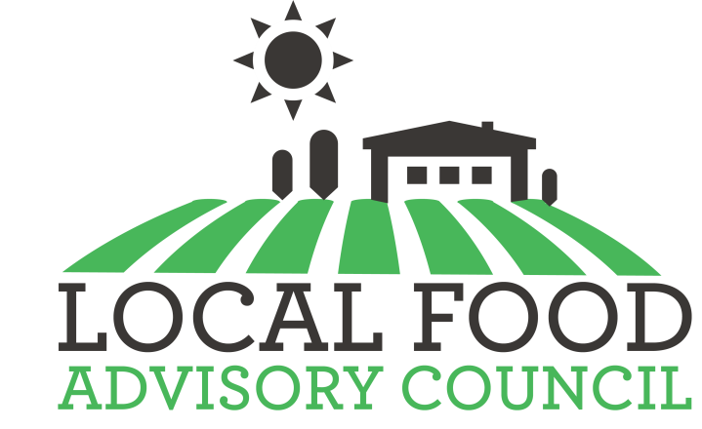

Utah Local Food Advisory Council

Agenda
August 15, 2019
2:00 pm – 4:00 pm
Utah Department of Agriculture and Food
Main Conference Room—2nd floor
350 North Redwood Road. Salt Lake City, Utah 84116

- Welcome & Introductions—Steve Handy/Gene Davis, Council 5 min.
- Review minutes--Council 5 min.
- Open Meeting Law—Mandatory annual training 30 min.
- Appropriations Requests updates 30 min.

  - Utah Produce Incentives—funded (Natalie Loots, Utah Dept. of Health)
    - Budget and implementation plan update
  - Incentivizing Local School Meals—2020 Leg. Request (Kate Wheeler, Utah State Board of Education)
    - Proposal added to UDAF FY ’21 budget
    - Report on Utah State Board of Education presentation
    - Proposal video
  - Food Hub Start-Up Fund—2020 Leg. Request (Laurie Seron, Utah Dept. of Agriculture & Food)
    - Proposal added to UDAF FY ’21 budget
    - Proposal video available to disseminate as appropriate
    - One pager to be updated
- Ogden/Weber Food Initiatives by Ogden Downtown Alliance and Farmers Market Ogden (Kimbery Bowsher, Ogden Downtown Alliance) 15 min.
- Salt Lake City Food Initiatives/SLC Food Policy Council
(Supreet Gill, SLC Corp. Sustainability Program Manager) 15 min.
- The Foundry Food Hub Project
(Hoang Nyugen, Sapa Investment Group) 15 min.

Upcoming meetings for 2020:
TBD

