MINUTES OF THE CITY OF WEST JORDAN

SPECIAL DEVELOPMENT MEETING

Thursday, May 16, 2019
12:00 p.m.
Community Room
8000 South Redwood Road
West Jordan, Utah 84088
______________________________________________________________________________

COUNCIL: Mayor Riding, Councilmember Alan Anderson, Councilmember Kayleen Whitelock, and Councilmember Chad Lamb.

STAFF: David Brickey, City Manager; Korban Lee, Assistant City Manager; Rob Wall, City Attorney; Duncan Murray, Assistant City Attorney; Brian Clegg, Public Works Director; Scott Langford, Development Services Director, and Tangee Sloan, Deputy City Clerk.

OTHER: Barrett Peterson and Ryan Peterson of Peterson Development

The meeting began at 12:05 p.m.

- WELCOME/INTRODUCTION

Mayor Riding welcomed everyone and turned the time over to Scott Langford.

- PRESENTATION OF PROPOSAL BY PETERSON DEVELOPMENT REGARDING COMMERCIAL NODE OVERLAY ZONE
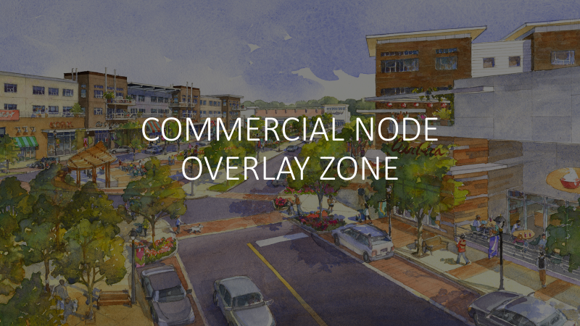
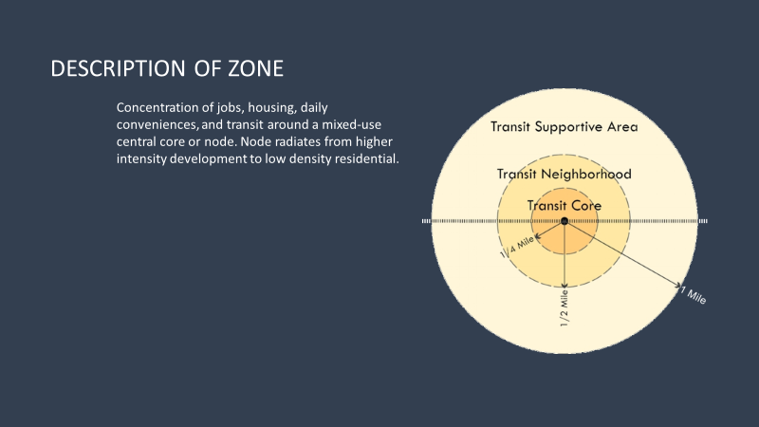

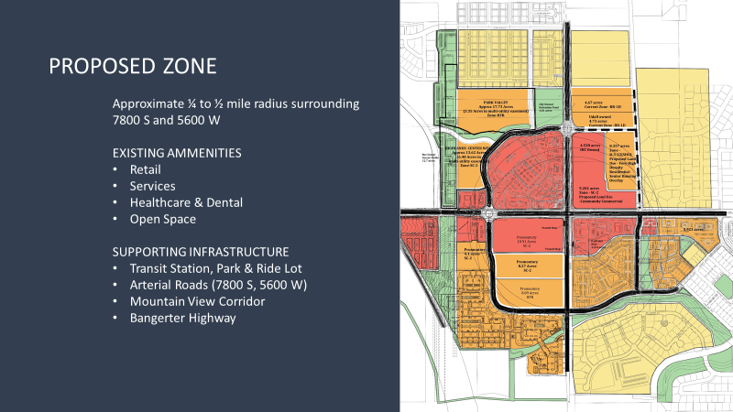

Scott Langford stated Peterson Development was aware of the overlay zone that the City Council directed staff to start working on. Peterson Development had been developing homes in West Jordan for several years and currently had a large amount of property on 7800 South 5600 West. Mr. Langford turned the time over to Barrett Peterson.

Barrett Peterson thanked the Council for taking the time to meet with them. He stated that Peterson Development had been building homes in West Jordan since the early 1990’s. The development he was currently addressing was The Highlands, located at approximately 5600 West 7800 South. He also addressed the need for density around the commercial nodes. Barrett stated they had put together the idea of a Commercial Node Overlay Zone. He believed density belonged around the corridors in this area.

Barrett stated when the Cap and Grade ordinance was put in place three or four years before, it had hurt some of their density plans in the area including Park Valley and Promontory Village. He explained they had amended their development agreement and that it was frustrating because it had already was been approved in the Master Plan.

There were two pieces of property that were zoned high density that could not be developed into attached housing or detached housing because the zone did not allow it.

- DISCUSSION PERTAINING TO A POTENTIAL AMENDMENT TO THE HIGHLANDS AGREEMENT

Mr. Peterson stated they would like to respectfully ask the Council to amend the Development Agreement where density was already planned.

Mr. Langford stated if the Council decided to amend the Development Agreement that had been approved by a past Council in 2016 and exclude Park Valley and Promontory Village from the Cap and Grade ordinance, it would not require going through the Planning Commission. Instead, it would require Peterson Development to bring in a detailed Sub Area Plan to the Design Review Committee. The Committee would potentially recommend it to the Planning Commission in a Public Hearing and then to the Council.

Mayor Riding asked Mr. Langford to read the amendment that Peterson Development had proposed.

Mr. Langford replied it would make more sense in the full context of the agreement. He said that it talked about the Cap and Grade ordinance and specific elements of the Highlands Master Plan that were exempt from the restrictions of the ordinance.

Mr. Langford stated the City Attorney’s office was in the process of reviewing other agreements that had been made between Peterson Development and the City in the context of the 2016 agreement, to make sure that if an amendment was made, it would not affect any of the other agreements with Peterson Development.

Mr. Peterson stated density belonged near commercial, transit and other density and should continue to be developed in a thoughtful way.

The City’s Planning staff was writing the interchange overlay zone. One big question they had was whether Peterson Development’s land would be included in that. If not, they felt that a commercial node overlay might work if the interchange overlay zone did not fit the property.

Mr. Langford replied that had yet was to be determined.

Mr. Peterson inquired about a realistic time frame for going before the City Council. Rob Wall explained to the councilmembers present that his office would be ready if/when the Council wished to move forward.

Councilmember Lamb replied the City should address the matter politically.

Mr. Peterson replied that Peterson Development’s hands were tied as they currently could not develop the land. It would take a year and a half to get through the planning process.

Councilmember Whitelock asked if Peterson Development had funding for the project. Mr. Peterson replied in the affirmative.

Mr. Peterson said they were reinstating the density from 9 to 18 units for the acre buffering the Ivory property when the development plan was brought in.

The Council discussed the development plan and agreement at great length.

Mr. Wall explained to Mr. Peterson that if there were things the Council was expecting the developer to do in order for the rezone to be approved, a more significant amendment of the development agreement would be necessary. Was the buffering already a requirement or did it need to be added to the agreement?

Mr. Langford said the amendment allowed them to move forward in the process. The process would still require a separate Development Agreement and a separate Development Plan.

Mr. Wall addressed the Council when he stated that the discussion was headed down a path wherein the parties agreed to ‘agree later’ and they knew how he felt about that as their attorney. He felt there needed to be more discussion and that based on what he had heard, the matter was not yet ready to go before the entire City Council.

Councilmember Anderson wished to move forward with the process.

Mr. Peterson stated that his company had been patiently waiting for the Cap and Grade ordinance to be repealed but that had not happened. Their hands were tied, yet the Our hands are tied yet the City wanted a great deal of help from them on a water line. He stated that Peterson Development needed some help from the City as well-- and in a timely manner.

Mr. Wall pointed out that City staff had spent over 100 hours attempting to reconcile the five current Peterson Development Agreements. The City had previously approved agreements but never reconciled them with one another. He now needed to go over the agreement with Mr. Langford and Duncan Murray. He made it clear that he was not attempting to stone wall or put Peterson Development off.

Ryan Peterson asked if it was fair to say that Mr. Wall’s point was more about the various development agreements rather than the buffering issue.

Mr. Wall stated that it was a combination of the two. The problem with the five prior agreements was that they did not match up. He also stated he did not believe it would take two months to finish the agreement but he did not believe it was ready to be placed on agenda.

Mayor Riding thanked the Petersons for meeting with the City and the meeting adjourned.

______________________________
JIM RIDING
Mayor

ATTEST:

_____________________________
TANGEE SLOAN
Deputy City Clerk

Approved this 17th day of July 2019

