
3330 South 1300 East
Millcreek, UT 84106
801-214-2700
millcreek.utah.gov

File # LUHO 2019-013

Land Use Hearing Officer Summary and Recommendation

Request Type: Enlargement of a Non-complying Meeting Date:
Structure
Parcel ID: 16-35-405-015 Current Zone: R-1-8
Property Address: 3820 S. Birch Drive Community Council: East Millcreek
Applicant Name: Jon Warren
Owner: Kerry and Alex Gonzales
Planner: Blaine Gehring, AICP
Planning Staff Recommendation: APPROVAL
PROJECT DESCRIPTION
Jon Warren, acting as contractor for the property owners Kelly and Alex Gonzales, is requesting an enlargement of a non-complying structure in the R-1-8 zone. The existing structure is non-complying because of its south side yard setback of 2 feet. The Gonzales would like to add an addition to the existing structure by enclosing a covered porch and walkway. The existing carport is setback 2 feet from property line making the home non-complying. No evidence of the carport being built with a building permit has been found. Staff finds that the enclosure of the porch and covered walkway will fit within required setbacks. Addition to the non-complying structure is in keeping with the spirit of Chapter 19.88 of the Millcreek Zoning Ordinance which requires authorization by the Land Use Hearing Officer and would not object to the hearing officer issuing a permit for the porch and walkway enclosure in this case.

19.04.380 - Noncomplying structure.
"Noncomplying structure" means a building or other structure or portion thereof lawfully constructed in compliance with the zoning ordinance existing at the time of construction, that no longer conforms to the height, area and/or yard regulations in the zone in which it is located due to changes to the zoning ordinance or to subsequent public acquisition of land for public improvements.
19.88.070 - Additions, enlargements, moving and reconstruction of a structure.

A. A noncomplying structure or building occupied by a nonconforming use shall not be added to or enlarged in any manner or moved to another location on the lot or reconstructed at another location on the lot except as provided by subsection B of this section unless such additions and enlargements comply with the regulations and intent of this title.

B. A building occupied by a nonconforming use or a noncomplying structure may be added to or enlarged or moved to a new location on the lot or reconstructed at a new location on the lot upon a permit authorized by the land use hearing officer, provided that the land use hearing officer shall find:

1. The addition to, enlargement of, moving of, or reconstruction of the structure at a new location on the lot is in harmony with one or more of the purposes of this title as stated in Section 19.02.020 of this title, and is in keeping with the intent of this title;
2. That the proposed change does not impose any unreasonable burden upon the lands located in the vicinity of the nonconforming use or structure.

19.02.020 - Purpose of provisions.
This title is designed and enacted for the purpose of promoting the health, safety, morals, conveniences, order, prosperity and welfare of the present and future inhabitants of City, including, among other things, the lessening of congestion in the streets or roads, securing safety from fire and other dangers, providing adequate light and air, classification of land uses and distribution of land development and utilization, protection of the tax base, securing economy in governmental expenditures, fostering the City's agricultural and other industries, and the protection of both urban and nonurban development.

19.88.150 - Application to have a structure declared a noncomplying structure.
Whenever a structure is in violation of the height or setback provisions of this title, the owner may file an application with the director or director's designee to have the structure declared noncomplying. The director or director's designee shall approve the application when the evidence clearly establishes the following: A. The structure has existed at its current location, with the same size, height and setbacks for at least ten years; B. The structure is found by the building official or designee to pose no threat to the health or safety of persons in or around the structure, and; C. The City has not taken enforcement action for the violation for a period exceeding five consecutive years during which the violation existed.

Planning Staff has declared the existing home as a non-complying structure, since it meets all of the requirements mandated by Section 19.88.150.

SITE AND VICINITY DESCRIPTION
The subject property is located in a residential neighborhood adjacent to single-family homes in an R-1-8 Zone. s.
Property Site

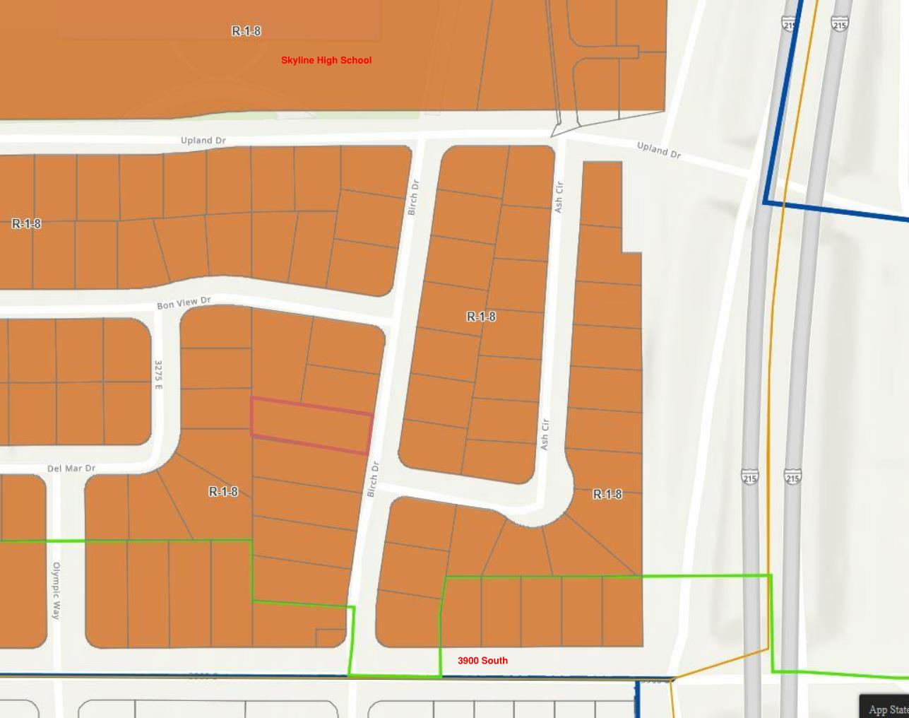
LAND USE CONSIDERATION
The home was built in 1953. A carport cover was added some time in the past however, no record has been found that the cover was done legally with a building permit. It sits just 2 feet from property line on the south lot line.

Aerial Map
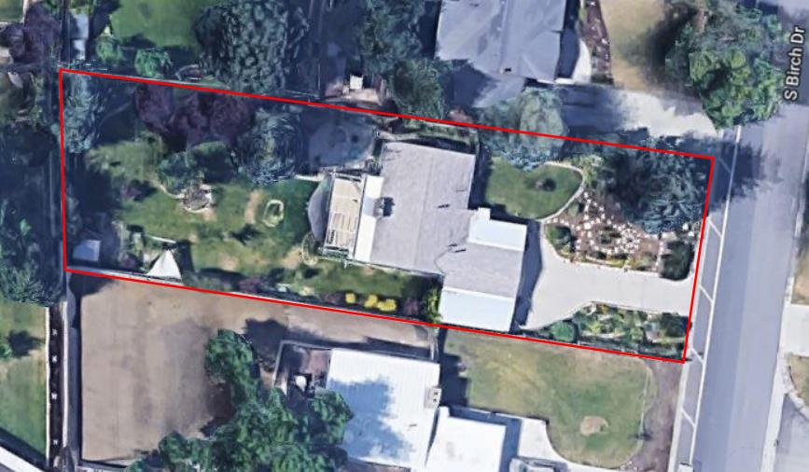

Existing Site Plan
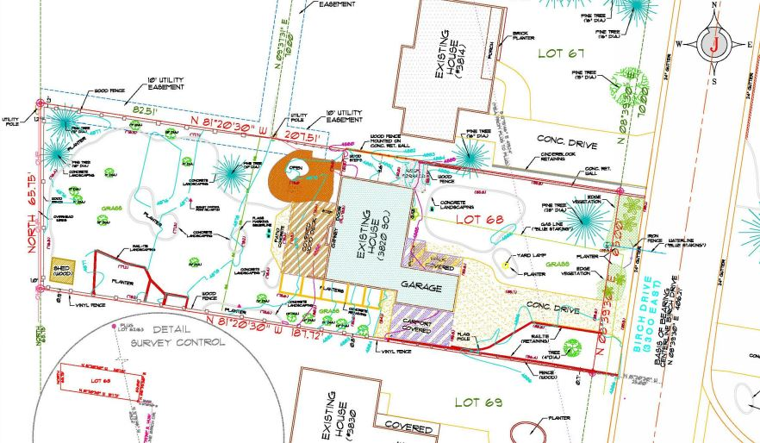

Proposed Site Plan
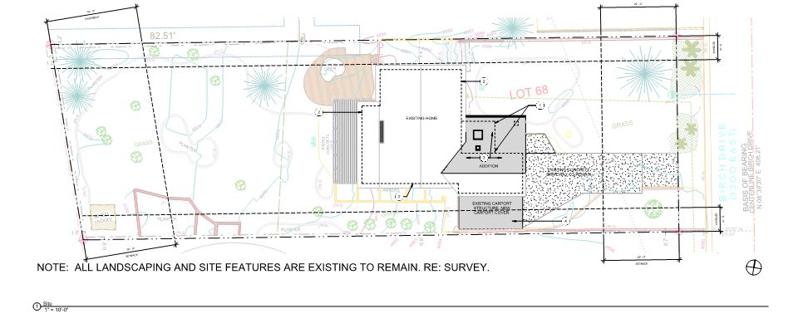
ISSUES OF CONCERN/PROPOSED MITIGATION
Staff has concerns about the non-conforming carport. Without evidence of this being legally built, it must be considered an illegal non-conforming use. Staff’s question is should it be brought into compliance with existing ordinance requirements?
PLANNING STAFF RECOMMENDATION
Based on a review of the plans submitted for a building permit, planning staff determined that the existing structure is not a legal noncomplying structure, and that the proposed addition qualifies for a hearing by the land use officer under the provisions of §19.88.070 (B) of the Millcreek Code.

The new addition would maintain the conforming front, rear and north side yards but would not meet the current required side yard setback on the south property line.
Staff recommends a finding that the project is in harmony with the purposes of the City’s zoning ordinance by upgrading the existing home and adding the enclosed porch and walkway in compliance with the R-1-8 Zone. The applicant’s request is not seeking exceptions to any Millcreek Ordinance and the change will therefore be compatible with the neighborhood.

Staff recommends a finding that this property does not impose any unreasonable burden upon the lands located in the vicinity of the noncomplying structure. The proposed expansion will maintain the current use and density but will upgrade the residence with new construction and is consistent with the historic pattern of development in the neighborhood.

For the above reasons, staff recommends approval of the request to expand a non-complying structure as provided in the exhibits in the staff report.

