Kanosh Town Corporation held the regular council meeting Wednesday, April 10, 2019, in the town office at 7:00 p.m.

Members present:
Mayor Frank Paxton, Councilmember's: Cleve Christensen, Neil Shumway, Rodney Whatcott, Kanosh Town Treasurer: Karen Crook and Kanosh Town Clerk: Cindy Turner. Councilmember Bart Whatcott was unable to attend this meeting.

Others in attendance:
Kanosh Town Attorney Justin Wayment, ULCT Attorney David Church, Kanosh Town Employee/ Kanosh Town Fire Chief John Hogan, Planning and Zoning committee members Ed Phillips, Blaine Blad, Hayden George, Geri Minton, Jens Christensen, David Hatton, Ilene Hatton, Thayne Christensen, Stan Kelsch, Suzie Kelsch, Dale Kelsch, Austin Kelch Tamera Kimball, Marjean Christensen, Stan Koyle, Sharon Taylor, Tali Whitaker, Jessica Whitaker, Brian Batt, Bob Davidson Beaver Lawn and Landscape. Brandon Stephenson,

Councilmember Neil Shumway lead all in attendance in a moment of reverence. Councilmember Cleve Christensen lead all in attendance in the Pledge of Allegiance.

Minutes of the March 2019 minutes were approved as amended through Councilmember Cleve Christensen, Councilmember Rod Whatcott provided a second to the motion, all Councilmember's voted in favor through roll call as noted below:
Mayor Frank Paxton: Aye
Councilmembers:
Neil Shumway: Aye
Cleve Christensen: Aye
Rodney Whatcott: Aye

Mayor Paxton read a note from Councilmember Bart Whatcott:
Please excuse me from this next town council meeting. I request that the below-listed items be read as my personal comments for the Parks and Cemetery;

Peter Davis has been contacted to continue the job as the caretaker for the Kanosh Town Cemetery for 2019. I told him that the job would once again start on April 15th (Monday) and stop on October 15th of this year. He seemed excited to resume his work on taking care of the cemetery. He has done a great job for us in the past.

I have contacted Liz Whitaker and she is giving the new updated burial information to Sunrise Engineering. So we can get updated information inside the directory kiosk at the cemetery prior to Memorial Day. I am having the veteran burial's plots highlighted in yellow so families can easily find a grave if their relative was a veteran. Fillmore has the same color marking for veterans also. I have also contacted Kelly Gillins at Sunrise and he is aware that Liz will be contacting him sometime next week.

I met with individuals from the Bureau of Land Management (BLM), Chad Kunz, Teresa Frampton, and Kyle Monroe. We discussed the BLM project; the Pahvant Valley Heritage Trail (PVHT). They have been working on this project over the past 10 years. Signage and other small improvements have been made to the trail during this time and this year they have finally been able to secure funding to fabricate and install interpretative panels along the trail. The kiosks will enhance the visitor experience as they visit the points of interest along the Pahvant Valley Heritage Trail and possibly increase the number of visitors to Kanosh as it will be a starting point or an ending point depending on where an individual started their trek. I feel that this could possibly help our community with visitors visiting our country store and gas station. The three communities that will have the kiosks installed will be Delta, Fillmore and Kanosh. There will be historical points along the way that can be accessed by truck or car. The labor to fabricate and installation costs will be paid for by the BLM. They just need a highly visible place in the communities for the sign to be placed. The timeline for installation of the kiosk is not known yet but it could possibly be installed by the middle of July of this year. The spot that I have selected to facilitate the BLM panel installation is just north of the city building between the curb and sidewalk. I told the BLM that we could have a slab of cement poured with the approval of the Town Council. It would make a great Eagle Scout project I feel. I have already talked with Stan Koyle and Jessica Whitaker to let them know this is a possibility. We just need to have a place prepared. I have contacted Bryce Whitaker with the State Road Department, and he said that the installation of the sign where I described would be ok. The sign is 47" X 47". I have attached a picture of the sign.

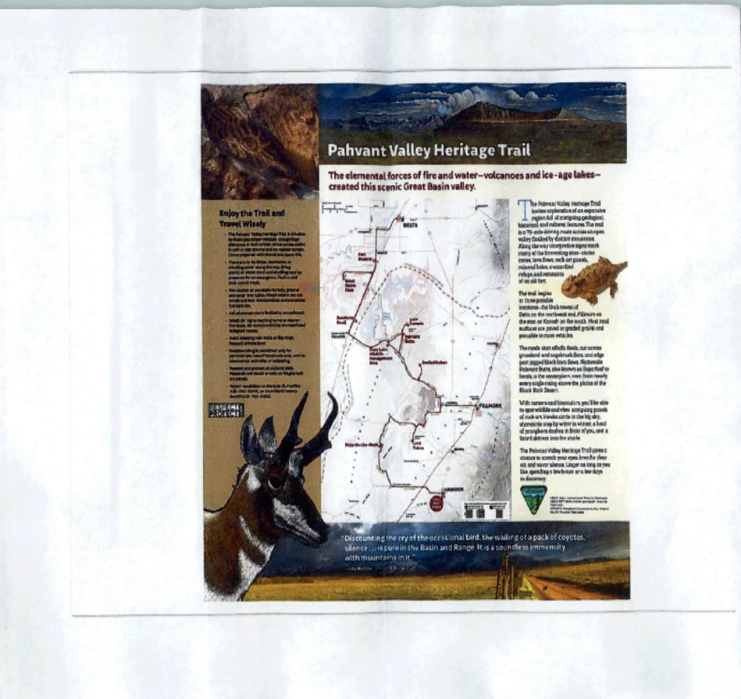

Warrants for the month of March were read discussed and approved to be paid through a motion by Councilmember Neil Shumway, Councilmember Rodney Whatcott seconded the motion, all Councilmember's voted in favor as noted below:
Mayor Frank Paxton: Aye
Councilmembers:
Neil Shumway: Aye
Cleve Christensen: Aye
Rodney Whatcott: Aye

Easter Egg Hunt:
Tali Pardo addressed Councilmembers in reference to the Kanosh Town Easter Egg Hunt, through the financial support of $190, she has volunteered to spearhead this event. Councilmember Cleve Christensen made the motion to approve 190$ for the Kanosh Town Easter Egg hunt, Councilmember Neil Shumway provided a second to the motion, all Councilmembers voted in favor.

Kanosh Town Fire Department:
*Kanosh Town Fire Chief John Hogan reported efforts to recruit new members are continuing.
*4.11.19 the Dominion Energy training on handling natural gas will be at the firehouse at 7:00 pm. General Public is encouraged to attend. The gas supervisor out of Cedar City will provide a safety orientation. Chief Hogan stressed the importance of "calling before you dig" the gas lines in Kanosh Town are not uniform.
*5.8.19 at the Kanosh Town hall at 6:00 the sexual harassment training will be presented, this training is also open to the public.
*The volunteers are already preparing for fire season, the heavy spring rains usually result in a lot of ground fuel.

CERT: Kanosh CERT Captain Geri Minton:
Commander Minton reported attending the monthly meeting of the CERT association, with the Millard County Sheriff's office. The emergency coordinator is Shane Brunson. There has been a change of title for the executive board officers from Commander and Co-Commander to Captain and co Captain, this was passed. Together, the CERT bylaws are being reviewed and revamped, nothing has yet been approved since there were so many CERT members absent from this meeting. All members will be notified that at the next monthly meeting the various changes will be addressed in the bylaws.

Planning and Zoning:
Planning and Zoning Chairman Ed Phillips: reported on the April 2 meeting, where 2 projects were presented and ready for review and approval, each were unanimously voted on in favor of by the Planning Commission. Each appeared to meet all criteria and requirement.

*Brian Batt: is seeking approval to build a home on the north end of town. The plan is to begin sometime in mid-May. Councilmember Neil Shumway motioned in approval of the building permit as presented, Councilmember Rod Whatcott provided a second to the motion, all in favor.

*Penney and Robert Poulsen presented plans for a shed to cover motor home. Councilmember Cleve Christensen motioned in approval of the building permit as presented, Councilmember Rod Whatcott provided a second to the motion, all in favor.

*Tamera Kimball then addressed the Councilmembers questioning whether or not she would require a building permit for an out house. Mrs. Kimball had met previously with the Planning and Zoning Commission and they had no objection to the out door latrine. This is a building under 200 square feet, the only concern voiced over this construction would be if there was any conditions set by the County Health department. Councilmember Cleve Christenson will follow up.
Bob Davidson, Beaver LawnScape:
Mr. Davidson is the owner of Beaver LawnScape. Mr. Davidson met together to address the needs of Kanosh Town in reference to vegetation control after which they were able to put together a plan. The below plan was presented a plan to the council for approval. Following a careful review of the proposal Councilmember Cleve Christensen made motion to accept and sign an agreement proposal with Beaver LawnScape, Councilmember Rodney Whatcott provided a second, all Councilmembers voted in favor.
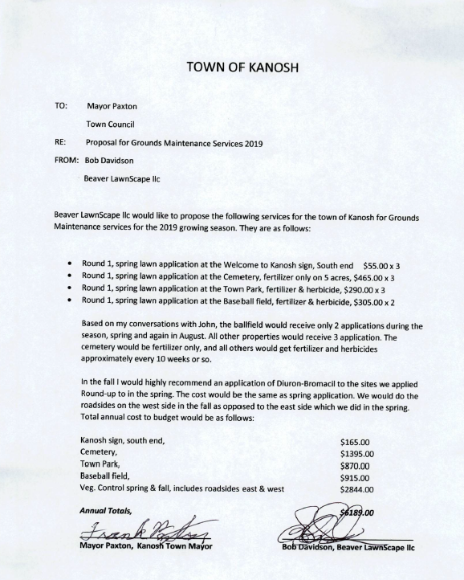

David Hatton: Petition
David Hatton: Presented the following Petition to the Councilmembers addressing:
1. Freedom of Speech
2. Freedom of Press
3. Business Licenses
4. Land use Ordinance
Ilene Hatton read the petition for the record.
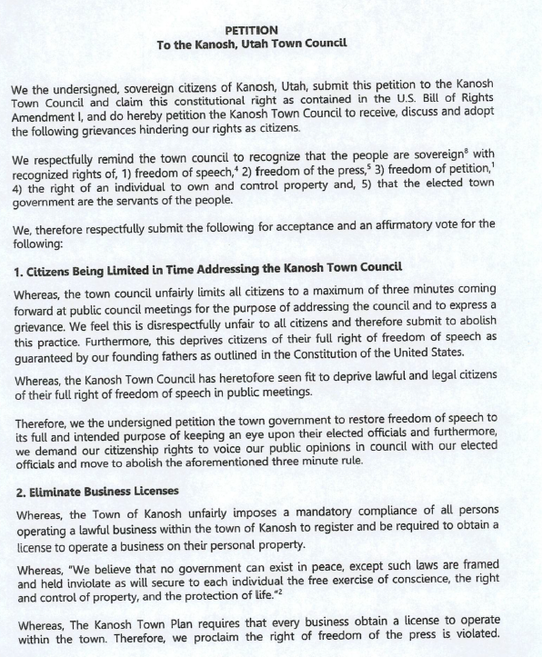
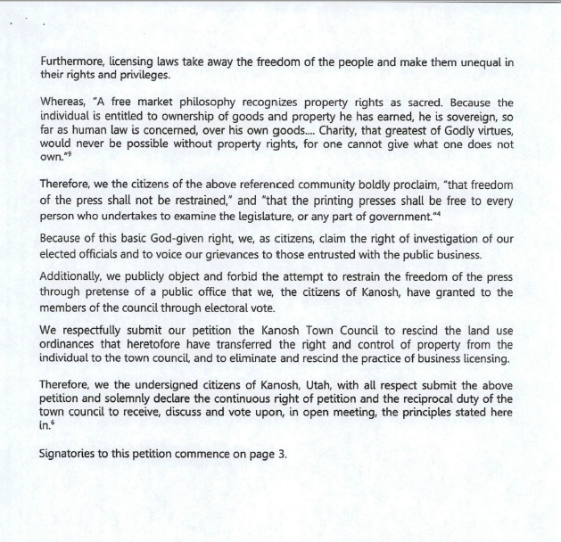

Note: Signature pages have not been included in these minutes. Mayor Paxton inquired
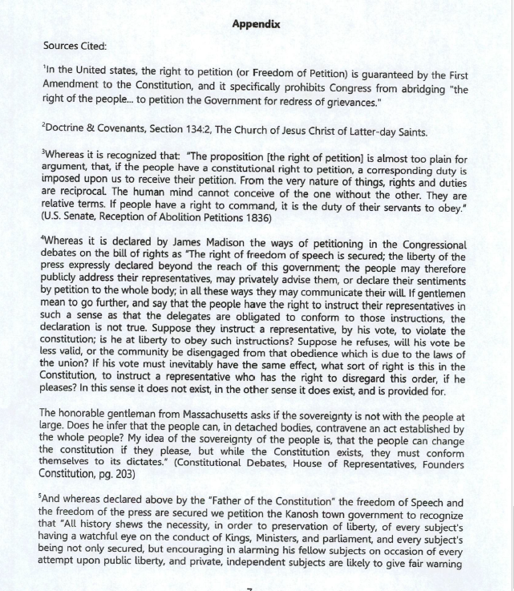
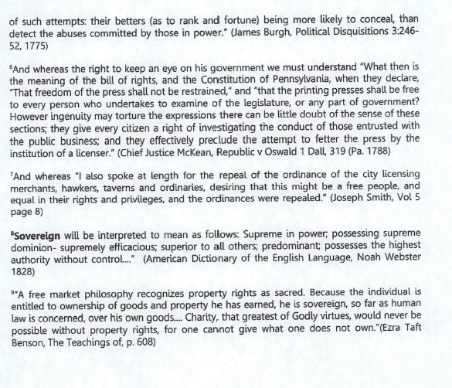
David Hatton stated that the Town has the duty to receive, discuss and vote on the principals, they are not required to adopt them, therefore, Mr. Hatton ask each Councilman what their view is on the 3 minute limit of the freedom of speech:

*Councilman Neil Shumway stated that maybe 3 minutes is on the small side but there should be a reasonable expectation, that we should not be here all night. Believing that there is a reasonable way to meet that. There are ways, just as you have done, to get on the agenda and address a specific need, I believe that the public comment section of the meeting is for brief comments, not requiring any action, just to comment. I don't know that we need to have unlimited time, it does need to be reasonable.

*Mayor Frank Paxton replied, with all do respect, I like it just the way it is.

*Councilman Cleve Christensen indicated he would lean to adjusting it to a 5-minute rule but if we want to keep entertaining the comment past that at the will of the council, we would except that. I believe 5 minutes is plenty of time to voice your opinion.

*Councilman Rodney Whatcott commented that he does not believe that the freedom of speech is not reduced by having a 3 minute limit, I believe that having a public comment in a public meeting is a freedom of speech. To be limited to a period of time, I do not believe that infringes that. Maybe 3-minutes is short for certain topics and maybe an eternity for other topics. If it needs to be adjusted then it can be, but I do believe a time limit is necessary.
Mr. Hatton stated that Salt Lake City has a 5 minute time limit. He then stated that an individual here stood and ask to address those in attendance after others had already spoken, the meeting was closed. Another time, the Citizen got up and read a paper written by a government official, the meeting was 41 minutes long and the next time the government body met 2 minutes was the restriction. It appears on the surface that although there has not been a 3 minute limit in all the history of Kanosh, and Kanosh has not grown, that these restrictions were aimed at certain people who they did not agree with and did not want to listen to.

Mr. Hatton then questioned if there were any other questions or comments noting that in the petition anyone could participate at the end of the discussion.

*Mrs. Tamera Kimball questioned what kind of place would this be without guidelines.

Mr. Hatton responded by stating that a man by the name of Joseph Smith attended a city council meeting and exhorted him at length to rescind the business licensing law because it took away the freedom of the people and made them unequal in their rights and privileges. That is what a licensing law does.

The general consensus of those in attendance was that there needs to be order in all things.
*In reference to the land use ordinance, Mr. Hatton stated, once again the constitution says that the people are sovereign. James Madison says that the very definition of sovereign has no superior, has full ascendency, has all power. Allodial land title is a real property ownership system where the real property is owed free and clear of any superior landlord, this is what sovereign means. When you pass a land use ordinance it tells the citizens they are no longer sovereign, the Town Council is now sovereign. So instead of being a servant of the people the Town Council now becomes the master and once again sovereign on your property, sovereign on your neighbors property if he encroaches upon you, any of the situations that you talk about he has a constitutional provision which is called tort law. Mr. Hatton offered several other examples which are not included in these minutes.
Ilene Hatton stated that the group of individuals who have signed this petition would just like to make the Councilmembers aware of their concerns. Mr. Hatton thanked the Council for "honoring their petition".

Mr. Hatton stated to complete the petition process it must be voted upon. Mayor Paxton deferred comments to the Kanosh Town legal counsel.
Mr. David Church commented "it would be polite to eventually make a decision on this, but under our Utah Public Meetings Act it would require an agenda item. He also pointed out that on the agenda for later, the Rules of Procedure for Public Meetings of the Town, which will cover the number of minutes. Obviously if we were going to vote to repeal the Zoning Ordinance, Business Licensing Ordinances etc. the law would require a public hearing before the Planning Commission and some other things before it could be voted on. In order to repeal the business licensing ordinance you would have to prepare an ordinance that would have to be available in advance so it could be voted on. What could be done, would be for the Mayor to ask the Council if there are other than the Rules of Procedure, that these items be placed on the agenda at a future date so instruction could be given to the city attorney to prepare the appropriate documents so people would either know that you are moving forward with it with some changes or not."
Councilmember Rodney Whatcott made the motion to go into closed session to for the purpose to discuss strategy on pending legal issues, Councilmember Cleve Christensen seconded the motion, all Councilmember's voted in favor as noted below through a roll call vote:
Mayor Frank Paxton: Aye
Councilmembers:
Neil Shumway: Aye
Cleve Christensen: Aye
Rodney Whatcott: Aye

Mr. David Church noted that the pending litigation he will be discussing with the council names Ed Phillips as a defendant and therefore it would be appropriate to invite Mr. Phillips in for at least that part of the litigation. Councilmembers concurred.

Councilmembers, Attorney David Church, Attorney Justin Wayment, Ed Phillips and Kanosh Town Clerk Cindy Turner assembled into a closed session at 8:50 p.m.

.
The Public was invited back into the regular Kanosh Town Corporation meeting at 9:43.

For the record: Mr. David Church is an attorney who has been assigned to represent Kanosh Town in one of the lawsuits, that being the one between TJ Lavato vs. Kanosh Town and Frank Paxton and Edgar Phillips. The plaintiffs are being represented by Mr. Todd Macfarlane, he has indicated that he is going to amend the complaint to add an additional defendant, Mr. Bart Whatcott and an additional plaintiff Mr. David Hatton.

Mr. David Church addressed the council and all in attendance stating that when Mr. Macfarlane called to indicate the additions, Mr. Church indicated to him that in reviewing his complaint it appeared that the Town would have a good chance of success on most of the allegations in the complaint but that there were some problems with some of the Towns procedures regarding the planning commission and the open and public meeting act. They entered into some discussion about how this could be resolved quickly and try to bring a little more peace in the valley at least on this one issue. Mr. Church and Mr. Macfarlane negotiated a potential agreement, the first step in the agreement is for the town to consider whether or not they would be willing to enter into the agreement with the plaintiffs and then the individually named defendants would also have to agree and of course the individual plaintiffs would also have to agree to it.

For the record, Mr. Church provided a summarization of the proposed settlement agreement requires the Town to do as a condition of settlement and then he invited the Council to give him instruction through formal action on behalf of the Town. What the agreement would do is, as you recall one of the issues that came up and lead to the lawsuit was how the repeal of Town resolution 101012 which dealt with building permits for agricultural buildings in the town. We would agree as part of the settlement that the action taken to repeal the resolution in October 10th 2010 was null and void and would agree that if the Town decides to take future action to repeal it, not agreeing that we won't or that we will, but we would agree that if we did that we would treat it the resolution as a land use regulation and would first run the issue of the repeal through the planning commission process, public hearing process and then bring it back to the Town Council. We would also agree that as we are required by law, that the Kanosh Town Council and Planning Commission will be trained in the provisions of the open public meetings act on an annual basis and make reasonable efforts to comply with it. Which is just a statement of what we are doing and what the law requires. We would also agree under this that we would adopt written formal rules of procedure for both the planning commission and the Town Council. That would include in them a provision that all agendas would have a public comment portion on them. We are required by State law to have a rules and procedure for both our meetings. We have obviously had some informal policies in the past, this will formalize those and put them in writing for everyone to see. We would also agree that in order to protect people from the appearance of bias, that since the Mayor and Mr. Phillips and Mr. Whatcott have been named personally in the lawsuit by Mr. Lavato and Mr. Hatton and their attorney, that when matters of an administrative type come before the town, to make sure that there is not the appearance of bias or conflict of interest because of the lawsuit, that the Mayor would recues himself from participating in administrative decisions and Mr. Whatcott would and Mr. Phillips would when it dealt with those three individuals, Mr. Macfarlane, Mr. Hatton or Mr. Lavato. Administrative matters are not legislative matters, administrative matters are when you hand out permits, shut off water, take action through policy. We are not agreeing that they would not participate in the normal legislative, making policy that kind of thing for the Town. Lastly, we would acknowledge that the powers of the municipal government municipality operated under the 5 member council form of government are vested in a council consisting of 5 members, one of which is the Mayor and that any legislative enactment including ordinance, resolution or any action which would create a liability against the municipality requires a recorded roll call vote of the council, which is just a statement of the law. Our insurance company has agreed to reimburse the plaintiffs $7,500.00 for their costs and attorney fees in bringing the law suit. That is what we were told the plaintiffs would accept, they have not signed yet or have not accepted it, the status on their side is unknown. Mr. Church indicated he would desire from the Town, where the Town is on this settlement and then of course the individual defendants would have to decide for themselves as they would also have to submit their signatures.

Councilmember Cleve Christensen made motion that the Mayor on behalf of the Town of Kanosh to pass, adopt and sign the stipulation settlement agreement and release of claims subject to the individual parties approval and execution along with Plaintiffs approval of the same. Councilmember Neil Shumway seconded the motion, all Councilmember's voted in favor as noted below through a role call vote:
Mayor Frank Paxton: Aye
Councilmembers:
Neil Shumway: Aye
Cleve Christensen: Aye
Rodney Whatcott: Aye

Justin Wayment; Kanosh Town Attorney:
Mr. Wayment stated that back in 2013 all Towns were required to adopt a Meeting Policy and Procedures, unfortunately Kanosh Town did not have Counsel that was helping the Town with that, Kanosh Town had one informally and have followed it fairly well, but there should be one in place. Mr. Wayment read form the "Purpose" portion of the document: In order to conduct the public's business in an open and efficient manner, the Town Council of Kanosh Town, Utah hereby establishes rules of order and procedures for public meetings of the Town, including, but not limited to, the Town Council, Planning Commission, and other Town Boards. These procedures and policies are to ensure (a) order and procedure; (b) ethical behavior; and (c) civil discourse. (See U.C.A. 10-3-606) Nothing herein is intended to control content, intimidate or silence an individual, but is only intended to provide efficient means of carrying on the public business. Furthermore these procedures and policies do not deny any other alternative means of communication on city matters, including providing documents for public record without redaction on a basis of content. Note: the Kanosh Town Public Body meeting Policy and Procedures document can be seen in it's entirety following these minutes.

Councilmember Rod Whatcott motioned that we adopt ordinance no 04102019 A Ordinance of the Governing Body of Kanosh Town Adopting Rules of Procedure for the Public Meetings of the Town, Councilmember Cleve Christensen provided a second to the motion, all Councilmember's voted in favor as noted below through a role call vote:
Mayor Frank Paxton: Aye
Councilmembers:
Neil Shumway: Aye
Cleve Christensen: Aye
Rodney Whatcott: Aye

Mayor Paxton asked each department head if there was anything to report from their respective department:
Councilmember Neil Shumway: Electrical Department had nothing new to report at this time.
Councilmember Cleve Christensen: Road Department had nothing new to report at this time.
Councilmember Rodney Whatcott: Water Department had nothing new to report at this time.

Review of Delinquencies:
Councilmembers reviewed the monthly delinquency list. It was determined, again, to handle those accounts in arrears according to established Town policy.

Public comment:
- Stan Koyle: Seems odd that David Hatton has been added to the plaintiff portion of this lawsuit, when he was chairman of the Planning and Zoning Chairman for several years and could have had control of it then, instead of where we are now. Just a comment, it just seems odd. In reference to the names on the petition discussed tonight, I think that people need to know that when they sign off on something it is a matter of public record and they are not just signing off on it because someone told them a song and dance that they think they could sign off by way of getting rid of them. I would like to see the list, maybe is should be posted.
- Sharon Taylor: As a citizen of Kanosh, I would like to Thank the town council for all the time you put in and all the work you do behind the scenes. We appreciate it.
- Ed Phillips: spoke on behalf of the anonymous donor. There was a man who left a sizeable estate, he had no heirs who cared about him so he left his entire estate to no individual. He left it to the Town and the people of the Kanosh area. He also requested that Ed Phillips be his power of attorney when it was needed. As the successor or trustee of the estate he left the final judgment of any distribution to Ed.
- John Hogan:–there has been an anonymous donor volunteer to pay for the roof repairs on the shop as well as the repairs to the meeting hall roof.

Old Business:
*F450 truck repairs: There has been an anonymous donor volunteer to pay the remainder of the repair bill.
*Clean up: The Kanosh Town clean up begins on 4.15.19 and will be posted on the power bills and on the Face book page.
*24th of July: the first committee meeting is scheduled for the 23rd of April @ 6:30 pm

There being no further business to come before the board, the meeting adjourned.

Frank Paxton Cindy Turner
Kanosh Town Mayor Kanosh Town Clerk

