Kanosh Town Corporation held the regular council meeting Wednesday, March 13, 2019, in the town office at 7:00 p.m.

Members present:
Mayor Frank Paxton, Councilmember's: Cleve Christensen, Bart Whatcott, Rodney Whatcott, Kanosh Town Treasurer: Karen Crook and Kanosh Town Clerk: Cindy Turner.

Others in attendance:
Kanosh Town Attorney Justin Wayment, Kanosh Town Employee/ Kanosh Town Fire Chief John Hogan, Planning and Zoning committee members Blaine Blad, Hayden George, Geri Minton, Jens Christensen, and Ed Phillips. David Hatton, Ilene Hatton, Todd Macfarlane, Thayne Christensen, and Katie Stephenson.

Minutes of the February 2019 minutes were approved as amended through Bart Whatcott, Councilmember Cleve Christensen provided a second to the motion, all Councilmember's voted in favor as noted below:
Mayor Frank Paxton: Aye
Councilmembers:
Bart Whatcott: Aye
Cleve Christensen: Aye
Rodney Whatcott: Aye

Warrants for the month of March were read discussed and approved to be paid through a motion by Councilmember Bart Whatcott, Councilmember Rodney Whatcott seconded the motion, all Councilmember's voted in favor as noted below:
Mayor Frank Paxton: Aye
Councilmembers:
Bart Whatcott: Aye
Cleve Christensen: Aye
Rodney Whatcott: Aye
CERT: Kanosh CERT Captain Geri Minton
*Captain Minton presented the CERT meeting schedule for the year to each of the Councilmembers.

*Captain Minton received a telephone call from the new emergency coordinator through the Millard County Sheriff's office. She was invited to and attended the Millard County CERT meeting. Shane Brunson is the new Millard County emergency coordinator, Ester Duncan is the new Commander (she served as the co-commander last year). There have been several Millard County CERT team members resign. Following the CERT meeting, Mrs. Minton attended a meeting with Sheriff Jacobson and Shane Brunson, wherein it was noted that there will be several revisions in the Millard County CERT to include the Bylaws. Regardless, Kanosh CERT and Millard County CERT have now taken positive steps to resolve their differences.

Fire Department Report:
*Council member Bart Whatcott commended Mrs. Geri Minton on her organization of the fire station. Mrs. Minton reported the fire department has a new refrigerator, a new commercial washing machine (donated), and a new bulletin board.

*Fire Chief John Hogan reported things are going well with the fire department, we have a couple of new members.

*Chief Hogan attended a meeting of County planners where actions concerning flooding sandbagging were addressed. This meeting is held quarterly, as Kanosh Town Fire Chief, Mr. Hogan will plan to attend the meeting regularly.

The Fire Department has two pieces of training scheduled in April:
April 11th at the firehouse at 6:30: Dominion Energy will give a gas safety training
April 10th Division of Labor is going to present sexual harassment, this will be a mandatory meeting for all firefighters. This will be 1-hour training, possibly a little longer if she includes workplace harassment. This will be documented training. Council members and the planning commission are also invited to attend. This training will be scheduled for @6:00 at the Kanosh Townhall.

Planning and Zoning:
*Building Permits: Mrs. Geri Minton presented Thayne Christensen's building permit for a shed to the Council for approval at this time, the permit has been reviewed and approved by the planning and zoning committee. Council members reviewed the permit and everything is in order and all fees have been paid. Following Council review, Councilmember Cleve Christensen motioned in approval of the permit as presented, Councilmember Bart Whatcott seconded the motion, All Councilmembers voted in favor as noted below:
Mayor Frank Paxton: Aye
Councilmembers:
Cleve Christensen: Aye
Bart Whatcott: Aye
Rodney Whatcott: Aye

Kanosh Town Attorney Justin Wayment "Open and Public Meetings Act"
Mr. Wayment provided the annual Utah Open Meeting training for everyone in attendance to include the Planning Commission members and Fire Chief.

Every year under the statute we are required to have the open meeting training, The presiding officer of the public body shall ensure that the members of the public body are provided with annual training on the requirements of Utah Code Title 52 - 4
Note: Please see a copy of Utah code 52-4 following these minutes.

The following is a summary of the Key Provisions of the Open and Public Meeting Act:
Purpose (Section 52-4-102)
The Open and Public Meetings Act was enacted upon the premise that the state, its agencies, and its political subdivisions exist to aid in the conduct of the people's business. As such, a public body should deliberate and take action openly.

Definitions (Section 52-4-103)
*Meeting means a convening of a public body or a specified body• with a quorum present to discuss, receive comment on, or act upon a matter over which the public body or the specified body has jurisdiction or advisory power.
*Meeting does not mean a chance or social gathering, a convening• of a public body that has both legislative and executive responsibilities in certain circumstances, or a convening of the State Tax Commission to consider a confidential tax matter.
*Public Body is any administrative, advisory, executive, or• legislative body of the state or its political subdivisions that
** is created by constitution, statute, rule, ordinance, or resolution;
** expends, disburses, or is supported by tax revenue; and
** is vested with the authority to make decisions regarding the public’s business. *Specified Body is an administrative, advisory, executive, or legislative body that is not a public body and has at• least one member who is a legislator appointed by the president, speaker, or governor.

Public Notice (Section 52-4-202)
*A public body, or specified body meeting at the capitol hill complex, shall give notice at least 24 hours before each meeting. The public notice shall
**include the date, time, and place of the meeting;
** include an agenda that lists specific topics to be considered;
** be posted in specified places, including the Utah Public Notice Website; and
** be provided to a newspaper or local media correspondent.
* A public body may discuss a topic raised by the public that is not listed on the agenda, but may not take final action on the topic.

Minutes and Recordings (Section 52-4-203)
*A public body shall keep written minutes and a recording of all meetings. A recording is not required for a site visit if no vote or action is taken by the public body.
*Pending minutes shall
** indicate that the public body has not yet approved the minutes, and
** be available to the public within 30 days.
*Within three business days after holding a public meeting, a recording of an open meeting shall be posted on the Utah Public Notice Website.
*Within three business days after approving written minutes, the approved minutes and any public materials distributed at the meeting shall be
**posted on the Utah Public Notice Website, and
**made available at the public body's primary office.

Closed Meetings (Sections 54-4-204, and 52-4-205)
*A meeting is open to the public unless it is closed by a two-thirds vote with a quorum present at the open meeting
*The public body shall announce the reasons for the closed meeting and enter the reasons into the minutes of the open meeting.
*The public body may only hold a closed meeting for certain reasons, including the discussion of
** a person’s character, competence, or health;
**strategy for collective bargaining; of pending or imminent litigation;
**an acquisition or sale of real property, including water rights or shares;
**the deployment of security personnel, devices, or systems;
**the investigation of criminal conduct;
**specified commercial information discussed by a county legislative body;
**certain legislative or political subdivision ethics complaint matters;
**fiduciary or commercial information being discussed by the Utah Higher Education Assistance Authority;
**certain deliberations and decision making involved in the procurement process
*A public body may not close a meeting to discuss filling a midterm vacancy or temporary absence or to discuss a person whose name was submitted for consideration to fill a midterm vacancy or temporary absence.

Closed Meeting Exceptions (Section 52-4-204)
*No vote is required to close a meeting for the Independent Legislative Ethics Commission to review an ethics complaint.
* If a public body is required to hold a closed meeting, it may do so by a simple majority vote instead of a two-thirds majority vote.

Emergency Meetings (Section 52-4-202)
*A public body or a specified body may hold an emergency meeting and bypass some public notice requirements if unforeseen circumstances arise that require urgent consideration. A public body may not hold an emergency meeting unless it makes an attempt to notify all members and a majority of its members approve the meeting. A public body need not give a 24-hour notice if unforeseen circumstances require an emergency meeting and the public body gives the best practical notice possible.

Electronic Meetings (Sections 52-4-207 and 52-4-209)
*A public body may not convene or conduct a meeting by electronic communications unless it has adopted procedures to govern electronic meetings.

Penalties (Sections 52-4-302 and 52-4-305)
* Open Meetings—Any final action taken in violation of the Open and Public Meetings Act is voidable by a court.•
* Closed Meetings—It is a class B misdemeanor to knowingly or intentionally violate closed meeting provisions of• the Open and Public Meetings Act.

Council Reports:
Park Department:
*The Town Easter egg hunt is coming up, our local young women's organization have volunteered to spearhead the Kanosh Town Easter egg hunt again this year through Kanosh Town financial support of $190.00. Action on this matter will be addressed in the next months meeting.

*On or about April 15th the water on the park should be turned on before that Councilmember Bart Whatcott would like to have weed and feed spread over the park.

Cemetery:
*Council member Bart Whatcott reported that Peter Davis, our cemetery caretaker, will begin grooming the cemetery for Memorial Day, weather permitting on the 15th of April.

Electrical Department:
Nothing to new to report at this time.

Road Department:
*Councilmember Cleve Christensen and Town Employee John Hogan met on what was discussed last month and determined locations on the intersections for the street signs.

*Councilmember Christensen commended our Town employees on the good job they have done in keeping the snow plowed from our city streets.

*Town Employee John Hogan reported that the repairs to the F450 are close to completion.

Water Department:
*Council member Rodney Whatcott reported that Town Employee John Hogan was able to obtain his credits at the water conference he attended in St. George.

*Some new legislation coming through mandates we will need to begin preparing for include monitoring our incoming water flow. In light of this, Councilmember Rodney Whatcott has already begun reaching out for quotes needed to replace some of our older meters.

Review of Delinquencies:
Councilmembers reviewed the monthly delinquency list. It was determined, again, to handle those accounts in arrears according to established Town policy.

Kanosh Town Clean up:
As noted in Resolution 06092010B the annual Kanosh Town Clean up will commence April 15 and go until May 15th.

.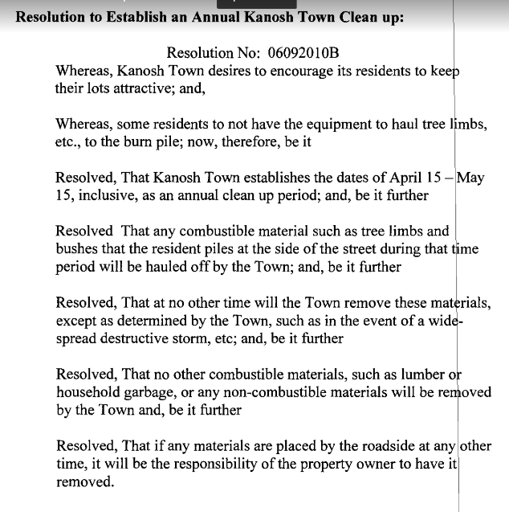
Water Rate Increase:
In light of information received Councilmember Rodney Whatcott motioned to table the proposed water rate increase until further knowledge can be obtained, Councilmember Bart Whatcott provided a second to the motion, all Councilmember's voted in favor as noted below:
Mayor Frank Paxton: Aye
Councilmembers:
Bart Whatcott: Aye
Cleve Christensen: Aye
Rodney Whatcott: Aye

24th of July Chairman:
Mayor Paxton appointed Council member Cleve Christensen to serve as the 24th chairman, Councilmember Rodney motioned to confirm Councilmember Cleve Christensen to the 24th of July Chairman position, Councilmember Bart Whatcott seconded the motion, all Councilmember's voted in favor as noted below:
Mayor Frank Paxton: Aye
Councilmembers:
Bart Whatcott: Aye
Cleve Christensen: Aye
Rodney Whatcott: Aye
Councilmember Cleve Christensen stated that the first committee meeting will be scheduled for the first part of May.

New Hire:
Mayor Frank Paxton reported that one of our part-time employees, Mr. Cloyd Hutchinson expressed his desire to relinquish his employment through the Town of Kanosh. We will advertise through the newspaper and throughout town in an effort of filling the position. The following will be posted

***Notice of Employment opportunity***
Kanosh Town Corporation is accepting applications for a part-time position; Job description and job requirements are outlined below:
Part-time position criteria:
*Must exemplify Leadership skills.
*Must be over 18 years of age.
*A good working knowledge of "General shop and work area safety"
*Working knowledge of diesel and gas motors and be able to troubleshoot and repair
*Heavy equipment operation preferred backhoe, 10 wheeled dump truck, tractor, ATV with associated attachments.
*Maintenance of equipment, service equipment as needed and directed
*Take readings on a water meter at the chlorinator building as a water systems operator as directed.
*Become certified at a minimum as a "small System Water Operator" certification should be acquired in a one year period from the date of hire and attend classes to maintain water
*Respond for "on call snow removal"
*Willing to acquire a license to spray city right-of-ways and other city properties to control weeds.
*Have or acquire CDL class B drivers license.
Kanosh Town Corporation is an equal opportunity employer.
Interested individuals contact Cindy Turner at 253-0151 to request a job application.
All applications must be returned by no later than May 3.
Councilmember Bart Whatcott motioned to advertise for the part-time job in Kanosh to be decided the first scheduled meeting on May 8th during the regular council meeting. Councilmember Rodney Whatcott seconded the motion, all Councilmember's voted in favor as noted below:
Mayor Frank Paxton: Aye
Councilmembers:
Bart Whatcott: Aye
Cleve Christensen: Aye
Rodney Whatcott: Aye

PUBLIC COMMENTS (Three Minute Limitation Each)
Mr. David Hatton addressed his question to Councilmember Rodney Whatcott.
Question: after the discussion on limiting public comments to 3 minutes, How did you vote?
Councilmember Rodney Whatcott's reply: We did not vote on it, we did it on the advice of legal counsel.
Mr. Hatton then directed his question to Councilmember Cleve Christensen.
Councilmember Cleve Christensen's reply: We didn't vote, we decided as a council.
Question: How do you decide without having a vote?
Councilmember Cleve Christensen's reply: through recommendation by legal counsel.

Kanosh Town Legal Counsel, Justin Wayment commented, the Mayor sets the agenda and he can decide what is on the agenda and how it is set. Municipalities can place reasonable limitations on speakers during public comments, such as limiting each speaker to a reasonable amount of time.

FOLLOW UP ON OLD BUSINESS
*Councilmember Bart Whatcott has been contacted regarding the poor cell phone reception in Kanosh Town. Kanosh Town is in fact, located in a marginal area for cell phone reception. In his conversation with the people at Verizon it was pointed out that this creates a safety factor if we are unable to call for help, we can call 911 without an issue but if we try to call someone else for help there could be an issue due to dropped calls. The individual Councilmember Whatcott spoke to through tech support, told him to be prepared because if your telephone has one X at the top (flip phones) or 3G that service will no longer be available after this year, 2019. If you have a 4G new style of a phone then your phone will match what the signal is going to be. The tower going up in Fillmore is a Verizon tower and will be located in the northwest corner of the football field. This tower may affect us in a positive way, the other one straight west of Kanosh Town is shadowed by Black Rock so we do not get a signal up from that to help us out. Councilmember Bart Whatcott plans to continue to work on this in an effort of gaining better reception for Kanosh Town. Councilmember Whatcott was also informed that it could take up to 10 years to get approval and build a tower. (worst case scenario). Complaints can be voiced on the Verizon Facebook page.

*Millard County Landfill rate increase.
Kanosh Town Treasurer Karen Crook reported Millard County will implement the following rate increase at the landfill.
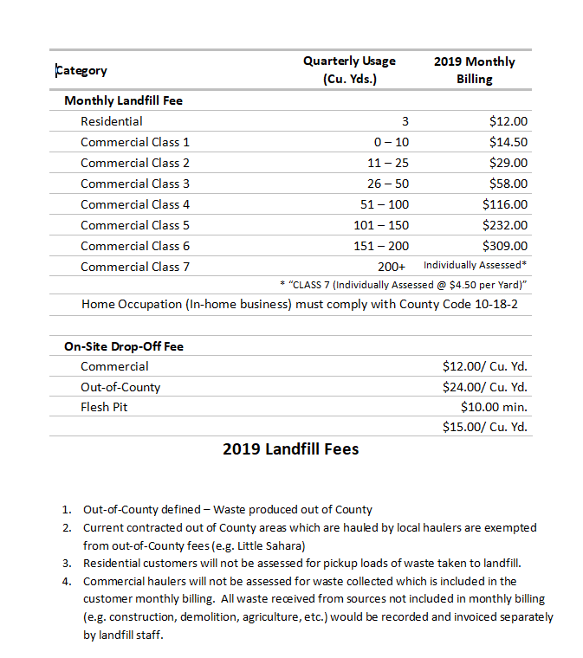
Update on the status of the Roof repairs at the town office, the supplies for the repair have been ordered as soon as the weather permits construction will begin.

The Public body will conduct a closed meeting
Councilmember Bart Whatcott motioned to move into a closed session to discuss pending Legal Issues, eminent and/or pending litigation, Councilmember Rodney Whatcott seconded the motion, all Councilmember's voted by roll call in favor as noted below:
Mayor Frank Paxton: Yes
Councilmembers:
Bart Whatcott: Yes
Cleve Christensen: Agree
Rodney Whatcott: Agree

Council members resumed the regular session of this council meeting at 10:40 through motion by Councilmember Cleve Christensen and seconded by Council member Rodney Whatcott, all Councilmember's voted by roll call in favor as noted below:
Mayor Frank Paxton: Yes
Councilmembers:
Bart Whatcott: Yes
Cleve Christensen: Agree
Rodney Whatcott: Agree

Attorney Justin Wayment recommended the Town of Kanosh invest in a television which could be mounted on the wall to be run off of the computer, enabling all in attendance to follow the agenda, documents etc.

No action determined from the closed session, any action is pending continuing legal consultation.
There being no further business to come before the board, the meeting adjourned.

Frank Paxton Cindy Turner
Kanosh Town Mayor Kanosh Town Clerk

Kanosh Town Corporation held a closed council meeting Wednesday, March 13, 2019, in the town office .
Mayor Frank Paxton, Councilmember's:, Cleve Christensen, Bart Whatcott, Rodney Whatcott, and Kanosh Town Clerk: Cindy Turner.
Council member Neil Shumway was unable to attend this meeting.
Others in attendance: Attorney Justin Wayment

Mayor Frank Paxton called the meeting to order.
The purpose of this closed session to discuss pending Legal Issues, eminent and/or pending litigation

Councilmember Bart Whatcott motioned to adjourn the closed session and reconvene the regular council meeting, Councilmember Rodney Whatcott provided a second to the motion, All Councilmember's voted in favor through a roll call vote as noted below.
Mayor Frank Paxton: Aye
Councilmembers:
Bart Whatcott: Aye
Cleve Christensen: Aye
Rodney Whatcott: Aye

Frank Paxton Cindy Turner
Kanosh Town Mayor Kanosh Town Clerk

