12.30.130 Flag Lots And Access Created By Easement(S)
The purpose is to allow residential development on lots meeting all size requirements without the minimum frontage requirements. Homes may have access via private drives connecting to a public street.
- Permitted by Conditional Use. To make practical use of property for a residential dwelling, Flag Lots, or Access by Easement(s), may be created in any new major subdivision by Conditional Use Permit if all of the following requirements are met herein:
Flag lots are only allowed in new Standard Subdivions.

- It has been demonstrated to the DRC, Planning Comm, and City Council that because of topographical features or unique situations associated with the Parcel proposed to subdivide, that substantial use of the parcel cannot occur unless a Flag Lot is allowed to be created.

- A single Flag Lot will consist of the flag portion that meets the area reqirements of the Zone. Also the existing home or lot and it’s Street Frontage must meet the requirements for a standard building lot in that Zone.
- A maximum of two flag lots are allowed in any Standard Subdivion and can be one of two configurations. Mirrored configuration. (Two side by side lots with adjacent 30’ wide stems.) Or Stacked configuration. (Two lots one behind the other with the stems adjacent.) There will also be a 20’ fire access easement down the Joint common property line of the lot stems recorded on the Subdivision Plat.
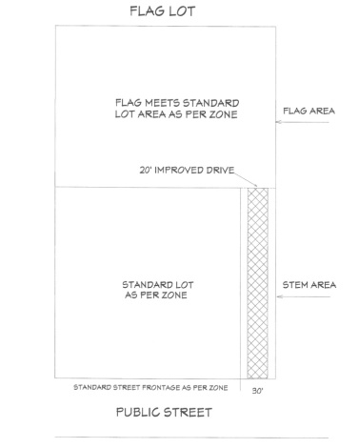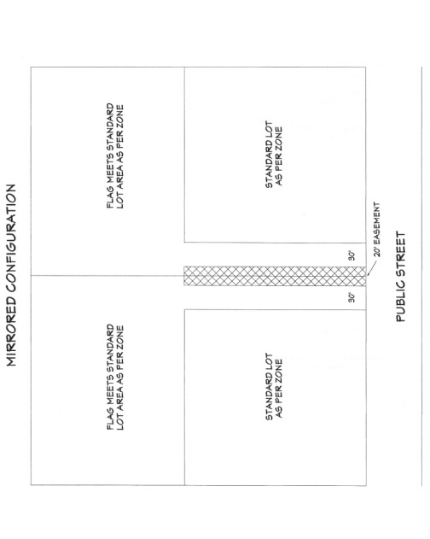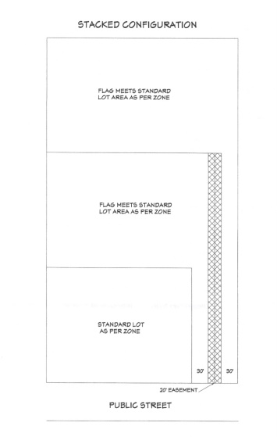
- Other Requirements Size, Area, and Layout Requirements. Flag lots and access to lots may be approved as a conditional use provided that:
  - The flag lot or access easement has a minimum of thirty (30) feet of frontage on an improved, dedicated street.
  - The flag lot stem must front on a City street and may not access any other City street, access road, driveway, or flag lot stem.
  - The flag portion of the lot (not including the stem) must meet a minimum lot area site development standard for its Zone. See Table 12.100.012. requirement of 20,000 sq. ft. for an RE-20 zone, or 40,000 sq. ft. in an A-1 zone. The stem may count for up to 5% of the total minimum lot size. The lot must also meet the width requirements for the zone it is located in.
  - The design of all structures must conform to the existing neighborhood with regard to height, appearance, and placement on the lot. The Planning and Zoning Commission may make an on-site visit for each flag lot to establish conformity. At the discretion of the Planning and Zoning Commission, minimum setback requirements may be increased to allow for special circumstances and/or conditions.
  - At the public hearing for the Conditional Use Permit, the adjacent property owners can request the Planning Commission to consider such items as fencing, landscaping, home orientation, and special lighting restriction as conditions to the request.
  - All requirements of other City ordinances, including the Subdivision Ordinance, shall apply to flag lot requirements. In case of a conflict, the requirements of the flag lot ordinance shall prevail. All applicable requirements of State and Local Codes must be followed.
- All flag lot plot plans must be approved by the local fire protection agency for emergency vehicle access requirements prior to the issuance of a building permit. No dwelling/structure shall be located beyond 500 feet from the public street as measured along the centerline of the driveway or access road to the nearest point of the structure.
  - Roadway Surface. Specifications submitted by a licensed engineer must demonstrate an all-weather surface capable of supporting the imposed load of fire apparatus and shall be approved by the local fire protection agency.
  - Width. The access road or driveway shall be a minimum of sixteen (16) twenty (20) feet in width.
  - Turnarounds. Curves and Turns. A turn-around shall be provided at the end of the access road or driveway in accordance with the standards and specifications of the current State Adopted Fire Code.
- General Conditions.
  - Maintenance. The access road or driveway shall be maintained by the property owners or possessor of the premises in good condition and repair and with adequate snow removal so as to provide free and uninhibited access by emergency vehicles. Turnarounds must be included in the snow removal process. No services will be provided by the City on any access road except fire protection. Garbage collection shall occur at the City right-of-way in a location specified in the conditions of approval.
  - Distance to Buildings. Any access road or driveway shall be extended to within 150 feet of all portions of the exterior walls of the first story of any building.
  - Maximum Grade. The maximum grade for access roads or driveways shall be twelve (12) percent.
Signs. Property owners shall be required to identify and mark fire lanes to the satisfaction and approval of the local fire protection agency. Signs shall be posted and maintained near the entrances of the access roadways or driveways. Spacing and placement of the signs shall be subject to the approval of the local fire protection agency. Signs shall read “No Parking, Emergency Vehicle Access Road”. A sign shall also show the street address of the flag lot.
  - Fire Hydrants / Fire Protection. A fire hydrant shall be installed in accordance with the local fire protection agency requirements at the expense of the owner/developer and shall be connected to a water line approved by the Public Works Director of Hyde Park City. Fire hydrants shall be located on all required access roads or driveways as required by the local fire protection agency and/or Hyde Park City Planning and Zoning Commission and/or Hyde Park City Council and shall be located within five (5) feet of the required access road or driveway. If, in the opinion of the local fire protection agency, fire hydrants are vulnerable to vehicle damage, appropriate crash posts shall be required. Required crash posts shall be as conditioned by the local fire protection agency. No obstruction shall exist within a three (3) foot working area of each fire hydrant. Hydrant shut-off valves shall be located no closer than five (5) feet from the hydrant and no further than twenty (20) feet from the hydrant.
  - Emergency Access Easements. The property owner/developer shall grant unto the City an easement along the full width of the access road or driveway permitting access to City owned/contracted emergency and service vehicles and inspection personnel. In addition, the property owner/developer shall grant unto the City a utility easement extending from the public street to the fire hydrant and having a minimum width of ten (10) feet for the purpose of use, operation, maintenance and repair of such hydrant and water line.
  - Other Conditions. Such other conditions and standards as the Planning and Zoning Commission may deem necessary.
  - All required improvements shall be completed at the expense of the property owner/developer. Bonding shall be required by the City Council as a condition of approval and to insure that improvements are completed in a timely and satisfactory manner.

