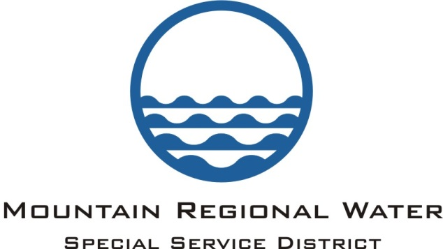
Administrative Control Board
Agenda
February 7, 2019

Notice is hereby given that he Administrative Control Board of Mountain Regional Water SSD, Summit County, Utah will meet in Regular Meeting session on March 14, 2019 at the Silver Summit Academy located at 6407 N. Business Park Loop, Park City Utah, 84098 at 6:00 p.m.

- Call to Order and Public Input:

- Executive Session – Personnel:

- Move into Open Session:

- Consent Agenda:
  - Approval of the Feb 7, 2019 ACB Meeting Minutes
  - Approval of the January 2019/ February 2019 Check Register
  - Consideration of Approval of P.O.
  - Loughlin Proposals -Tank Well
  - Aqua Proposal - 2019 Projects
  - Notice of Intent to Award Construction Contract - Lang Equipment, LLC
  - Other

- Questions on Department Updates:

- Financial Management: Lisa Hoffman
  - January / February 2019 Financial Report:
  - MRW Semi-Annual Cash Report:
  - Other:

- Strategic Plan Update: Scott Morrison

- Impact Fee Facilities Plan and Analysis Process Update: Scott Morrison

- Annual Board Member Training: Dave Thomas

- Elections of Officers for MRWSSD:
  - Chairman of the Board:
  - Vice Chairman of the Board:
  - Audit / Finance Committee Chair:
  - Audit Finance Committee: All Board Members
  - Conservation Committee Chair:
  - Two Board Members Personnel Committee
    - Board Member:
    - Board Member:
  - District Clerk for 2019 - 2020: Scott Morrison
  - Treasurer for the Board 2019 – 2020: Lisa Hoffman
  - Approve a Credit Limit for Employees:

- Legal: Dave Thomas
  - Consideration of Approval of Recommendation the Governing Board of Mountain Regional Water Special Service District to Annex SL-I-2-40 into Mountain Regional Water Special Service District:
  - Update on Community Water:
  - Other

- General Manager Comments:
  - Recent Meeting Update with David Ure & Tom Fisher
  - House Bill 411 Community Renewable Energy Act
  - Other:

- Adjourn:
Pursuant to the American with Disabilities Act, Individuals needing assistance attending the meeting, March 14should contact Marti Gee at 435-940-1916 ext. 302 to make arrangements. The next MRW Administrative Control Board Meeting will be held on April 18, 2019.

