Kanosh Town Corporation held the regular council meeting Wednesday, December 12, 2018, in the town office at 7:00 p.m.

Members present:
Mayor Frank Paxton, Councilmember's: Neil Shumway, Cleve Christensen, Bart Whatcott, Rodney Whatcott, Kanosh Town Treasurer: Karen Crook and Kanosh Town Clerk: Cindy Turner. Town Employee: John Hogan

Others in attendance:
John Hogan, Planning and Zoning Hayden George Geri Minton, Scott McDonald, Brandon Cummings, Wenda Crabb, Steve Crabb, Tyler Crabb, Roger Whitaker, Gordon Fuller, Ginger Whitaker,

Councilmember Neil Shumway offered a moment of silence, followed by everyone in attendance standing and facing the flag where Councilmember Bart Whatcott lead everyone in the pledge of allegiance.

Minutes of the November 2018 minutes were approved as amended through Councilmember Neil Shumway, Councilmember Rodney Whatcott provided a second to the motion, all Councilmember's voted in favor as noted below:
Mayor Frank Paxton: Aye
Councilmembers:
Bart Whatcott: Aye
Neil Shumway: Aye
Cleve Christensen: Aye
Rodney Whatcott: Aye

Warrants for the month of December were read discussed and approved to be paid through a motion by Councilmember Cleve Christensen, Councilmember Bart Whatcott seconded the motion, all Councilmember's voted in favor as noted below:
Mayor Frank Paxton: Aye
Councilmembers:
Bart Whatcott: Aye
Neil Shumway: Aye
Cleve Christensen: Aye
Rodney Whatcott: Aye

Before continuing with the meeting, Mayor Frank Paxton digressed from the agenda for the purpose of making the following departmental appointments:

First: In the last fire meeting the members of our fire department elected Mr. John Hogan to serve as the new Kanosh Town Fire Chief. Councilmember Cleve Christensen "wholeheartedly" motioned in favor of accepting John Hogan as the new Kanosh Town Fire Chief, Councilmember Bart Whatcott provided a second to the motion, all Councilmember's voted in favor as noted below:
Mayor Frank Paxton: Aye
Councilmembers:
Bart Whatcott: Aye
Neil Shumway: Aye
Cleve Christensen: Aye
Rodney Whatcott: Aye

Mayor Frank Paxton informed Councilmembers that Kanosh Town needs to appoint an alternate representative to attend Fire District meetings when the primary representative is unable to attend, Mayor Paxton appointed Councilmember Neil Shumway to serve as the alternate representative for Kanosh Town, Councilmember Shumway accepted this appointment, all Councilmember's voted in favor of this appointment as noted below:
Mayor Frank Paxton: Aye
Councilmembers:
Bart Whatcott: Aye
Neil Shumway: Aye
Cleve Christensen: Aye
Rodney Whatcott: Aye

Mayor Frank Paxton informed the council of a vacancy on the Planning and Zoning Commission, Mr. Cornell Atkinson will no longer be able to serve, Mayor Paxton has appointed Mr. Geri Minton to serve the remainder of Cornell's term, which she accepted. Councilmember Bart Whatcott motioned to confirm Mrs. Geri Minton's appointment on Planning and Zoning Commission, Councilmember Rodney Whatcott provided a second to the motion, all Councilmember's voted in favor of this appointment as noted below:
Mayor Frank Paxton: Aye
Councilmembers:
Bart Whatcott: Aye
Neil Shumway: Aye
Cleve Christensen: Aye
Rodney Whatcott: Aye

The Current Planning and Zoning Commission members and the year their appointment is completed:
Blaine Blad 2020
Jens Christensen 2020
Geri Minton 2020
Ed Phillips 2022
Haden George 2022

Fire Department Report:
Fire Chief John Hogan addressed the Councilmembers, thanking them for the confirmation of his new appointment. Chief Hogan reiterated that his position will always be an open door policy, there is nothing down at the firehouse that is secret. Everyone is always welcome to inspect files, anything they need to do. Chief Hogan wants to work together closely with the council. Basically, there will be a little bit of a change as far as he sees his role as a fire chief more administrative than active, they will be recruiting new members and trying to get them all trained up. Chief Hogan is also looking very cautiously for a set of bylaws from Fillmore City, Kanosh bylaws cannot be located. Possibly within the next 30 days, Kanosh Fire Department will be creating their bylaws, he would like to have the Fire District Representatives Councilmember Cleve Christensen and Councilmember Neil Shumway's input on the bylaws. Upon completion and approval, a copy of the bylaws will be given to the clerk for the file. Chief Hogan plans to have the Kanosh Fire dept. members will have more say in what goes on in our fire department, without the fire department members there is no fire department. Chief Hogan is open to suggestions, planning to have a lot more training. The plans for this October include a big fire prevention week.

Chief Hogan also expressed his desire to have someone trained within a year to take over the position as fire chief should the position ever become available.

Planning and Zoning:
*Planning and Zoning member Geri Minton reported there were no new building permits to be presented at this time.
*Mrs. Minton reported she will be busy working on organization of the Planning and Zoning files and the filing cabinet.
*Final approval for Mr. Roy McNaughton's building permit. Councilmember Bart Whatcott motioned to move ahead with approval of the permit, with the contingency that McNaughton's will pay for the pole and any other associated costs, Councilmember Rodney Whatcott provided a second to the motion, all Councilmember's voted in favor as noted below:
Mayor Frank Paxton: Aye
Councilmembers:
Bart Whatcott: Aye
Neil Shumway: Aye
Cleve Christensen: Aye
Rodney Whatcott: Aye

Broadband Internet Gordon Fuller:
Gordon Fuller addressed the Council stating they would like to bring another internet into Kanosh, asking if they could also use the tower behind the town hall to put their radios on. They are currently using a tower at Flowell Electric and the Stewart Electric. This should not have any effect on what we are already doing with the tower. With the use of the Tower behind the Town hall they would offer free internet to Kanosh Town and Kanosh Fire Department. They would be selling 30 MB download service and a 5 MB upload for $40.00/month with no data cap and no term contract. They are buying fast internet services and then shooting it out wirelessly to the customers.

They currently provide internet service in Wells Nevada and would like to bring internet options to other rural communities.

Councilmember Bart motioned to move forward and pursue the new internet service option, Councilmember Neil Shumway provided a second to the motion, all Councilmember's voted in favor as noted below:
Mayor Frank Paxton: Aye
Councilmembers:
Bart Whatcott: Aye
Neil Shumway: Aye
Cleve Christensen: Aye
Rodney Whatcott: Aye

Mr. Fuller agreed to attend the January 2019 meeting and bring a contract for Councilmembers to review.

Steven Maxfield:
Mr. Maxfield was not in attendance however Town Employee John Hogan spoke in his behalf, stating that the other day when the county was putting in the cattle guard up by the cemetery, John spoke to Steve and he had commented that the last couple of funerals we have had there has been a lot of traffic congestion up there. The problem is that if it is rainy, anytime you get off on the North side of the north access road you could be stuck. So what happens is Steve is unable to access his property because people are parking in the way. He would like to see if we would go 20 feet out and put gravel on the dirt and make it into a parking area. Councilmember Bart Whatcott presented his plans for that problem. Where the cattle guard is there is an 8' or 10' gate that swings over and hooks by the cattle guard, his plan is to come off 8' from the existing oil and gravel in 8' of gravel north of the existing road so people can park on the gravel without getting stuck and then little by little putting down gravel and road base so in the future when we have the money, we can oil it and put the other into grass. Councilmember Bart Whatcott plans to begin the project sometime in the spring or early summer. This matter will appear as an agenda item before any physical action is taken or pursued further.

Flowell electric rep: Brandon Cummings
*Mr. Cummings addressed the Councilmembers in reference to their progress on the new line and making himself available to answer questions or address concerns. Their new line will provide additional voltage when in full operation. We will have a dedicated line with not a lot on it. We still may see power bumps which cannot be avoided. In the contract we have with Flowell Electric when they switch the voltage, they would have 18 months to complete the project. In the agreement, they would provide the labor to install the transformers to the metering point and Kanosh would pay for the equipment, Flowell is willing to carry the bill until they get the line energized.

*The primary question from the townspeople is "when with the $10.00 surcharge fee be off of the utility bills?" The answer is that there is a pretty good chance it may not come off, or the power rates may be raised to compensate. The suggestion of impact fees may also be considered.

Council reports:
*Parks: Councilmember Bart Whatcott issued a heartfelt "Thank you" to Debbie Hogan and Janet Barton for all they did for the Christmas tree lighting ceremony.
*Not much to report on the Parks.

*Cemetery: Councilmember Bart Whatcott has spoken with town employees about taking the truck up to get the rocks, big rocks, through permission from the Forest Service. The rocks will be used safeguard the new cemetery directory board.

*Electric Department: nothing new to report at this time

*Roads: nothing new to report at this time.

*Water: Councilmember Rodney Whatcott reported that Town employee John Hogan sent in the water samples on the water found at the springs, however, we have not yet heard back. *Councilmember Rodney Whatcott motioned in approval of signing the on-call contract with Sunrise Engineering, allowing payment to them by Kanosh Town, for their services until funding sources are made available, Councilmember Bart Whatcott provided a second to the motion, all Councilmember's voted in favor as noted below:
Mayor Frank Paxton: Aye
Councilmembers:
Bart Whatcott: Aye
Neil Shumway: Aye
Cleve Christensen: Aye
Rodney Whatcott: Aye

See contract below :
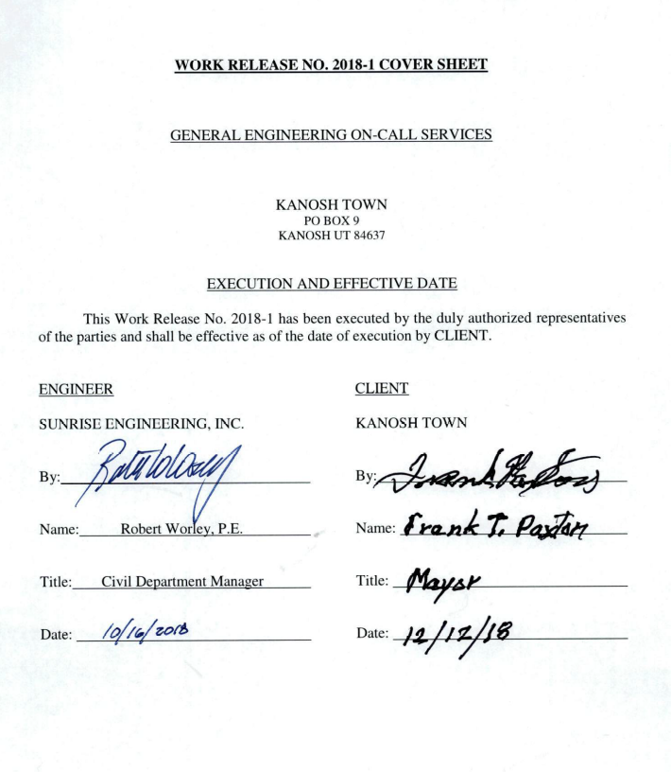
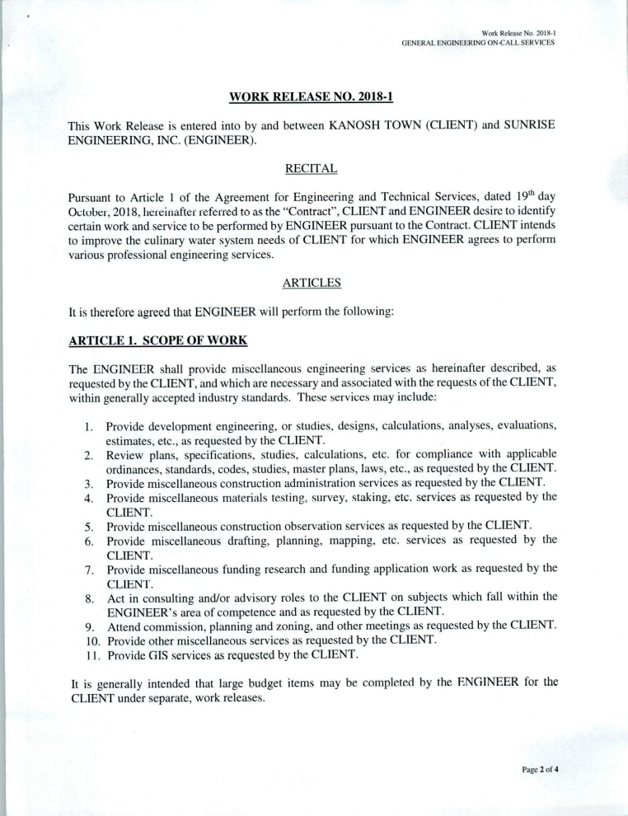
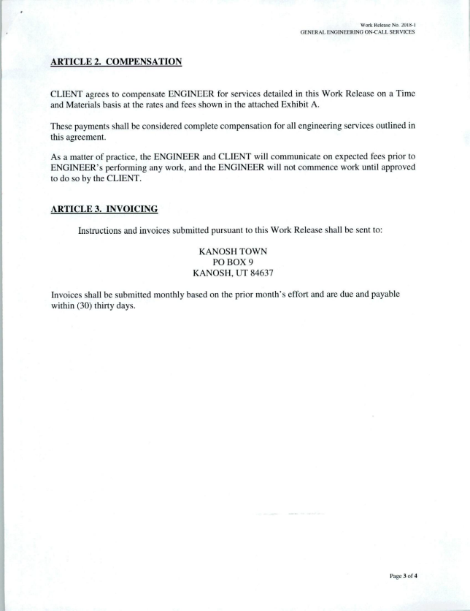
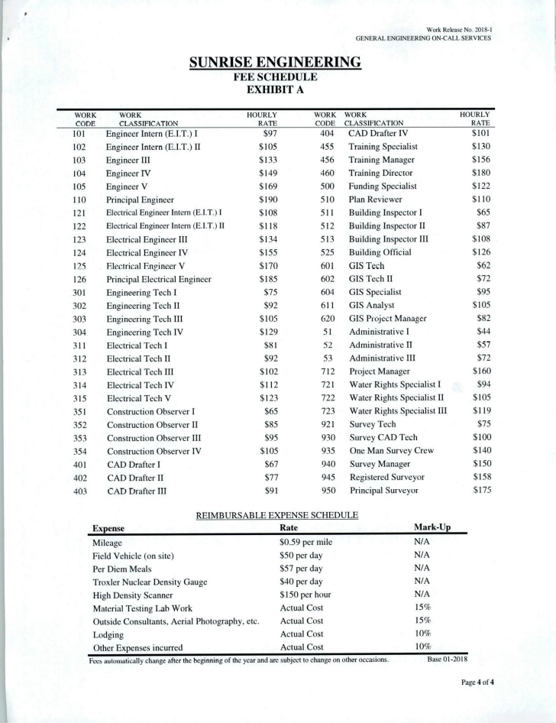
In reference to the Beaver Dam, Councilmember has been in touch with the DNR, requesting they remove the Beaver or kill it whatever. He recommended making contact with Tilden Kesler, who has a furbearer permit and having him take care of it, Councilmember Bart Whatcott has made contact.

Review Utility Delinquencies:
Council members reviewed the monthly delinquency list. It was determined again to handle those accounts in arrears according to established Town policy.

Council members discussed out of town rates, recognizing that out of town rates should be the same across the board. This will be addressed further in the January meeting.

General Government:
*Holiday celebration: Council members will meet on Tuesday, December 18th at the fire station at 6:00 pm for the official sacking of Santa's Christmas candy and potluck dinner.

*Councilmember's discussed annexation and unanimously agreed that if the out of town water rates are raised we could drop annexation. Councilmember Cleve Christensen motioned to surrender our efforts of annexation, Councilmember Rodney Whatcott provided a second to the motion, all Councilmember's voted in favor as noted below:
Mayor Frank Paxton: Aye
Councilmembers:
Bart Whatcott: Aye
Neil Shumway: Aye
Cleve Christensen: Aye
Rodney Whatcott: Aye

*Mayor Paxton notified the Council that Kanosh Town has now been served with another legal action.

*Fire Chief John Hogan notified the Councilmembers that there are four cases of 'Birth of Kanosh" books in the firehouse.

Public comment:
*Town Employee John Hogan expressed his appreciation to the young women and young men for fixing the holiday wreaths.

*Scott MacDonald: addressed the Council by way of clarification, no additional water will be allowed outside of town limits?
Councilmember's replied, correct.
Mr. MacDonald stated one of the properties he is looking at purchasing, he was told the town will take water to as a result of a lawsuit.
Councilmember's replied, correct. However, the location of the water connection has been predetermined by the legal counsel.

Old Business:
*Town Employee John Hogan reported that there was an oil leak on the F450 and he made an appointment with Sahara Motors to have it looked at. On the way over there it quit, no way to start it, the computer said: "please pull safely to the side of the road". It was towed into Sahara Motors after an evaluation of the truck they said that the good news is the leak was a radiator hose, the bad news the #2 cylinder has no compression and the reason that the truck shut down was because the crankcase was completely full of diesel fuel and it was going into the catalytic converter. The decision of what to do with the truck will be addressed further in next months meeting.

*Electric discount: Councilmember Rodney Whatcott motioned to award a 10% holiday discount, to be extended to everyone who maintains a "current" status on their utility billing Councilmember Neil Shumway seconded the motion, all Councilmember's voted in favor as noted below:
Mayor Frank Paxton: Aye
Councilmembers:
Bart Whatcott: Aye
Neil Shumway: Aye
Cleve Christensen: Aye
Rodney Whatcott: Aye

There being no further business to come before the board, the meeting adjourned.

Frank Paxton Cindy Turner
Kanosh Town Mayor Kanosh Town Clerk
Agenda:
Out of town rates treat everyone the same.

Action plan for the F40

