Kanosh Town Corporation held the regular council meeting Wednesday, January 9, 2019, in the town office at 7:00 p.m.

Members present:
Mayor Frank Paxton, Councilmember's: Neil Shumway, Cleve Christensen, Bart Whatcott, Rodney Whatcott, Kanosh Town Treasurer: Karen Crook and Kanosh Town Clerk: Cindy Turner. Town Employee: John Hogan

Others in attendance:
Kanosh Town Employees John Hogan and Cloyd Hutchins, Planning and Zoning committee members Blaine Blad and Geri Minton, Scott McDonald, Brandon Stephenson, Robert Worley Scott Macdonald, Steve Crab, David Hatton, Ilene Hatton, Dale, and Suzie Kelch.

Councilmember Rodney Whatcott offered a moment of silence, followed by everyone in attendance standing and facing the flag and Councilmember Cleve Christensen lead everyone in the pledge of allegiance.

Minutes of the December 2018 minutes were approved as amended through Bart Whatcott, Councilmember Rodney Whatcott provided a second to the motion, all Councilmember's voted in favor as noted below:
Mayor Frank Paxton: Aye
Councilmembers:
Bart Whatcott: Aye
Neil Shumway: Aye
Cleve Christensen: Aye
Rodney Whatcott: Aye

Warrants for the month of December were read discussed and approved to be paid through a motion by Councilmember Cleve Christensen, Councilmember Bart Whatcott seconded the motion, all Councilmember's voted in favor as noted below:
Mayor Frank Paxton: Aye
Councilmembers:
Bart Whatcott: Aye
Neil Shumway: Aye
Cleve Christensen: Aye
Rodney Whatcott: Aye

Fire Department Report:
Fire Chief John Hogan reported Mr. Richard Black has agreed to serve Kanosh Town as the assistant Fire chief, Mr. Black has a history of a firefighter/paramedic for the Salt Lake County Fire Department, where he was Captain and served for over 30 years. Mrs. Geri Minton has agreed to serve as the secretary for the Fire Department and has already been organizing all of the files. Efforts are still underway to encourage and enlist new volunteer firemen.

The Kanosh Fire department Emergency crews responded to a report of a vehicle fire after a semi truck pulling a tanker and a pup trailer caught fire as it was climbing a hill on the freeway, the truck was hauling sodium bisulfate chemicals, the highway was closed within a half-mile radius of the fire, The driver was able to escape the cab without injury. Following the fire, the volunteers learned that if the composite tank hauling the chemical had been leaking and had interacted with water the results would have been lethal. Chief Hogan informed the vice president of Thatcher Company the should be prepared to receive a bill for $1800.00 of which he agreed to pay.

Planning and Zoning Report:
*Planning and Zoning Commission spokesman Geri Minton addressed the Council members stating there are no new building permits to report at this time.

*It was also noted that the McNaughton's agreed to pay for power that went underground.

Council reports:
*Park report:
There isn't much to report on the park until the spring.
*Cemetery:
The rocks discussed in last months meeting have been retrieved and will be positioned in the spring.
Council member Bart Whatcott will be working with Mrs. Liz Whitaker to obtain an updated cemetery map for the cemetery.

Electric Department Report:
There is nothing new to report in the electrical department this month.

Road Department Report:
Council member Cleve Christensen expressed his appreciation for our town employee's efforts in snow removal for the roads and sidewalks, they completed the snow removal in a timely and efficient manner.

Water Department Report:
Council member Rodney Whatcott reported that Town Employee John Hogan will be attending water conference in St. George, Council member Rodney Whatcott will try to attend at least one day of the conference.

General Report:
Action Plan for the Ford 450, the truck has 16,000 miles and the engine is gone, #2 cylinder is not working, we were pumping diesel fuel back into the catalytic converter. We have learned through research that the 450 motor is one which is NOT sought after if you were going to buy a Ford truck. We have had the truck for 10 years so there is no warranty. Council members have information on the purchase of a new truck: 43587.00 another 580218. These trucks are not cheap. The drive train and everything else with exception of the motor on our truck is in good shape. There has been a discussion of putting in a new motor, John Pratt was contacted however he stated he would "rather not work for Kanosh Town." Several other vendors were contacted in relation to the installation of a new motor. The possibility of a trade in was also discussed, none of the vendors were interested in a trade in. Roughly it would cost $17,000 to replace the engine, less to repair it however we would still have the 450 engine with no guaranty. Council member Bart Whatcott motioned to table any decision at this time, giving everyone a little time to consider all options, Council member Neil Shumway seconded the motion, all Councilmember's voted in favor as noted below:
Mayor Frank Paxton: Aye
Councilmembers:
Bart Whatcott: Aye
Neil Shumway: Aye
Cleve Christensen: Aye
Rodney Whatcott: Aye

Gordon Fuller Broadband internet:
Mr. Fuller was unable to attend the council meeting, however, provided the following contract to include free internet to the fire station agreed via

.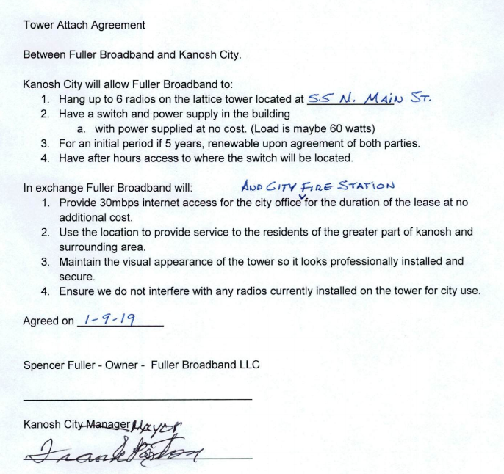
Council member Rodney Whatcott motioned to accept contract with Fuller broadband as amended, Council member Cleve Christensen seconded the motion, all Councilmember's voted in favor as noted below:
Mayor Frank Paxton: Aye
Councilmembers:
Bart Whatcott: Aye
Neil Shumway: Aye
Cleve Christensen: Aye
Rodney Whatcott: Aye

Water rate increase:
At the suggestion of legal counsel the chair opted to accept a motion to table the water rate increase at this time. Councilmember Rodney Whatcott motioned to table any further action at this time Councilmember Neil Shumway seconded the motion, all Councilmember's voted in favor as noted below:
Mayor Frank Paxton: Aye
Councilmembers:
Bart Whatcott: Aye
Neil Shumway: Aye
Cleve Christensen: Aye
Rodney Whatcott: Aye

Sunrise Engineering:
Brandon Stephenson and Robert Worley of Sunrise Engineering addressed the council members in relation to the development of Spring #4. Just below spring 4, there is seepage measuring at 18 gallons per minute however it is unknown if it is coming from the creek or the spring. John took some water samples, from the creek the new spring and spring 4 to see if there are any similarities in the water quality. Even after the testing, there is no clear answer. A few months ago the goal was to make application to the Community Impact Board and their next deadline is February 1. Sunrise Engineering recommended that the alternatives be looked at closely with the expectations in line. There are some risks involved with developing the spring, the 18 gallons of water coming out now is being influenced by the creek. Even if just 1 gallon of that comes from the creek it all has to be dumped, there cannot be any influence coming in from the creek. Other risks were also addressed to include the potential for excessive cost. We are not under the gun to develop a spring so we do not need to rush, it would be irresponsible not to look at all of the options. Another option would be to consider a well, a common well drilled for municipalities can produce about 300 gallons per minute, with an average cost of $600,000.00 to a million dollars to do it, whereas the spring work we are looking at about $200,000.00. There are risks with a well too, there are always risks involved with water development we all need to be aware of. Another benefit of a well would be that it would give the town a second source.

The recommendation of Sunrise Engineering is to submit the February 1 application but to set on this information and make an informed decision. The other dates for application is June and then October.

After the Council members discussed the options presented, Council member Rodney Whatcott motioned that we continue the investigation of spring 4 as well as other water sources and do not submit an application for the February 1 grant, Councilmember Bart Whatcott seconded the motion, all Councilmember's voted in favor as noted below:
Mayor Frank Paxton: Aye
Councilmembers:
Bart Whatcott: Aye
Neil Shumway: Aye
Cleve Christensen: Aye
Rodney Whatcott: Aye

Review Utility Delinquencies:
Council members reviewed the monthly delinquency list. It was determined again to handle those accounts in arrears according to established Town policy.

Public comments limited to three minutes per person:
*Scott McDonald: read an excerpt in relation to the Freedom of the press and freedom of speech, quoting writers of the founding era of the founding fathers.
*Dale Kelsch: read another excerpt in relation to the Freedom of the press and freedom of speech, quoting writers of the founding era of the founding fathers.
*Ilene Hatton: read another excerpt in relation to the Freedom of the press and freedom of speech, quoting writers of the founding era of the founding fathers.
*David Hatton: read another excerpt in relation to the Freedom of the press and freedom of speech, quoting writers of the founding era of the founding fathers. Mr. Hatton concluded with the question of who put the 3-minute limitation on each public comment.
*Hayden George: Inquired about indemnification or representation he sent to the town on December 21, he had not received a reply to date. Mayor Paxton stated that Kanosh Town Legal counsel would be making contact with him. Mr. George stated that the things stated against him were that he was acting within a resident of Millard County, It was noted that Mr. George is still in good standing with the Planning and Zoning Board.

Old Business:
No old business to be discussed at this time.
There being no further business to come before the board, the meeting adjourned.

Frank Paxton Cindy Turner
Kanosh Town Mayor Kanosh Town Clerk

