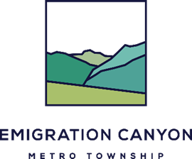

Emigration Canyon Metro Township
Regular Meeting Schedule for 2019

Meeting Place: Unified Fire Authority Fire Station,
5025 E Emigration Canyon Road, Salt Lake City, UT 84108

Staff Meeting: 7:00 PM
Public Meeting: Will begin immediately after the Staff Meeting

The Public is Welcome to Attend Both Meetings

(Unless the Council Specifies Otherwise)

Thursday January 24, 2019
Thursday February 28, 2019
Thursday March 28, 2019
Thursday April 25, 2019
Thursday May 23, 2019
Thursday June 27, 2019
Thursday July 25, 2019
Thursday August 22, 2019
Thursday September 26, 2019
Thursday October 24, 2019
Thursday November 28, 2019
Thursday December 26, 2019

