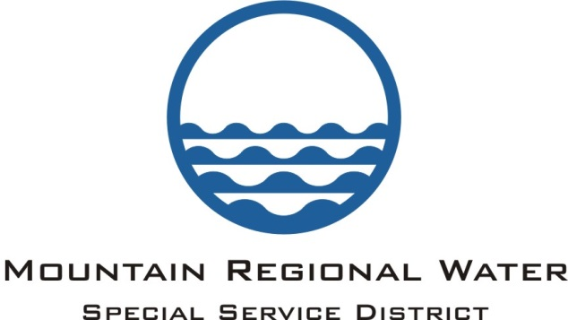
Administrative Control Board
Agenda
February 7, 2019

Notice is hereby given that he Administrative Control Board of Mountain Regional Water SSD, Summit County, Utah will meet in Regular Meeting session on February 7, 2019 at the Silver Summit Academy located at 6407 N. Business Park Loop, Park City Utah, 84098 at 6:00 p.m.

- Call to Order and Public Input:

- Executive Session – Personnel and Property Acquisition:

- Move into Open Session:

- Consent Agenda:
  - Approval of the January 3, 2019 ACB Meeting Minutes
  - Approval of the December Check Register
  - Consideration of Approval of P.O. to Pall Water Technology Services for $147,307.96 for filtration modules, associated parts, and a service and installation contract. Filtration modules will replace those in two skids at MRW Signal Hill Water Treatment Plant
  - Other

- Questions on Department Updates:

- Financial Management: Lisa Hoffman
  - December 2018 Financial Report:
  - Other:

- Strategic and Capital Improvement Plan Update: Scott Morrison

- Consideration of Approval of Surplus Water Agreement to serve Community Water System on Mountain Lodges:

- Public Service: Marti Gee
  - Recognition of Stacy Blonquist-Outstanding Service By a Water Operator from Rural Water Association of Utah:

- Legal: Dave Thomas
  - Summit County Franchise Agreement:
  - Update on Community Water:
  - Other

- General Manager Comments:
  - Property Purchase for new Well Update:
  - Antenna Update:
  - Drought Response Planning Update:
  - Other:

- Adjourn:
Pursuant to the American with Disabilities Act, Individuals needing assistance attending the meeting, February 7, 2019 should contact Marti Gee at 435-940-1916 ext. 302 to make arrangements. The next MRW Administrative Control Board Meeting will be held on March 14, 2019.

