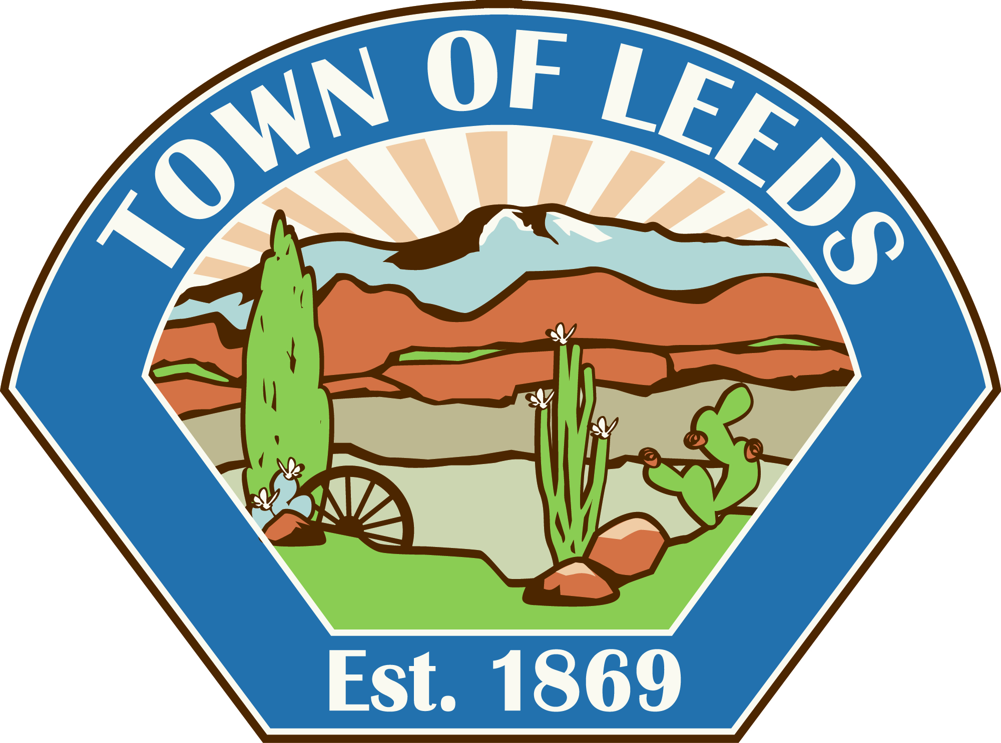
TOWN OF LEEDS

Planning Commission Meeting
PUBLIC HEARING NOTICE
Notice is hereby given that a Public Hearing will occur at the
Planning Commission Meeting on
Wednesday, February 6, 2019, at 6:30 p.m.
At the Leeds Town Hall at 218 North Main Street, Leeds, Utah.

The Leeds Planning Commission will hold a public hearing on the above-mentioned date to consider the following proposed items:

1. Zone Change on Parcel L-4-1-12-122 for DHP Properties & Z2Z Properties from Open Space (OS) to Commercial (C) on approximately 0.510.

Copies of the proposed Zone Change Plat will be available for review at the Leeds Town Hall during regular business hours (9:00 a.m. to 4:00 p.m. Monday – Thursday)

Interested persons are encouraged to attend the public hearing to be held in the Leeds Town Hall at 218 North Main Street, or present their views in writing to the Leeds Town Clerk/Recorder prior to the meeting.

Certificate of Posting
The undersigned Clerk/Recorder does hereby certify that the above notice was posted January 25, 2019. The public places being at Leeds Town Hall, Leeds Post Office, the Utah Public Meeting Notice website http://pmn.utah.gov, the Town of Leeds Website www.leedstown.org, also published in the Spectrum Newspaper.

Peggy Rosebush
Clerk/Recorder

