FIRST PUBLIC HEARING

MINUTES OF HENEFER TOWN COUNCIL MEETING
MEETING HELD, Henefer Town Council Room, December 4, 2019, 7:00 p.m.

The Henefer Town Council meeting convened in regular session on Tuesday, December 4, 2109, in the Henefer Town Council Room at 7:04 p.m.

Present: Mayor Kay H. Richins, Council Members, Robin K. Riches, Matthew P. Shill, Detton L. Fawcett,
Ryan K. Mosher
Town Planner, Richard Butler
Public, Brian Cornia

Mayor Richins called for a motion to open the Community Development Block Grant Public Hearing. Detton L. Fawcett made a motion to open the Public Hearing. Ryan K. Mosher seconded the motion. . Vote: AYE: Kay H. Richins, Detton L. Fawcett, Robin K. Riches, Ryan K. Mosher, Matthew K. Shill NAY: none, ABSTAINING: none, ABSENT: none

COMMUNITY DEVELOPMENT BLOCK GRANT PUBLIC HEARING:

Mayor Kay H. Richins opened the public hearing for the CDBG program and stated that the purpose of the public hearing is to provide citizens with pertinent information about the Community Development Block Grant program and to allow for discussion of possible applications for the 2019 funding cycle. It was explained that the grant money must be spent on projects benefitting primarily low and moderate-income persons. The Mountainland Association of Governments in which Henefer Town is a member, is expecting to receive approximately $550,000 in this new program year. All eligible activities that can be accomplished under this program are identified in the CDBG Application Policies and Procedures Manual and interested persons can review it at any time. Mayor Kay H. Richins read several of the eligible activities listed including stations, acquisition of real property, provision of public services such as food banks or homeless shelters. Mayor Kay H. Richins indicated that in the past Henefer Town has received CDBG grants for the construction of a new water storage tank, water improvements in Franklin Canyon, and also Henefer sewer system improvements. The city has handed out its capital investment plan as part of the regional “Consolidated Plan”. This list shows which projects the city has identified as being needed in the community. It was asked that anyone with questions, comments, or suggestions during the hearing please identify themselves by name, before they speak. The clerk will include your names in the minutes and we would like to specifically respond to your questions and suggestions during the hearing. Mr. Brian Cornia commented that he felt it was a great idea to apply for the CDGB grant. Mayor Kay H. Richins responded to the comment by stating that the CDGB grant would be used for a new culinary water tank to provide additional storage for the existing system. Mayor Kay H. Richins then opened the meeting up to further suggestions from the audience. Mrs. Robin K. Riches inquired where the new tank would be constructed. Mayor Kay H. Richins responded to the question by stating that the new tank would be constructed in either Bachelor’s Canyon or Franklin Canyon. Mrs. Robin K. Riches inquired if JUB Engineering would be assisting with the grant application process. Mayor Kay H. Richins responded to the question by stating that JUB would be assisting with the grant application. Mr. Matthew P. Shill inquired when an approximate start date for tank construction would be. Mayor Kay H. Richins responded to the question by stating that construction would probably begin in early fall. Mayor Kay H Richins asked if there were any other suggestions? Mayor Kay H. Richins called for a
2| Page Council Meeting_______________________________________________ December 4 ,2018
motion to adjourn the public hearing. Matthew P. Shill made a motion to adjourn the Public Hearing for the Community Development Block Grant. Robin K. Riches seconded the motion. The hearing was adjourned at 7:18 p.m. Vote: AYE: Kay H. Richins, Detton L. Fawcett, Robin K. Riches, Ryan K. Mosher, Matthew K. Shill NAY: none, ABSTAINING: none, ABSENT: none
COUNCIL MEETING RESUMES
Next on the agenda was Brian Cornia. Brian explained that he owns the property at 345 S Henefer Rd. Brian informed the council that he had just received a bill for $19,000.00 from the disaster clean-up company that cleaned his rental home after an abandoned line had broken and flooded the basement. Brian presented the bill to the town council. Mayor Richins informed Mr. Cornia that upon notification of the water leak, Shelley Richins contacted ULGT, which is Henefer Town’s insurance company. The insurance instructed Shelley to have the property owner immediately have a disaster clean-up company begin clean-up of the flooded area. Mr. Cornia informed the council that he had received a letter from Henefer Town’s insurance company which offered him $5,000.00 if he would sign a no-fault agreement. Mr. Cornia contacted his homeowners insurance. Upon inspection from his insurance adjustor, Mr. Cornia was notified that his insurance would not pay for the clean-up. Shelley Richins presented the letter from the insurance which stated that they would only pay Mr. Cornia $5,000.00 under the no-fault clause. Mayor Richins instructed Mr. Cornia to not sign the no-fault agreement . Mayor Richins also informed Mr. Cornia that he has turned all documentation over to Sheldon Smith, Henefer Town attorney, for review. Mayor Richins suggested that Mr. Cornia submit the disaster clean-up bill and the no-fault letter from ULGT to his insurance agent. Mr. Cornia will be put on the January agenda for further discussion. Mayor Richins suggested hiring Roto-Rooter to occasionally clean the sewer lines to prevent back-ups.
Next on the agenda was Richard Butler with recommendations for the building permit application process. Mr. Butler presented the following list of items to be eliminated from the building permit process.
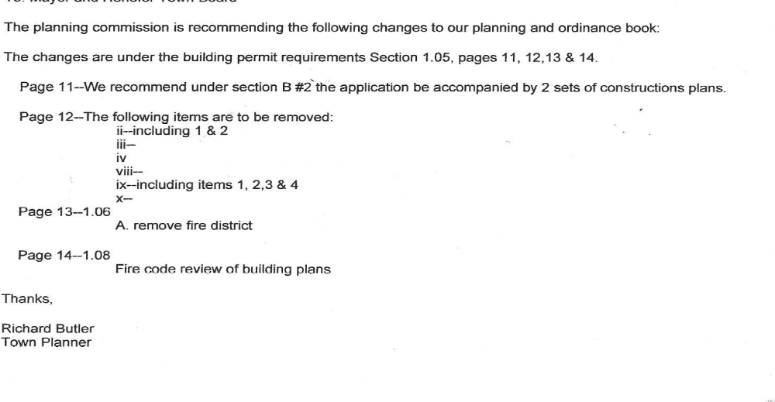
3| Page Council Meeting_______________________________________________ December 4, 2018
Richard Butler explained that a survey & site plan will still be required, but these changes will eliminate other unnecessary items unless building is in a sensitive overlay area. Mayor Richins called for a motion to accept the recommended changes to the planning & zoning book. Ryan K. Mosher made a motion to accept the recommendation from the planning & zoning commission to make changes to the planning & zoning book. Matthew P. Shill seconded the motion. Vote: AYE: Kay H. Richins, Detton L. Fawcett, Robin K. Riches, Ryan K. Mosher, Matthew K. Shill NAY: none, ABSTAINING: none, ABSENT: none
Mayor Richins informed the council that JUB had performed flow tests on the Bachelor and Franklin Canyon springs. The Franklin Canyon spring had dropped approximately 90 gpm from the early summer flow test of 246 gpm. The Bachelor Canyon spring was approximately 126 gpm. Brent Ovard informed the council that he had accompanied the engineer for JUB to the collection site in Franklin Canyon. There were several options discussed to repair and improve the collection.
Next on the agenda was a discussion of the dissolution of the Board of Adjustments. Mayor Richins explained to the council that many other communities are appointing an administrative judge instead of a Board of Adjustments to settle variance requests for building permits. Richard Butler explained that citizens would still submit all site plans to the planning & zoning commission for a building permit. The planning commission would evaluate the plans to make sure all offsets are met according to the current ordinances. If the setbacks aren’t met, the building permit would be denied. The citizen could then request a hearing with the administrative judge to determine if a variance would be granted. Matthew P. Shill inquired what the course of action is if the variance is denied. Mayor Richins explained that the matter would be taken to court at that point. Mayor Richins suggested a public hearing for the dissolution of the Board of Adjustments and the appointment of an administrative judge for the January 15, 2019 meeting. Matthew P. Shill suggested that the current fee of $150.00 for a variance would have to be re-examined. Mayor Richins informed the council that he would check with Sheldon Smith on the approximate cost of a variance hearing.
Next on the agenda was a discussion of the water rates. Detton Fawcett inquired if JUB had any data to simplify the rate changes. Matthew P. Shill presented data on other water utility rates of cities with populations between 500 – 1000 people throughout the state. Matthew Shill suggested the following rate changes for Henefer:
Base - $35.00 up to 15,000 gallons
Tier 1 -$ .75/1,000 gallons 15,000 - 30,000 gallons
Tier 2 - $ 2.00/1,000 gallons 30,000 - 50,000 gallons
Tier 3 - $ 3.00/1,000 gallons 50,000 +

Detton Fawcett reviewed the list of water meters which are currently unable to be read. Detton suggested that the meter at the Kirt Richins residence needs to be replaced. Mayor Richins asked Shelley Richins to schedule a public hearing for the water rate increase for the January 15 meeting.

Next on the agenda was a public discussion. Brent Ovard informed the council that the crossover line through the Steve Richins property is leaking. The line needs to be examined to determine the best repair option. Brent Ovard also suggested gathering up water rights and getting them filed with the State.

4| Page Council Meeting_______________________________________________ December 4, 2018
Next on the agenda was a review of the November 6, 2018 town council meeting minutes. Corrections suggested were: the prayer was offered by Ryan K. Mosher and the Pledge of Allegiance was led by Angela Jones; page 2, 1st paragraph change the to that; 2nd paragraph, change sentence to “The more funding sources that Henefer can partner with, will increase the chances for funding”; add current water utility rates; 3rd paragraph, change had to has and the Christmas tree lighting is from 7:00 – 8:00; page 3, 3rd paragraph, change old service to an abandoned service line, change mitigate to communicate.

Mayor Richins called for a motion to accept the November 6, 2018 minutes. Matthew P. Shill made a motion to accept the November 6, 2018 minutes once corrections are made. Detton L. Fawcett seconded the motion. Vote: AYE: Kay H. Richins, Detton L. Fawcett, Robin K. Riches, Ryan K. Mosher, Matthew K. Shill NAY: none, ABSTAINING: none, ABSENT: none
Robin Riches reported that the Henefer Town tree lighting and Santa visit were a huge success. There were over 200 children at the Santa visit. Robin also reported that the RAP tax presentation went extremely well. Matthew Shill presented a power point presentation at the meeting. Notification of the grant award should be December 12. If funding is obtained, the Henefer Rodeo Club will need to be put on the January agenda to discuss projects. The Henefer Christmas House competition will be on December 20.

Kay H. Richins reported that he will hire colonial flag to have a pole climber climb the flagpole to repair the pulley, add weights to the flag, and put a new finial on top. The cost will be $8.00/sq. ft. to climb the pole and perform repairs.

Matthew P. Shill had no new reports for the cemetery.

Detton L. Fawcett reported a sewage back-up in the main line. Four homes were affected by the back-up. The insurance company has been notified and a claim has been filed. Detton recommended hiring a jet truck from Roto Rooter for preventative maintenance on the sewer lines in the spring of 2019.

Ryan K. Mosher reported that the sewer lift station is operating well and is being pumped monthly.

Mayor Richins informed the council that Kent Lundquist has submitted signed paperwork to Paul Ferry to record and transfer the property for an additional water tank in Bachelor’s Canyon.

Mayor Richins called for a motion to adjourn the meeting. Detton L. Fawcett made a motion to adjourn the meeting. Ryan K. Mosher seconded the motion. Vote: AYE: Kay H. Richins, Detton L. Fawcett, Robin K. Riches, Ryan K. Mosher, Matthew K. Shill NAY: none, ABSTAINING: none, ABSENT: none

________________________________ ___________________________________ Kay H. Richins, Mayor Shelley D. Richins, Town Clerk

