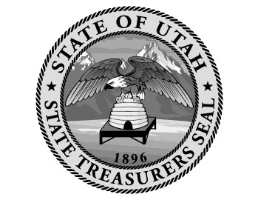
Office of the State Treasurer
Public Entity Resolution
No. 2019-01-2

Certification of Authorized Individuals
I, Joe Smolka (Name) hereby certify that the following are authorized: to add or delete users to access and/or transact with PTIF accounts; to add, delete, or make changes to bank accounts tied to PTIF accounts; to open or close PTIF accounts; and to execute any necessary forms in connection with such changes on behalf of Greater Salt Lake Municipal Services District (Name of Legal Entity). Please list at least two individuals.

Name | Title | Email | Signature(s)
Cathy Jensen | CFO | cajensen@slco.org
Bart Barker | General Manager | BBarker @slco.org

The authority of the named individuals to act on behalf of Greater Salt Lake Municipal Services District
(Name of Legal Entity) shall remain in full force and effect until written revocation from
Greater Salt Lake Municipal Services District (Name of Legal Entity) is delivered to the Office of the State Treasurer.

Signature of Authorization
I, the undersigned, Board Chairman (Title) of the above named entity, do hereby certify that the forgoing is a true copy of a resolution adopted by the governing body for banking and investments of said entity on the day of , 20 19 , at which a quorum was present and voted; that said resolution is now in full force and effect; and that the signatures as shown above are genuine.

Signature Date Printed Name Title
Joe Smolka Board Chairman

STATE OF UTAH )
§
COUNTY OF )

Subscribed and sworn to me on this day of , 20 , by
Joe Smolka (Name), as Board Chairman (Title) of
Greater Salt Lake Municipal Services District (Name of Entity), proved to me on the basis of satisfactory evidence to be the person(s) who appeared before me.

(seal)

Signature

