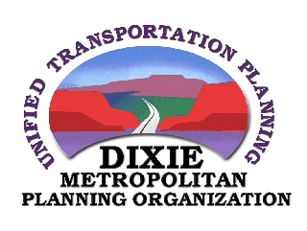
Transportation Advisory Committee (DTAC)
AGENDA

January 2, 2019
Meeting at 1:00 PM

Five County Association of Governments – Large Conference Room

Conducting: Chuck Gillette, Chair

- Administrative
  - Consider Minutes from December 5, 2018

- TIP
  - TIP Funding Status
  - Consideration and/or Selection of 2019-2023 TIP projects
    - 1450 South Extension to Crosby Way (I-15)
    - 1450 S (SG) to 3650 S (Wash) Realignment
    - 3650 South Extension

- Long Range Planning
  - COG Priority Project List / January 8, 2019 meeting
  - Discussion on 2019-2050 RTP financial assumptions as discussed at DTEC
  - Discussion of 2019-2050 Long Range Plan Projects Lists

- Local Project Status Updates

  - Hurricane
  - Ivins
  - LaVerkin
  - Leeds
  - St. George
  - Santa Clara
  - Toquerville
  - Washington City
  - Washington County
  - UDOT

- Upcoming Meetings / Deadlines
  - January 8, 2019 – COG meeting
  - January 16, 2019 – DTEC Meeting
  - February 6, 2019 – DTAC Meeting
  - February 14, 2019 – Transportation Expo

- Adjournment

