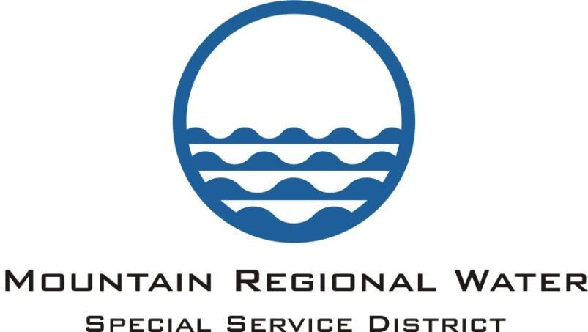

ADMINISTRATIVE CONTROL BOARD

AGENDA

November 15, 2018

The Administrative Control Board of Mountain Regional Water SSD, Summit County, Utah will meet in Regular Meeting session on November 15, 2018 at the Silver Summit Academy located at 6407 N. Business Park Loop, Park City Utah, 84098 at 6:00pm. The following is the agenda for said session.

- Call to Order and Public Input:

- Executive Session - Personnel and Property Acquisition:

- Move to Open Session:

- Consent Agenda:
  - Approval of the October 25, 2018 ACB Meeting Minutes
  - Approval of the October 2018 Check Register

- Questions on Department Updates:

- Financial Management: Lisa Hoffman
- October 2018 Financial Report:
- Fitch Rating Review:
- Other:

8. Legal: Dave Thomas
- Update on Community Water:
b. Consideration of purchase of property from SBWRD for MRW:
c. Training Requirements for the MRW Administrative Control Board:
d. Consideration of Approval of the MRW Employee Contracts:
e. Other:

9. General Manager Comments: Scott Morrison
- Consideration of Approval of Merit Bonus for MRW Employees:
- Discussion of the Methodology for Wholesale Water Rates for - Western Summit County Project Master Agreement:
- Other:

10. Adjourn:

Pursuant to the Americans with Disabilities Act, individuals needing assistance attending the meeting, December 13, 2018 should contact Marti Gee to make arrangements. The next MRW Board Meeting will be held on November 15, 2018.

