July 30th, 2018

Dear Resident,

The Town of Virgin has begun the Process of Disconnect (De-Annex) from the Mesa Road (Smith' Mesa). The Town of Virgin does not have the funding, equipment or staff to maintain, upgrade and supply the service this road requires. A Public Hearing will be held August 22nd, 2018 in a regularly scheduled Town Council Meeting, to accept public input (notice below).

If you have any questions or concerns, please contact the Town Office 435-635-4695.

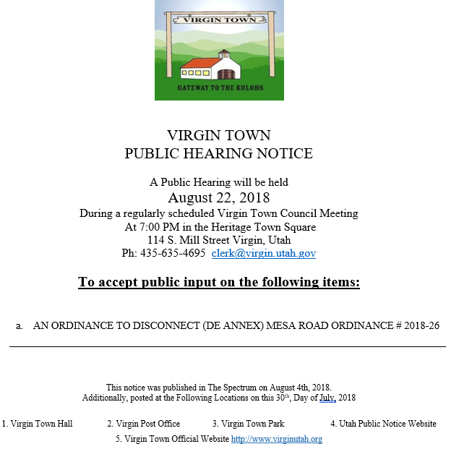
Sincerely,

Monica Bowcutt
Virgin Town
Clerk/Recorder

