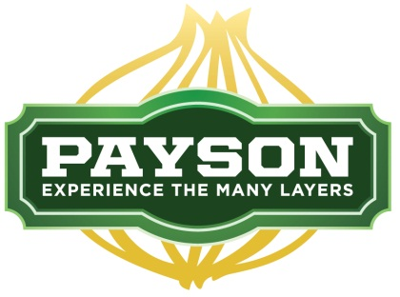

Notice is hereby given that the Payson City Council will hold a special meeting on Saturday, February 20, 2016 at 8:00 a.m. in the Payson City Council Chambers at the Payson City Center, 439 West Utah Avenue, Payson, UT. Some Councilmembers may attend by Electronic Device.

The agenda will be as follows:

- Discussion Regarding Sewer Issues With Salem City
- Discussion Regarding Green Waste With Salem City
- Discussion Regarding Led Sign At Wagon Wheel Park
- Discussion Regarding Capital Projects
- Discussion Regarding Zap Tax
- Discussion Regarding Transportation Fee
- Discussion Regarding Golf Course Reception Center
- Discussion Regarding Budget Issues

I, Amanda Baker, Deputy City Recorder, do hereby certify that the above notice was posted in the Payson City Center and on the Utah Public Notice Website on this 18th day of February, 2016. The press was duly notified.

/s/ Amanda Baker
Deputy Recorder

In accordance with the Americans with Disabilities Act, Payson City will make reasonable accommodations to participate in the meeting. Requests for assistance can be made by calling 801-465-5209 at least 48 hours in advance of the meeting to be held.

