



Site Plan Review
Meeting Date Nov 2, 7 pm 1528 Sunset Road, Lake Point, UT 84074
Applicant Frank McCown
Property Owner CJM HOLDINGS LLC
Request Commercial Site Plan Review
Property Address 8401 Commerce Dr. Lake Point, Utah 84074
Parcel 01-508-0-0019
Acreage 3.469 Acres
Zone CG Commercial General
Prepared by Jamie Olson
Presented by Jamie Olson

Scope of Decision- This is an administrative matter to be decided by the land use authority Lake Point City Council upon receiving a recommendation from the Planning and Zoning Commission and a review from the Development Review Team (DRT).
Request Summary
- Proposal of a shop accessory structure to an already existing and established Lake Point Business McCown Technology Corporation
- Building/Shop is 75’ by 100’
- Building/Shop height of approx. 25 feet
- The site already has parking- no addition parking needed for proposed building.
- No landscaping, just gravel. No signs, lighting, or utilities for shop.
- The Zoning is CG- Commercial General and is an allowed use under Chapter 13.5.2. through 13.5.3.

Special Approvals

No special approvals

General Plan Considerations
This application does not go against anything in the Lake Point General Plan adopted in
Ordinance 2024-05 on April 10, 2024.

DRT Committee Review, Findings and Corrections
- Building Official approved and no comments or corrections made
- Engineering approved and any comments or corrections made
  - Requests for additional information on drainage and missing elements to the application. All items resolved
- Fire Marshal approved and any comments or corrections made
  - Required fire access road from Garfield Circle- resolved
- Zoning Administration approved and any comments or corrections
  - Requests for additional information on drainage and missing elements to the application. All items resolved
- Any public feedback
  - No public feedback to report
- Traffic Report waived by engineering- does not front UDOT road and subdivision was designed for this traffic.
- Geotechnical Study independently provided by applicant for this parcel by Gordon Spilker Huber
- Land Survey Provided
- Complies with proposed use under current zoning -state ordinance and use

Development Review Team (DRT) Approvals

The following departments have reviewed the site plan application which provides the subject for this staff report, and it has been found to be appropriate for review by the Lake Point City Planning Commission and/or City Council.

Fire Marshal (Buck Peck)
City Recorder/ Zoning Administrator (Jamie Olson)
Engineering (Dan Fechner)
Building Official (Kelly Brown)
Rocky Mountain Power- N/A
Enbridge- N/A
Lake Point Improvement District - N/A
Oquirrh Mountain Water Company - N/A

Recommendation

Based on the findings and conclusion listed in this report, staff recommends the Planning Commission review and approve the Site Plan Review Application for applicant David Burkett.

Supporting Document

Parcel Location and CG Zone Boundary
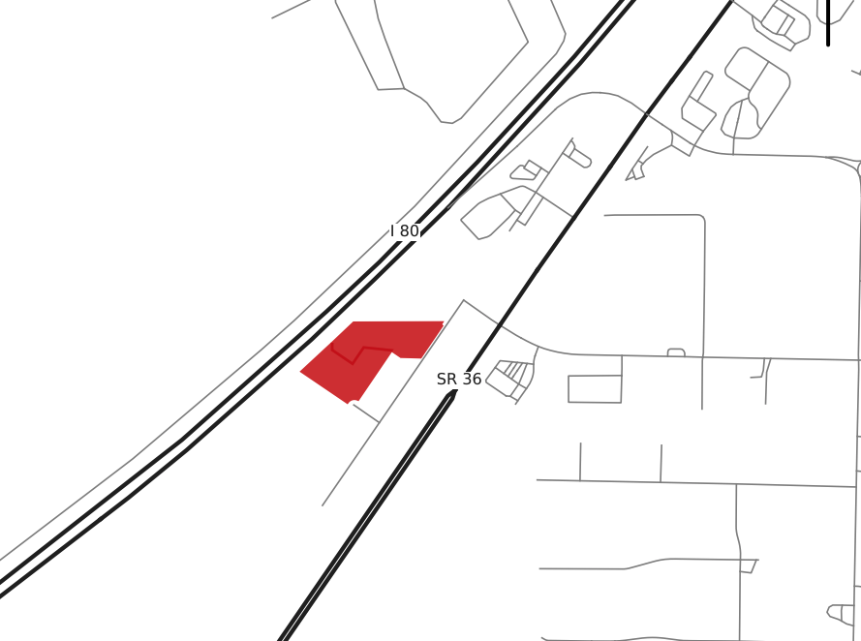

Site Plan of Building

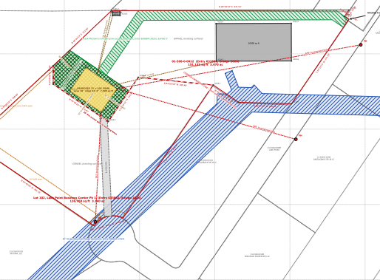

Endwall
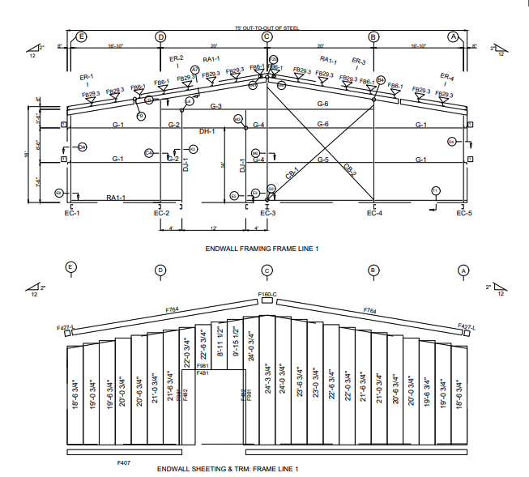

Sidewall

