Millcreek
1330 E Chambers Avenue
Millcreek, UT 84106

Request for Proposals

2300 East Roundabout Landscaping Concept Plan

Due

Proposal Deadline: Monday, November 23,2026, at 5:00 PM Mountain Time
Question Deadline: Monday, November 16, 2026, at 5:00 PM Mountain Time

1. Introduction. Millcreek, a Utah municipality (the “City”), requests proposals from qualified firms or individuals (“Proposers”) to develop a concept plan for landscaping and beautifying the 2300 East Roundabout located at the interchange at the exit from I-80 at 2300 East. This Request for Proposals (“RFP”) establishes the scope, submission requirements, evaluation process, and conditions for selection. The City anticipates awarding one contract through this solicitation.

1.1 Procurement requirements. This procurement is governed by Millcreek Municipal Code Chapter 2.22 and other applicable procurement requirements. If this RFP conflicts with a controlling legal requirement, that requirement governs.

1.1. Intent. This RFP establishes the minimum requirements for Responses submitted a response.

2. Background of the Project. The City is seeking proposals from qualified consultants with specific experience in landscape design, right-of-way information, GIS data, UDOT standards, utility ownership, parcels, rights-of-way, and easements within the study area.

3. Detailed Description of Services/Scope of Work. The required services (“Services”) are described in Exhibit “A”—Scope of Work. Exhibit A identifies the required tasks, deliverables, schedule, meetings, City-provided information and assistance, required file formats, and acceptance requirements. Proposers shall base their technical and fee proposals on the full scope in Exhibit A, as modified by any written addenda. Proposers shall clearly identify assumptions, exclusions, proposed deviations, and separately proposed optional services. An assumption, exclusion, or deviation does not amend the scope unless expressly accepted by the City in the executed agreement. The City may reject material deviations from the required scope.

4. Proposal Requirements. Submit the technical proposal as a PDF by email to Rita Lund at rlund@millcreekut.gov. Submit the fee proposal as a separate PDF by email to purchasing@millcreekut.gov. Both documents must be received by the applicable City email system no later than the Proposal Deadline stated above. Use the subject line “2300 East Roundabout Landscaping Concept Plan”—[Proposer Name]—Technical Proposal” or “Fee Proposal,” as applicable. Name each attachment to identify the Proposer, project, and document type. Do not include pricing information in the technical proposal. The Proposer is responsible for timely delivery, readable attachments, and compliance with all submission requirements. Sending an email before the deadline does not establish timely receipt. The City may acknowledge receipt, but an acknowledgment does not establish responsiveness. Late proposals will be rejected. Proposal modifications or withdrawals must be submitted in writing to the applicable submission address and received before the Proposal Deadline. The technical proposal may not exceed ten pages, excluding the cover page, introductory letter, and resumes. Tables of contents, organizational charts, exhibits, and appendices count toward the limit. One of the ten pages may be an 11-by-17-inch sheet; all other pages shall be 8.5 by 11 inches. Each printed side counts as one page. Use readable text and clearly identify the required sections. The City will not evaluate technical-proposal content that exceeds the page limit. The Proposal must include the following:

4.1. Introductory Letter. Include an introductory letter expressing an interest in providing these Services. The introductory letter should be addressed to:

Rita Lund
Millcreek City Hall
1330 East Chambers Avenue
Millcreek, UT 84106

Include an e-mail address for the consultant's primary contact. The letter must confirm that the proposal remains valid for at least 90 calendar days after the Proposal Deadline.

4.2. Relevant Experience: Provide an organizational chart showing the individual team members, qualifications, breakdown of responsibilities, and the percentage of work expected to be performed by each team member. Indicate other offices/locations/subconsultants that might provide services and a percentage of work to be performed at those locations. Please describe the proposer’s relevant experience on similar projects. Provide information for at least three such projects. Proposer shall demonstrate the following qualifications:

- Proven experience in performing landscaping strategies for large areas adjoining busy roadways
- Strong understanding of urban landscapes and management practices
- Understanding of social science and best practices in drought tolerate landscaping
- Excellent communication and writing skills
- Ability to work collaboratively with city staﬀ and community members

4.3. Work Approach: Describe the methodology and process to complete the scope of work attached at the end of this RFP, including any potential innovative or creative solutions for the project. This approach should also identify any of the proposed strategies to control costs, ensure operational effectiveness, describe outputs to be delivered, and identify the advantages of the proposal to Millcreek. This section should include a summary of the time expected to complete each primary task in the scope of work and the classification of personnel to be used. Identify any additional services to be provided by subconsultants or resources outside the firm.

4.4. Fee Proposal: The proposed project fee to complete the project with subtotals by task as identified in the scope of work. This fee proposal should include work hours to be completed by each key team member and other support staff classifications, as well as proposed billing rates. List optional services separately, with their prices, and do not include them in the required-scope lump sum. For evaluation, the “evaluated fee” is the all-inclusive lump sum for the required scope; optional services will not be included in fee scoring. Identify rates proposed for additional services, which may be performed only if authorized in accordance with the executed agreement. Proposed rates do not authorize additional work or payment.

4.5. References. Provide the name, address, and contact person for government or private entities for which the Proposer has performed similar services and that can attest to its performance on relevant projects. The City may contact the references and conduct its own investigation. The results may be grounds for disqualification in the City’s sole and absolute discretion. In addition, please provide information that details how the Proposer will produce a document that conforms to the WGAC2.1, Level AA standard.

5. Identification of Anticipated Potential Problems/ Conflicts. Identify foreseeable problems, constraints, schedule risks, and dependencies associated with the Services, together with proposed solutions. Disclose actual or potential conflicts of interest involving the Proposer, proposed team, or subconsultants and the City or its officials or employees, together with proposed mitigation measures. Disclose any suspension or debarment affecting eligibility to perform the Services. Information materially affecting the Proposer’s eligibility or ability to perform must be accurate and updated promptly during the solicitation process.

6. Evaluation Criteria and Scoring Process. The Evaluation Committee will review all Proposals received. Each evaluation criterion has been given a percentage based on its relative value. The requirements and each associated percentage are as follows:

- Relevant Experience (50%)
- Work Approach (40%)
- Fee (10%) The points assigned to each fee proposal will be based on the lowest proposal fee. The Proposer with the lowest proposed fee will receive 100% of the fee points. All other Prospers will receive a portion of the total fee points based on the percentage of their proposed fee that exceeds the lowest proposed fee. The formula to compute the points is: Fee Points x (lowest proposed fee/proposed fee).
- References (references are a mandatory minimum requirement, and the City may do its investigation, and the result of the investigation at any time during the solicitation process may result in a disqualification based on the City’s sole and absolute discretion)

7. Selection. The City will appoint an Evaluation Committee. A designated City representative who is not a committee member will receive and review fee proposals and calculate fee scores. Fee information will not be provided to the committee until its technical scoring is finalized.

The above criteria will be used to evaluate the Proposals. If such a modification occurs, each Proposer being interviewed will be notified at least twenty-four (24) hours before the revised criteria interview. In addition, the City may conduct discussions with the Proposers who are being considered for selection for the award. In addition, one or more Proposers may be invited to participate in an interview; however, the Evaluation Committee reserves the right to modify the interview criteria. Proposals may be accepted without discussion or interview. The Mayor or his designee will make the award.

8. General Information. City reserves the right to reject any and all Responses. The City reserves the right to amend, modify, or waive any requirement outlined in this RFP. Response to this RFP is at the Proposer’s sole risk and expense. All Proposers must comply with applicable federal, state, and local laws and regulations. Except for written responses provided by the contact person described below, the City has not authorized anyone to make any representations regarding the subject matter of this RFP. All requests for clarification or additional information regarding this RFP must be submitted in writing to the contact person described below, no later than (Insert date generally one week before due date). The contact person will endeavor to respond to such requests for clarification or additional information. If the contact person deems, in her sole and absolute discretion, that such a response is of general applicability, his response, if any, will be posted on the City’s website at Millcreekut.gov (which constitutes a written response). Entities responding to this RFP are encouraged to review such websites frequently. The City anticipates selecting one or more of the responding Proposers, but there is no guarantee that any responding Proposer will be selected. Public records and confidentiality. Materials submitted in response to this RFP become City records and will be retained, classified, and disclosed in accordance with the Government Records Access and Management Act (“GRAMA”), Utah Code Title 63G, Chapter 2, and other applicable law.

A Proposer claiming business confidentiality should identify the specific information claimed to be protected and submit a written claim with a concise statement of supporting reasons in accordance with Utah Code Section 63G-2-309. A blanket confidentiality designation does not establish that an entire proposal is protected. The City will determine classification and disclosure under applicable law and will observe applicable notice and appeal requirements. The City does not guarantee confidentiality or agree to confidentiality restrictions imposed unilaterally by a Proposer.

9. Terms of Contract. The successful Proposer will be required to contract with the City to provide the Services described herein. If the selected Proposer and the City Attorney cannot negotiate an acceptable agreement, then another Proposer(s) will be selected by the Mayor, or his designee, and negotiation will continue with such other Proposer(s) until an acceptable agreement is completed.

10. Contact Person. For more information on the Proposal, contact Rita Lund at rlund@millcreekut.gov, 1330 East Chambers Avenue, Millcreek, UT 84106. For American with Disabilities Act (ADA) accommodation, contact our ADA Coordinator at 801-214-2751 or adainfo@millcreekut.gov.

Exhibit A

Detailed Description of Services/Scope of Work

Background and Context

Millcreek, a Municipal Corporation (“City”), is requesting proposals/bids (“Proposals” or “Responses”) from qualified proposers (“Proposers”) to develop a concept plan for landscaping and beautifying the 2300 East Roundabout located at the interchange at the exit from I-80 at 2300 East.

The 2300 East Roundabout was installed and landscaped by Salt Lake County in 2016 but has since fallen into disrepair with the irrigation system inoperable and weeds overtaking the landscaping that was completed at that time.

The study area is located in Millcreek, Utah, within Salt Lake County, and encompasses the main roundabout on 2300 East and two traffic circles on Heritage Way, and Vimont Avenue. The area is adjacent to residences, a drive-thru car wash, Congregation Kol Ami synagogue, a local business hub, and a small parking area for the adjacent businesses.

The study area is generally hot and dry with nightly canyon winds moving down Parley’s Canyon into the valley.

The 2300 East exit is a main entrance into Millcreek and complaints have been expressed by residents about the run-down first impression for travelers entering the city. Millcreek is interested in cleaning up and upgrading the area to provide a pleasant experience for visitors and residents alike.

The information listed below is intended to provide interested Consultants with basic information but is not meant to limit a proposal’s content or to exclude any relevant or essential data, tasks, or project steps. Consultants are at liberty and are strongly encouraged to exercise creativity and to recommend innovative approaches and practices in performing the plan, given their scope of work. Material changes in scope will require approval from Millcreek prior to implementation.

Project Approach and Workplan
Provide a detailed narrative describing the Consultant’s understanding of the project’s objectives and its proposed methodology for accomplishing each task outlined in the Scope of Work.
Describe in detail the Consultant’s proposed methodology for completing the scope of work, including any potential innovative or creative solutions for the project. The approach should also identify any proposed strategies to identify ongoing maintenance and upkeep needs and identify the advantages of the proposal to Millcreek. This section should include a summary of the time expected to complete each task in the scope of work and the classification/relevant experience of personnel to be used. Identify any additional services to be provided by sub consultants or resources outside the firm.
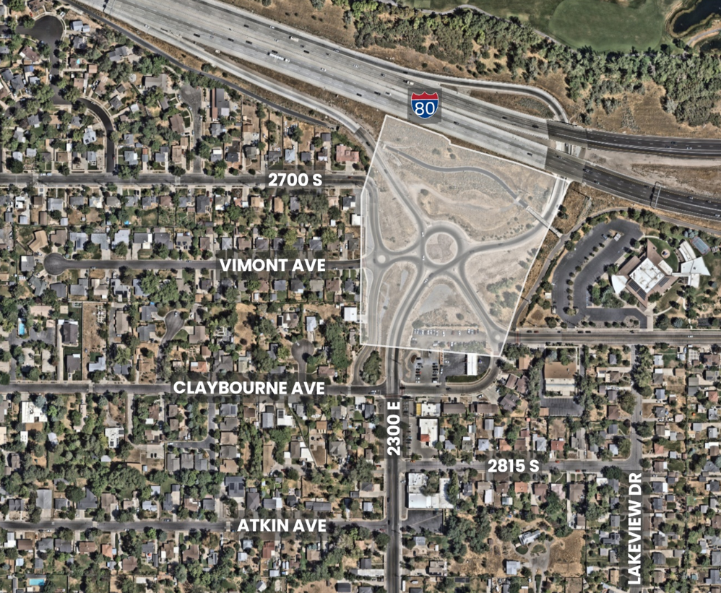

Project Area

The project area is outlined in the map shown above and encompasses a large roundabout on 2300 East and two smaller traffic circles on Heritage Way and Vimont Avenue. The area includes a parking area for the business cluster along 2300 East and a section of Parley’s Trail including a bridge and an underpass for the trail.

Scope of Work

Task 1 – Project Initiation and Data Collection
- Conduct a kickoff meeting with Millcreek staff to confirm scope schedule, communication protocols, and project goals.
- Review existing GIS data, utilities (including available water system), right-of-way information, UDOT standards, and environmental constraints including local weather conditions, floodplains, and all other pertinent considerations relevant to the concept plan. Data collection shall include a comprehensive inventory of parcels, rights-of-way, and easements within the study area – capturing public, private, and utility ownership interests, including but not limited to UDOT and the Metropolitan Water District infrastructure – drawn from County Recorder/GIS and title research.
- Conduct a site visit to document existing relevant physical, drainage, sightline, environmental, and access conditions - such as slopes, barriers, structures, surface utilities, vegetation, drainage features, encroachments, and traffic patterns – recognizing this list is illustrative rather than exhaustive. Site visit findings shall be documented with photographic evidence and an existing conditions map.
- Identify and engage key stakeholders, including adjacent Canyon Rim and Salt Lake City residents, other adjacent property owners, and community organizations to gather input on concerns and ideas.
- Conduct a public open house to establish baseline community awareness and solicit feedback prior to final concept development. Document public engagement. Track and maintain a project log of all comments received.

Deliverables: Existing Conditions Summary Memo, Exiting Conditions Map, and Public Engagement Summary.

Task 2 – Clearing and Landscaping Alternatives Development
- Identify all decrepit existing infrastructure, determine any salvageable material and outline removal costs where required.
- Identify and map any existing landscaping with consideration as to whether any plantings would be appropriate for inclusion in a new landscaping plan.
- List and describe appropriate plantings for the area, including a map of locations with consideration of local weather conditions and drought tolerant plants.
- Consideration should be included for a potential “Welcome to Millcreek” signage and an artistic component to provide an aesthetic entrance for visitors. Coordinate with the Millcreek Arts Council and the Canyon Rim Citizens Association to capture preferences.
Deliverables: Description and mapping of three alternative planting and signage plans.

Task 3 – Agency and Utility Coordination
- Coordinate with UDOT early in the process to obtain feedback on access, line of sight and permitting requirements.
- Coordinate with the Salt Lake City Department of Public Utilities early in the process to consider future plans for utility upgrades in the plan area.
- Coordinate with Millcreek staff and all other relevant agencies to review the three alternative plans for review and comment.
Deliverable: Agency and Utility Coordination Summary, including anticipated permits and approvals.

Task 4 – Public Outreach
- Conduct a second public open house to present the three alternatives and gather feedback prior to the selection of a preferred alternative.
- Document public engagement. Track and maintain a project log of all comments received.
Deliverable: Public Engagement Summary.

Task 5 – Conceptual Design
- Prepare concept level drawings of the preferred alternative.
- Identify necessary improvements to infrastructure, including Salt Lake City Department of Public Utilities easements, future upgrades, and necessary water hook-ups for irrigation.
- Identify UDOT requirements.
Deliverable: Concept Design Plan

Task 6 – Estimate and Implementation Strategy
- Develop planning level cost estimates for preferred alternative including clearing of existing infrastructure, environmental mitigation and contingencies. Estimates should be presented as ranges reflecting the uncertainty inherent in planning-level analysis, with clearly stated assumption.
- Develop planning level cost estimate for artistic component as a separate estimate apart from landscaping plan.
- Develop an implementation strategy that accounts for project timeline and construction activities identifying required permitting.
- Identify specific federal, state, and local funding programs the project is likely to be eligible for, with notes on application timing, competitiveness, and match requirements.
Deliverable: Cost Estimate and Implementation Strategy including cost estimates for landscaping and art component, and funding strategies.

Task 7 – Final Report
- Compile all conceptual design and strategies from Tasks 1-6 into a single cohesive final concept study report suitable for funding.
- Prepare a standalone executive summary suitable for non-technical audiences including elected officials, grant reviewers, and the public
- Submit a draft report to Millcreek staff for review and comment prior to finalization. Consultant shall incorporate all staff comments and submit a final document within an agreed-upon timeframe.
- Present final findings and recommendations to Millcreek City Council and/or relevant stakeholders.
- Provide all final deliverables in both PDF and editable file formats, including exhibits, drawings, and date files, to ensure Millcreek retains full use of all work products for future project phases.
Deliverable: Final Feasibility Study Report (PDF and editable formats), Executive Summary, and Presentation Materials.

