Present: Tony Jolley (Information Technology), Megan Hillyard-online (Administrative Services), Richard Jaussi (Auditor), Talia Butler-online (Public Works), Rashelle Hobbs-online (Recorder), Sheila Srivastava (Treasurer), Chris Stavros (Assessor), Lisa Ashman-online (District Attorney), Hoa Nguyen-online (Council), Robert Sampson-online (Community Services), James Taylor (Sheriff), Brad Park (Surveyor), Eric Biggart (Mayor Administration), Kelly Colopy-online (Human Services), Thomas Reese-online (Clerk)
Representation Absent: N/A
Staff Present: Trevor Hebditch, Rina Shipley-online, Dean Bullock-online, Hillary Boccagno-online, Cherie Root, Mark Miller, Lee Wilstead-online, Kira Moody-online, Jeff Graham-online, Teddy Arnold-online, Kimball Ball-online, Jon Thelen-online, Valina Eckley-online, Robert Fowler-online, Wendy Ormsby, Melody Baugh
Welcome & Remote Meeting Instructions | 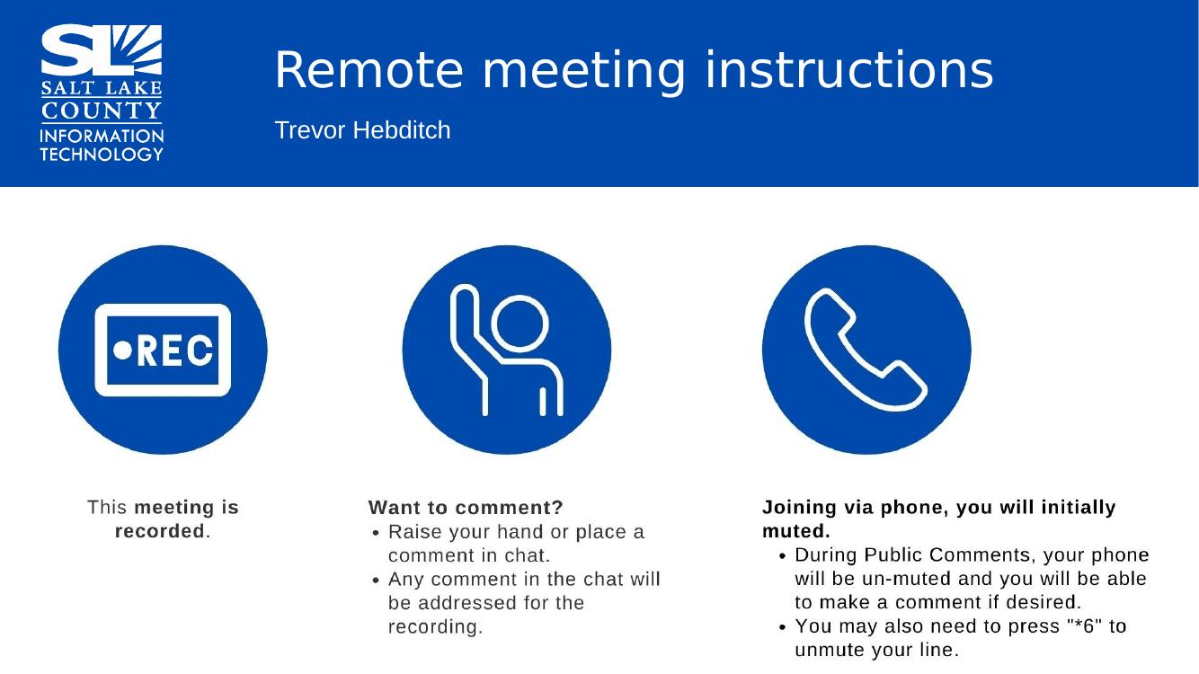
Public Comments | No public comments
Approval of minutes from June 25, 2026 TAB Meeting  Approval of minutes from May 21, 2026 GIS Meeting | Motion to approve the both TAB & GIS minutes by Chris Stavros. Rachelle Hobbs seconds the motion. No discussion.  Motion passed unanimously.
2027 Budget  (Mark Miller) | 
Budget Items Discussion  (TAB Members) | The committee reviewed proposed 2027 technology and GIS-related budget requests to approve a recommended priority ranking to forward to the Mayor and County Council.  Budget funding requests were previously reviewed and scored by IT leadership, Solutions Working Group (SWG), and Portfolio Working Group (PWG). Each group evaluated requests based on factors: 1) Value to County/High Value demonstrated, 2) Risk Mitigation, 3) Project Feasibility  Requests to be funded through separate revenue sources (i.e. Library, Parks & Recreation, or other special funds) were ranked separately than General Fund requests.  Committee expressed first priorities are those items essential to maintaining County operations, including:  - GIS-related infrastructure  - Hardware and software maintenance, including Microsoft Office.  - Network/storage infrastructure, including Servers  New Campus: Any equipment that can be used and not cost deferred maintenance will be used in the new building. Getting closer to understanding actual needs and cost of new building. IT is close to sending out an email to the County re:tech needs for new building.  The committee noted significant increases in technology costs. IT has been working to negotiate contracts and reduce those increases where possible.  After discussion, group generally agreed on the highest priorities.  These priorities will be presented at a meeting with Mayor’s Finance this month. We are unsure how much total funding will be available. Some lower cost items may be able to be moved up the list depending on total funding granted this year.  Motion and Vote: Motion made by Richard Jaussi to recommend the rankings as outlined. Chris Stavros seconds the motion.  No further discussion.  Motion passed unanimously.
Upcoming Meeting Schedule | 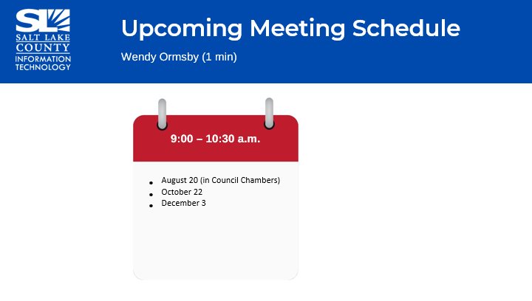
Review Action Items  (Wendy Ormsby) | Communicate recommended technology request priorities to the Mayor and Council
Next TAB meeting: August 20, 2026 (in Council Chambers) | 
End of Session | Motion to adjourn the meeting by Brad Park. No objections. Meeting Adjourned. So moved.
Submitted by Wendy Ormsby

