Present: Tony Jolley-online (Information Technology), Megan Hillyard (Administrative Services), Richard Jaussi (Auditor), Kade Moncur-online (Public Works), Will Kocher (Recorder), Sheila Srivastava (Treasurer), Chris Stavros-online (Assessor), Lisa Ashman-online (District Attorney), Hoa Nguyen-online (Council), Robert Sampson-online (Community Services), James Taylor-online (Sheriff), Brad Park (Surveyor), Eric Biggart (Mayor Administration), Lannie Chapman-online (Clerk)
Representation Absent: Human Services
Staff Present: Trevor Hebditch, Rina Shipley-online, Dean Bullock-online, Hillary Boccagno-online, Cherie Root, Mark Miller, Lee Wilstead-online, Kira Moody-online, Jeff Graham-online, Teddy Arnold-online, Kimball Ball-online, Jon Thelen-online, Valina Eckley-online, Robert Fowler-online, Truc Tran, Melody Baugh
Welcome & Remote Meeting Instructions | 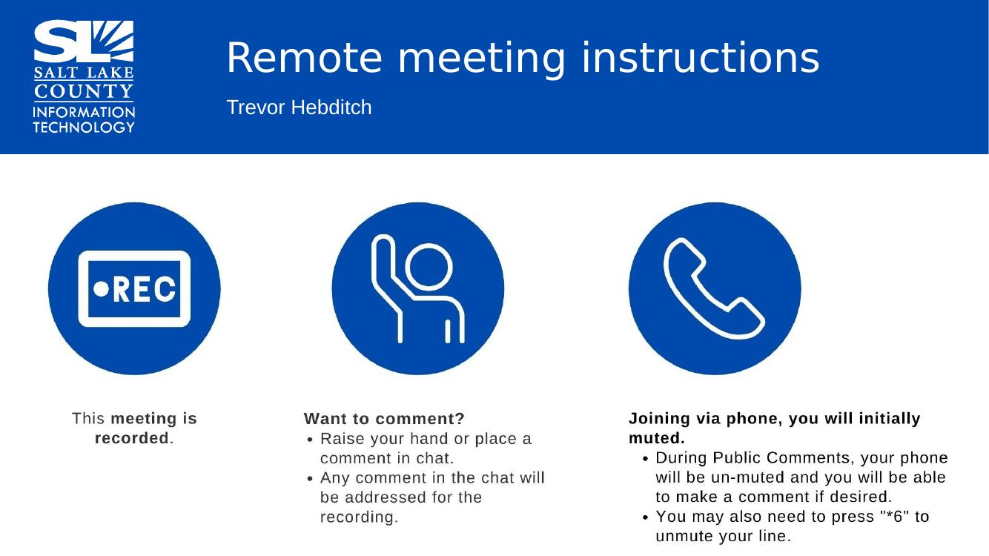
Public Comments | No public comments
Technology FTE Report  (Tracy Byington)  Brad: What is the definition of unique in the County agencies?  Tracy: Only in the agency. Some classifications are county wide but there are some specific to the Agencies. These positions would not be found in IT. | 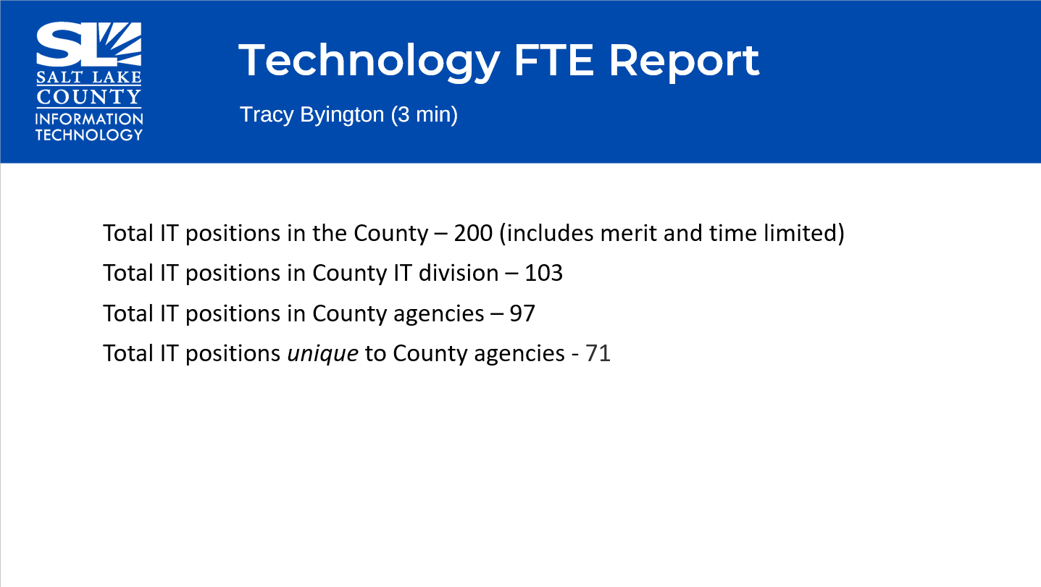
STWG Updates  (Lindsy Bently & Teddy Arnold)  Goals: working together on template like the story map template. ELA/Needs Assessment, Data catalog, and GIS/AI.  Restarted GIS User Group meeting which starts today August 20th at 10:30 am | 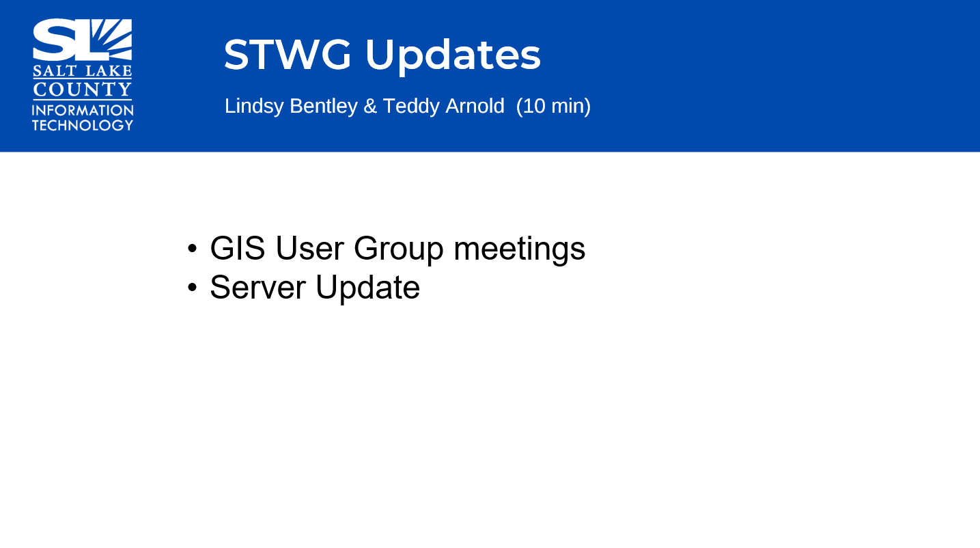  GIS Server Update-Teddy  - Long run upgrading infrastructure to version 11.5 but very close to finishing the project.  - Migrated to new server instances and complete the  - In process- Database migration. Migrated 15 and working on the last 3. 2 year process after to organize it.  - Continually updating to make sure things are in compliance and best practice to keep UpToDate.
ESRI User Conference Review  (Samantha Kight) | Brad: Great networking and training tool for users.  Samantha’s experience: World’s largest gathering of GIS Professionals.  Spoke about highlights of the conference.  Presented using story map  PDF will be available and shared.
County GIS Day  (Lindsy Bentley) | Announce GIS Day at the County Tuesday, November 17th, 2026  Theme; GIS : Powering Purpose and Innovation
ELA Renewal Negotiations  (Lindsy Bentley) | 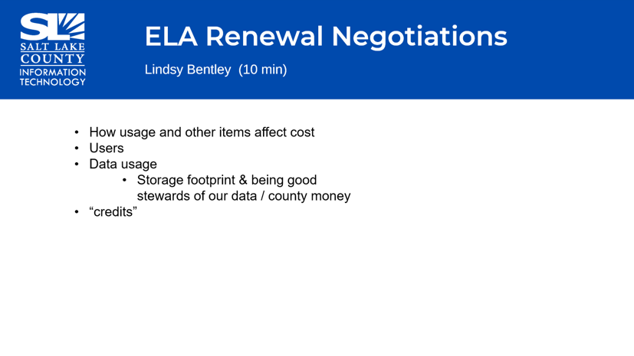  Massive effort from multiple offices and learned a lot from this. ESRI discussions about licenses and users (100 more uses that we have not been able to track)  - How it affects cost  - If we are using these licenses the best way possible  - Data storage discussion, credit cost us money and need to be aware what we are storing online and storage cost credit and cost County money.  - Comments: Kudos from Brad Park to get us a good price on renewal. Conversations working level group, better stewards and continue keeping price low.
Records Management & Relations to ELA  (Maren Slaugh) | 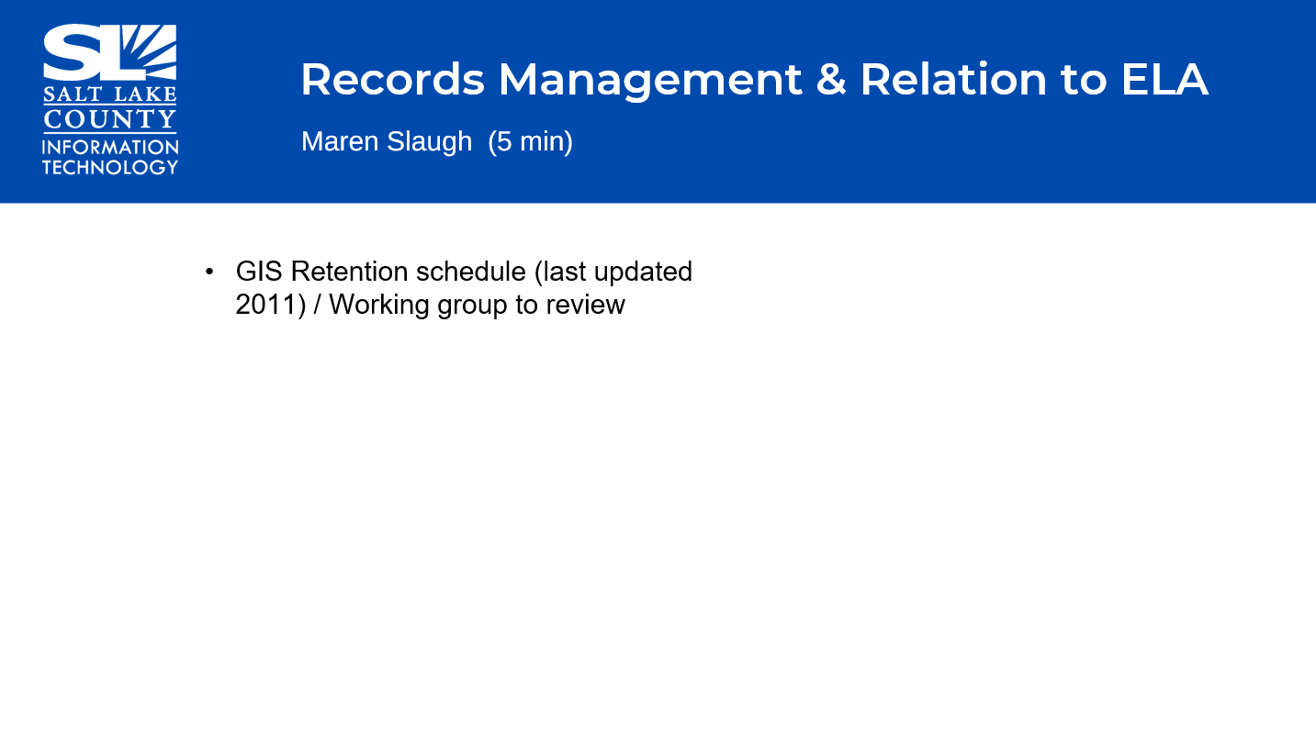  Current state covering 7 County agencies. Retention is a group of agencies, classification and retention which have not been looked at for a long time since 2011.  - Recommendation to keep GIS retention schedule but also have same information on the agency-specific retention schedule which will trigger it to be reviewed.  - Review the schedule, what we need to update and remove?  Questions/comments: Megan asked Get more attention so we don’t have a lag in review like this? Data hygiene and data maintenance is important. Does everyone have the tools they need to review it regularly?  Maren: Every agency will have their own agency contact that handles the record and data. Suggest once a year, sit down and review so we can stay on top of things. Rely on agency to come to us to update their retention schedule but I can work on remaining agencies. Through an app versus email.  Sheila: Things that are not noted as required retention items. Example: Past two predecessors saved and I save notes, is there a recommendation to purge old information like that without having to go through that manually.  Maren: They are supposed to review everything they have and send everything to archive. Offboarding process is that they need to review and supervisor need to review. Just delete that and talk to our team/or DA team and it should have been transferred.
Privacy Program Update  (Aaron Moyes)  Trained data coordinators on the foundation of the privacy program. ODI team helping with SharePoint, all resources will be available. Training done every 3 months. | 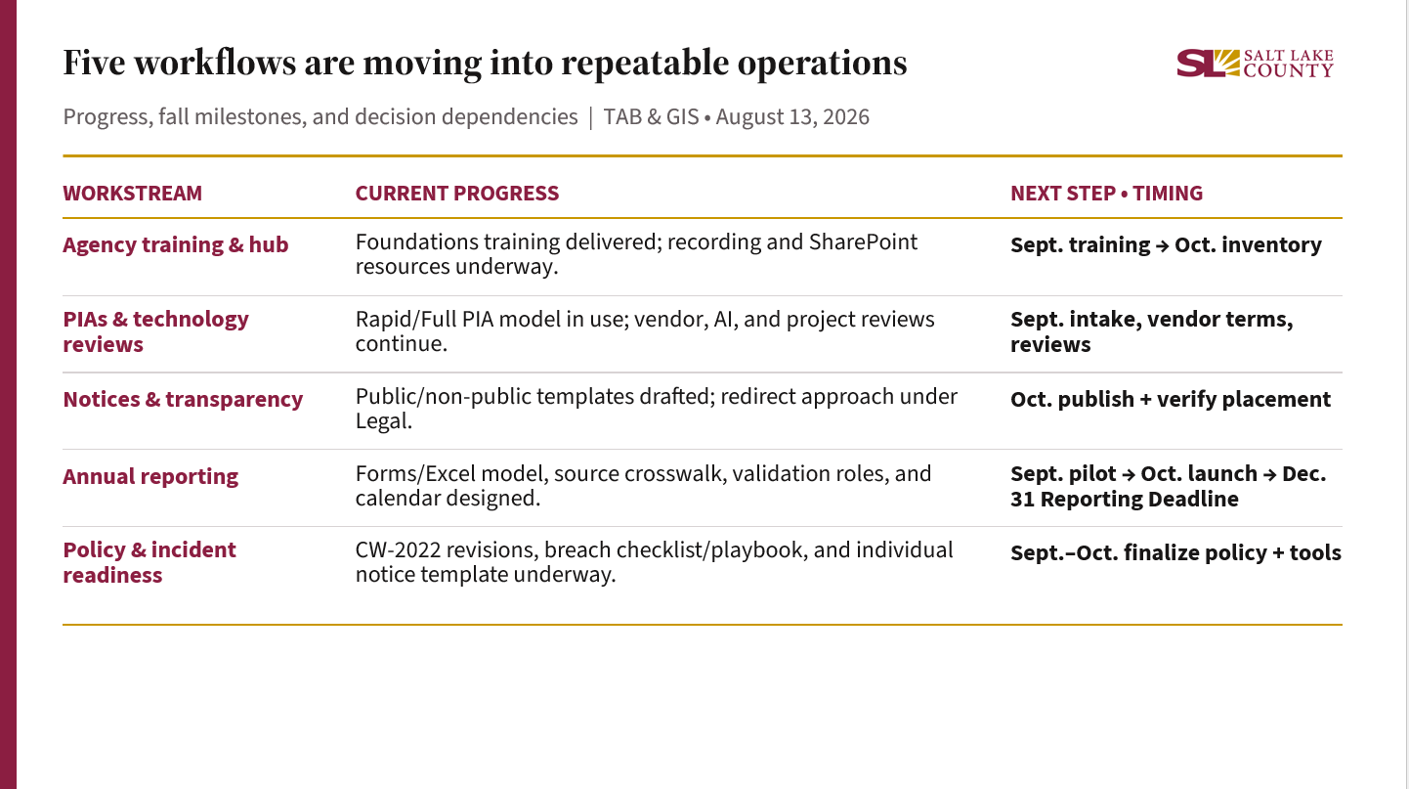
Here is a high-level update on where the Privacy Program is. The main point is that the foundational pieces are moving into repeatable County operations, with most of the next implementation work concentrated in September and October.
For agency training and support, I delivered the Privacy Program Foundations training for Agency Data Coordinators on August 6. The recording is available, and I am continuing to build the coordinator hub so training, templates, guidance, and reporting resources are easier to find. The next module will focus on privacy notices and approved delivery methods. After that training, the Data Coordinators can begin using the collection-point inventory tool. That sequence is intentional: coordinators need the notice context before they document and evaluate collection points.
For PIAs and technology reviews, the Rapid Assessment and Full PIA model is in use, and vendor, AI, and project reviews continue. My Fall focus is to standardize intake and tracking, coordinate reusable vendor privacy terms with Procurement and Legal, and close priority reviews with clear conditions and ownership. I assess privacy impacts and practical safeguards; the agency owner, Legal, Records, Security or IT, and Procurement still confirm the matters within their authority.
For notices and transparency, the public website and non-public collection templates are drafted. The remaining design question is the redirect approach for collection by phone, email, and at a counter, where a traditional form may not provide the notice directly. Legal and Records review will affect the final approach. Once that decision is made, I can publish the practical templates and begin working with agencies to audit notice placement.
For annual reporting, I have designed the Forms and Excel model, source crosswalk, validation roles, and reporting calendar. The plan is to pilot with select agencies in September, launch the agency collection process in October, validate the inputs in November, and prepare the County submission for December 31. Data Coordinators will provide agency-specific facts and flag unknowns; I will coordinate validation with the appropriate program owners and reviewers and compile the Countywide report for CAO review.
For policy and incident readiness, the CW-2022 revisions, breach checklist, and individual notification template are underway. I will coordinate that work with Legal, Records, Security for IT, and affected agencies. The privacy assessment is one part of incident response; legal notification requirements, records issues, technical containment, and agency facts must be confirmed by the responsible experts.
Three pending decisions can affect the sequence: the redirect notice approach, the scope and governance of the CW-2022 revisions, and reusable vendor contract language. The two main dependencies are also important: training comes before inventory, inventory supports reporting, and policy decisions may cascade into notices, PIAs, and incident tools.
The main way TAB can help is early visibility. If a new or materially changing system will collect, use, disclose, or share personal data, please flag it before procurement or production. Early review gives the agency and the appropriate reviewers time to identify workable safeguards before key decisions are locked in.
[Sources]
- SLCo_TAB_Privacy_Update_Slide_Outline.docx, August 2026.
- SLCo Privacy Program Roadmap FY2027, June 2026.
- SLCo Annual Privacy Program Reporting Plan Outline, reviewed August 2026.
- SLCo Data Coordinator Training Outline.
- SLCo PIA Rapid Assessment.
- SLCo public and non-public privacy notice agency templates.
- User-provided current program context through August 2026.
Artificial Intelligence Working Group  (Trevor Hebditch) | 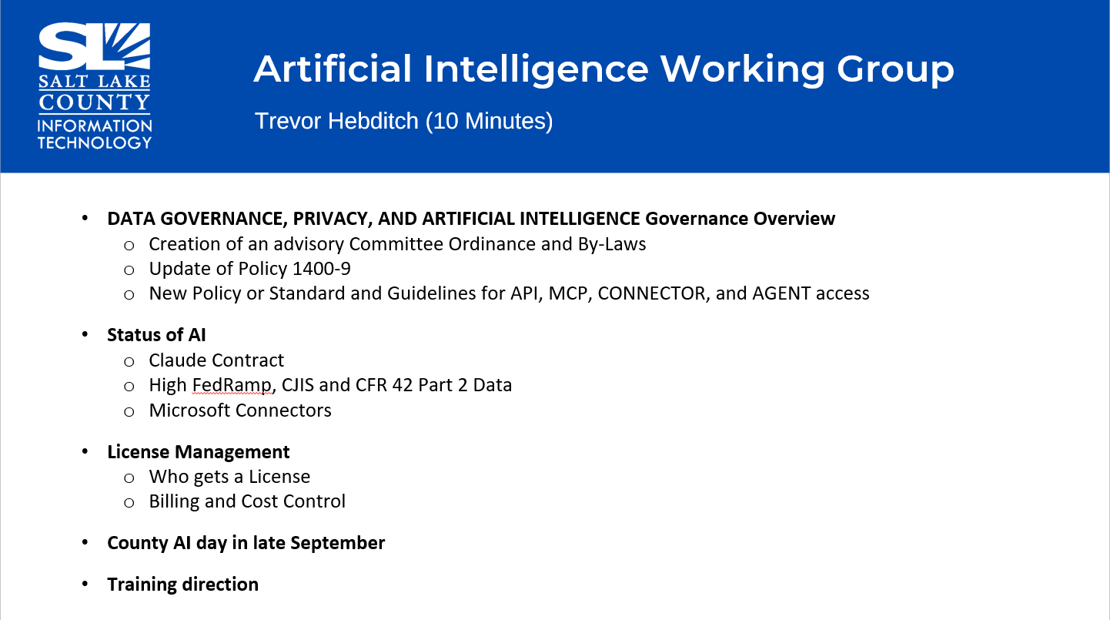  Evolving very fast, multiple people interested.  Finalized to use Claude. Council may choose to limit the usage.  Governance: Process of creating new steering committee.  Updating policy to reflect the usage of AI.  Issue of different people wanting to use different tools, how to ensure people are using it properly.  HIPPA and CJIS compliance.  Cost control: tier system and request more if they need to use more. Will come back with a proposal.  Looking at structures. No potential data lost and controlled.  Licensing: Need to work out how that looks like.  Outdated HIPAA policy and needs to be reviewed. Reduce risk to the County.  October 1st, County AI Day? Working on how that would look like.  Working on training, working with HR will need to have training.  Brad: Governance in place and best practices.  The County is leading in that approach regarding governance in AI.  Trevor: Push to get this in place this year.  Tony: Training piece will be essential. Training needs to be in place before someone uses AI. Trevor working on HOW to and frequently asked questions.  Eric: The people using AI the most are also up to date on threats. The people dabbling will get in trouble, weak link.  Sheila: Clearly state in policy when they are allowed to access County and should be limited to professional work and not personal use.  Trevor: Majority of people using it has more gains. Mechanism to proactively identify people who are putting information in that are invalid. Data Governance working on that side of it.  Richard: Work for audit paper to cross check, huge time saver and more accurate. We needed Claude two years ago but the more we can demonstrate to the Council, that would be awesome.  Trevor: Fill out form for your office and get the license assigned to you. Reach out via email or directly.
Other Business?  (TAB Members)  None | 
Communications Items  (Chair & CIO)  None | 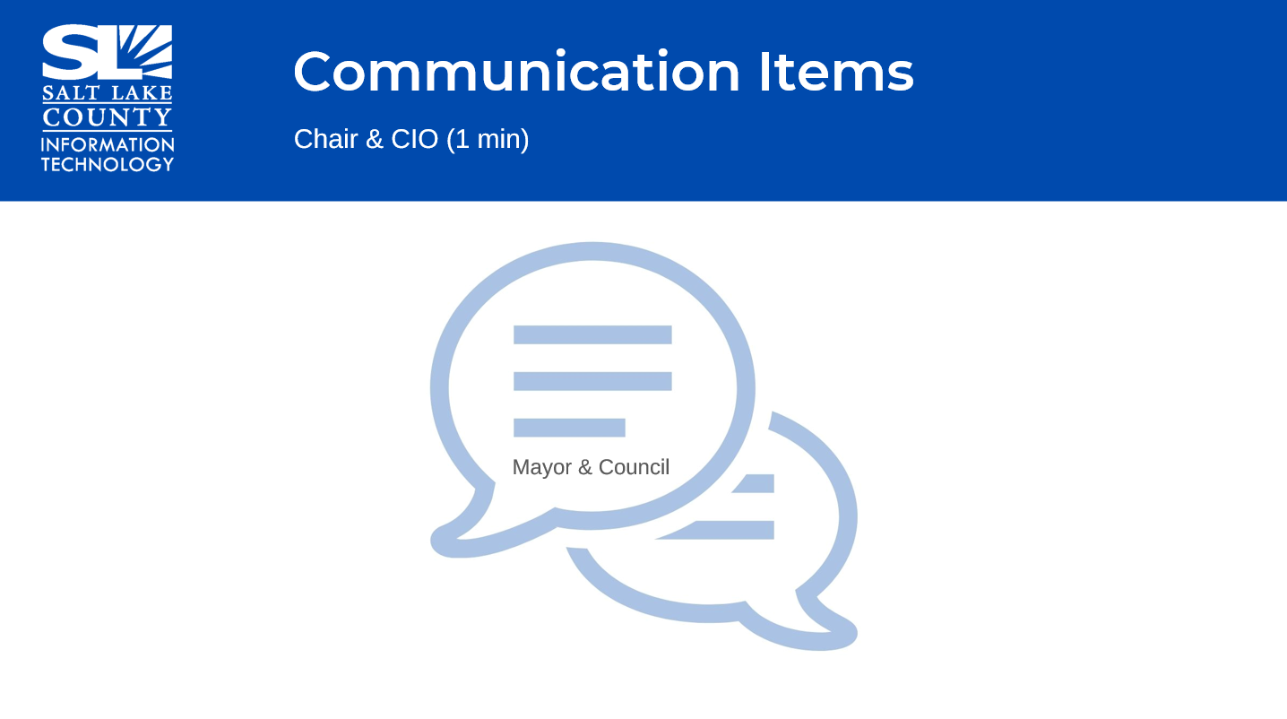
Upcoming Meeting Schedule  (Melody Baugh) | 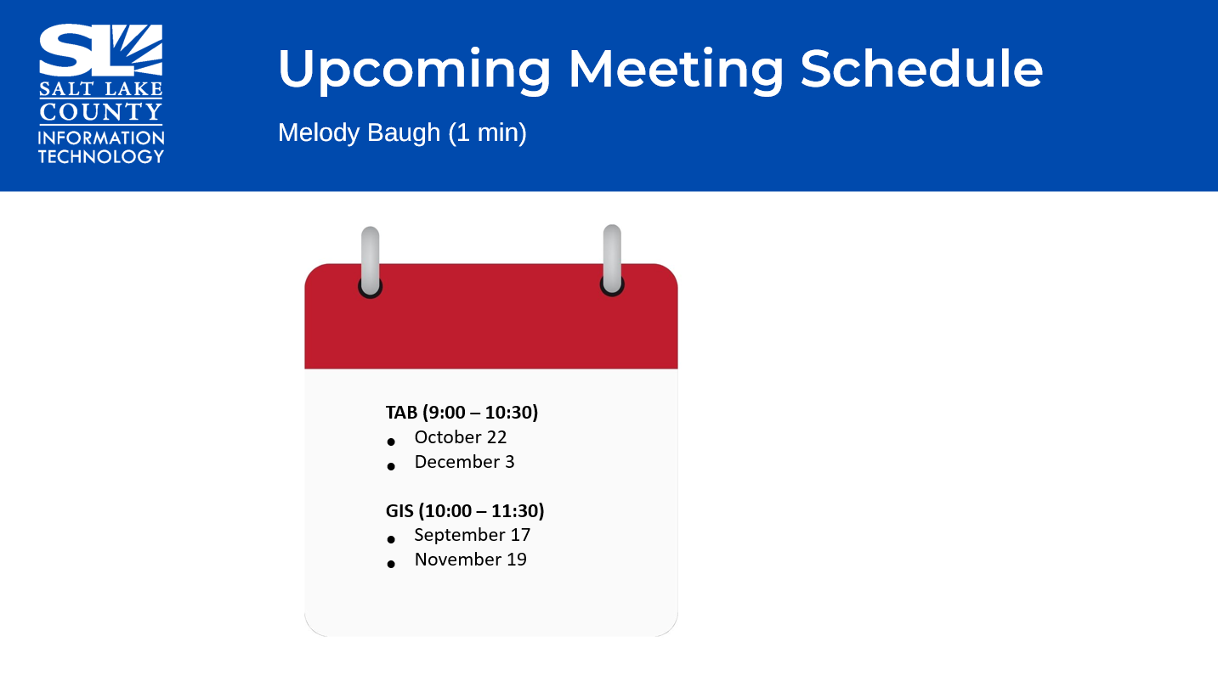
Review Actions items  (Melody Baugh)  None | 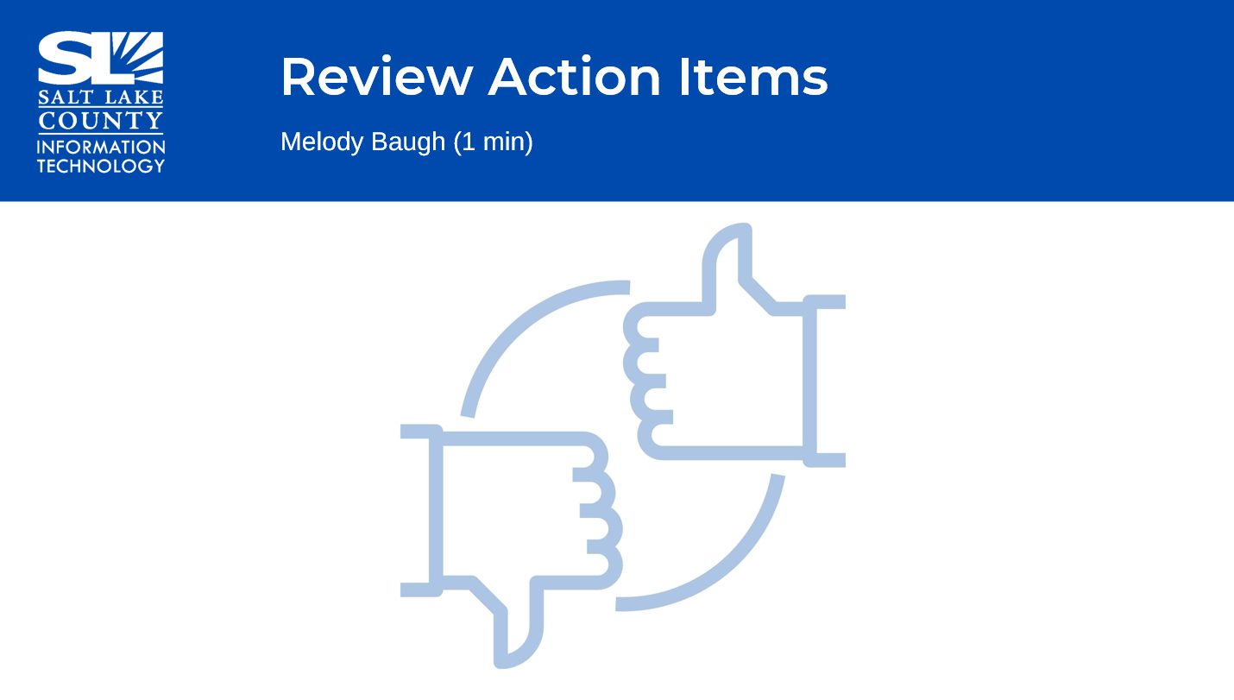
Next TAB meeting: October 22, 2026. | 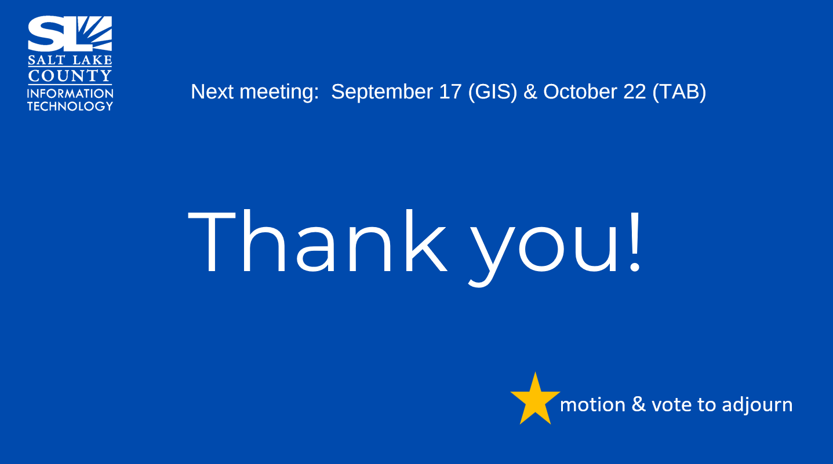
End of Session | Motion to adjourn the meeting by Brad Park. No objections. Meeting Adjourned. So moved.
Submitted by Truc Tran

