October 13, 2026

Utah State Tax Commission
John L Valentine, Chair
210 N 1950 West
Salt Lake City, Utah 84134

Re: Extension of Board of Equalization Deadline

Dear Commissioner Valentine:

The Salt Lake County Board of Equalization is requesting an extension of the appeal deadline beyond the 60-day limit, as pursuant to Utah Code Ann. § 59-2-1004. It is the intention of the Board to complete all appeals filed on or prior to September 15 by March 31, 2027.

We thank you for your consideration of this request. Sincerely,
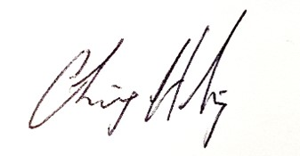

Chris Harding
Clerk of the Salt Lake County Board of Equalization

cc: Josh Nielsen, Director Property Tax
Aimee Winder Newton, Chair
Brad Neff, Tax Administrator

